11.1

源代码：

package triangletest;

import java.util.*;

public class TriangleTest{

public static void main(String args[]){

Scanner ss=new Scanner(System.in);

System.out.println("please input there sides and color of triangle ");

double a=ss.nextDouble();

double b=ss.nextDouble();

double c=ss.nextDouble();

String co=ss.nextLine();

System.out.println("please input a boolean date to indicate this object if be filled");

boolean k=ss.nextBoolean();

Triangle cs=new Triangle(a,b,c);

cs.setColor(co);

cs.setFilled(k);

System.out.println(cs.toString());

System.out.println("the area = "+cs.getArea());

System.out.println("the Perimeter = "+cs.getPerimeter());

System.out.println("the object filled is "+cs.isFilled());

}

}

class Triangle extends GeometricObject{

double side1=1.0;

double side2=1.0;

double side3=1.0;

public Triangle(){};

public Triangle(double side1,double side2,double side3){

this.side1=side1;

this.side2=side2;

this.side3=side3;

}

public double getSide1(){

return side1;

}

public double getSide2(){

return side2;

}

public double getSide3(){

return side3;

}

public double getArea(){

double s=(side1+side2+side3)/2;

return Math.sqrt(s*(s-side1)*(s-side1)*(s-side1));

}

public double getPerimeter(){

return side1+side2+side3;

}

public String toString(){

return "Triangle: side1= "+side1+"\nside2= "+side2+"\nside3= "+side3;

}

}

class GeometricObject{

private String color;

private boolean filled;

private java.util.Date dateCreated;

public GeometricObject(){};

public GeometricObject(String color,boolean filled){

this.color=color;

this.filled=filled;

}

public String getColor(){

return color;

}

public void setColor(String color){

this.color=color;

}

public boolean isFilled(){

return filled;

}

public void setFilled(boolean filled){

this.filled=filled;

}

public java.util.Date getDateCreated(){

return dateCreated;

}

public String toString(){

return "this object's color is "+color+"\nthis object filled "+filled;

}

}

UML图：

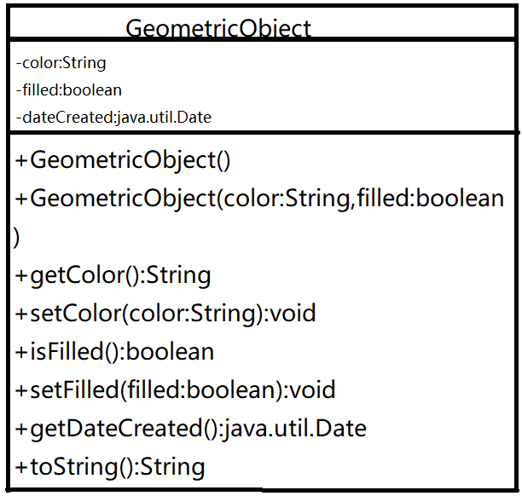

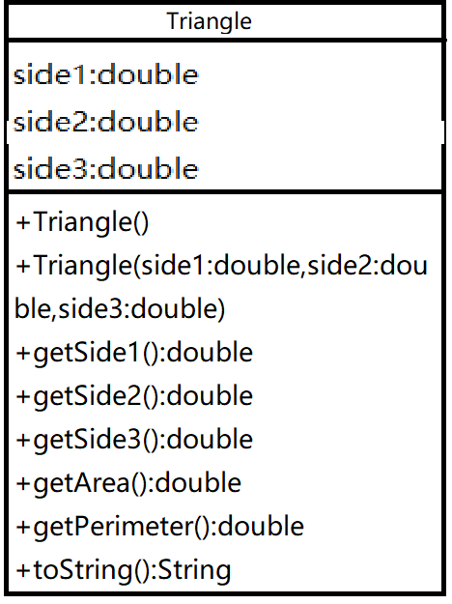

运行结果：

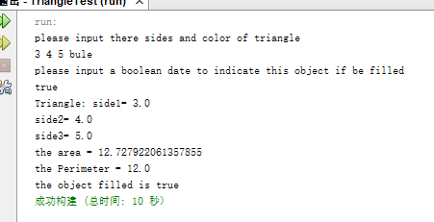

11.2

源代码：

package test;

import java.util.*;

public class Test{

public static void main(String args[]){

Date ss=new Date();

Date cs=new Date(561555550000L);

System.out.println(ss.getYear()+" "+ss.getMonth()+" "+ss.getDay());

System.out.println(cs.getYear()+" "+cs.getMonth()+" "+cs.getDay());

}

}

class Person{

private String name,address,tel,email;

public Person(String name,String add,String tel,String email){

this.name=name;

this.address=address;

this.tel=tel;

this.email=email;

}

public String toString(){

return " name:"+name+" address:"+address+" tel:"+tel+" email:"+email;

}

}

class Student extends Person{

public static final int GRADE_ONE=1;

public static final int GRADE_TWO=2;

public static final int GRADE_THREE=3;

public static final int GRADE_FOUR=4;

private int grade;

public Student(String name,String add,String tel,String email,int grade){

super(name,add,tel,email);

this.grade=grade;

}

public String toString(){

return super.toString()+" the grade is "+grade;

}

}

class Employee extends Person{

private String office;

private double salary;

private Date hireDate;

public Employee(String name,String add,String tel,String email,String office,

double salary){

super(name,add,tel,email);

this.office=office;

this.salary=salary;

this.hireDate=new Date();

}

public String toString(){

return super.toString()+

" office is "+office+" salary is "+salary+" hire date is "+hireDate;

}

}

class Faculty extends Employee{

private int officeHours;

private String rank;

public Faculty(String name,String add,String tel,String email,String office,

double salary,int officeHours,String rank){

super(name,add,tel,email,office,salary);

this.rank=rank;

this.officeHours=officeHours;

}

public String toString(){

return super.toString()+" doffice hours is "+officeHours+" rank is "+rank;

}

}

class Staff extends Employee{

private String title;

public Staff(String name,String add,String tel,String email,String office,

double salary,String title){

super(name,add,tel,email,office,salary);

this.title=title;

}

public String toString(){

return super.toString()+" the title is "+title;

}

}