12.2

源代码:

package test;

import java.util.\*;

public class Test{

public static void main(String args[]) throws InputMismatchException{

Scanner ss=new Scanner(System.in);

System.out.println("please input two intnumber");

int a=ss.nextInt();

int b=ss.nextInt();

try{

if(a<0||b<0){

throw new InputMismatchException("input error please input again");

}

int c=a+b;

System.out.println("result: "+c);

}

catch(InputMismatchException ax){

System.out.println(ax);

}

}

}

运行结果：

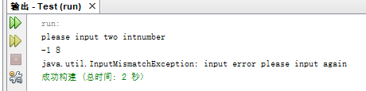

12.15

源代码：

package test;

import java.util.\*;

import java.io.\*;

public class Test{

public static void main(String args[]) throws IOException{

Scanner ss=new Scanner(System.in);

System.out.println("please input a filename");

String ff=ss.next();

Scanner sx=new Scanner(ff);

java.io.File fl=new java.io.File(ff);

int[] mu=new int[100];

System.out.println(fl.getAbsolutePath());

if(fl.exists()){

System.exit(1);

}

PrintWriter os=new PrintWriter(fl);

int i=0;

while(sx.hasNext()){

mu[i]=sx.nextInt();

i++;

}

os.close();

for(i=0;i<100;i++){

System.out.println(mu[i]);

}

}

}