**COVID-19 US County Rice University Data & Demographics**

By: Ahmed Lotfy, Bueze (Lucas) Okose, Kanjicai (Brock) Dong

Context:

The United States have recently become the country with the most reported cases of 2019 Novel Coronavirus (COVID-19). This dataset contains daily updated number of reported cases & deaths in the US on the state and county level, as provided by the Johns Hopkins University. In addition, I provide matching demographic information for US counties.

Project Plan:

In this project we are going to scrape the demographic and the daily no. of cases per county data in US from JAN till AUG 2020 from

<https://www.kaggle.com/headsortails/covid19-us-county-jhu-data-demographics>

loading the data into PostgreSQL DB and build an end point user interactive dashboard using HTML/JS, the data retrieval using python/flask API.

Optional: creates a user interface using Python/Flask API for gathering the daily collected information from each COVID Test Site in each county in US then visualize the Information on the dashboard.

The following 2 diagram showing both the workflow and a tentative dashboard design.

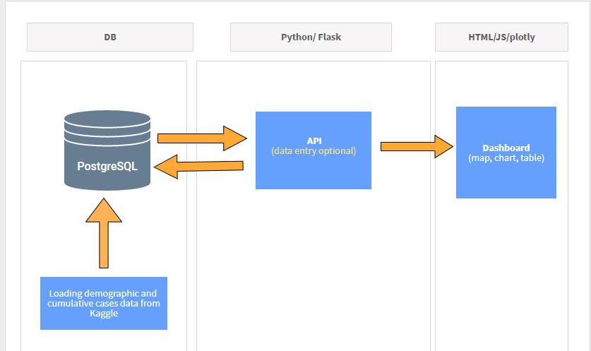

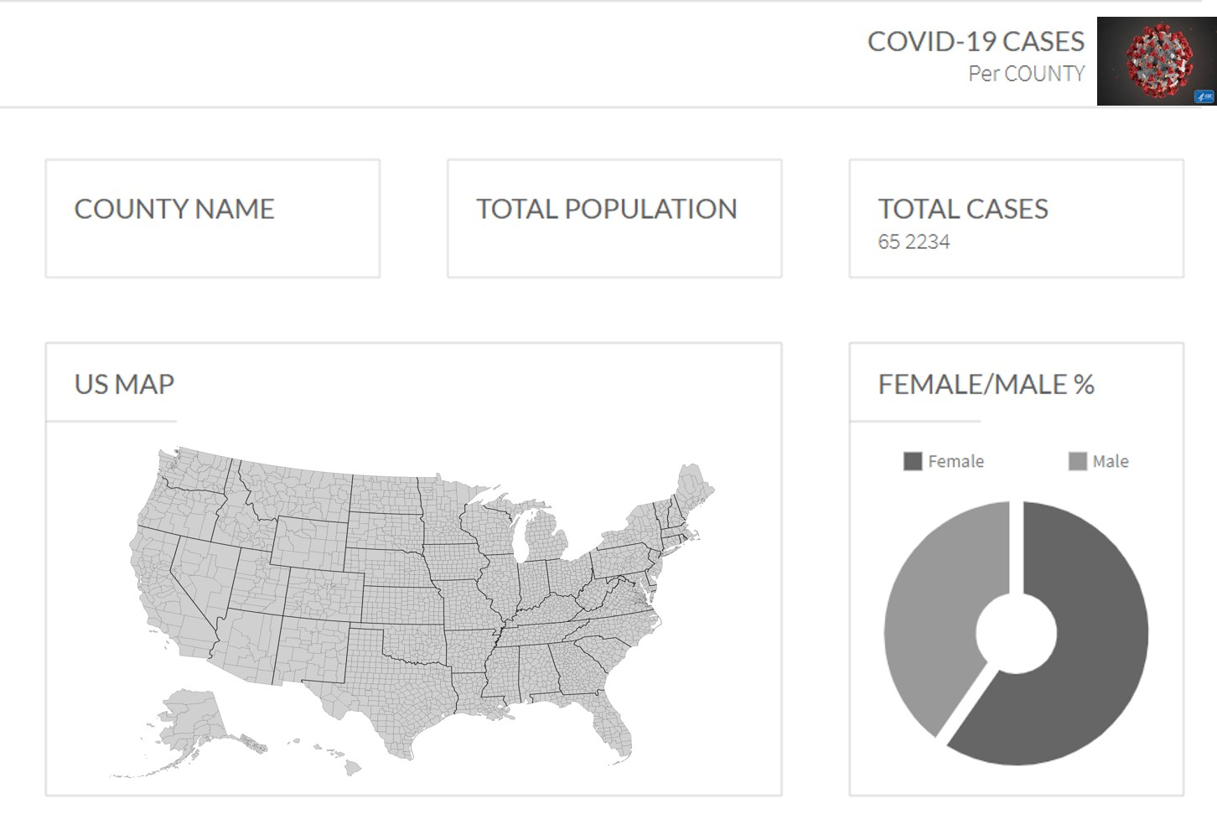

Github Link:

<https://github.com/KanjicaiBrockDong/Project-2--Data-Visualization>