19 April 2024 1BM21CS086

**Implement Linear and Multi-Linear Regression algorithm using appropriate dataset**

**Algorithm Screenshot**

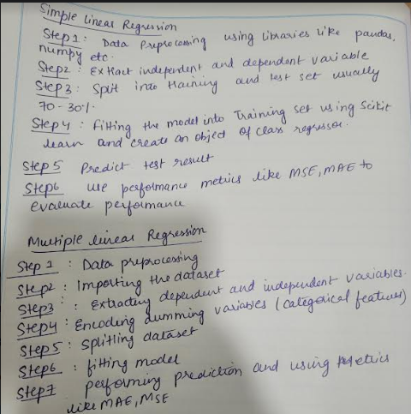

**Code Screenshot and Output:**

