19 April 2024 1BM21CS086

**Build KNN Classification model for a given dataset.**

**Algorithm Screenshot**

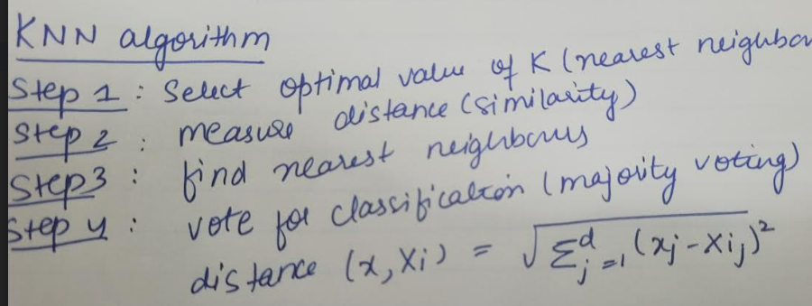

**Code Screenshot and Output:**



