FitTrack AI - Personalized Fitness Recommendations Using AI

Description
FitTrack AI is a secure and scalable backend application designed to manage workout records and provide AI-based fitness recommendations. The system is developed using Node.js, Express.js, MongoDB, and Mongoose. It provides RESTful APIs for user registration, authentication, workout management, workout search, and personalized fitness guidance.
The application follows the Model-View-Controller (MVC) architecture, which helps to keep the backend organized, maintainable, and easy to extend. User authentication is handled using JSON Web Tokens (JWT), while user passwords are protected using bcrypt.js before being stored in MongoDB. JWT authentication middleware is used to verify users before they can access protected APIs.
One of the important features of FitTrack AI is the integration of Google Gemini AI. The AI system uses information such as the user's age, fitness goal, and experience level to generate suitable workout recommendations. It can also provide fitness insights by analysing workout-related statistics, including the number of workouts completed, average workout duration, and calories burned.
The backend provides responses in a standard JSON format, which allows the APIs to be easily connected with web applications, mobile applications, or other external systems. Input validation, error handling, route protection, and separate service modules are included to make the application more reliable and easier to maintain.

Scenario-Based Case Study

Background
Rahul is a person who regularly follows a fitness routine. However, he currently maintains his workout information using notebooks and spreadsheets. Even though he exercises consistently, managing his previous workout records and checking his progress becomes difficult. He also does not have proper guidance to select workouts according to his fitness goals and current experience.

Problem
- Maintaining workout records manually is difficult.
- Workout details may become disorganized or inaccurate.
- There is no secure authentication system for protecting personal workout information.
- Finding a particular workout from old records takes time.
- Users do not receive workout recommendations based on their personal requirements.
- There is no automated analysis of workout performance.
- Calculating workout duration and calories manually can be inconvenient.

Solution
- FitTrack AI provides a centralized backend for storing and managing user workout information. Users can create an account, log in securely, and perform different operations on their workout records through REST APIs. They can add, view, modify, delete, and search work out details whenever required.
- The application also uses Google Gemini AI to provide personalized workout recommendations and fitness insights. The recommendations are generated using user information and workout statistics.
- Security is maintained through JWT-based authentication, password hashing with bcrypt.js, protected routes, validation, centralized error handling, and MongoDB schema rules.

Usage

User Usage
- After creating an account, the user can log in using their registered email and password. Once authentication is successful, a JWT token is generated and used to access the protected APIs.
- An authenticated user can perform the following operations:
- Add new work out details.
- View previously stored workouts.
- Get a particular workout using its ID.
- Edit existing workout information.
- Remove workout records that are no longer required.
- Search workouts using workout name, category, or date.
- Get AI-generated workout recommendations.
- Generate fitness insights based on workout statistics.

AI Usage
The AI functionality is implemented through a separate service that communicates with Google Gemini.

The user can provide details such as:
- Age
- Fitness Goal
- Experience Level

Based on these details, the AI can generate:

- Personalized workout plans
- Weekly exercise suggestions
- Recommendations suitable for different experience levels
- Motivational fitness guidance
- Basic safety suggestions

The user can also provide workout statistics such as:

- Total number of workouts
- Average workout duration
- Total calories burned
- Using these statistics, the AI module generates personalized insights about the user's workout activity.

Outcome
The FitTrack AI backend makes workout management easier by replacing manual record keeping with a centralized digital system. Users can securely maintain their workout history and receive AI-based recommendations according to their fitness information.
JWT authentication helps protect personal workout data from unauthorized access. The AI functionality provides additional guidance by analysing user details and workout statistics.
The MVC-based structure also makes the application easier to maintain and modify. In the future, the system can be expanded with features such as nutrition tracking, BMI calculation, wearable device connectivity, workout reminders, and detailed fitness analytics.

1. Software Requirements
The following software tools and technologies are required to develop and run the FitTrack AI backend. Operating System: Windows 10/11, macOS, or Linux. The application can be developed and executed across different operating systems.
- Node.js (v16 or above): Used as the runtime environment for executing the backend application.
- npm (v8 or above): Used for installing and managing the required Node.js packages.
- Express.js: Used for creating the REST API routes and handling server-side requests.
- MongoDB: Used as the database for storing user accounts and workout information.
- Mongoose: Used to define MongoDB schemas and interact with the database from the Node.js application.
- Postman: Used for testing and checking the REST API endpoints and their responses.
- Visual Studio Code: Used as the development environment for writing and managing the project files.

2. Hardware Requirements
The minimum hardware requirements for developing and running the FitTrack AI backend are:
- Processor: Intel Core i5 (8th Generation or above), AMD Ryzen 5, or an equivalent processor.
- RAM: At least 8 GB is recommended. 16 GB can be used for smoother performance when running MongoDB, the backend server, and development tools together.
- Storage: A minimum of 1 GB of free storage space is required for the project files, dependencies, and database-related development requirements.

Project Architecture

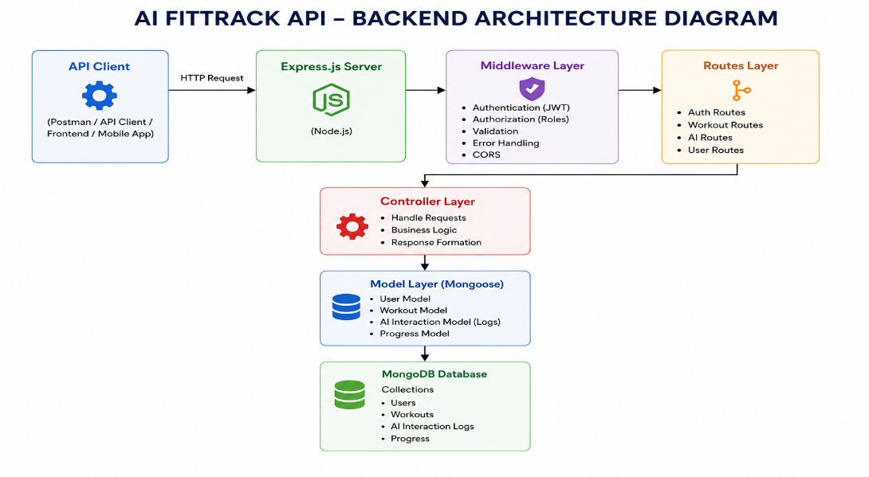
The FitTrack AI follows a layered architecture based on the MVC (Model–View–Controller) design pattern. The application separates routing, business logic, database interaction, middleware, and AI services into independent modules, making the project easier to maintain and scale.
When a client sends an HTTP request, the Express server receives it and forwards it to the corresponding route. Protected routes first pass through the authentication middleware, which validates the JWT token before granting access. Controllers process validated requests and invoke business logic or AI services as required. Database interactions are handled through Mongoose models, while Google Gemini AI is accessed through a dedicated service layer. Finally, the controller returns a structured JSON response to the client.
This layered approach improves modularity, security, and maintainability while ensuring that each component has a single responsibility.

Overall Architecture Components
- Client Application (React / Mobile Application / Postman
- Express Server
- API Routes
- Authentication Middleware
- Controllers
- Service Layer
- Google Gemini AI Service
- MongoDB Database
- Mongoose Model

All these components communicate through defined interfaces. This reduces dependency between modules and makes it easier to add new features in the future.

Components Definition

The FitTrack AI backend is divided into multiple modules, where each module is responsible for a particular task. This separation of responsibilities makes the system easier to develop, maintain, and scale. A request moves through the required layers before accessing the database or AI functionality.

1. Client Layer (Frontend/API Consumer)

The Client Layer is the part through which users or external applications communicate with the backend. It may be a React-based frontend, mobile application, or API testing software such as Postman. The client sends requests to the backend and receives the processed information as JSON responses.

Responsibilities

Sends HTTP requests to the backend.

Displays workout-related information.

Saves the JWT token received after successful login.

Calls the AI recommendation APIs.

Shows the responses and error messages received from the server.

APIs Accessed

Authentication APIs

Workout Management APIs

AI Workout Recommendation APIs

AI Fitness Insight APIs

2. Express Server Gateway

The Express server works as the main entry point for all requests coming from the client. It manages the server configuration, processes incoming data, applies middleware, and directs requests to the required routes and controllers.

Responsibilities

Runs the HTTP server.

Processes JSON request data.

Supports Cross-Origin Resource Sharing (CORS).

Loads and manages application routes.

Connects the required middleware.

Handles application-level errors.

Example Responsibilities

Accept the incoming HTTP request.

Process and validate the request format.

Send the request to the appropriate route.

Return the final JSON response to the client.

3. Authentication Middleware

The authentication middleware is used to secure APIs that require user authentication. It checks the JWT token provided with the request and allows access only when the token is valid.

Responsibilities

Read the Authorization header.

Obtain the JWT token from the request.

Verify whether the token is valid.

Decode the user information from the token.

Attach the authenticated user details to the request.

Block requests with invalid or missing authentication.

Benefits

Restricts access to unauthorized users.

Protects personal workout records.

Ensures that only logged-in users can use secured APIs.

Keeps authentication logic separate from controller functions.

4. Route Layer

The Route Layer contains the API endpoints of the application. It receives client requests and connects each endpoint with its corresponding controller function.

Authentication Routes

User Registration

User Login

User Profile

Workout Routes

Create Workout

View All Workouts

Search Workouts

View Workout by ID

Modify Workout

Remove Workout

AI Routes

Generate Workout Recommendations

Generate Fitness Insights

5. Controller Layer

The Controller Layer handles the main request-processing logic of the application. It receives requests from the routes, checks the required input, communicates with services or database models, and sends the appropriate JSON response.

Authentication Controller

Handles:

Registering new users

Authenticating users during login

Retrieving user profile information

Workout Controller

Handles:

Adding new workout records

Retrieving workout records

Editing existing workouts

Removing workout records

Searching stored workouts

AI Controller

Handles:

Preparing and sending requests to Google Gemini

Receiving AI-generated workout recommendations

Sending the generated AI results back to the client

6. Service Layer

The Service Layer contains application logic that is kept separately from the controllers. These services can be reused whenever the same functionality is required by different parts of the application.

Gemini AI Service

This service is responsible for:

Creating suitable prompts for the AI.

Sending the prompts to Google Gemini.

Receiving the generated AI response.

Processing and returning the recommendation in a usable format.

JWT Service

This service handles:

Generating JWT tokens.

Setting the token expiration period.

Verifying the identity of authenticated users.

Password Service

This service manages:

Converting passwords into secure hashes.

Comparing entered passwords with stored password hashes during login.

7. Database Layer

The database layer is responsible for storing the permanent information used by the application. MongoDB is used as the database, while Mongoose provides a structured way for the Node.js application to communicate with MongoDB.

Collections

Users Collection

Workouts Collection

Advantages

Supports flexible data structures.

Provides efficient data storage and retrieval.

Can handle increasing amounts of application data.

Makes the database easier to work with through Mongoose models.

.

Entity Relationship (ER) Diagram Description
The AI FitTrack backend consists of two primary collections that are logically connected through a one-to-many relationship.


1. User Entity
The User entity stores authentication and profile information.

Attributes
Field | Type | Description
_id | ObjectId | Primary Key
name | String | User Name
email | String | Unique Email Address
password | String | Encrypted Password
createdAt | Date | Record Creation Time
updatedAt | Date | Last Updated Time

Constraints
- Email must be unique.
- Password is encrypted using bcrypt.
- Name is mandatory.
- JWT token is generated after successful login.

2. Workout Entity
The Workout entity stores workout-related information for each authenticated user.

Attributes
Field | Type | Description
_id | ObjectId | Primary Key
user | ObjectId | References User Collection
workoutName | String | Workout Name
category | String | Workout Category
duration | Number | Duration (Minutes)
caloriesBurned | Number | Calories Burned
workoutDate | Date | Workout Date
createdAt | Date | Created Timestamp
updatedAt | Date | Updated Timestamp

Relationship

User → Workout
Relationship Type: One-to-Many
A single user can create multiple workout records. Each workout belongs to only one authenticated user.
Example:
John Doe
- Morning Running
- Evening Jogging
- Upper Body Strength
- Cycling Session
This relationship is maintained using the user field inside the Workout schema, which stores the ObjectId of the corresponding user.

Key Features
The FitTrack AI provides a complete backend solution for workout tracking and AI-assisted fitness guidance.

1. Secure Authentication
The application implements JWT-based authentication.
Features include:
- User Registration
- Secure Login
- Password Encryption
- JWT Generation
- Protected APIs

2. Workout Management
Users can perform complete CRUD operations.
Supported Operations
- Add Workout
- View Workout
- Update Workout
- Delete Workout
Each workout is linked to its authenticated user.

3. Workout Search
Users can search workouts using:
- Workout Name
- Workout Category
- Workout Date
This improves accessibility of workout history.

4. Google Gemini Integration
The backend communicates with Google Gemini AI to generate intelligent workout recommendations.
Input
- Age
- Fitness Goal
- Experience Level
Output
- Weekly Workout Plan
- Suggested Exercises
- Training Tips
- Safety Recommendations

5. AI Fitness Insights
The AI module analyzes workout statistics.
- Input
- Total Workouts
- Average Duration
- Calories Burned
Output
- Performance Analysis
- Improvement Suggestions
- Motivational Advice
- Fitness Progress Summary

6. Centralized Error Handling
The application returns meaningful JSON error responses for:
- Invalid Credentials
- Missing Authentication Token
- Validation Errors
- Database Errors
- Internal Server Errors

7. RESTful API Design
The backend follows REST principles.
Supported HTTP Methods
- GET
- POST
- PUT
- DELETE
Responses are returned in JSON format.

8. Modular Architecture
The project separates responsibilities into
- Models
- Controllers
- Routes
- Middleware
- Services
- Configuration
This improves maintainability and scalability.

Roles and Responsibilities
The AI FitTrack backend supports one primary role.

Authenticated User

Responsibilities
- Register an account.
- Login securely.
- View profile information.
- Add workout records.
- View workout history.
- Search workouts.
- Update workouts.
- Delete workouts.
- Request AI workout recommendations.
- Request AI fitness insights.

Permissions
Operation | Permission
Register | Yes
Login | Yes
View Profile | Yes
Add Workout | Yes
Get Workouts | Yes
Search Workouts | Yes
Update Workout | Yes
Delete Workout | Yes
AI Recommendation | Yes
Fitness Insights | Yes

User Flow



MVC Architecture Pattern
The FitTrack AI is designed using the Model–View–Controller (MVC) architecture pattern. This architecture separates application logic into independent components, improving code organization, maintainability, and scalability.


Model Layer (Data Layer)
The Model Layer defines the structure of the application's data using Mongoose schemas. It communicates directly with MongoDB and performs database operations.
Models in the project include:
- User Model
- Workout Model
Responsibilities:
- Schema Definition
- Data Validation
- CRUD Operations
- Collection Mapping

View Layer (API Interface)
Since AI FitTrack is a backend REST API, there are no traditional UI templates. The View Layer is represented by API consumers such as React applications, mobile applications, or Postman, which interact with the backend through HTTP requests and receive JSON responses.
Responsibilities:
- Send Requests
- Receive JSON Responses
- Display Data
- Handle Client-side Interaction

Controller Layer (Business Logic)
The Controller Layer acts as the intermediary between the View and Model. It processes incoming requests, validates input, invokes services and models, and sends structured JSON responses back to the client.
Responsibilities:
- Request Validation
- Business Logic Execution
- Database Interaction
- AI Service Invocation
- Response Generation
The separation of these three layers ensures loose coupling, simplifies testing, enhances code readability, and makes the application easier to extend with future features.

Project Setup and Configuration
The FitTrack AI project follows a well-structured backend architecture that separates business logic, routing, database operations, middleware, and AI services into individual modules. This modular design improves code readability, maintainability, and scalability while making the project easier to debug and extend.
The backend is developed using Node.js and Express.js, with MongoDB as the primary database and Google Gemini AI for intelligent fitness recommendations.

Creating Project Folder

Step 1: Create the Project Folder
Create a new folder with the project name.
AI-FitTrack-API

Step 2: Open the Project
Open the project folder in Visual Studio Code.

Step 3: Create the Server Folder
Inside the project directory, create a folder named:
server
All backend source code will be maintained inside this folder.


Step 4: Initialize Node Project
Open the terminal inside the server folder and execute:
npm init -y
This command generates the package.json file containing project metadata and dependency information.

Step 5: Install Required Packages
Install the required dependencies.
npm install express mongoose dotenv bcryptjs jsonwebtoken cors
Install Nodemon as a development dependency.
npm install --save-dev nodemon

Environment Variables
Sensitive information is stored in the .env file.
Example
PORT=5000

MONGO_URI=mongodb://localhost:27017/aifittrack

JWT_SECRET=your_secret_key

GEMINI_API_KEY=your_google_gemini_api_key
Using environment variables improves security by preventing sensitive information from being exposed in source code.
3: Backend Development
Backend development focuses on implementing REST APIs that allow authenticated users to manage workouts and interact with Google Gemini AI.
The project is divided into multiple modules that collectively perform authentication, workout management, AI integration, and database operations.
Major modules include:
- Server Configuration
- Database Configuration
- Authentication
- Workout Management
- AI Recommendation
- Middleware
- Error Handling

4: Database Configuration
The FitTrack AI uses MongoDB as its primary NoSQL database for storing user credentials and workout information. Mongoose serves as the Object Data Modeling (ODM) library, enabling seamless interaction between the application and the MongoDB database. Mongoose provides schema validation, middleware support, data relationships, and simplified CRUD operations.
The database layer is responsible for maintaining data integrity, validating incoming requests, and ensuring secure storage of user information.

MongoDB Configuration
MongoDB stores application data in collections rather than traditional relational database tables. The FitTrack AI maintains separate collections for users and workouts.

Database Collections
- Users Collection
- Workouts Collection
Each collection stores JSON-like documents (BSON format), allowing flexible schema design while maintaining efficient data retrieval.

Installing Mongoose
Install Mongoose using npm.
npm install mongoose
Mongoose acts as the bridge between the Node.js application and MongoDB by providing schema definitions, validation, and database methods.

MongoDB Connection
The database connection is configured inside the config/db.js file. This module establishes a connection to the MongoDB server when the application starts.


Responsibilities
- Connect to MongoDB
- Handle Connection Errors
- Display Connection Status
- Export Database Connection

Advantages
- Centralized database configuration
- Reusable connection module
- Automatic connection management
- Simplified error handling

Mongoose Schemas
The AI FitTrack backend contains two primary Mongoose schemas:
- User Schema
- Workout Schema
Schemas define the structure, validation rules, and relationships for MongoDB documents.

1. User Schema (models/User.js)
The User schema stores authentication information for registered users.

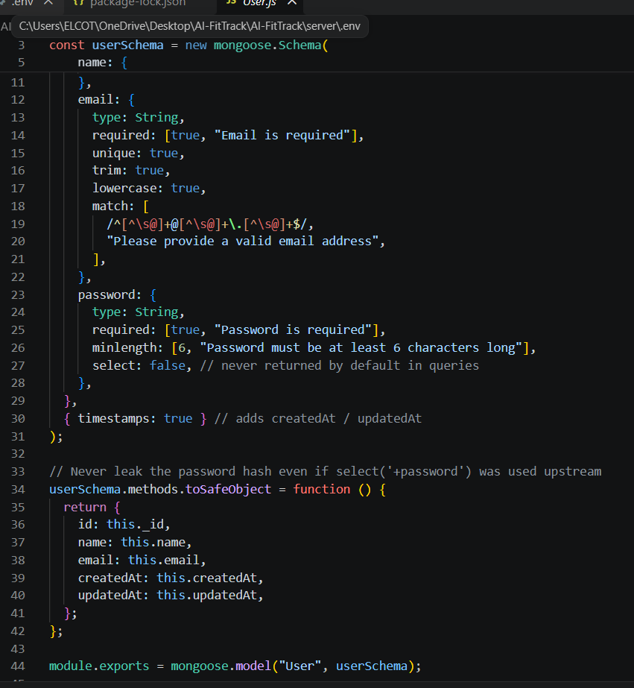
Validation Rules
- Name cannot be empty.
- Email must be unique.
- Password is mandatory.
- Password is encrypted using bcrypt.js before saving.
- Automatic timestamps are enabled.

User Schema Features
- Email uniqueness validation
- Password hashing
- Automatic timestamps
- Secure authentication support
- JWT integration

2. Workout Schema (models/Workout.js)
The Workout schema stores workout information created by authenticated users.

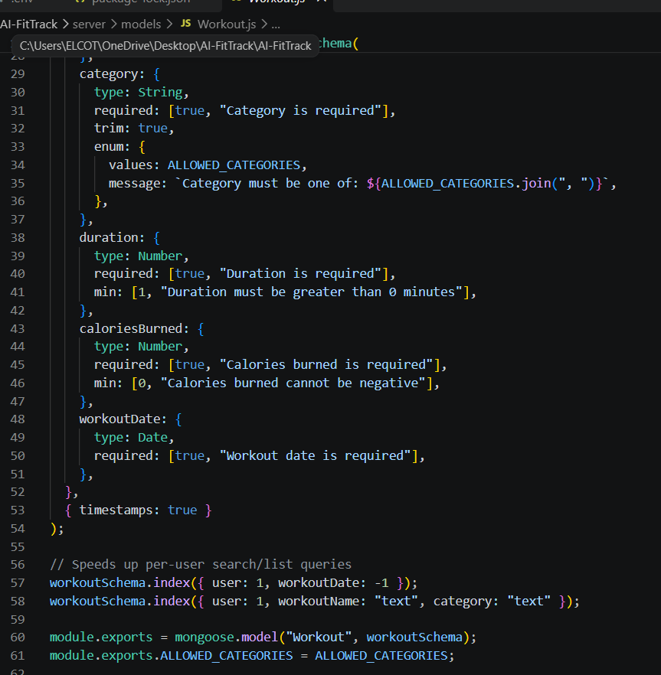Validation Rules
- Workout Name is mandatory.
- Category is mandatory.
- Duration must be greater than zero.
- Calories Burned must be greater than or equal to zero.
- Workout Date is required.
- Every workout belongs to one authenticated user.

Workout Schema Features
- Schema validation
- Automatic timestamps
- User relationship
- Easy search support
- Efficient CRUD operation

5: Project Execution
Install Postman or ThunderClient (VS Code extension).
Start the backend server:
“npm start”

API Testing
API testing ensures that every endpoint functions correctly and returns the expected response. The FitTrack AI is tested using Postman, allowing developers to verify request handling, authentication, database operations, and AI integration.
Testing is performed in the following order:
- Authentication APIs
- Workout APIs
- AI APIs

Authentication API Testing

Register User

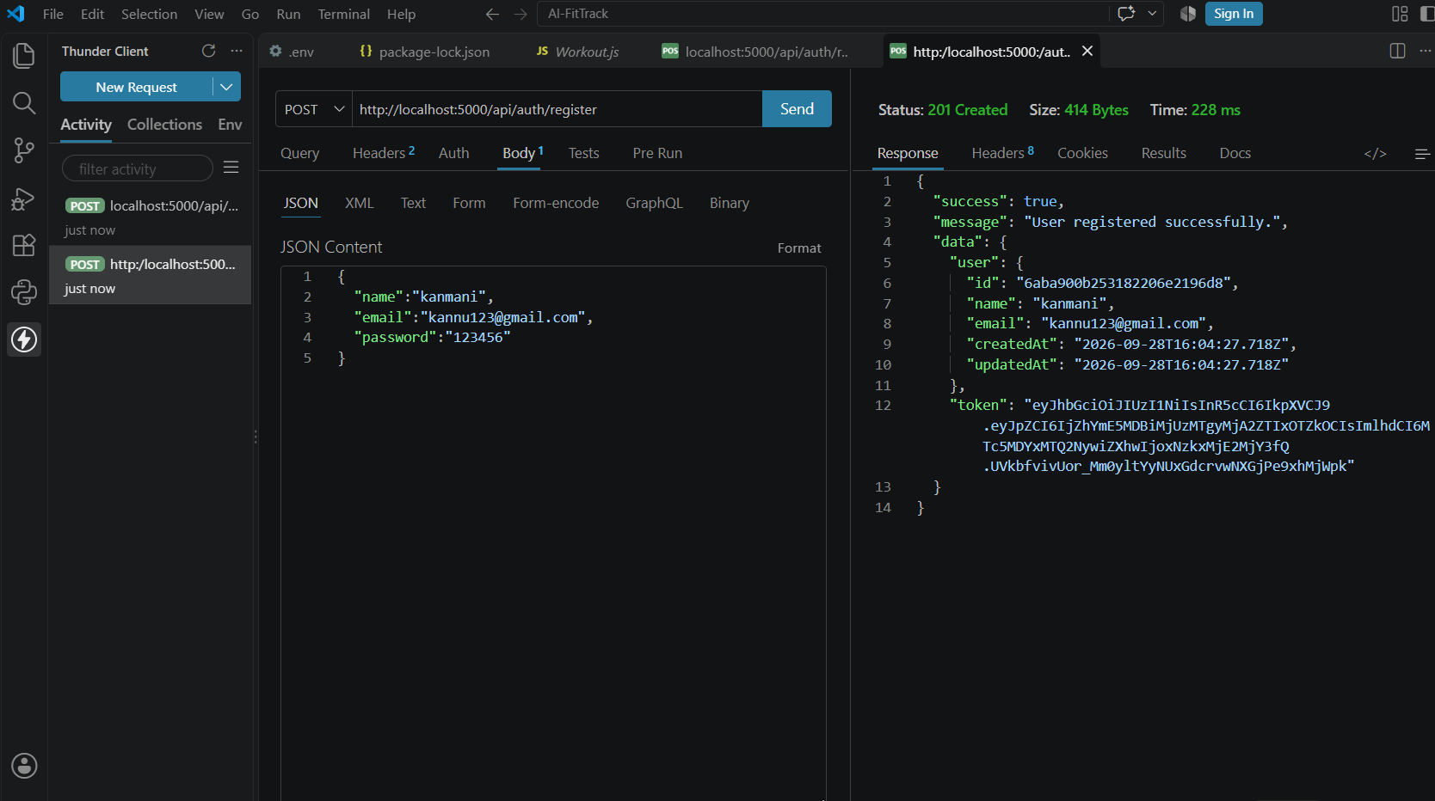

Login User

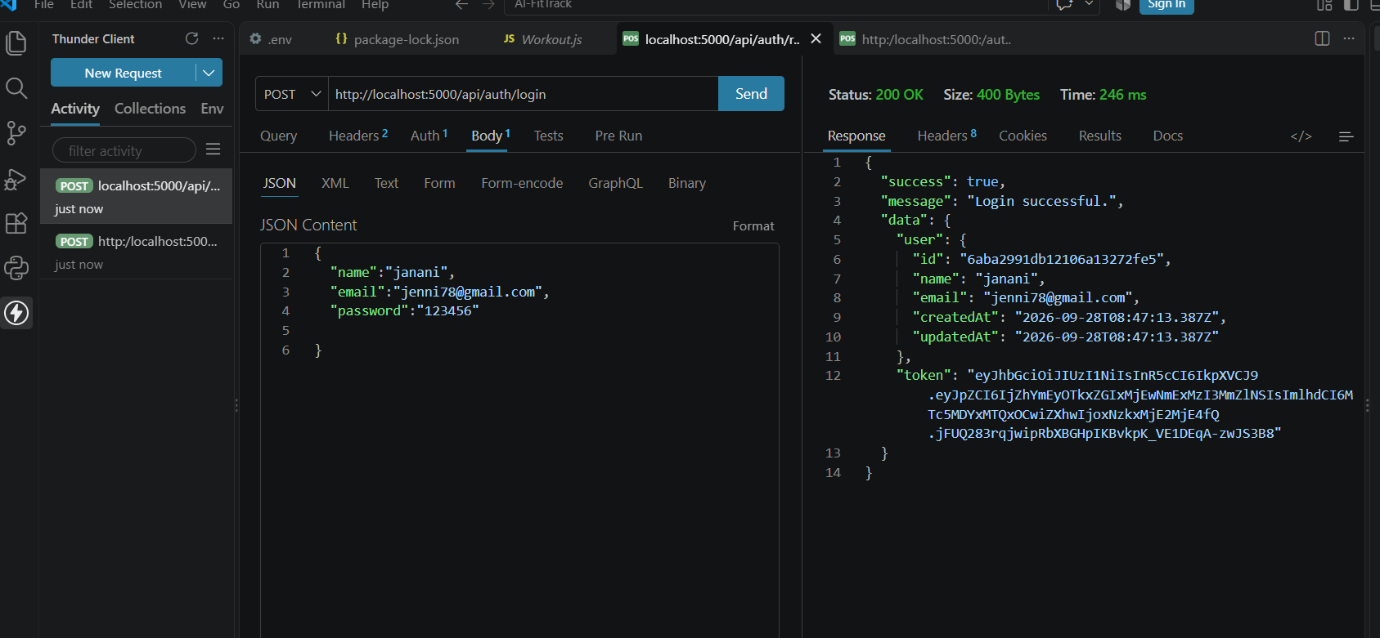

Get Profile
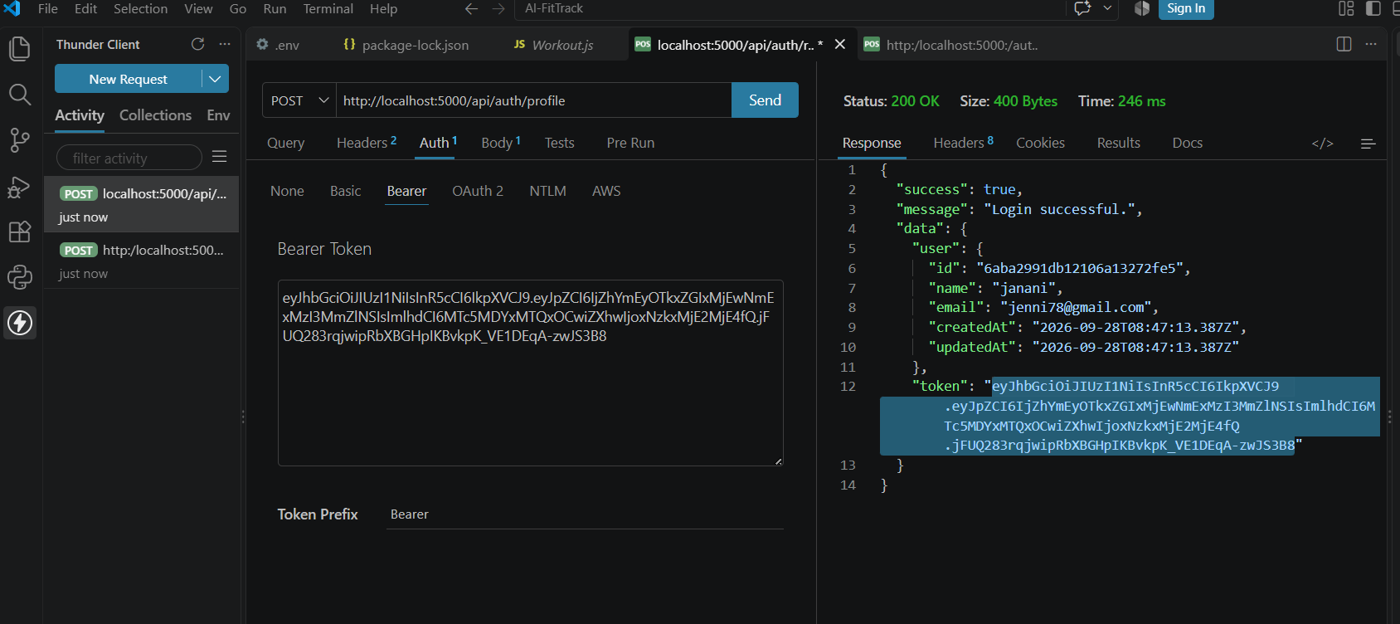
Workout API Testing

Add Workout


Get All Workouts


Get Workout By ID

Update Workout


Delete Workout

AI API Testing

Workout Recommendation


Fitness Insights



Demo Video Link: https://drive.google.com/file/d/1uqdk0rk7d55xy2L0Py54b3QmCDA0Lj36/view?usp=sharing

API TESTING VIDEO : https://drive.google.com/file/d/1_TYaAXGgF41oUertJqpLSP4FsTQloyoR/view?usp=sharing
Code Drive:
https://drive.google.com/drive/folders/1rI62599jjKhyk2CNxKfZJLjOE84D_Mnn?usp=sharing

