WOXSEN UNIVERSITY
B.Tech Artificial Intelligence and Machine Learning | Design and Analysis of Algorithms
HackerRank Profile
Name | Student ID | Platform / username | Profile link
Priyakaran Reddy Pakanati | 25WU0101090 | HackerRank / priyakaranreddy | hackerrank.com/profile/priyakaranreddy

1. Profile login screenshot
HackerRank profile, logged in as Priyakaran Reddy Pakanati (@priyakaranreddy). The badge shown is Problem Solving.
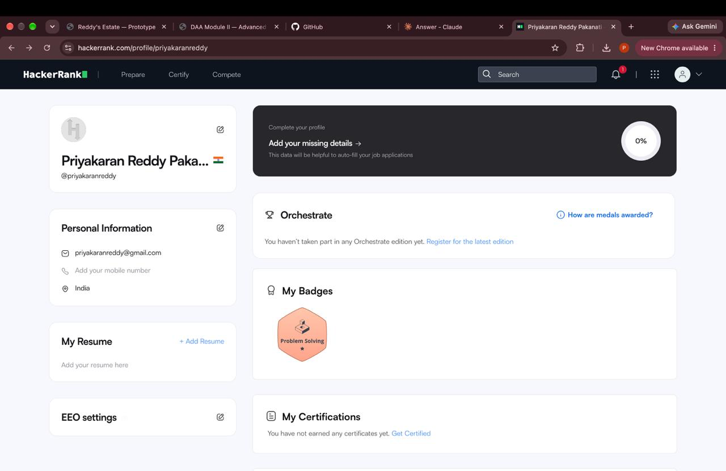

2. Problems solved (11)
All eleven problems below show Result: Accepted in the submissions list (Solve Me First is on page 2). Score is the points awarded by HackerRank.
No. | Problem name | Topic | Language | Result | Score
1 | Solve Me First | Warmup | C++ | Accepted | 1.0
2 | Compare the Triplets | Implementation | C++ | Accepted | 10.0
3 | A Very Big Sum | Warmup / Arithmetic | C++ | Accepted | 10.0
4 | Diagonal Difference | Arrays / Matrices | C++ | Accepted | 10.0
5 | Basics of Sets and Relations #1 | Sets and Relations | Text | Accepted | 5.0
6 | Basics of Sets and Relations #2 | Sets and Relations | Text | Accepted | 5.0
7 | Basics of Sets and Relations #3 | Sets and Relations | Text | Accepted | 5.0
8 | Basics of Sets and Relations #4 | Sets and Relations | Text | Accepted | 5.0
9 | Basics of Sets and Relations #5 | Sets and Relations | Text | Accepted | 5.0
10 | Basics of Sets and Relations #6 | Sets and Relations | Text | Accepted | 5.0
11 | Basics of Sets and Relations #7 | Sets and Relations | Text | Accepted | 5.0

3. Submissions screenshots (page 1 and page 2)
Page 1 of the submissions list: ten submissions, all Accepted.
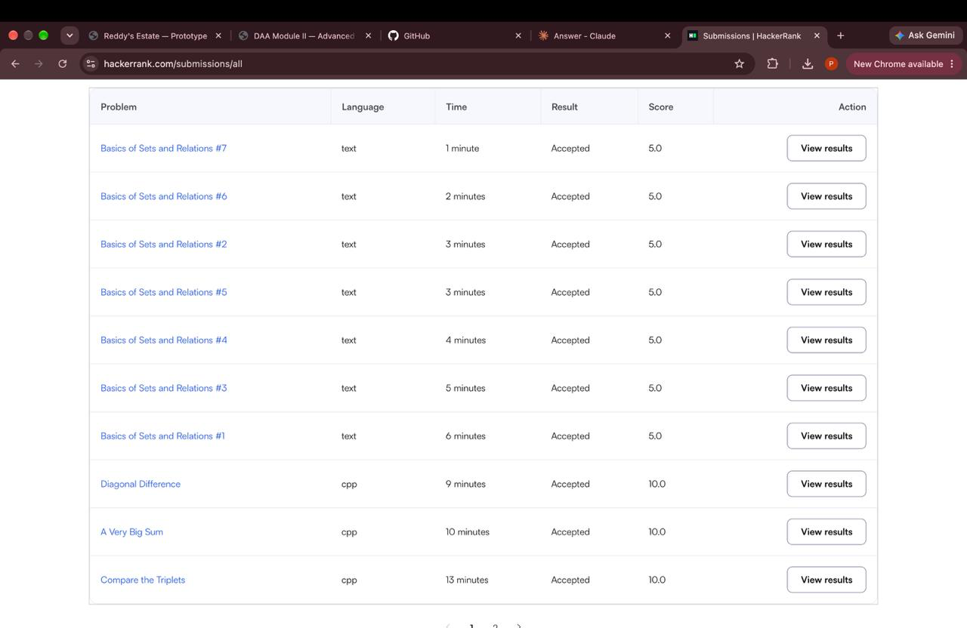
Page 2 of the submissions list: an earlier Compare the Triplets attempt that had a compilation error (0.0), and two Solve Me First submissions, both Accepted (1.0).
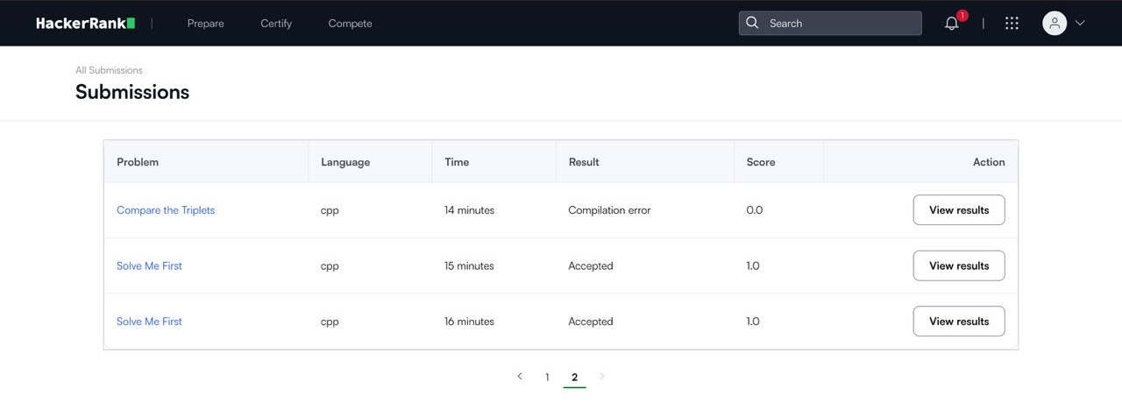

4. Badges and certificates
Badge earned: Problem Solving (1 star). No HackerRank certificate has been earned yet.

