WOXSEN UNIVERSITY
B.Tech Artificial Intelligence and Machine Learning | Design and Analysis of Algorithms
LeetCode Profile
Name | Student ID | Platform / username | Profile link
Priyakaran Reddy | 25WU0101090 | LeetCode / priyakaranreddy | leetcode.com/u/priyakaranreddy

1. Profile login screenshot
LeetCode profile of priyakaranreddy: 10 problems solved (2 Easy, 6 Medium, 2 Hard), all in C++.
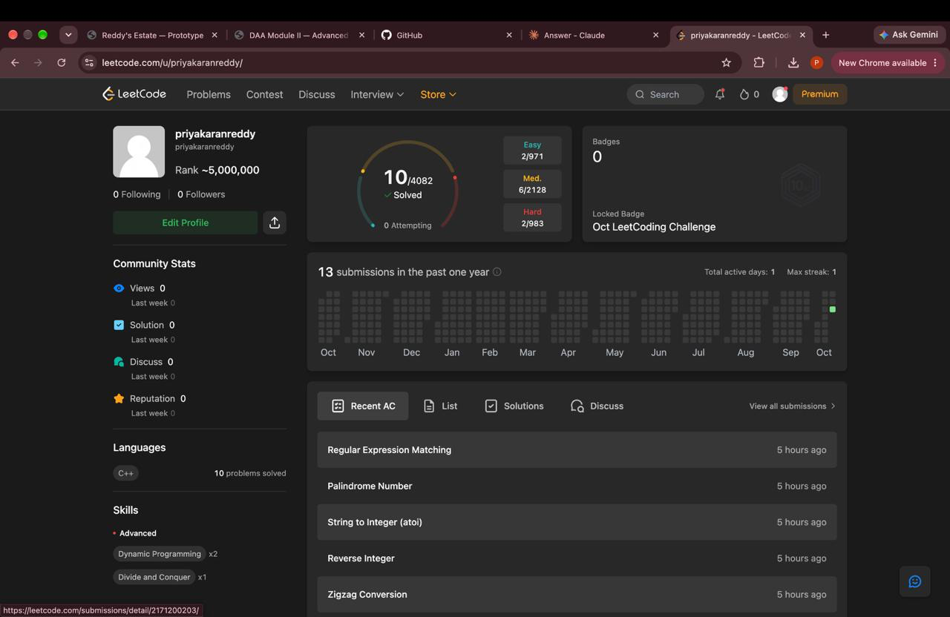
2. Problems solved (10)
Every problem below shows Accepted on LeetCode. The screenshot in section 3 lists all of them.
No. | Problem name | Difficulty | Topic / technique | Language
1 | Two Sum | Easy | Hash table | C++
2 | Add Two Numbers | Medium | Linked list | C++
3 | Longest Substring Without Repeating Characters | Medium | Sliding window | C++
4 | Median of Two Sorted Arrays | Hard | Binary search / divide and conquer | C++
5 | Longest Palindromic Substring | Medium | Dynamic programming | C++
6 | Zigzag Conversion | Medium | String simulation | C++
7 | Reverse Integer | Medium | Math | C++
8 | String to Integer (atoi) | Medium | String parsing | C++
9 | Palindrome Number | Easy | Math | C++
10 | Regular Expression Matching | Hard | Dynamic programming | C++

3. Accepted submission screenshots
Practice History (leetcode.com/progress): problems 1 to 10, all Accepted.
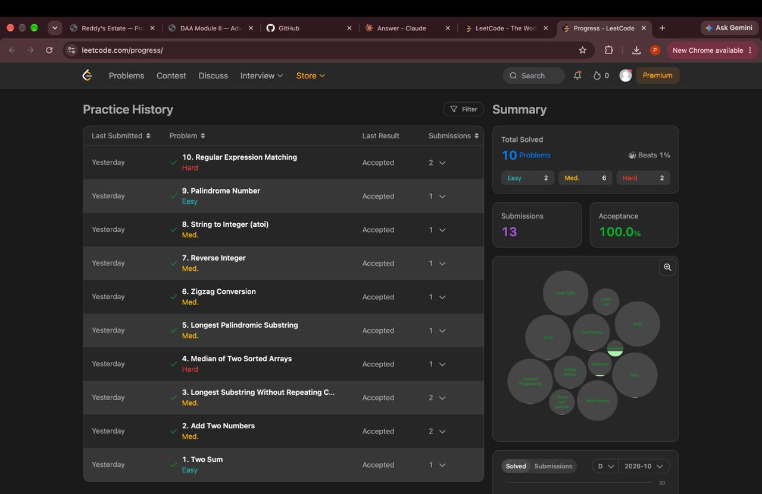
4. Certificates
No LeetCode certificate or badge earned yet.

