WOXSEN UNIVERSITY
B.Tech Artificial Intelligence and Machine Learning | Database Management Systems
LeetCode Profile
Name | Student ID | Platform / username | Profile link
Priyakaran Reddy | 25WU0101090 | LeetCode / priyakaranreddy01 | leetcode.com/u/priyakaranreddy01

1. Profile login screenshot
LeetCode profile of priyakaranreddy01: 11 problems solved (5 Easy, 5 Medium, 1 Hard), all in MySQL.
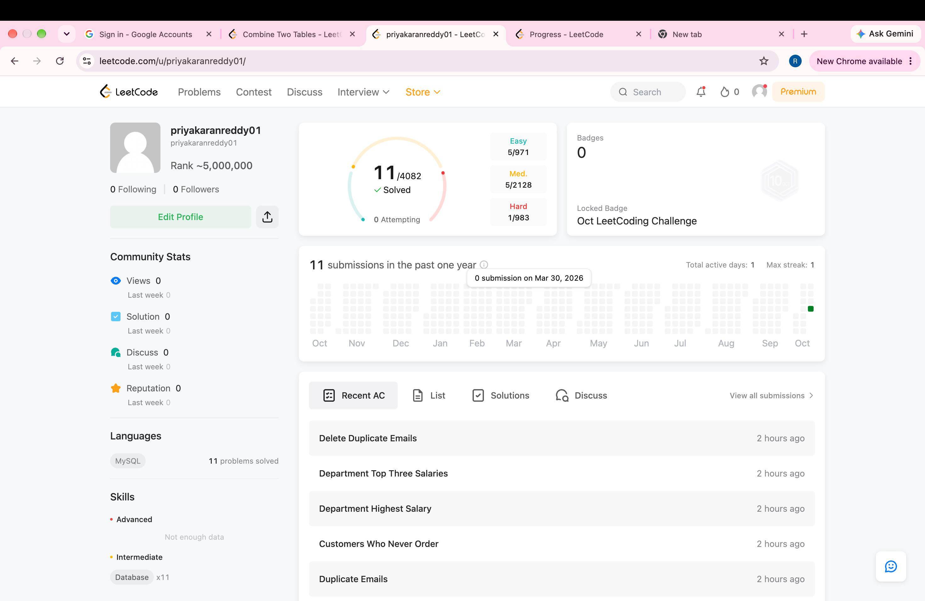
2. Problems solved (11)
Every problem below shows Accepted on LeetCode. The screenshot in section 3 lists all of them.
No. | Problem name | Difficulty | Topic / technique | Language
175 | Combine Two Tables | Easy | LEFT JOIN | MySQL
176 | Second Highest Salary | Medium | Subquery / LIMIT OFFSET | MySQL
177 | Nth Highest Salary | Medium | Functions / LIMIT OFFSET | MySQL
178 | Rank Scores | Medium | Window function (DENSE_RANK) | MySQL
180 | Consecutive Numbers | Medium | Window function (LAG) / self join | MySQL
181 | Employees Earning More Than Their Managers | Easy | Self join | MySQL
182 | Duplicate Emails | Easy | GROUP BY / HAVING | MySQL
183 | Customers Who Never Order | Easy | LEFT JOIN / NOT IN | MySQL
184 | Department Highest Salary | Medium | JOIN with subquery | MySQL
185 | Department Top Three Salaries | Hard | Window function (DENSE_RANK) | MySQL
196 | Delete Duplicate Emails | Easy | DELETE with self join | MySQL

3. Accepted submission screenshots
Practice History (leetcode.com/progress): problems 175 to 196, all Accepted.
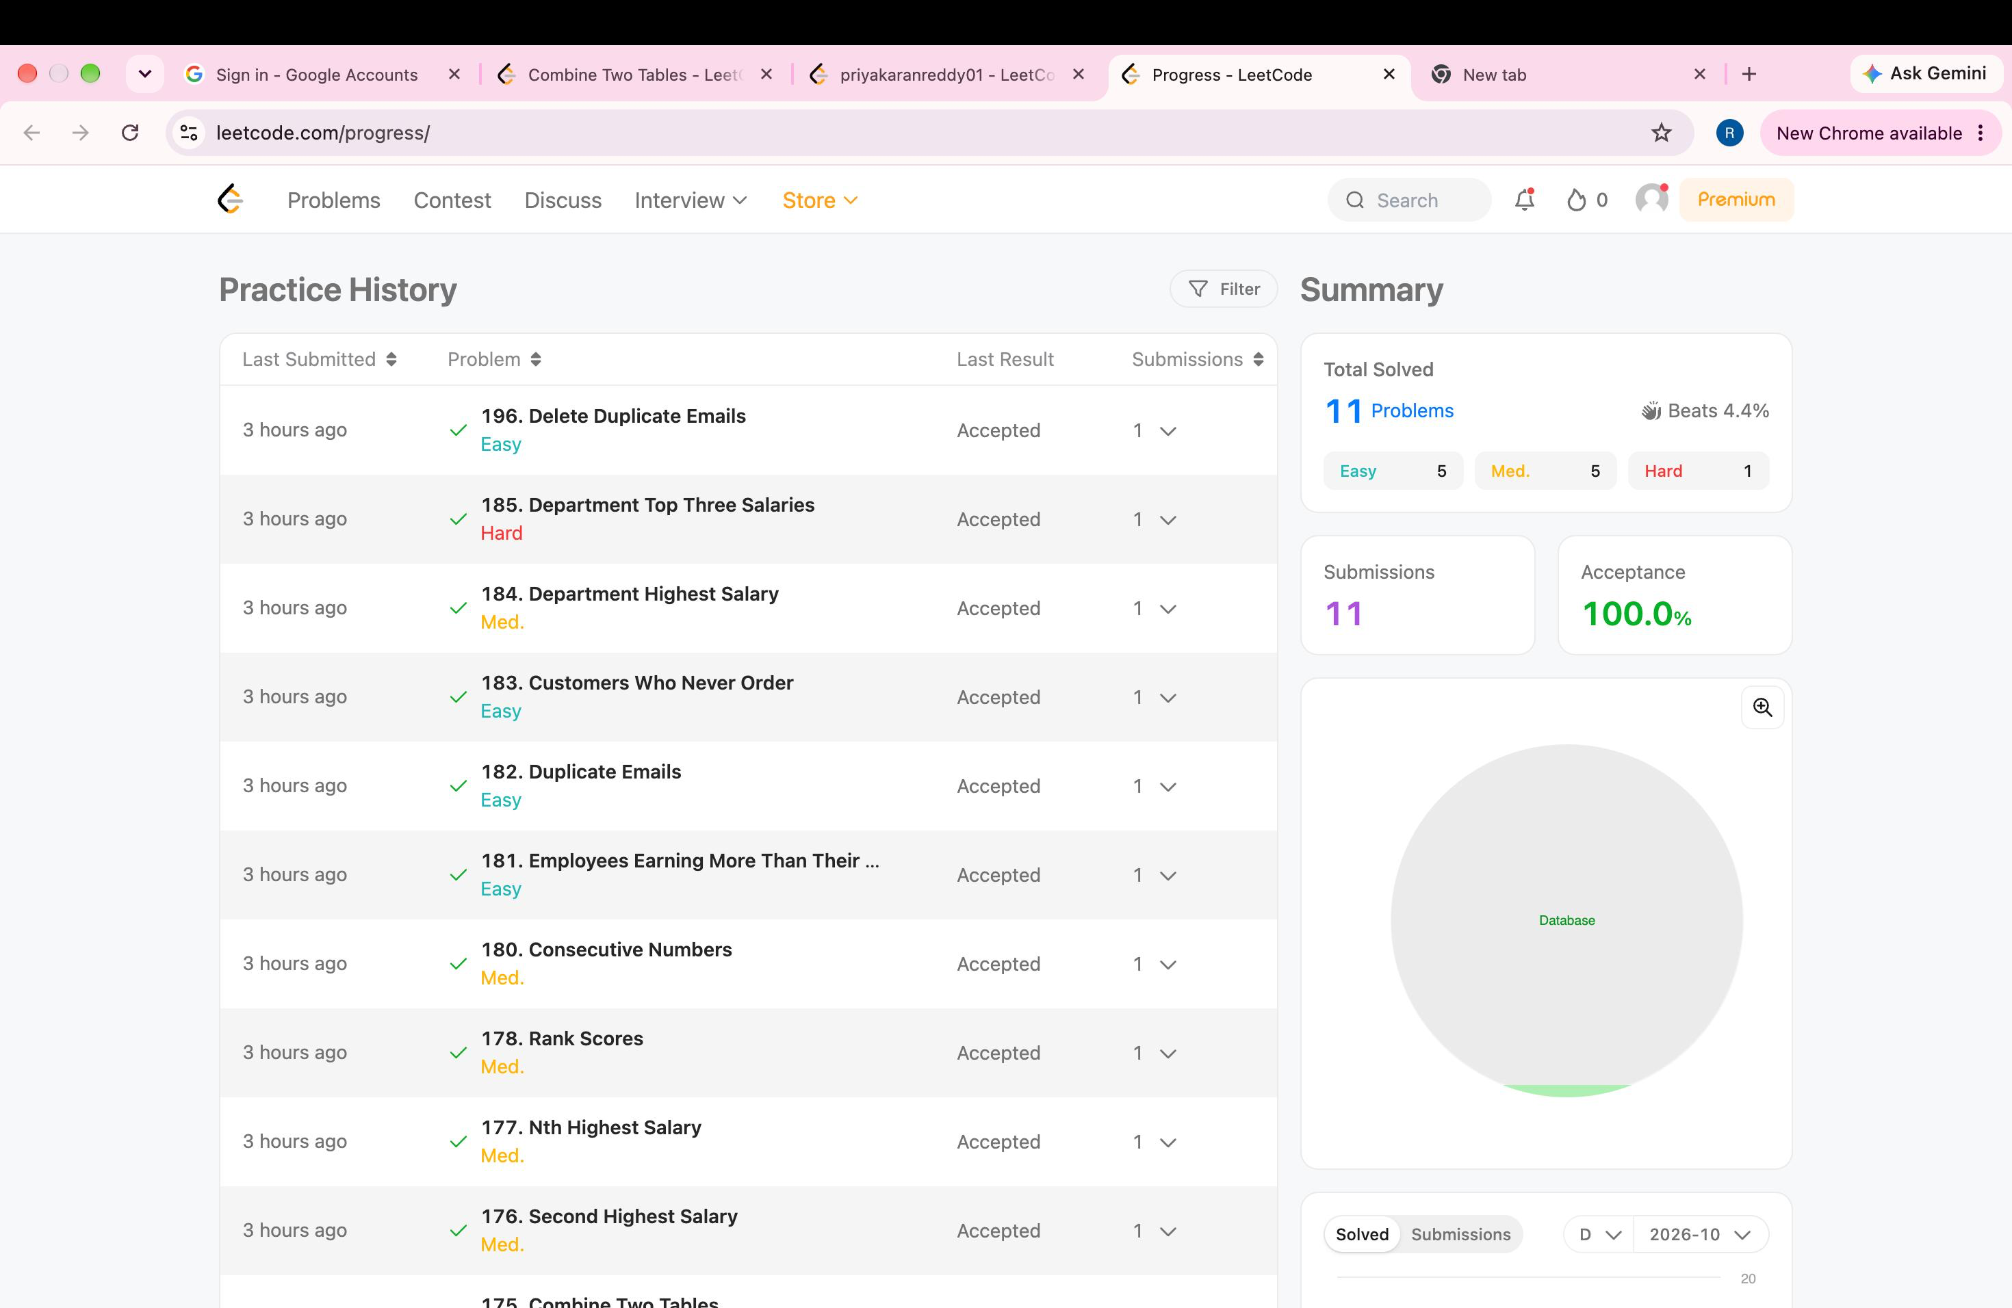
4. Certificates
No LeetCode certificate or badge earned yet.

