XForge SDK Compiler Flow Documentation
Client-facing description of the model compiler, scheduler, and generic backend execution path. Prepared July 30, 2026.
Summary: The SDK compiles a YOLO TFLite model into generic MLIR tile operations, packages constants and manifests, and lets the hybrid runtime scheduler route work through CPU, emulator, or backend execution paths. Backend-facing details are presented through stable public labels only.

Compiler Flow
The compiler flow starts from a quantized YOLO TFLite model and converts supported operators into tiled MLIR operations. The emitted constants and manifests describe tensor shapes, tile boundaries, scheduling metadata, and backend-ready compute packets. The hybrid runtime scheduler then chooses the correct execution path for each operator and returns INT32 results to the scheduler for post-processing or the next scheduled tile.
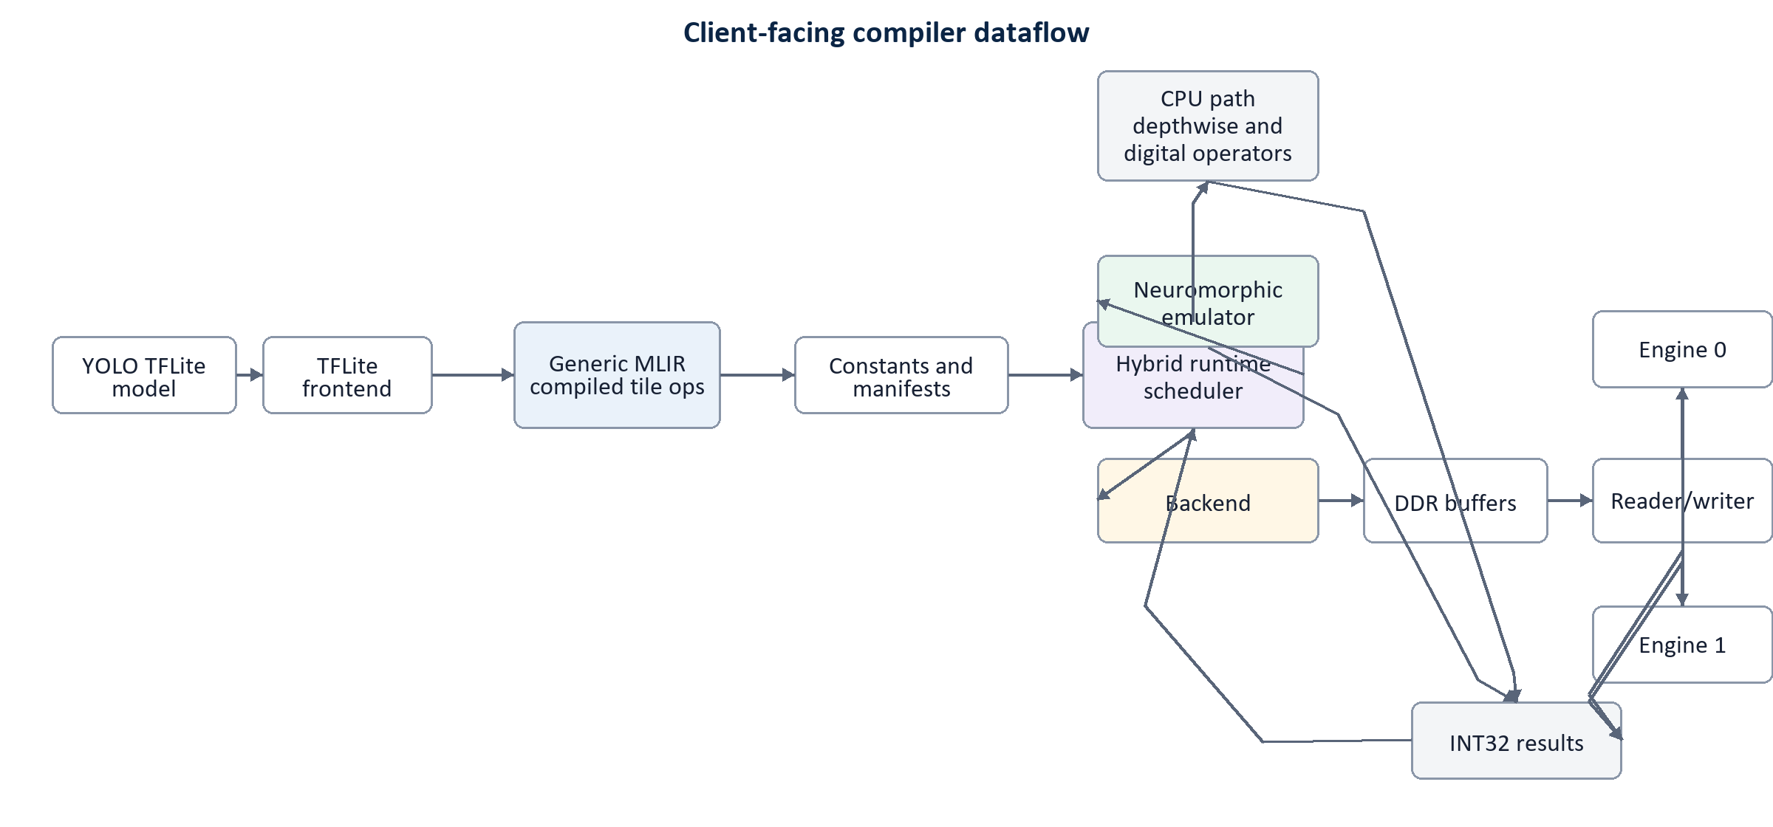
Figure 1. Public compiler and runtime dataflow.

Stage Responsibilities
Stage | Role | Output / behavior
YOLO TFLite model | Input artifact | Provides the quantized model graph, weights, and tensor metadata.
TFLite frontend | Import and normalize | Reads the model, validates supported operators, and converts tensors into compiler-ready form.
Generic MLIR compiled tile ops | Lowered IR | Represents compute as tiled operations with explicit loop dimensions and data movement boundaries.
Constants and manifests | Packaged metadata | Stores weights, scales, shapes, tile plans, and runtime descriptors.
Hybrid runtime scheduler | Execution control | Partitions work across CPU, emulator, and backend paths based on operator type and availability.
CPU path | Digital fallback | Handles depthwise and digital operators that are not mapped to the compute backend.
Neuromorphic emulator | Software validation | Runs backend-compatible compute behavior without requiring a connected compute target.
Backend | Compute target | Accepts scheduled compute packets and exposes generic memory and engine interfaces.
DDR buffers | Tensor staging | Holds input tiles, intermediate tensors, constants, and result buffers.
Reader/writer | Data movement | Streams tensors between buffers and compute engines.
Engine 0 / Engine 1 | Parallel compute | Executes scheduled tile operations and emits INT32 partial or final results.
INT32 results | Result contract | Collects outputs from all paths and returns them to the scheduler for merge and continuation.

Runtime Dataflow
- The TFLite frontend imports the model and normalizes graph, tensor, and quantization metadata.
- The compiler lowers supported compute regions into generic MLIR tile operations.
- Constants and manifests are generated so the runtime knows where each tile, tensor, scale, and weight block belongs.
- The hybrid runtime scheduler routes depthwise and digital operators to the CPU path, validation work to the neuromorphic emulator, and mapped compute tiles to the backend.
- The backend stages tensors through DDR buffers, streams them through the reader/writer interface, and dispatches work to Engine 0 and Engine 1.
- Each execution path returns INT32 results to the scheduler, which merges outputs and continues the model graph.

Backend Naming Contract
The public documentation uses stable abstraction names so clients can understand the execution behavior without depending on internal platform or board-specific details. These labels are the names that should appear in user-facing setup guides, diagrams, demos, and SDK logs.
Public label | Meaning in the compiler flow
Backend | The configured compute target selected by the scheduler.
DDR buffers | The public memory-staging abstraction for input, weight, intermediate, and output tensors.
Reader/writer | The generic data-movement interface between buffers and engines.
Engine 0 / Engine 1 | Parallel compute lanes exposed by the backend abstraction.
Neuromorphic emulator | The software execution path used for backend-compatible validation.

Validation Checklist
- Compile a known YOLO TFLite model and confirm the generated MLIR tile operation count is stable.
- Check that constants and manifests are emitted with the expected tensor shapes, scales, and tile dimensions.
- Run emulator mode and confirm INT32 outputs are generated without a connected backend target.
- Run backend mode in the configured deployment and confirm buffer staging, reader/writer dispatch, and engine execution complete successfully.
- Compare final detection outputs against a reference runtime within the accepted quantization tolerance.
- Review client-facing logs and documentation to confirm only public backend labels are shown.

Client Deployment Notes
The SDK can be shared as a Python package for model compilation, manifest generation, emulator validation, and Streamlit-based demonstrations. A connected backend target is required only when the deployment is configured to run accelerated backend execution. Compile-only and emulator modes can run locally on the client machine.
For client installations, expose configuration options such as model path, output directory, emulator mode, backend mode, and result validation. Keep platform-specific settings inside deployment configuration files rather than public diagrams or user-facing package names.

