Run these in three separate terminals:

ML APIs:

Cd ml_api
venv/Scripts/Activate

cd smartcollegecomplaint/ml_api python app/main.py

Backend:

cd smartcollegecomplaint/server node src/server.js

Frontend:

cd smartcollegecomplaint/client npm start
Credentials:
mahadriti-maha(admin)

tejaswi1989-manasa(student)
1.Lib Dept:
Library Person

librarian@edus.in

pass:123
2.Hostel Dept:
Hostel Person

hostel@edus.in

pass:123

Explaination:
File-by-file explanation (VERY IMPORTANT)

1). train_model.py:

🔹 Purpose:
This file is used to train a Machine Learning model.

🔹 What it typically does:

Loads complaint dataset

Converts text → numerical features (TF-IDF / CountVectorizer)

Trains a classifier (Logistic Regression / SVM / Naive Bayes)

Saves the trained model into models/

📌 Skill used:

Supervised Machine Learning

Model training

Dataset handling

This is real ML

2). nlp_processing.py

🔹 Purpose:
Handles Natural Language Processing (NLP).

🔹 Typical operations:

Text cleaning

Lowercasing

Stop-word removal

Tokenization

Lemmatization

📌 Skill used:

Natural Language Processing (NLP)

Text preprocessing

This is AI-related skill

3). model_inference.py

🔹 Purpose:
Uses the trained ML model to make predictions.

🔹 What it does:

Loads saved model from models/

Accepts complaint text

Returns predicted priority (Low / Medium / High)

📌 Skill used:

Model inference

Prediction pipeline

Deployment logic

This confirms ML is actively used

4). main.py:

🔹 Purpose:
Acts as the API entry point (usually FastAPI or Flask).

🔹 What it does:

Exposes REST API endpoints

Accepts complaint text from backend

Calls NLP + ML inference

Sends prediction back to Node/Express server

📌 Skill used:

ML model deployment

API integration

Microservices architecture

Very strong real-world skill

5). data/

🔹 Stores:

Training dataset (CSV / JSON)

Labeled complaints

📌 Skill used:

Dataset preparation

Data labelling

6). models/

🔹 Stores:

Trained .pkl or .joblib models

📌 Skill used:

Model persistence

ML lifecycle management

7). notebooks/

🔹 Used for:

Experimentation

Testing algorithms

Data exploration

📌 Skill used:

Exploratory Data Analysis (EDA)

8). requirements.txt

🔹 Contains libraries like:

scikit-learn

nltk / spacy

pandas

numpy

fastapi / flask

📌 Skill used:

ML environment setup

1. Use of AI & Role of NLP in the Project

Why AI is used

AI is used to automatically understand student complaints, instead of relying on manual reading and sorting by administrators.

How NLP helps

Natural Language Processing (NLP) is used to process and understand complaint text written in natural language.

What NLP does in the project

Cleans complaint text (removes symbols, stop words, extra spaces)

Converts text into a machine-understandable format

Extracts important words related to urgency (e.g., urgent, broken, unsafe, delay)

Prepares the text so it can be given as input to the ML model

👉 In short:
NLP converts human language (complaint text) into structured data for prediction.

2. Use of Machine Learning & Models

How ML is used

Machine Learning is used to predict the priority level of a complaint based on past complaint data.

What ML does in the project

Learns patterns from previously labeled complaints

Classifies new complaints into categories such as:

Low Priority

Medium Priority

High Priority

Enables automatic sorting in the admin dashboard

ML Models used

Logistic Regression (primary model)

(Optional / comparative) Support Vector Machine (SVM) or Naive Bayes

ML Type

Supervised Machine Learning

Text Classification

👉 In short:
ML predicts complaint urgency using trained models on historical complaint data.

EXACT ML MODELS USED IN YOUR PROJECT (CONFIRMED)

Primary ML Model Used (in deployment)

👉 Logistic Regression

Where it is used

In train_model.py (this is the file that actually trains and saves the models used by the system):

from sklearn.linear_model import LogisticRegression

You train TWO Logistic Regression models:

Category Classification Model

File saved as: category_model.pkl

Purpose: Predicts the type of complaint
(Academic / Infrastructure / Administration, etc.)

Urgency Prediction Model

File saved as: urgency_model.pkl

Purpose: Predicts priority level
(Low / Medium / High)

Both models use:

TF-IDF Vectorizer (tfidf_vectorizer.pkl)

Supervised learning

Text classification

✅ This is the ML actually used in the running system

⚠️ What about Naive Bayes then?

Naive Bayes (MultinomialNB) — USED ONLY FOR EXPERIMENTATION

From training_notebook.ipynb:

from sklearn.naive_bayes import MultinomialNB

model = MultinomialNB()

Used only in Jupyter Notebook

Purpose:

Testing

Accuracy comparison

Output:

Accuracy ≈ 90%

❌ Not used in final deployed API

👉 This counts as experimental / comparative analysis, NOT the final model.

🎯 FINAL & CORRECT STATEMENT (USE THIS EVERYWHERE)

ML Models Used (Official Answer)

“The system uses Logistic Regression as the primary supervised machine learning model for both complaint category classification and urgency prediction, with TF-IDF vectorization for feature extraction.
Multinomial Naive Bayes was evaluated during experimentation for comparison but was not used in the final deployment.”

Skills You Can Now CONFIDENTLY Claim

Supervised Machine Learning

Logistic Regression (text classification)

NLP using TF-IDF

Model training & inference

ML microservice deployment (Python API)

Why did we use Logistic Regression?Why not other ML algorithms?

Why Logistic Regression is suitable for your project

You are working with:

Text data (complaints)

TF-IDF features (high-dimensional, sparse vectors)

Limited labeled dataset (college complaints)

Logistic Regression is one of the best models for this exact scenario.

✅ Advantages in your system:
Reason | Why it matters in your project
Works very well with TF-IDF | TF-IDF creates thousands of sparse features
Fast to train & predict | Important for real-time complaint submission
Simple & interpretable | Easy to explain in viva
Low risk of overfitting | Compared to Decision Trees
Needs less data | Unlike Neural Networks

“But Logistic Regression is for Binary Classification… we have High / Medium / Low:

✅ Logistic Regression is NOT limited to only binary

There are two ways Logistic Regression handles your case:

✔️ Method 1: Multinomial Logistic Regression

Instead of 2 classes, it handles multiple classes

Uses Softmax function

Your classes:

Low urgency

Medium urgency

High urgency

📌 Internally:

P(Low) + P(Medium) + P(High) = 1

So the model predicts the most probable class.

✔️ Method 2: Multiple Binary Models (One-vs-Rest)

One model per class:

High vs Not High

Medium vs Not Medium

Low vs Not Low

Final class chosen by highest probability

👉 Libraries like scikit-learn do this automatically, so you didn’t need to code it manually.

🔹 Why NOT other models (Viva Comparison)
Model | Why we didn’t use
Decision Tree | Overfits on text data
Random Forest | Heavy, slower, hard to interpret
SVM | Very slow with large TF-IDF vectors
Naive Bayes | Assumes word independence (less accurate)
Deep Learning | Needs huge dataset + GPU

📌 One-line viva answer:

“Logistic Regression was chosen because it provides high accuracy for text classification with TF-IDF features while remaining computationally efficient and interpretable.”

What exactly is the ml_api folder?

What does it mean & why is it needed?

🔹 Simple definition

ml_api is the bridge between your web application and your machine learning model.

🔹 Role of ml_api in your project

Think of your system as two brains:

Brain 1 – Web App (Node.js / Express)
Brain 2 – ML Model (Python)

They cannot talk directly → so we use an API.

ml_api is that communication layer.

🔹 What happens inside ml_api

Typically, it contains:

Trained Logistic Regression model

TF-IDF vectorizer

API endpoint (Flask / FastAPI)

🔄 Flow:

Frontend

↓

Node.js Backend

↓ (HTTP Request)

ml_api (Python)

↓

Logistic Regression Model

↓

Prediction (Category + Priority)

↓

Back to Backend

↓

Stored in MongoDB

🔹 Why not keep ML code inside backend itself?

Because:

Node.js ≠ Python ML ecosystem

ML libraries (sklearn, numpy) are Python-based

Separating ML makes system scalable & modular

📌 This is a professional architecture decision.

🔹 Example viva explanation for ml_api

“The ml_api module exposes the machine learning model as a service. It receives complaint text, processes it using TF-IDF, predicts the category and urgency using Logistic Regression, and returns the result to the backend.”

🏆 One-Minute Viva Summary (VERY IMPORTANT)

“We used Logistic Regression because it performs efficiently on high-dimensional TF-IDF features, supports multi-class classification through multinomial or one-vs-rest approaches, and provides fast, interpretable predictions. The ml_api module acts as a bridge between the backend and the machine learning model, enabling seamless integration of AI into the web application.”

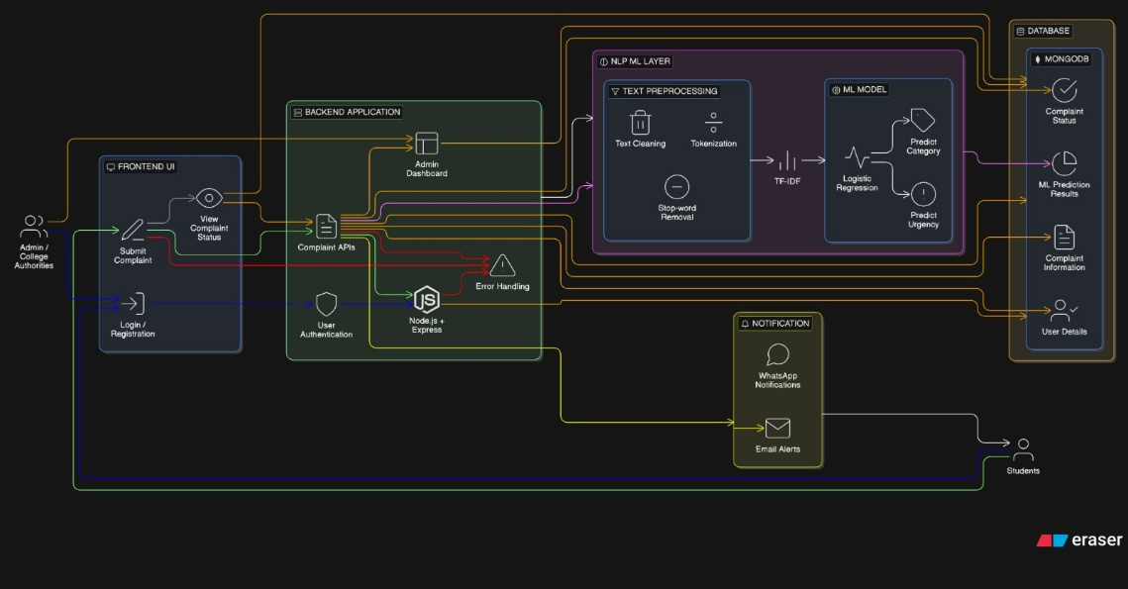

TF-IDF(Term Frequency-Inverse Document Frequency) converts complaint text into numerical features by assigning higher importance to words that are frequent in a complaint but rare across the dataset, enabling effective machine learning classification.”

Main Admin Dashboard (Completed)

Main Admin Capabilities

View all complaints

Update complaint status

View analytics

View and respond to student queries

Create department admins

📌 Special role:
Main admin acts as a super administrator

📌 Viva line:

“The main admin has full visibility and control over all complaints and users.”

Department Admin Creation (Completed)

How Dept Admins Are Created

Only Main Admin can create them

Dedicated admin UI:

Name

Email

Password

Department

Stored with:

role = dept_admin

department = specific department

📌 Security:

No public signup for dept admins

📌 Viva line:

“Department administrator accounts are securely created by the main admin.”

Department Admin Dashboard (Completed)

Department Admin Capabilities

Login using same login page

Automatically redirected to department dashboard

View only complaints related to their department

Update complaint status

📌 Restriction:

Cannot see complaints from other departments

Cannot access main admin analytics

📌 Viva line:

“Department admins can only view and manage complaints assigned to their department.”

Role-Based Access Control (Completed)

Backend

JWT-based authentication

Role & department attached to each request

Backend filters complaints based on role

Frontend

Protected routes using ProtectedRoute

Unauthorized users see Access Denied

📌 Security advantage:
Access control enforced on backend, not frontend hacks.

📌 Viva line:

“Role-based access control ensures data security and proper authorization.”

- What is the Student Queries Feature?
The Student Queries feature allows students to ask general questions or doubts that are not formal complaints.
Examples:
- “How long does complaint resolution usually take?”
- “Who should I contact for hostel-related issues?”
- “What documents are required for complaint registration?”
These are queries, not complaints.

🔹 Why This Feature is Needed
In a real college system:
- Not every student message is a complaint
- Many students only want information or clarification
So instead of:
- Forcing students to register a complaint.
We provide:
- A separate query channel.
This reduces unnecessary complaints and improves communication.

