TILLAI AND CO LPG DISTRIBUTION AGENCY

( A UNIT OF INDANE)

NAME: KANNAN BALRAJ TILLAI

INTERNSHIP DURATION: 6 Months

INTERNSHIP PLACE: PONDICHERRY
ACKNOWLEDGEMENT

I would like to express my sincere gratitude to Tillai & Co LPG Distribution Agency for providing me with the opportunity to undertake a six-month internship within the organization. This experience has been immensely valuable in shaping my practical understanding of the LPG distribution sector, and I am deeply thankful for the trust placed in my abilities and the responsibilities entrusted to me.
I extend my immense gratitude to my supervisor and the entire staff of Tillai & Co for their unwavering guidance, encouragement, and support throughout the internship. Their willingness to share knowledge, offer constructive feedback, and involve me in key operational activities greatly enriched my learning experience and professional growth.
I am also particularly grateful to my colleagues for their warm welcome and consistent support, which enabled me to integrate seamlessly into the work environment. The professional yet friendly atmosphere at Tillai & Co was both motivating and inspiring, encouraging me to perform at my highest potential.
This internship has served as a significant milestone in my career development. The insights and skills acquired during this period will undoubtedly contribute meaningfully to my future endeavors.
Once again, I extend my sincere appreciation to all the remarkable individuals at Tillai & Co LPG Distribution Agency for making this internship a truly rewarding experience.

TABLE OF CONTENTS

Sl No. | TITLE | Page number
1. | Introduction To The Internship | 5
2. | Objectives Of The Internship | 6
3. | Scope Of The Internship | 7
4. | Operational Workflow | 8
5. | Supply Chain Overview | 12
6. | Daily Work Schedule | 15
7. | Roles & Responsibilities | 16
8. | Challenges & Solutions | 17
9. | Departments Visited | 19
10. | Operational Process | 21
11. | HSE Standards | 23
12. | S.W.O.T Analysis | 25
13. | Types Of LPG Cylinders | 27
14. | Modes Of Cylinder Booking | 29
15. | Summary | 31
16. | Future Prospects | 33
17. | References | 35

INTRODUCTION

Indane Cylinder Distributor Agency
Overview of the Internship

This report presents a comprehensive overview of my six-month internship at Tillai & Co LPG Distribution Agency, a unit affiliated with Indane in Pondicherry. The primary objective of this internship was to gain practical exposure to the operations and management of LPG distribution while bridging the gap between academic concepts and field application in the energy sector.

Departmental Exposure and Learning

During my internship, I was actively involved in multiple operational divisions, including customer service, logistics, inventory management, and compliance. This hands-on engagement allowed me to observe and understand the agency’s end-to-end supply chain processes, as well as the regulatory and safety protocols associated with LPG distribution.

Scope of the Report

Furthermore, this report outlines the organizational structure, departmental workflows, roles and responsibilities assigned to me, and the challenges encountered. Reflections on personal and professional development, coupled with insights gained throughout the internship, are also documented. Emphasis has been placed on the integration of safety practices, customer service excellence, and operational efficiency—critical aspects of a successful LPG distribution agency.

Importance of the LPG Sector

Given the increasing reliance on clean and affordable energy in both domestic and commercial settings, LPG distribution plays a vital role in national energy infrastructure. This internship has offered me the unique opportunity to witness how such agencies contribute to energy accessibility and customer satisfaction.

OBJECTIVES OF THE INTERNSHIP:

The internship at Tillai & Co LPG Distribution Agency was designed to achieve the following key objectives:
- Operational Understanding
- To gain hands-on exposure to the core operations of LPG distribution, including storage, logistics, delivery, and customer engagement.
- To understand the complete lifecycle of an LPG cylinder from filling at the bottling plant to final delivery at the consumer’s location.
- Professional Skill Development
- To develop essential workplace competencies such as teamwork, communication, time management, and problem-solving.
- To improve my customer service skills through direct interaction with clients and resolution of their concerns.
- Safety and Compliance Awareness
- To become familiar with the safety standards, regulatory requirements, and standard operating procedures (SOPs) governing LPG handling and distribution.
- Industry Exposure
- To build an understanding of the structure and functioning of LPG distribution agencies in India.
- To establish professional relationships and networks within the LPG sector for future career growth.
- Logistics and Inventory Management
- To learn about inventory tracking, route planning, scheduling, and stock management systems that ensure efficient service delivery.

SCOPE OF THE INTERNSHIP

- Industry Overview: Understanding the structure and functions of LPG distribution in India.

- Agency Overview: Studying the organizational framework, departments, and workflow at Tillai & Co.

- Assigned Tasks: Documenting responsibilities across departments such as logistics, customer service, and billing.

- Operational Observation: Gaining practical insights into cylinder handling, safety compliance, and delivery protocols

- Skill Development: Acquiring technical, interpersonal, and documentation skills through active engagement.

- Customer Interaction: Observing communication practices and handling customer grievances.

- Process Analysis: Identifying operational challenges and suggesting potential improvements.

OPERATIONAL WORKFLOW

The day-to-day activities in an Indane LPG distribution agency involve a mix of operational, customer service, and administrative tasks to ensure safe, efficient, and timely supply of LPG cylinders to customers. Key activities include:

- Cylinder Receipt and Verification

- Incoming LPG cylinders are received from authorized bottling plants.

- Delivery documents such as truck numbers, consignment types, and invoices are verified upon arrival.

- Cylinders are unloaded and categorized into filled, empty, and defective units.

- A random sample (typically 10%) of the filled cylinders is weighed to ensure compliance with permissible limits. Non-compliant cylinders are immediately returned.

- Stock and Price Management

- Opening stock and retail selling prices of all cylinder types are prominently displayed at the premises.
- Daily stock registers are maintained for filled, empty, and defective cylinders. These are kept available for regular inspections by oil marketing companies (OMCs).

- Inventory Control and Order Placement

- Indents for refilled cylinders are placed in a timely manner with bottling plants.

- Adequate stock equivalent to at least two days of average daily sales is maintained to prevent shortages.

- Inventory levels are monitored regularly to avoid overstocking or understocking.

- Home Delivery Operations

- Delivery schedules are planned daily, including time-specific deliveries (e.g., under the Preferred Time Delivery scheme).
- Sufficient infrastructure—vehicles and trained delivery staff—is ensured to meet delivery demands.

- Backlogs are managed promptly through additional shifts or rerouting.
- Customer Service and Support

- The customer service team assists with booking inquiries, new connection requests, and general information.

- Service teams respond to complaints such as LPG leakages and appliance issues and provide safety education.

- A complaint/suggestion register is maintained and made easily accessible to customers.

- Office hours, service timings, and holidays are clearly displayed.

- Safety and Compliance

- All safety regulations regarding cylinder storage, handling, and transportation are strictly followed.

- Weight and pressure checks are conducted regularly, and all safety records are documented.

- Staff undergo regular safety training and are equipped with protective gear during handling.

- Administrative and Documentation Work

- Customer documentation including KYC forms and address proofs is processed and verified.

- Records of sales, delivery slips, invoices, and customer interactions are maintained.

- Voucher management (TV, TTV, ITV) is part of the administrative workflow.

- List and order management

- Keep the indent on time for a cylinder filled in bottling plants, maintaining stock equal to at least two days of average daily sales.

- Monitor inventory levels to prevent deficiency or overstocking, and arrange additional delivery infrastructure when there is backlog.

- Staff Management and Training
- Staff members, including delivery personnel, showroom assistants, and mechanics, are required to wear uniforms and carry identification cards.

- Regular training sessions are conducted on safety, customer service, and operational procedures.

- Marketing and Communication

- Updated notices, safety instructions, and promotional materials from the OMC are displayed at the agency.

- Customers are informed about new schemes, safety campaigns, and operational updates.

- Regulatory Compliance and Restrictions

- Until it is authorized, do not buy, sell or exchange cylinders or pressure regulators with other distributors.

- Avoid any misconduct mentioned in marketing discipline guidelines (MDG) and maintain loyal demonstrations as per the distributor agreement.

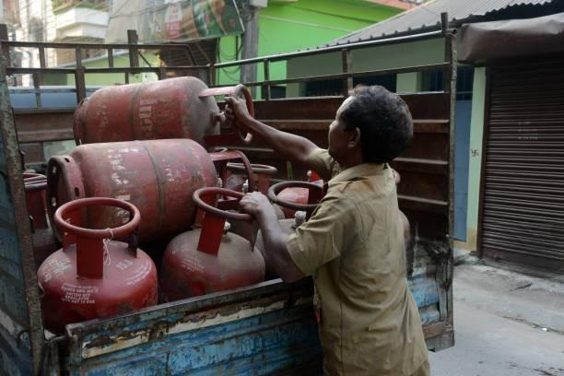

SUPPLY CHAIN OVERVIEW (LPG CYLINDER)

The LPG supply chain in an Indane Cylinder Distribution Agency includes several major stages and responsibilities, which ensure safe and efficient distribution from the bottling plant to the last consumer:

- Purchase and bottling

- Bulk LPG is sourced and is transported to bottling plants.

- In the bottling plant, LPG is filled in a standard size cylinder suitable for domestic or commercial use.

- Transport to distributor

- The filled cylinder is loaded on trucks and is transported from the bottling plant to the storage warehouse of the LPG distributor.

- On arrival, the distributor verifies the delivery by matching truck and cylinder details and confirming receipt time.

- Receipt and storage on distributor

- The cylinders were unloaded and sorted in the specified areas for filled, empty and defective cylinders.
- A random sample (normally 10%) of the cylinder is weighed to ensure the ideal quantity; Any discrepancies are recorded and cylinders are lower back out of doors the permissible restriction.

- Inventory and inventory management

- Distributors maintain a each day sign in for crammed, empty and defective cylinders.

- Retail sales costs and inventory tiers must be displayed for transparency.

- Booking and order processing

- Refills bookings through customer e-book, cell app or online platform.

- The corporation maintains the facts of reserving and plans accordingly.

- Last mile delivery

- The cylinder is transported to customers' homes or business installations within the prescribed area of ​​the distributor.

- The transport body of workers guarantees secure handling and set up, frequently checks for leaks and provides basic safety instructions.

- Customer carrier and compliance

- Distributor is the primary point of contact for consumer questions, complaints and service requests.
- Agencies have to comply with government directives, quality standards, and security regulations.

- A bunch of empty cylinders
- Customers’ empty cylinders are collected at delivery, returned to the warehouse for inspection and refilled via the drawing system.

- Key roles for INDAN’s distributor:
- Product integrity during shipping and warehousing.
- Keep detailed records of your stock and customers.
- Advocate for the use of LPG and educate consumers on its safety.
- Managing customer service issues and coordinating with oil providers can present significant operational challenges.
- Distributors play an essential role in the secure and efficient distribution of LPG to end-users through this optimized supply chain.

DAILY WORK SCHEDULE

Sl No. | Time | Activity Description
1. | 09:00 AM – 09:30 AM | Marked attendance and participated in daily briefing with the supervisor.
2. | 09:30 AM – 11:00 AM | Assisted in customer service, addressing booking queries and basic complaint handling.
3. | 11:00 AM – 01:00 PM | Observed and participated in booking documentation and KYC verification.
4. | 01:00 PM – 02:00 PM | Lunch break
5. | 02:00 PM – 03:30 PM | Visited storage units, learned about safety protocols and delivery operations.
6. | 03:30 PM – 04:30 PM | Supported billing operations and monitored subsidy updates.
7. | 04:30 PM – 05:00 PM: | Prepared daily report and discussed learning outcomes with the supervisor.

ROLES AND RESPONSIBILITIES

- Assisted in the smooth execution of daily operations, including the receipt, storage, and dispatch of LPG cylinders

- Provided customer service support by addressing inquiries, resolving complaints, and facilitating new connection requests.

- Maintained accurate records of cylinder inventory, customer bookings, shipments, and regulatory documentation.

- Supported the implementation and monitoring of safety standards related to storage, handling, and transportation of LPG cylinders, in compliance with industry regulations.

- Coordinated with transport personnel for scheduling and tracking deliveries to ensure timely and secure dispatch.

- Assisted with billing processes, cash handling, and the preparation of accounting records as required.

- Accompanied delivery personnel on field visits to observe real-time distribution processes and customer interactions.

- Reported daily tasks, observations, challenges, and improvement suggestions to the supervisory team.

CHALLENGES FACED AND SOLUTIONS

Sl No. | Challenge | Description | Solution
1. | Handling Customer Concerns and Expectations | During my initial days, I found it challenging to address customers who were concerned about delivery delays, subsidy clarifications, or booking fulfillment. | With guidance from senior staff, I learned to remain composed, actively listen to concerns, and communicate information clearly. Understanding both the customer’s viewpoint and the agency’s procedures helped me manage such interactions with greater empathy and effectiveness.
2. | Adapting to the Operational Workflow | The LPG distribution process involved multiple departments working in close coordination, which felt overwhelming at first. | I made a conscious effort to observe and assist colleagues across departments. Through note-taking, asking questions, and reviewing internal manuals, I gradually developed a clearer understanding of the entire workflow.
3. | Bridging Technical Knowledge Gaps | Initially lacked familiarity with certain technical aspects, such as cylinder classifications (e.g., XtraTej, Nanocut), safety regulations, and subsidy guidelines. | To enhance my understanding, I referred to product documentation, participated in safety briefings, and engaged with technical staff. These experiences significantly improved my technical knowledge and confidence.
4. | Managing Time During Peak Hours | During multiple delivery schedules, maintaining productivity under time constraints was sometimes difficult. | I prioritized tasks based on urgency, used simple checklists to stay organized, and coordinated with team members to ensure smooth operations and minimize delays.
5. | Becoming Familiar with Software Tools | Initially, I was unfamiliar with the specialized LPG booking and billing software used in the agency. | I requested brief training sessions and practiced under supervision. Over time, I became proficient in using the system for data entry, status checks, and invoice generation.

DEPARTMENTS VISITED

- Customer service/front office

- Customers handled the assistance related to questions, complaints and booking.
- Viewed interactions and dispute resolution practices.

- Booking and documentation section

- Learned about cylinder booking processes (online and offline).

- Booking records, subsidy status and KYC documentation maintained.

- Department of distribution and logistics

- Delivery scheduling, root planning and vehicle loading processes understood.

- Overview of delivery management and real -time tracking of delivery.

- Inventory and storage unit

- Secure cylinder handling, stacking and storage practice studied.

- Stock gained insight into maintenance, leak check and quality control.

- Department of Accounts and Billing

- Learned how customers invoices, subsidy and payment are processed.

- Digital payments understood integration and monthly revenue tracking.

- Safety and compliance unit

- Implementation of LPG Safety Protocol and Emergency Response Processes.

- Documents related to security audit and documents related to compliance of criteria.

- Technical and maintenance section

- Received insight into cylinder inspection, valve testing and repair processes.

- It was understood how the faulty or expired cylinder is handled.

OPERATIONAL PROCESS

- LPG Cylinder Procurement
- We procure LPG cylinders from authorized OMC’s like Indian Oil, BPCL, HPCL.

- Application and acceptance. Distributors are by application and selection process, including site inspection and OMC guidelines.

- After appointment, the distributor obtains filled cylinders from the closest bottling plant based on the needs and allocation determined by the OMC.

- Storage and security - Distributors must have an exclusive storage warehouse of a minimum capacity (say 8000kgs for urban, 5000kgs for rural locations).

- Compliance with safety standards is non-negotiable, encompassing adequate ventilation, fire suppression systems, and routine safety inspections.

- Access to the storage must have an all-weather, motorable approach road so that cylinder trucks can move safely and unimpeded.

- The warehouse and activities are inspected regularly and comply with statutory and OMC safety standards.

- Order processing and delivery

- Order fulfillment - refill or new connection orders arrive at the agency’s office or showroom, face-to-face or via phone or online.

- The agency records stock and cylinder movements generating buffer inventory to meet customer demand.
- Cylinders are delivered to customers’ homes by trained delivery staff, who must perform Pre-Delivery Checks (PDC) in the presence of the customer.

- Each distributor is allotted a specific area (locality/village/town) for service, as specified by the OMC.

- Customer service and complaint

- Customer interaction - The agency’s showroom or office is the locus for client questions, new relationships, paperwork and invoicing.

- Complaint Resolution - Agencies have to be quick in dealing with customer complaints such as leakage, late delivery or defective cylinders.

- Distributors to educate customers on safe use of LPG and emergency response.

- Service quality. Providing exceptional service and fostering trust are critical to the agency’s reputation and continued success.

HSE STANDARDS IN LPG OPERATIONS

- Safety Protocols in LPG Handling
- Routinely checking cylinders for leaks or dings prior to shipment.

- Safe storage of LPG cylinders in a ventilated, fireproof space.
- Protective equipment (gloves, safety shoes) usage by delivery and handling personnel.
- Teach your employees the proper way to load, unload and transport cylinders.
- Absolutely obey safety placards, no smoking regulations and keep away from fire.

- Emergency Instructions

- In the event of gas leakage or fire — immediate evacuation.
- On-site fire extinguishers and sand buckets.
- Emergency numbers (fire station, medical aid, IOC helpline) clearly marked.
- Scheduled mock drills and safety briefings for staff.
- Isolation of the leak source, and switching off all electrical appliances, in case of a suspected gas leak.

- Environmental Considerations

- Dispose of punctured or expired cylinders in authorized locations.

- Eliminating paper with e-invoicing and e-recordkeeping.

- Making certain that delivery vehicles are emission-compliant and maintained.

- Prompting customers to cook with energy-efficient LPG stoves to save gas.

- Awareness drives on safe and green usage of LPG

SWOT ANALYSIS

- Strengths:
- Well-established and trusted brand under Indian Oil Corporation.

- Efficient delivery system for domestic and commercial LPG cylinders.

- Trained staff with knowledge of safety protocols and customer service.

- Digital systems for booking, billing, and voucher management.

- Weaknesses:
- Limited infrastructure during high-demand periods.

- Occasional delays in delivery due to supply chain disruptions.

- Dependence on manual entries in some operational areas.

- Limited customer awareness about complaint redressal channels.

- Opportunities:
- Potential for digitization and process automation

- Scope for commercial LPG to cover more segments.

- Chance to run LPG safety and services awareness campaigns.

- Bringing lightweight composite cylinders to appeal to city dwellers.

- Threats:

- Increasing competitive pressures from private LPG distributors and substitutes.

- Operational risks from transportation strikes or regulatory changes

- Non-compliance with safety protocols may lead to significant operational hazards or regulatory penalties.

- Delays or lack of communication can lead to customer dissatisfaction and trust issues.

TYPES OF LPG CYLINDERS

- Domestic Cylinder:
These cylinders are used to meet domestic cooking needs.

- 14.2 kg subsidized cylinder
Regular domestic LPG cylinders were provided with government subsidies.

- 14.2 kg non-subsidized cylinder
The same as above, but sold at market price without subsidy to consumers with unqualified or high-use.

- 10 kg overall cylinder
Available in subsidized and non-subsidized variants. The fiber is a transparent layer to see-soaked, non-forest, and LPG levels made of overall materials.

- 5 kg FTL (Free Trade LPG) Cylinder
Which is also called small cylinder; Portable and easily available at select outlets. Non-SS.

- Commercial Cylinder:
Used in restaurants, hotels, bakeries and other commercial setups.

19 kg Indane Extratz Cylinder
High-demonstration commercial LPG with increased heat production and energy efficiency. Non-SS.

5 kg commercial cylinder
Small versions used in limited scale commercial operations. Non-SS.

3. Special objective cylinder:
Nanocut cylinder (17 kg)
- Especially metal has been developed for cutting and manufacturing industries. Provides an accurate, safe and cost-effective option for traditional oxy-acetylene gases.
- These cylinders are not intended for cooking or domestic use.

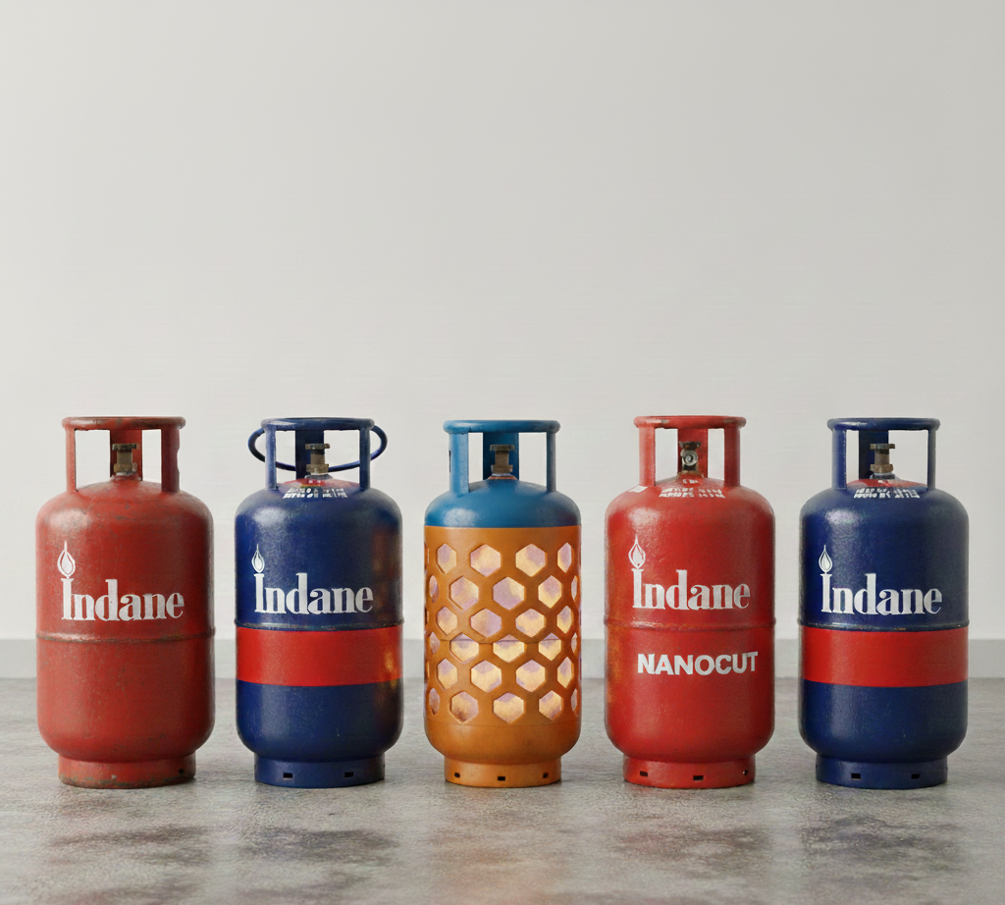

MODES OF CYLINDER BOOKING

1. Online Booking:
Indane official website:
Customers can log in to the Indane portal and book their refill online.

Indionoil a mobile app:
A user friendly app that allows booking, tracking and online payment.

2. IVRS (Interactive Voice Response System):
- 24x7 automatic call systems available in many regional languages.

- Customers can call the IVRS number specified for their area and follow the instructions to book refills.

3. SMS Booking:
By sending an SMS in a specific format on the IVRS number registered with the customer's registered mobile number.

4. WhatsApp Booking:
The IndianOil WhatsApp number (75888888824) can be booked by sending "refill" from the registered mobile number.

5. Missed Call Booking:
Customers can offer a missed call from their registered mobile number to 845495555555 to give a refill order.

6. Offline/Direct Booking In Agency:
- Customers can visit the LPG distributor's office and book cylinders in person.

- Especially useful for senior citizens or people who do not use digital means.

7. CSC (General Service Center):
Rural or semi-urban consumers can book refills through CSC centers run by the government.

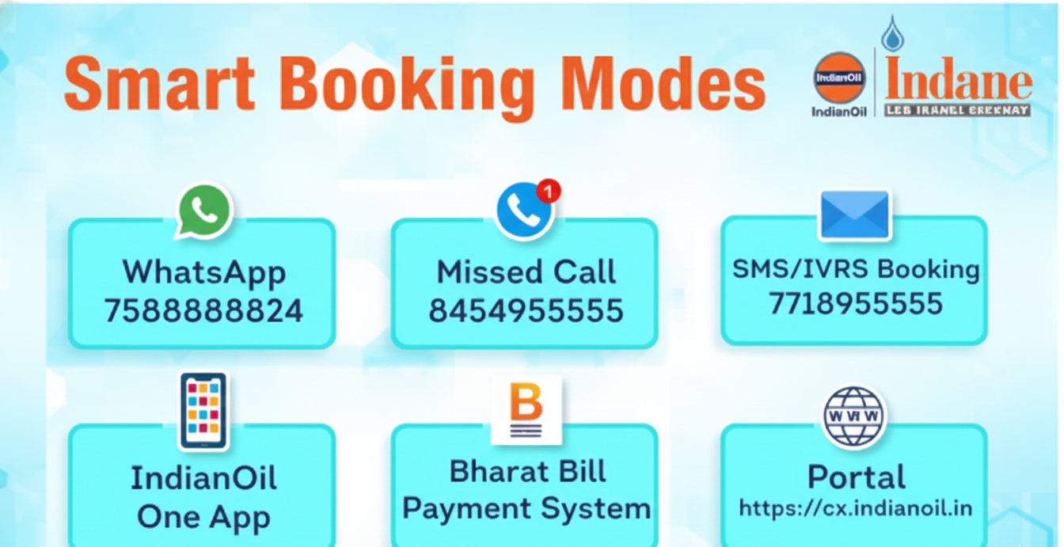

SUMMARY

This report summarizes the key observations, outcomes, and contributions made during my internship at the Indane LPG distributor agency, TILLAI & CO. The internship provided valuable hands-on exposure to the operational, technical, and customer service aspects of LPG distribution, while also enabling me to develop essential professional competencies

Internship objectives:
The primary objective of this internship was to gain practical experience in the LPG distribution sector by understanding the operational workflow of a cylinder distributor agency. In addition to learning about inventory control, order management, and customer interaction, I aimed to develop workplace skills such as communication, documentation, and time management. Familiarity with regulatory compliance and safety protocols governing LPG handling was also a key goal.

The nature of the work that was assigned:
Throughout the internship, I was involved in a range of responsibilities that spanned both fieldwork and office operations. These included assisting in the management of inventory, supporting customer order processing and payments, maintaining delivery records, and participating in the dispatch planning process. I also engaged directly with customers, addressed queries, and supported minor issue resolution. Additionally, I took part in periodic safety audits and inspections as guided by Indane's operating standards.

Key Learnings and Reflections::
This internship deepened my understanding of both business operations and regulatory frameworks in the LPG sector. I gained insights into supply chain coordination, customer satisfaction management, and safety assurance practices. The experience highlighted the importance of maintaining accurate inventory records and adhering to strict safety and service standards. Regular interaction with customers improved my interpersonal communication and problem-solving abilities, while observing internal processes helped me appreciate the complexities of operational planning and compliance.

Contribution to organization:
I actively contributed to the efficiency of daily operations by supporting team members in routine tasks and process improvements. For instance, I helped streamline aspects of the order processing workflow, resulting in shorter customer wait times. I also supported the implementation of an improved record-keeping system that enhanced the accuracy and accessibility of documentation. My participation in safety inspections reinforced compliance and contributed to the agency’s operational reliability. Overall, my efforts were directed toward improving service efficiency, customer satisfaction, and regulatory alignment.

FUTURE PROSPECTS

Tillai & Co LPG Distribution Agency holds significant potential for future development, particularly in enhancing service efficiency and expanding its market presence. With the increasing demand for clean and reliable cooking fuel in both urban and rural areas, the LPG sector is poised for sustained growth. This evolving demand landscape presents a strategic opportunity for the agency to broaden its customer base and strengthen its operational footprint.

1. Digital Transformation
One of the most promising avenues for growth lies in the adoption and integration of advanced digital technologies. By expanding the use of digital platforms for cylinder booking, billing, inventory management, and customer service, the agency can significantly enhance operational accuracy and reduce manual errors.
Features such as real-time delivery tracking, automated SMS notifications, and online grievance redressal systems will improve customer satisfaction and operational transparency.

2. Expansion of Commercial LPG Services
There is considerable potential in scaling up commercial LPG services to cater to small and medium-sized enterprises, including restaurants, hotels, bakeries, and other commercial entities. Establishing bulk supply arrangements with such establishments would diversify revenue streams and position the agency as a comprehensive energy solutions provider, rather than solely a domestic distributor.

3. Strengthening Safety and Compliance
To maintain credibility and ensure risk mitigation, it is essential to invest in regular training programs and the continuous updating of standard operating procedures (SOPs). By ensuring that all employees are well-versed in the latest safety guidelines and compliance standards, the agency can uphold a high standard of operational integrity and minimize the risk of accidents or regulatory violations.
4.Focus on Environmental Sustainability
Environmental responsibility is becoming increasingly important in the energy distribution sector. The agency can align itself with broader ecological goals by:
- Promoting the use of energy-efficient LPG appliances among consumers.
- Facilitating the safe and authorized disposal of damaged or expired cylinders.
- Maintaining an eco-friendly delivery fleet to minimize carbon emissions.
By adopting sustainable practices, the agency not only contributes to environmental preservation but also enhances its public image and compliance with emerging green regulations.

REFERENCES

- Indian Oil Corporation Limited – Indane LPG Official Website

- https://locator.iocl.com/indane/indane-tillai-and-co-gas-agency-white-town-puducherry-211331/Home

- Safety Guidelines for LPG Consumers – Indian Oil

- https://iocl.com/indane-safety

- LPG Distributorship Operational Manual – Indian Oil Corporation (Internal Resource)

- Internship Supervisor Discussions and On-Site Observations

- Government of India – Petroleum and Natural Gas Regulatory Board (PNGRB)

- https://pngrb.gov.in

- Company-provided documents and internal software systems (voucher handling, inventory management, etc.)

