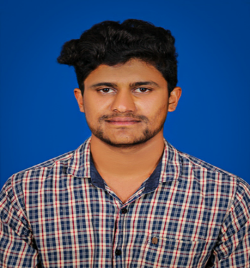



**U Musthaffa**

**Software Trainee**

# CONTACT

**PHONE:** +91 9080849176

**Email:** mmusthu451@gmail.com

# ACCOMPLISHMENTS

* Signing star award for team player.

# EDUCATION

* B. E. (Electronics & Communication) from TCE Engineering collage - Coimbatore 2021.
* H.SC From Government Hr.Sec School Thuneri, Nilgiris - 2017.
* SSLC From Government Hr.Sec School Thuneri, Nilgiris Tirupur – 2015.

About **1 Year and 2 months** of Extensive programming experience in designing User Interface applications and professional web applications using **HTML5, CSS3, Bootstrap, Media Queries, JavaScript, ES6, JSON, ReactJS**

## SKILLS

Web Technologies: HTML5, CSS3, JavaScript, ES6, JSON, React

Libraries: Bootstrap, React.js

Build Tools: NPM, Webpack, Babel

Testing: Jest, Enzyme

SDLC/Methodologies: Agile, Waterfall, Scrum

IDE: Visual Studio Code, Sublime Text

Version Control Systems: Git

## WORK EXPERIENCE

**Company: SM Technologies** **April 2022 to Present**

**Client:** [**Oneglobe Systems**](https://www.oneglobesystems.com/)**, Chennai**

* Design and development front end (UI) and functionality of the application.
* Developed Web Applications using HTML, CSS, NPM, JavaScript, Visual Studio Code, Bootstrap, Responsive, and React JS.
* Hands on experience on React JS to create re-usable UI-components using React JS.
* Working under Agile project management.
* Designed and Developed Web Applications using HTML, CSS, JavaScript, Visual Studio Code, Working under Agile project management.
* Created Dynamic web pages using JavaScript for validating different forms data.
* Manipulated data using CRUD (create, read, update and delete) operations of MongoDB database management system and handled database access and data transmission based on RESTful web services.
* Worked on state, and to create interactive React.js components. Integrating required server API calls.
* Created Dynamic web pages using JavaScript for validating different forms data.
* Added new features to web application.