OUTPUT SCREENSHOT: (FROM REPLIT)

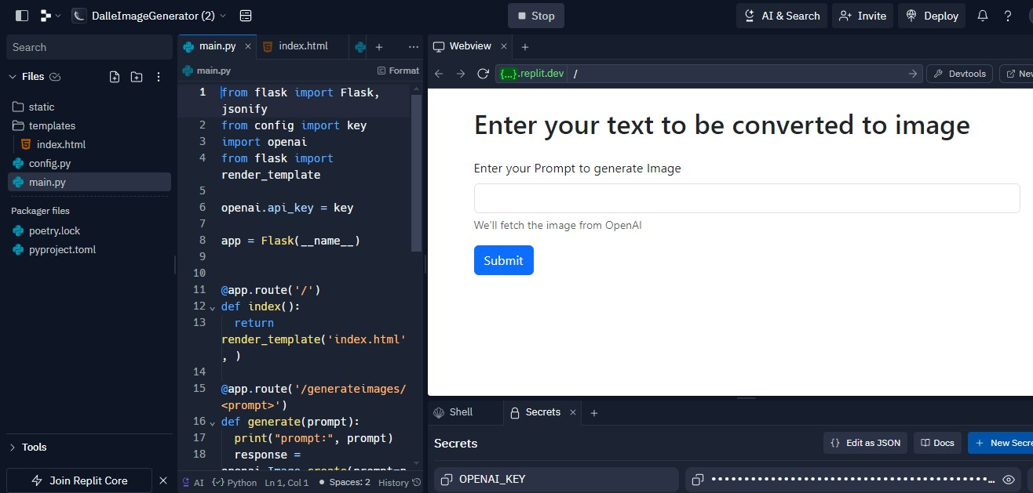

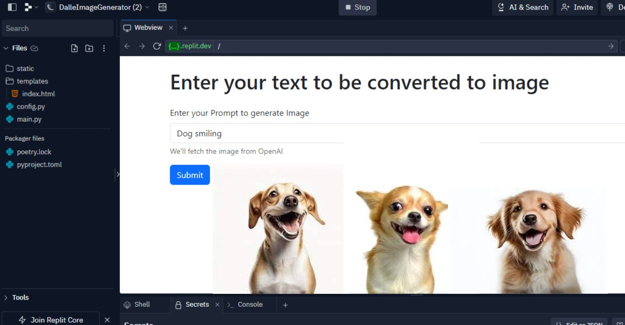

**APPENDIX:** Source code @github: https://github.com/Kannannair07/Gen_AI_Dall_E_image_generator