Assignment 1

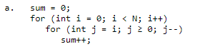

Line 1 = 1 unit

Line 2 = 1 + N + N = 2N + 1

Line 3 = N + N + N = 3N

Line 4 = N

Total = 6N + 2 = O(N)

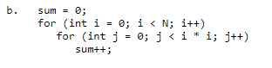

Line 1 = 1 unit

Line 2 = 1 + N + N = 2N + 1

Line 3 = 1 + (N – 1) + N = 2N

Line 4 = N

Total = 5N + 2 = O(N)

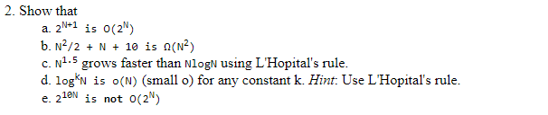

1. 2^(N+1) = 2 \* 2^N = 2^N \* 2^N = 2^2N = O(N)
2. N^2/2 + N + 10 = n^2/2 + N^2 + 10N^2 = 11/2 N^2 = O(N^2)
3. Lim n-> ∞ N^1.5 / N log N = ∞/∞

Using L’Hopital’s rule:

Lim n-> ∞ N^3/2 / ln (N) + 1 = ∞, so g(N) is o(f(N))

1. Lim n-> ∞ Log^k (N) / N = 0?
2. 2^10N / 2^N = c