**Intro to Git – The Starters**

**Git init**

* Tranforms the current directory to a git repository by adding a .git folder to the current directory.
* Makes the directory usable with git for revisions and versioning.

**Git init --bare <directory>**

* Bare repository is the one that has *no working tree*.
* You can only commit to bare repository by pushing to it from your local clone. It has no working tree, so it has no files modified, no changes.
* To have central repository the only way it is to have a bare repository.
* It's conventional to give bare repositories the extension .git.
* You almost always update a bare repository by pushing to it (using git push) from another repository.

**Git clone <repo URL>**

* Copies an entire repo.
* A fully fledged git repository with its own history, in an isolated envt. From the original repo
* cloning automatically creates a remote connection called origin pointing back to the original repository

**Git config user.name <name>**

* Author name for the particular repo’s commits.

**Git config --global user.name <name>**

* For current user (across all repos)

**git config --global user.email <email>**

* Author email

**git config --global –edit**

* Opens the global configuration file in a text editor for manual editing.

**Git config --edit**

* Current repo’s config.

Example:

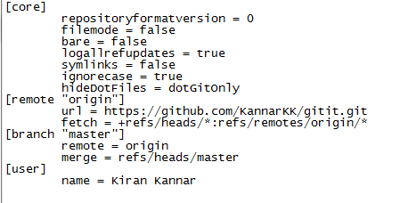

**git config --list**

Lists all configs