**Using ansible to deploy sample nginx/python application into kubernetes cluster.**

**Pre-requisites:**

1. **AWS INSTANCE WITH BASE IMAGE AS UBUNTU WITH T2.MEDIUM**
2. **DOCKER**
3. **ANSIBLE**
4. **KUBERNETES CLUSTER**
5. **AWS CLI INSTALLATION**

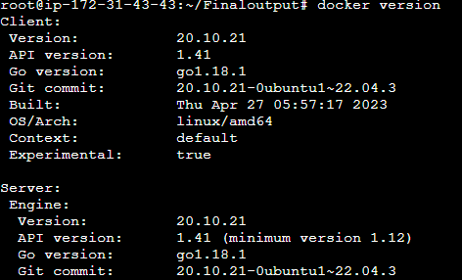

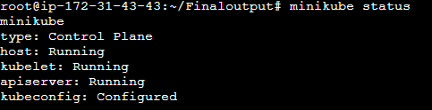

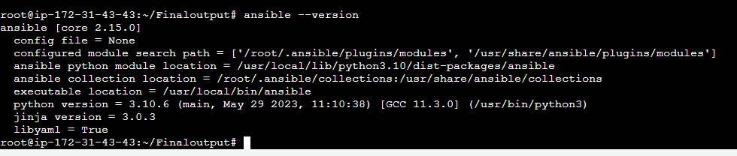

1. **Build docker image for sample nginx/python and push to aws elastic container registry(ECR) using**

**docker cli.**

* **Created a Docker file and build by taking base image as nginx and Exposed it to 80**
* **And created a repository and named newone and pushed my dockerfile image over there by giving aws configure and some push commands**

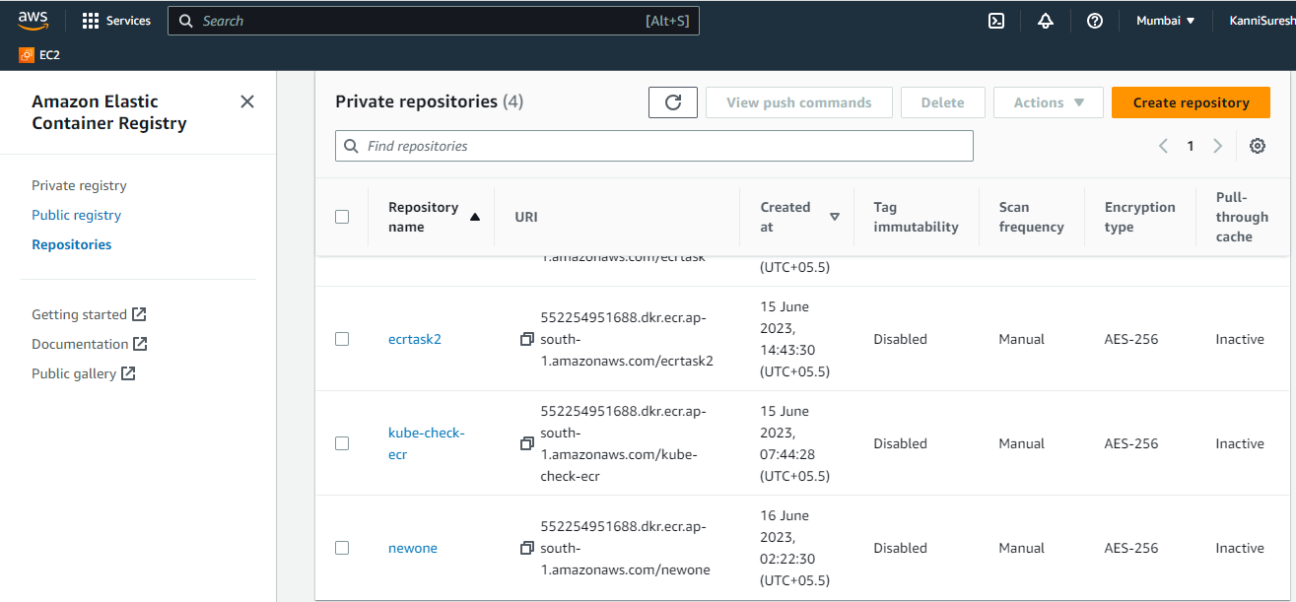

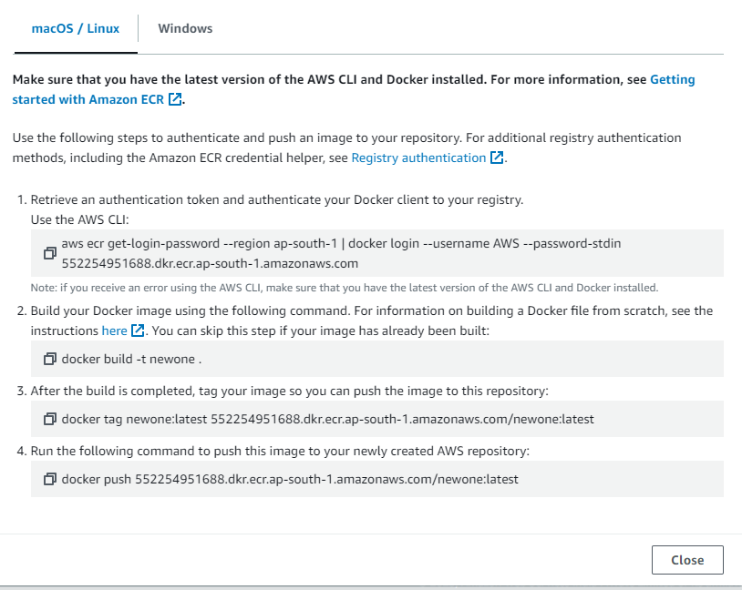

**2.Create ansible role to deploy nginx application into kubernetes cluster.**

* **Created the role by giving a command ansible-galaxy init my-role**
* **Created Deployment and service in the directory called tasks/ main.yml**

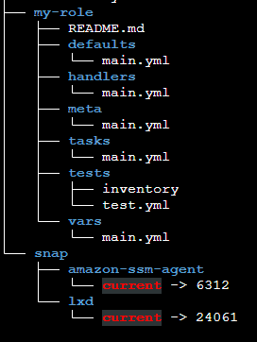

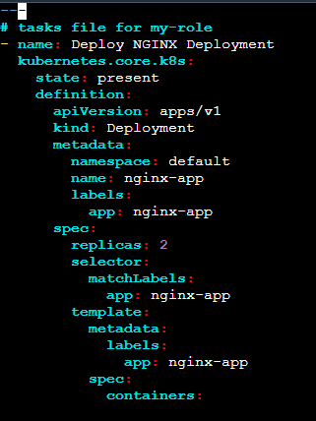

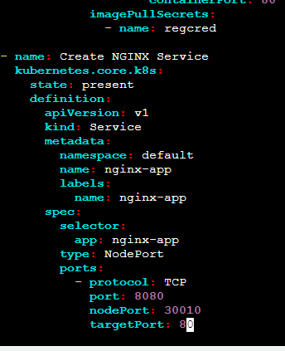

**3. Create ansible playbook to deploy nginx application.**

* **Created a ansible-playbook.yaml file to perform deployment on kubernetes cluster using that role i created**

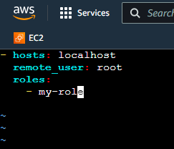

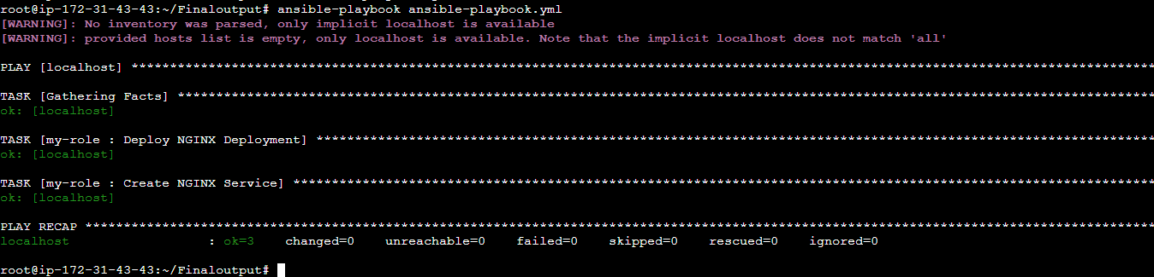

1. **Outcome is application deployed and run in k8s cluster. Able to access nginx website with url**

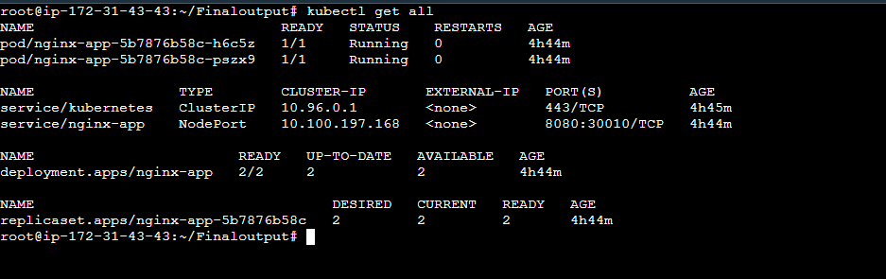

**To open the nginx web application from browser**

**http://3.110.193.98:8080/**

**OUTPUT:**

**Keep the code stuff into git repository**

**https://github.com/KanniSuresh/FinalAssessment16-06-23**

