**Exercise 1: Implementing the Singleton Pattern**

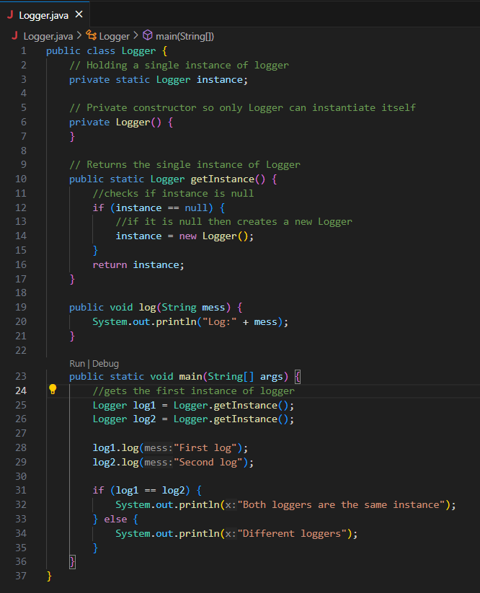

**OUTPUT:**

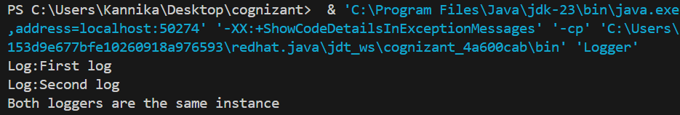

**Exercise 2: Implementing the Factory Method Pattern**

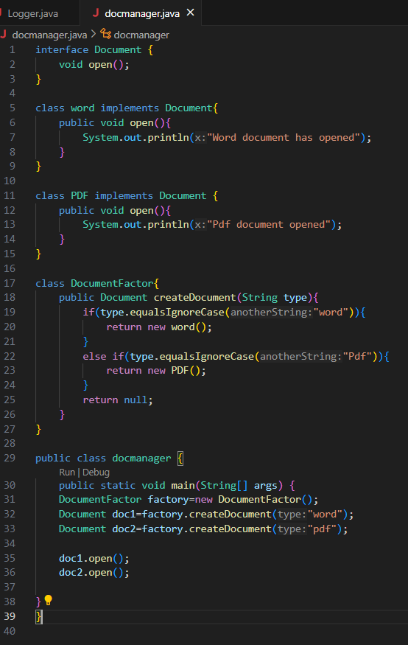

**OUTPUT:**

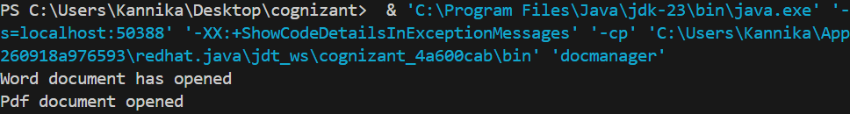

**Exercise 3: Implementing the Builder Pattern**

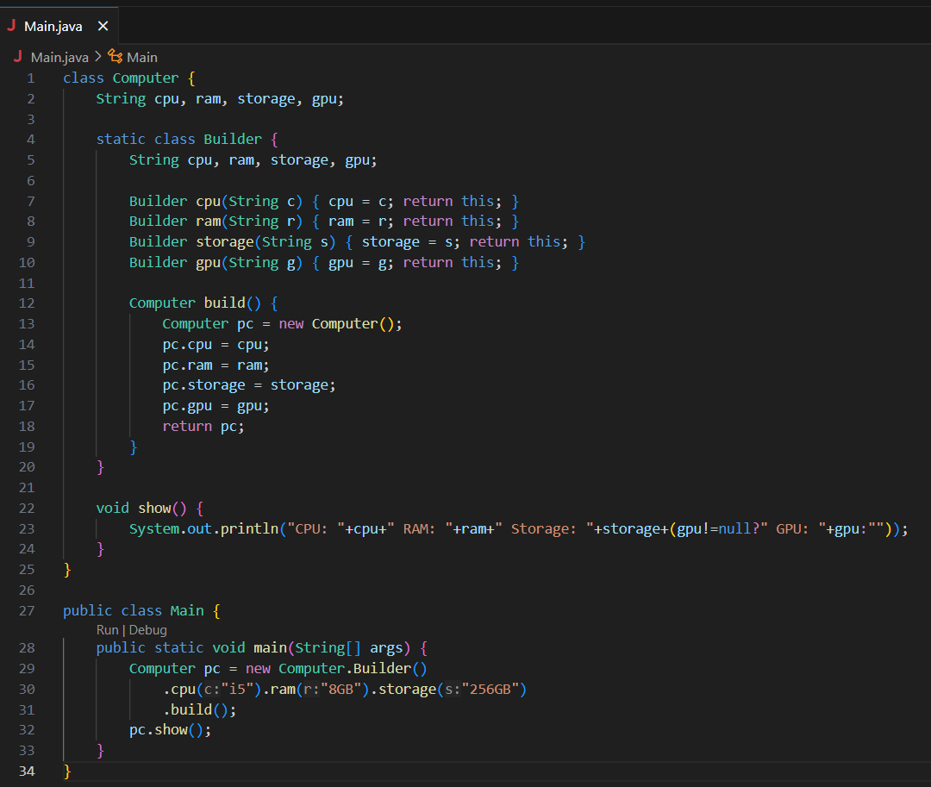

**OUTPUT:**



**Exercise 4: Implementing the Adapter Pattern**

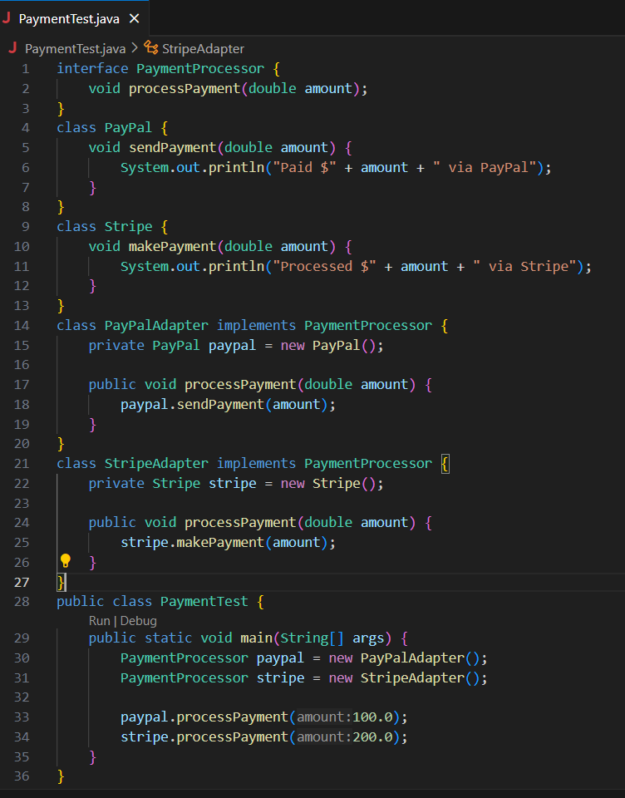

**OUTPUT:**

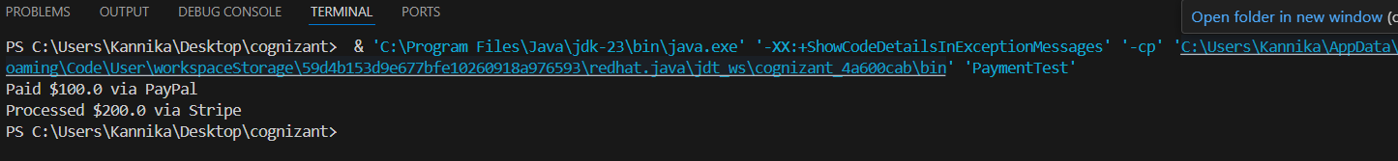

**Exercise 5: Implementing the Decorator Pattern**

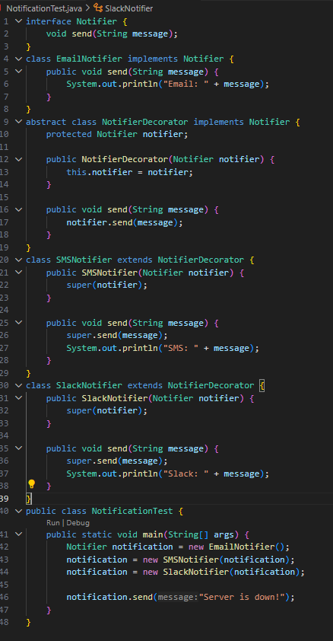

**OUTPUT:**

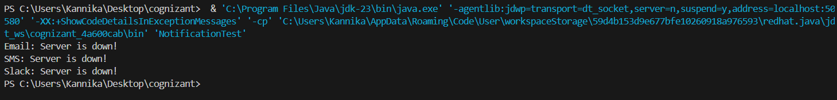

**Exercise 6: Implementing the Proxy Pattern**

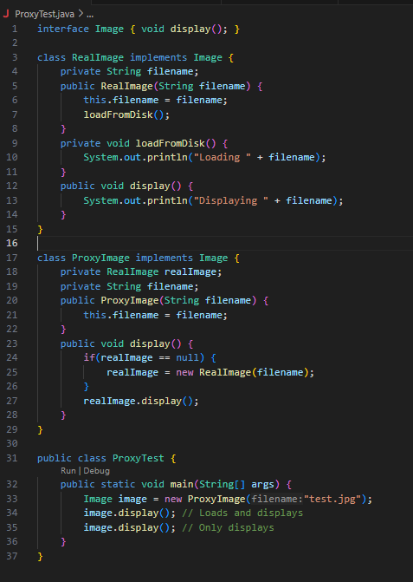

**OUTPUT:**

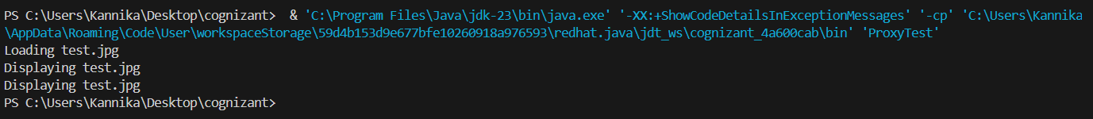

**Exercise 7: Implementing the Observer Pattern**

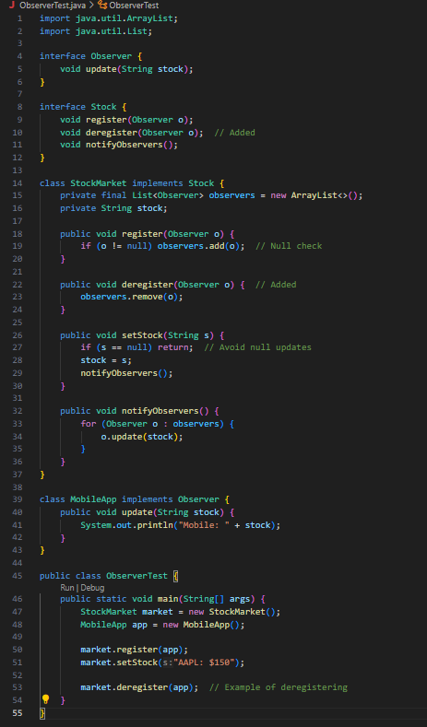

**OUTPUT:**

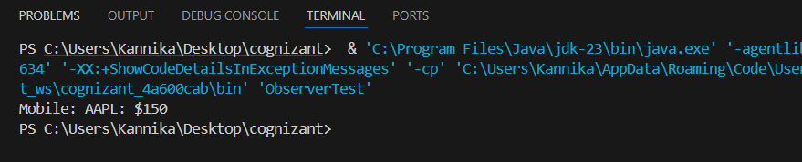

**Exercise 8: Implementing the Strategy Pattern**

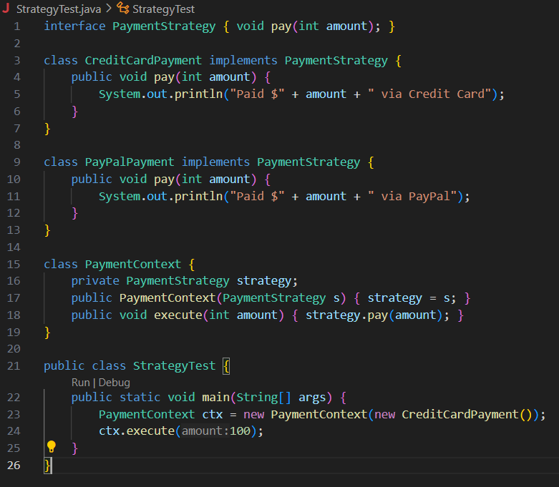

**OUTPUT:**

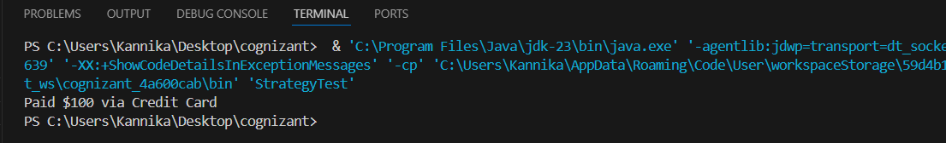

**Exercise 9: Implementing the Command Pattern**

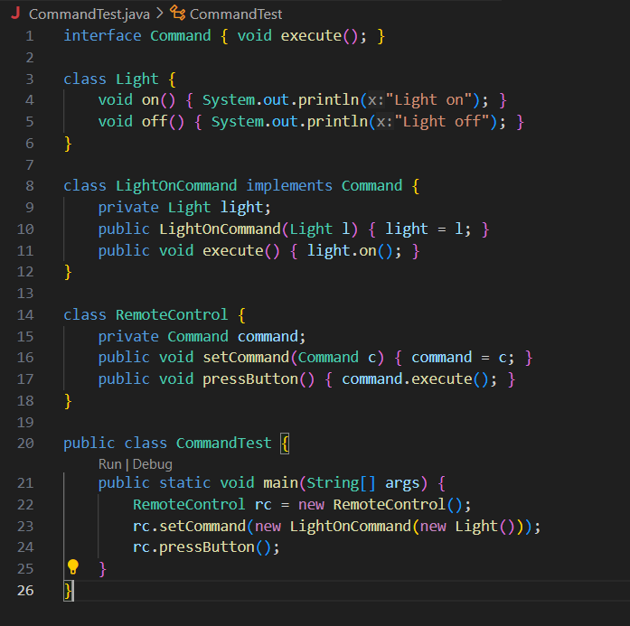

**OUTPUT:**

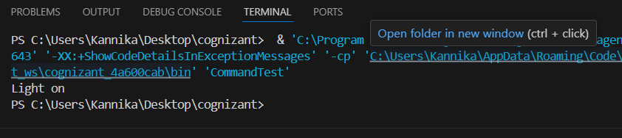

**Exercise 10: Implementing the MVC Pattern**

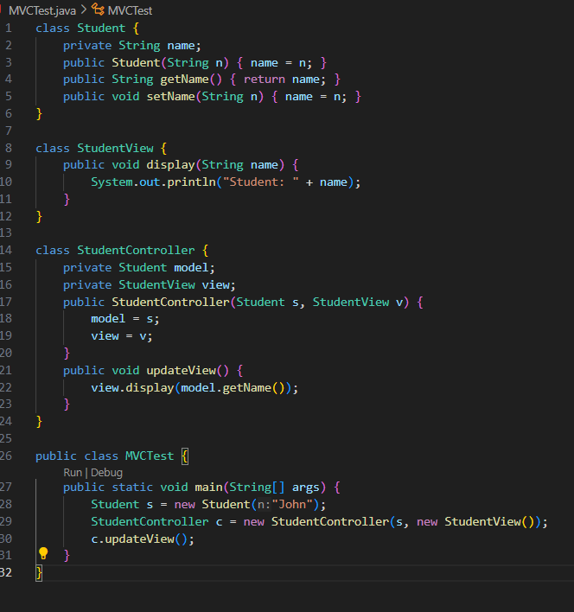

**OUTPUT:**

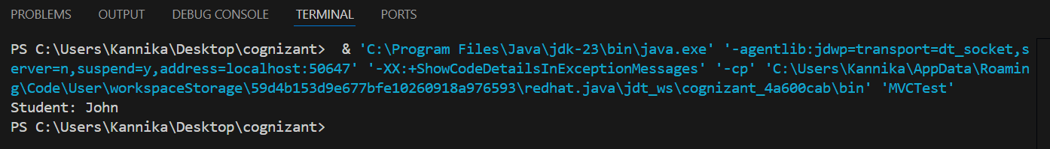

**Exercise 11: Implementing Dependency Injection**

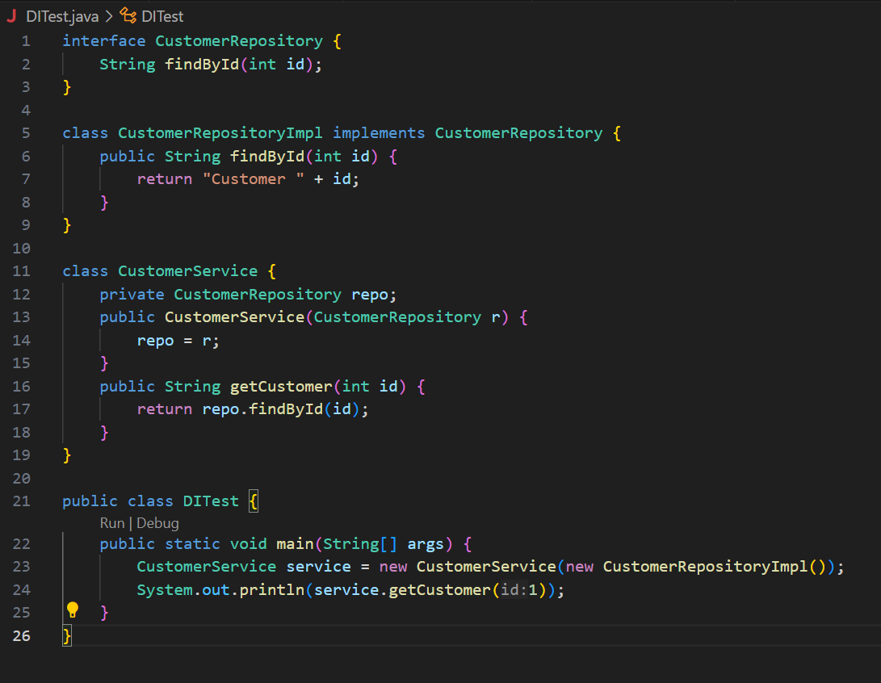

**OUTPUT:**

