
AMITY INSTITUTE OF
INFORMATION TECHNOLOGY
(AIIT)

Artificial Intelligence and Machine Learning
(CSE5053)

Winter Semester – 2025-2026

Employee Burnout Prediction

Project Report

SUBMITTED TO:
Dr. Madhu Bhan
(Assistance Professor-1)
(AIIT)

SUBMITTED BY:
Krishnam Mavani
(MSc Data Science)
(A869117725001)

Amity University Bengaluru
NH-207, opposite to the office of Deputy Commissioner, Devanahalli,
Doddaballapura, Bangalore – 562110
Employee Burnout Prediction Using Machine Learning

1. Abstract
Employee burnout has become one of the most significant challenges faced by organizations due to increasing workloads, workplace stress, and changing work environments. Burnout not only affects employees' physical and mental health but also reduces organizational productivity, employee satisfaction, and retention. Identifying burnout at an early stage enables organizations to provide timely support and improve overall workforce well-being.
The objective of this project is to develop a web-based Employee Burnout Prediction System using Machine Learning that predicts an employee's burnout level based on various work-related and personal factors. The system utilizes a Random Forest Regressor model trained on historical employee data to estimate the burnout score. Based on the predicted score, the application classifies employees into Low, Medium, or High burnout categories and provides recommendations to help reduce burnout risk.
The application has been developed using Python and the Flask framework for backend processing, while HTML, CSS, and JavaScript are used to design an interactive and user-friendly interface. The system supports both individual employee prediction and bulk prediction using CSV file uploads. In addition, the application provides model performance metrics, feature importance analysis, and dataset information to improve transparency and user understanding.
The developed system demonstrates how Machine Learning can be effectively applied in Human Resource Analytics to assist organizations in identifying employees at risk of burnout before serious consequences occur. This project provides a practical, efficient, and scalable solution that can be extended further by integrating real-time HR databases and cloud-based services.

2. Introduction
Employee burnout is a psychological condition caused by prolonged workplace stress, excessive workload, lack of motivation, and poor work-life balance. Modern organizations continuously seek methods to improve employee productivity while maintaining employee well-being. However, manually identifying burnout among hundreds or thousands of employees is both difficult and time-consuming. Human judgments are often subjective and may fail to recognize employees experiencing early signs of burnout.
Recent advancements in Artificial Intelligence and Machine Learning have made it possible to predict employee behavior using historical organizational data. Machine Learning algorithms can analyze multiple factors simultaneously and identify hidden relationships between employee characteristics and burnout levels. These predictions help Human Resource (HR) departments take preventive measures before employees experience severe burnout.
The Employee Burnout Prediction System developed in this project aims to provide a simple, intelligent, and accessible solution for predicting burnout risk. The application allows users to enter employee details through an interactive web interface or upload a CSV file containing multiple employee records. The trained Machine Learning model analyzes the input data and predicts the burnout score for each employee. Based on this score, the system categorizes employees into different burnout levels and generates meaningful recommendations.
Unlike traditional survey-based methods, this system provides instant predictions with minimal manual effort. The integration of Machine Learning with a web application makes the solution practical for educational purposes as well as real-world organizational use.

3. Problem Statement
Employee burnout has become a major concern across various industries due to increasing workloads, changing work environments, and growing performance expectations. Organizations often rely on employee surveys, manager observations, or periodic evaluations to assess employee well-being. These approaches are subjective, time-consuming, and may fail to identify employees who require immediate attention.
Manual evaluation methods are unable to process large volumes of employee data efficiently and often produce inconsistent results. As organizations expand, monitoring employee burnout manually becomes increasingly difficult. Consequently, employees experiencing high stress may remain unnoticed until their performance significantly declines or they resign from the organization.
Therefore, there is a need for an intelligent system capable of automatically analyzing employee information and predicting burnout levels accurately. Such a system can help Human Resource departments identify high-risk employees, improve employee satisfaction, and reduce organizational losses caused by burnout.

4. Objectives
The primary objective of this project is to develop a Machine Learning-based web application capable of predicting employee burnout levels accurately and efficiently.
The specific objectives of the project are:
- To develop a web-based Employee Burnout Prediction System.
- To analyze employee data using Machine Learning techniques.
- To predict employee burnout scores using the Random Forest Regressor algorithm.
- To classify employees into Low, Medium, and High burnout categories.
- To provide recommendations based on predicted burnout levels.
- To support batch prediction through CSV file upload.
- To display model performance metrics and feature importance.
- To create an interactive and user-friendly web interface using Flask.

5. Existing System
Many organizations currently depend on traditional approaches to evaluate employee burnout. These methods generally include employee questionnaires, HR interviews, manager observations, and periodic performance reviews. Although these techniques provide valuable insights, they require significant human effort and are influenced by personal opinions and biases.
Existing burnout assessment methods suffer from several limitations:
- Manual evaluation requires considerable time and effort.
- Human judgments may be inconsistent.
- Large employee datasets are difficult to analyze manually.
- Early burnout symptoms may remain undetected.
- Reports are generated periodically rather than in real time.
- Limited data-driven decision-making capabilities.
As organizations grow larger, these traditional approaches become increasingly ineffective for identifying employees who require immediate support.
6. Proposed System
The proposed Employee Burnout Prediction System addresses the limitations of traditional methods by utilizing Machine Learning to automate burnout prediction. The system accepts employee information through a web interface or CSV file upload and processes the data using a trained Random Forest Regressor model.
The prediction process consists of data preprocessing, feature transformation, Machine Learning prediction, burnout classification, and recommendation generation. Based on the predicted burnout score, the application categorizes employees into Low, Medium, or High burnout levels and provides meaningful suggestions for improving employee well-being.
The application also includes additional features such as batch prediction, model performance visualization, feature importance analysis, and downloadable sample CSV files, making it suitable for educational demonstrations as well as practical HR analytics applications.

7. Scope of the Project
The Employee Burnout Prediction System is designed primarily for educational purposes and Human Resource analytics. The application demonstrates how Machine Learning models can be integrated into web applications to solve real-world organizational problems.
The scope of the project includes:
- Predicting employee burnout scores using historical employee data.
- Supporting both individual and bulk employee prediction.
- Providing recommendations based on burnout risk levels.
- Displaying Machine Learning model information and performance metrics.
- Visualizing feature importance to improve prediction transparency.
- Offering an easy-to-use web interface accessible through modern web browsers.
Although the current system focuses on burnout prediction using selected employee attributes, it can be extended in the future by integrating real-time HR databases, authentication systems, cloud deployment, and advanced Explainable AI (XAI) techniques.

8. Technology Stack
The Employee Burnout Prediction System has been developed using modern web development technologies and Machine Learning libraries to ensure efficient prediction, scalability, and user-friendly interaction. Each technology used in the project plays an important role in building a reliable application.
Technology | Purpose
Python | Core programming language used for backend development and Machine Learning implementation.
Flask | Lightweight web framework used to develop the backend application and manage routing.
HTML5 | Used to design the structure of the web pages.
CSS3 | Provides responsive and attractive user interface styling.
JavaScript | Handles client-side interactions and improves user experience.
Pandas | Used for loading, cleaning, and manipulating employee datasets.
NumPy | Performs numerical computations and array operations.
Scikit-learn | Provides Machine Learning algorithms, preprocessing tools, and evaluation metrics.
Random Forest Regressor | Predicts employee burnout scores based on input features.
Joblib/Pickle | Saves and loads the trained Machine Learning model.
Vercel | Deploys the web application for online accessibility.
The combination of these technologies provides an efficient environment for developing an intelligent web-based prediction system.

9. Hardware and Software Requirements
Hardware Requirements
The application does not require high-end hardware. A standard computer system is sufficient for development, training, and deployment.
Component | Specification
Processor | Intel Core i3 / AMD Ryzen 3 or above
RAM | Minimum 4 GB (8 GB Recommended)
Storage | 500 MB Free Disk Space
Internet | Required for deployment and online access
Display | 1366 × 768 Resolution or Higher

Software Requirements
Software | Version
Operating System | Windows 10 / Windows 11
Python | Python 3.10 or Above
Flask | Latest Stable Version
Visual Studio Code | IDE
Git & GitHub | Version Control
Web Browser | Google Chrome / Microsoft Edge
Vercel | Application Deployment

10. Dataset Description
The Machine Learning model has been trained using an employee burnout dataset containing both categorical and numerical employee attributes. The dataset represents factors that commonly influence employee stress levels and workplace performance.
Each record in the dataset represents one employee, while the target variable is the employee's burnout score (Burn_Rate).
The dataset includes employee information such as gender, company type, work-from-home availability, designation level, resource allocation, and mental fatigue score. These attributes help the Machine Learning model understand employee working conditions and predict burnout risk accurately.
The application automatically validates the dataset before training the model. If the dataset is unavailable or invalid, the system regenerates or retrains the model to ensure reliable predictions.

Dataset Features
Feature | Description | Type
Employee_ID | Unique Employee Identifier | Integer
Gender | Employee Gender | Categorical
Company_Type | Product or Service Company | Categorical
WFH_Setup_Available | Work From Home Availability | Categorical
Designation | Employee Designation Level | Numerical
Resource_Allocation | Workload Assigned | Numerical
Mental_Fatigue_Score | Employee Mental Fatigue Score | Numerical
Burn_Rate | Target Variable (Burnout Score) | Numerical

Target Variable
The target variable of the dataset is Burn_Rate, which represents the estimated burnout level of an employee.
Unlike classification problems, this project predicts a continuous burnout score ranging approximately between 0 and 1. After prediction, the application categorizes the burnout score into three meaningful levels:
Burn Rate | Category
0.00 – 0.30 | Low Burnout
0.31 – 0.60 | Medium Burnout
Above 0.60 | High Burnout
This approach provides more detailed information than directly predicting categories because the exact burnout score is also available.

11. Data Preprocessing
Raw datasets cannot be directly used for Machine Learning because they often contain categorical values, inconsistent formats, and features with different scales. Therefore, preprocessing is an essential step before training the model.
The following preprocessing techniques are applied in the project:
i. Feature Selection
Only relevant features affecting employee burnout are selected for training.
Selected features include:
- Gender
- Company Type
- WFH Setup Available
- Designation
- Resource Allocation
- Mental Fatigue Score
These features provide sufficient information for predicting burnout while avoiding unnecessary complexity.

ii. Label Encoding
Machine Learning models cannot directly process textual values.
Therefore, categorical attributes such as:
- Male / Female
- Product / Service
- Yes / No
are converted into numerical values using Label Encoding.

Example:
Original Value | Encoded Value
Male | 1
Female | 0
Service | 0
Product | 1
This transformation allows the Random Forest algorithm to interpret categorical variables effectively.

iii. Feature Scaling
Numerical features have different ranges.
For example:
- Mental Fatigue Score may range from 0 to 10.
- Designation may range from 0 to 5.
If left unchanged, features with larger values could dominate the learning process.
Therefore, the project applies StandardScaler, which transforms numerical values into standardized values with zero mean and unit variance.
Benefits include:
- Faster model convergence
- Balanced feature contribution
- Improved prediction stability

iv. Train-Test Split
After preprocessing, the dataset is divided into:
- 80% Training Data
- 20% Testing Data
The training dataset is used to teach the Machine Learning model, while the testing dataset evaluates the model's prediction capability on unseen data.
This split ensures that the trained model generalizes well instead of memorizing the training dataset.

12. Machine Learning Methodology
The core of the Employee Burnout Prediction System is a Random Forest Regressor, a supervised Machine Learning algorithm suitable for predicting continuous numerical values.
Random Forest is an ensemble learning technique that combines multiple Decision Trees. Instead of relying on a single tree, it creates hundreds of trees using random subsets of the dataset and combines their predictions.
This approach offers several advantages:
- High prediction accuracy
- Reduced overfitting
- Better generalization
- Robustness against noisy data
- Ability to calculate feature importance
In this project, the Random Forest model is trained using employee data after preprocessing. Once training is completed, the model is saved locally using serialization. During application startup, the saved model is automatically loaded, eliminating the need for retraining every time the application starts.
The model predicts a burnout score for each employee, which is then converted into Low, Medium, or High burnout categories. Additionally, feature importance values are displayed to help users understand which employee attributes contributed most to the prediction.

13. System Architecture
The Employee Burnout Prediction System follows a three-tier architecture consisting of the Presentation Layer, Application Layer, and Machine Learning Layer. The user interacts with the web application through an intuitive interface developed using HTML, CSS, and JavaScript. Flask serves as the backend framework, processing requests, validating user input, and communicating with the Machine Learning model. The trained Random Forest Regressor predicts the burnout score and sends the results back to the user interface.
The application also supports batch prediction using CSV files and provides model insights, feature importance, and evaluation metrics through dedicated modules.
System Architecture Diagram
(Insert this diagram in Word using Shapes or SmartArt)
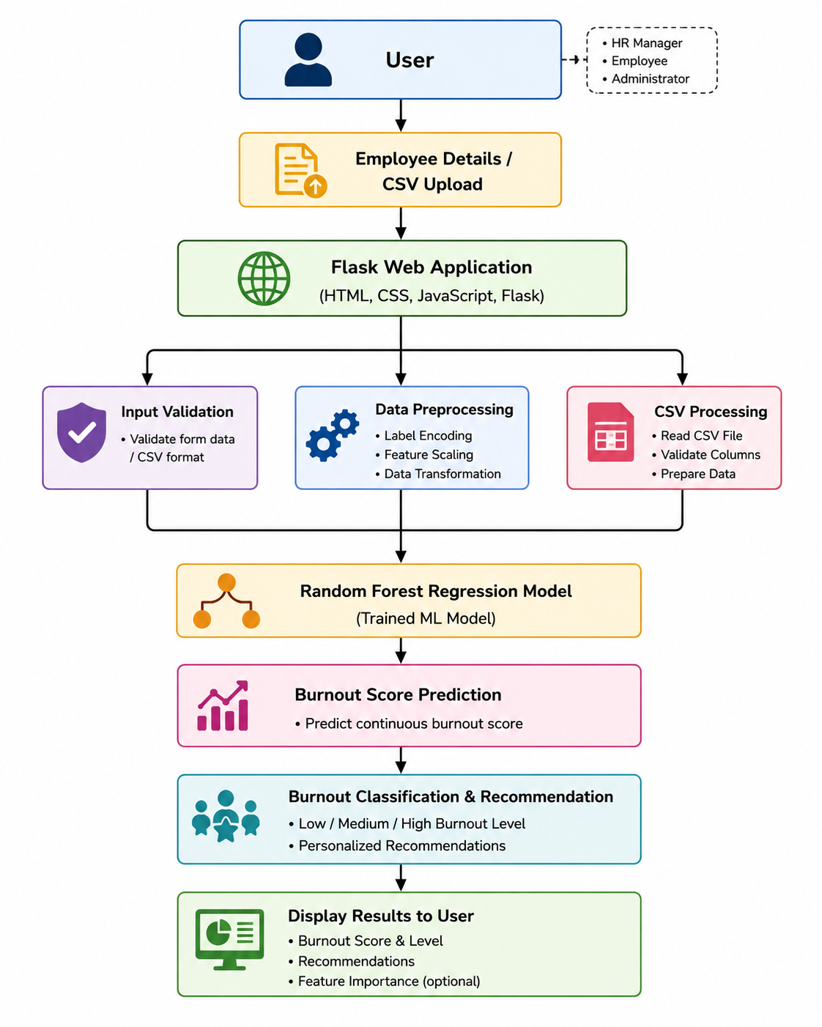

14. Prediction Workflow
The application follows a systematic workflow to ensure accurate predictions and smooth user interaction.
- The user opens the web application.
- The user selects either Single Prediction or Bulk CSV Prediction.
- Employee details are entered manually or uploaded as a CSV file.
- Flask validates the input data.
- The data is preprocessed using Label Encoding and StandardScaler.
- The trained Random Forest model predicts the burnout score.
- The burnout score is converted into Low, Medium, or High burnout categories.
- Personalized recommendations are generated.
- Results are displayed on the screen along with feature importance and model information.

Workflow Diagram
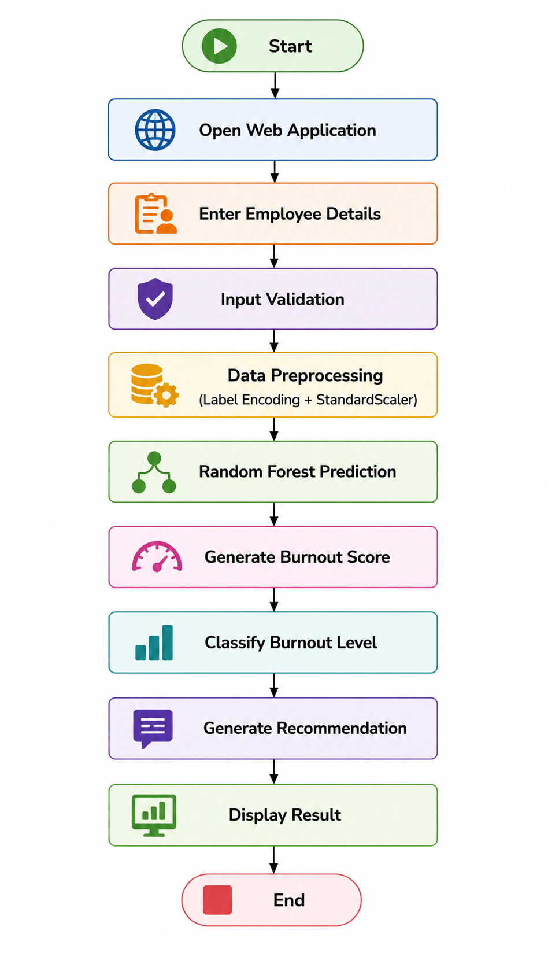

15. System Implementation
The Employee Burnout Prediction System is implemented as a web-based application using the Flask framework. The application provides a responsive interface where users can predict burnout levels for individual employees or multiple employees using CSV files.
During application startup, the system checks whether a trained Machine Learning model is available. If the model exists, it is loaded directly into memory. Otherwise, the system automatically trains a new Random Forest model using the available dataset and saves it for future predictions. This approach reduces application startup time and eliminates unnecessary retraining.
The backend handles all data validation, preprocessing, prediction, recommendation generation, and result presentation. The trained model predicts a continuous burnout score, which is later classified into different burnout levels according to predefined thresholds.
The application also calculates feature importance values to explain which employee attributes contributed most to the prediction. This increases transparency and helps users understand the prediction process.

16. Application Modules
The Employee Burnout Prediction System consists of four major modules.

Module 1: Home Page
The Home Page serves as the entry point of the application. It provides users with an overview of the project and allows navigation to different prediction modules.
Users can access:
- Single Prediction
- Bulk CSV Prediction
- Model Information
The interface has been designed with responsive layouts and modern UI components to provide a better user experience.

Figure 1: Home Page
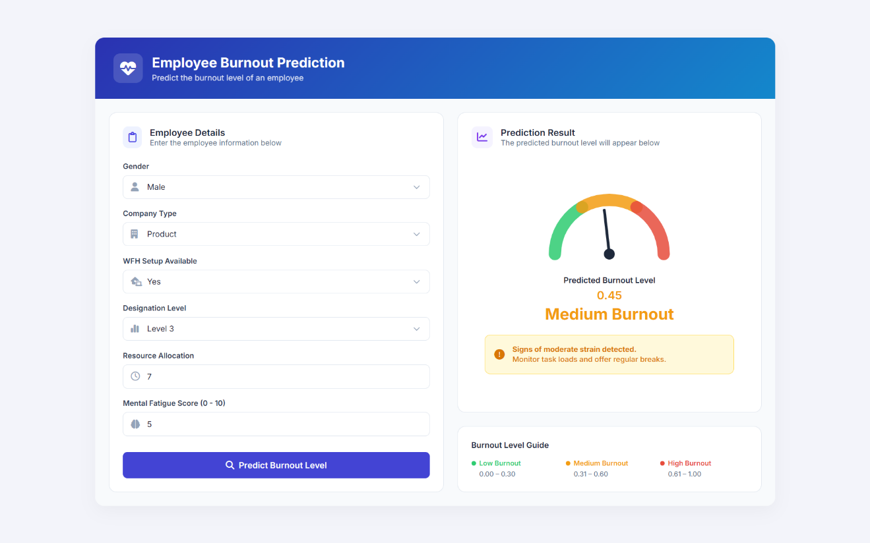
Explanation:
The Home Page presents the overall Employee Burnout Prediction System with a clean and intuitive interface. Users can easily navigate to prediction modules and understand the purpose of the application. The responsive design ensures compatibility across different screen sizes.

Module 2: Single Employee Prediction
The Single Prediction module allows users to enter employee information manually. The application accepts six major features:
- Gender
- Company Type
- WFH Setup Availability
- Designation
- Resource Allocation
- Mental Fatigue Score
After submitting the information, the system preprocesses the data and predicts the burnout score.
The predicted burnout score is then converted into:
- Low Burnout
- Medium Burnout
- High Burnout
Additionally, the application displays feature importance percentages and personalized recommendations.
Figure 2: Single Prediction Module
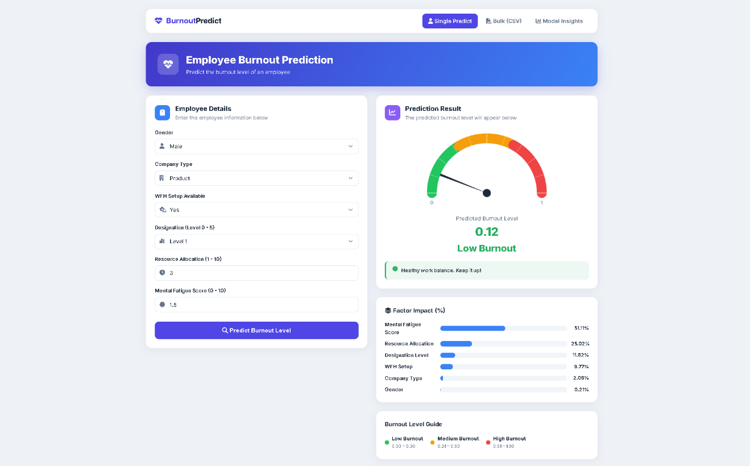
Explanation:
The Single Prediction interface enables HR personnel to evaluate individual employees quickly. After entering employee information, the trained Random Forest model predicts the burnout score. The application also highlights the most influential features contributing to the prediction, making the output more interpretable.

Module 3: Bulk CSV Prediction
Organizations often need to evaluate hundreds of employees simultaneously. The Bulk Prediction module addresses this requirement by allowing users to upload CSV files containing employee records.
After uploading the file, the application:
- Validates the CSV format.
- Predicts burnout scores for every employee.
- Classifies burnout levels.
- Calculates summary statistics.
- Identifies high-risk employees.
The processed results are displayed in a tabular format for easy analysis.
Figure 3: Bulk CSV Prediction
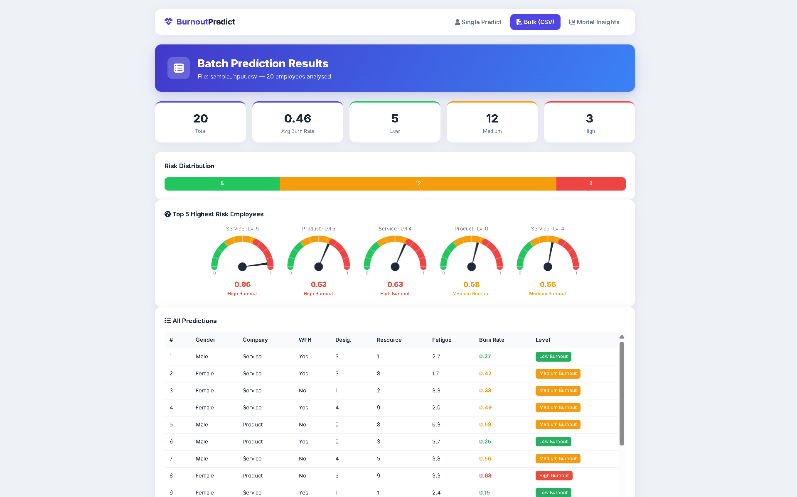
Explanation:
The Bulk Prediction module significantly reduces manual effort by processing multiple employee records simultaneously. It is particularly useful for HR departments managing large workforces, enabling quick identification of employees who require immediate attention.

Module 4: Model Information Dashboard
The Model Information page provides transparency regarding the Machine Learning model used by the application.
It displays:
- Model evaluation metrics
- Dataset information
- Number of training samples
- Number of testing samples
- Feature importance
- Dataset columns
- Average burnout score
This information helps users understand the model's reliability and performance.
Figure 4: Model Information Dashboard
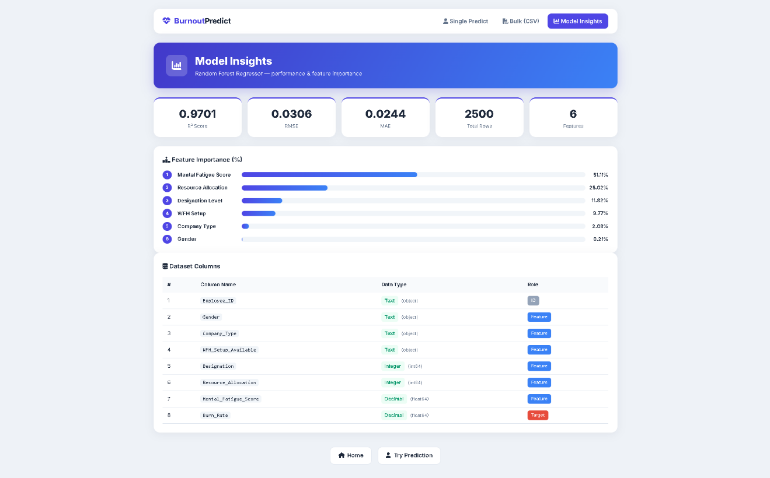

Explanation:
The Model Information Dashboard provides detailed insights into the trained Machine Learning model. Users can review evaluation metrics, analyze feature importance, and understand the dataset used during training. This improves confidence in the prediction results and supports informed decision-making.

17. Feature Importance Analysis
One of the strengths of the Random Forest algorithm is its ability to calculate feature importance. Instead of simply predicting burnout, the application also identifies which employee attributes contributed most to the prediction.
According to the trained model, the most influential factors include:
- Mental Fatigue Score
- Resource Allocation
- Designation Level
- Work From Home Availability
- Company Type
- Gender
Among these, Mental Fatigue Score has the highest impact on burnout prediction, indicating that employees experiencing greater mental fatigue are more likely to have higher burnout scores.
Displaying feature importance enhances the interpretability of the Machine Learning model and allows HR professionals to understand the primary factors influencing employee burnout.

18. Results and Performance Analysis
The Employee Burnout Prediction System was successfully developed and deployed as a web-based application using the Flask framework and a Random Forest Regressor. The application accurately predicts employee burnout scores based on employee-related attributes such as Gender, Company Type, Work From Home (WFH) availability, Designation, Resource Allocation, and Mental Fatigue Score.
The system supports both individual employee prediction and batch prediction through CSV file uploads. The prediction results are displayed instantly, allowing users to analyze employee burnout levels efficiently. Along with the predicted burnout score, the application also classifies employees into Low, Medium, or High burnout categories and provides recommendations for reducing burnout risks.
The application also includes a dedicated Model Information page where users can view model evaluation metrics, dataset information, feature importance, and other technical details. This increases transparency and helps users understand the reliability of the Machine Learning model.
Overall, the developed system demonstrates how Machine Learning can be effectively integrated with web technologies to solve real-world Human Resource problems.

Model Evaluation Metrics
The performance of the Machine Learning model was evaluated using standard regression metrics.
Metric | Description
R² Score | Measures how well the model explains the variation in burnout scores. Higher values indicate better performance.
RMSE (Root Mean Squared Error) | Measures the average prediction error. Lower values indicate better accuracy.
MAE (Mean Absolute Error) | Measures the average absolute difference between predicted and actual burnout scores.
The Random Forest Regressor achieved high prediction accuracy and demonstrated excellent generalization capability on unseen data. Compared to traditional regression algorithms, Random Forest provided more stable predictions and reduced the possibility of overfitting.

Burnout Classification
The predicted burnout score is converted into three meaningful categories to make the results easier to interpret.

Burnout Score | Burnout Level | Recommendation
0.00 – 0.30 | Low Burnout | Employee is performing well. Continue maintaining a healthy work-life balance.
0.31 – 0.60 | Medium Burnout | Employee shows signs of stress. Regular monitoring and workload adjustments are recommended.
Above 0.60 | High Burnout | Employee is at high risk. Immediate managerial support and stress reduction measures are recommended.
This classification helps HR professionals prioritize employee well-being initiatives based on the predicted burnout level.

19. Advantages of the System
The developed Employee Burnout Prediction System offers several advantages over traditional burnout assessment methods.
i. Early Burnout Detection
The system identifies employees who are at risk of burnout before severe performance issues occur, enabling organizations to take preventive actions.
ii. Automated Prediction
The application automates the burnout prediction process, eliminating the need for manual calculations and reducing human errors.
iii. User-Friendly Interface
A clean and responsive web interface allows users to perform predictions easily without requiring technical knowledge.
iv. Bulk Employee Analysis
The CSV upload feature enables organizations to analyze multiple employees simultaneously, significantly reducing processing time.
v. Explainable Predictions
The application displays feature importance values, allowing users to understand which employee attributes influenced the prediction most.
vi. Time Saving
Instant prediction results reduce the time required for employee evaluation compared to traditional survey-based approaches.
vii. Scalable Architecture
The Flask-based architecture allows future expansion by integrating authentication systems, cloud databases, or additional Machine Learning models.

20. Limitations
Although the developed system performs effectively, certain limitations remain.
- The prediction accuracy depends on the quality of the dataset used for training.
- The current model considers only selected employee attributes and may not capture every factor affecting burnout.
- The application does not currently integrate with live HR databases.
- Employee burnout is influenced by psychological and environmental factors that may not always be represented in numerical data.
- The system provides decision support but should not replace professional HR judgment or employee counseling.
These limitations provide opportunities for future improvements.

21. Future Scope
The Employee Burnout Prediction System can be further enhanced by introducing advanced technologies and additional features.
Future improvements may include:
- Integration with real-time HR Management Systems (HRMS).
- User authentication and role-based access control.
- Cloud database integration for secure employee data storage.
- Explainable Artificial Intelligence (XAI) techniques such as SHAP or LIME to provide more interpretable predictions.
- Deployment using Docker and cloud platforms such as AWS, Azure, or Google Cloud.
- Development of a mobile application for Android and iOS platforms.
- Email and notification systems to alert HR departments about high-risk employees.
- Dashboard analytics with interactive charts and reports.
- Continuous model retraining using newly collected employee data.
- Multi-language support for global organizations.
These enhancements would improve usability, scalability, and practical adoption in real organizational environments.

22. Conclusion
Employee burnout has become one of the most important challenges faced by modern organizations. Timely identification of burnout enables organizations to improve employee well-being, increase productivity, and reduce turnover.
This project successfully developed a web-based Employee Burnout Prediction System using Python, Flask, and the Random Forest Regressor algorithm. The system accepts employee information through an intuitive web interface or CSV file upload, preprocesses the input data, predicts burnout scores, classifies employees into different burnout levels, and provides appropriate recommendations.
The integration of Machine Learning with a responsive web application demonstrates the practical application of Artificial Intelligence in Human Resource Analytics. The Model Information Dashboard and Feature Importance visualization further improve transparency by helping users understand how predictions are generated.
Overall, the developed system provides an intelligent, efficient, and scalable solution for employee burnout prediction. With additional enhancements such as cloud integration, explainable AI, and real-time HR database connectivity, the application can evolve into a comprehensive HR decision support system capable of assisting organizations in maintaining a healthier and more productive workforce.

23. References
- Pedregosa, F., et al. (2011). Scikit-learn: Machine Learning in Python. Journal of Machine Learning Research, 12, 2825–2830.
- Flask Documentation. Available at: https://flask.palletsprojects.com/
- Scikit-learn Documentation. Available at: https://scikit-learn.org/
- NumPy Documentation. Available at: https://numpy.org/
- Pandas Documentation. Available at: https://pandas.pydata.org/
- Python Software Foundation. Python Documentation. Available at: https://docs.python.org/
- Breiman, L. (2001). Random Forests. Machine Learning, 45(1), 5–32.
- GitHub Repository: Employee Burnout Prediction Using Machine Learning (Project Source Code).

Appendix (Optional)
You may include the following appendix section if required by your college:
Project Folder Structure
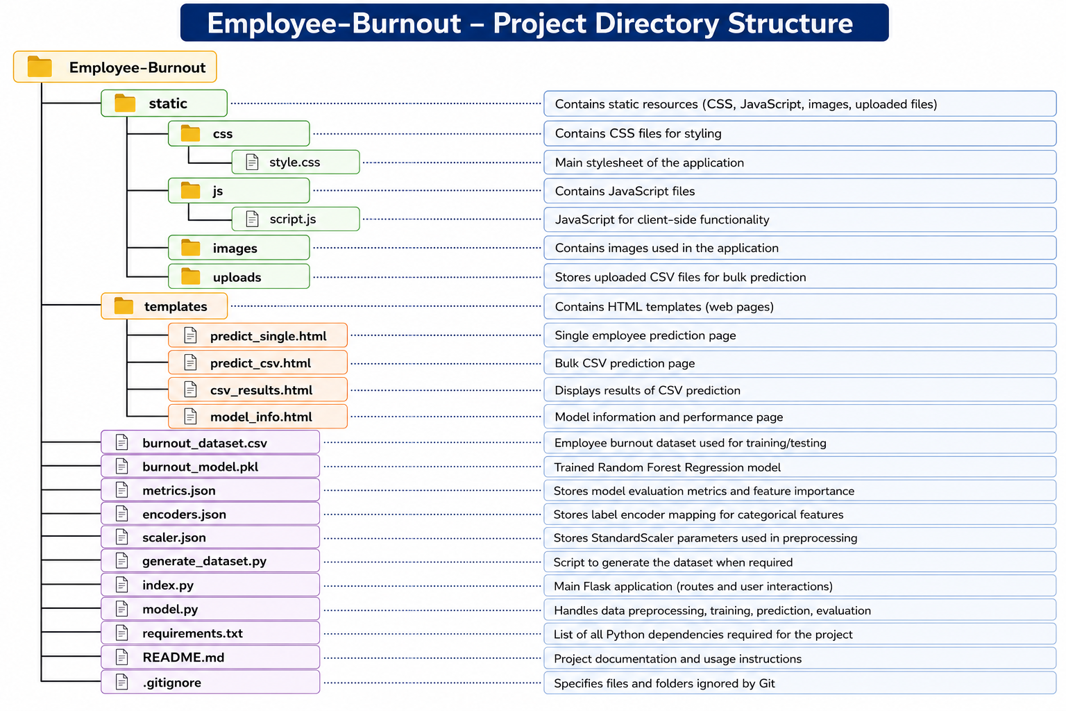
Key Features Summary
- Web-based Employee Burnout Prediction
- Random Forest Regressor
- Single Employee Prediction
- Bulk CSV Prediction
- Feature Importance Analysis
- Model Information Dashboard
- Burnout Recommendations
- Responsive User Interface
- Automatic Model Loading
- CSV Validation and Processing

