**Q. Explain Structure of HTML.**

Ans

* HTML stands for Hyper Text Markup Language.
* It is used to design web pages using a markup language.
* HTML is the combination of Hypertext and Markup language.
* Hypertext defines the link between the web pages.
* A markup language is used to define the text document within tag which defines the structure of web pages.

**Structure of HTML are as follows:**

It contains the essential building-block elements (i.e. doctype declaration, html, head, title, and body elements) upon which all web pages are created.

**<DOCTYPE! Html> :**

* This is the document type declaration.
* It declares a document as being an HTML document.
* The doctype declaration is not case-sensitive.

**<html> :**

* This is called the HTML root element.
* All other elements are contained within it.

**<head>:**

* The head tag contains the “behind the scenes” elements for a webpage.
* Elements within the head aren’t visible on the front-end of a webpage.
* Tags used in the Head section for Metadata:
  + <title>
  + <meta>
  + <link>
  + <style>
  + <script>
  + <base>

**<body>:**

* The body tag is used to enclose all the visible content of a webpage.
* In other words, the body content is what the browser will show on the front-end.

**Example:**

<html>

<head>

<title>

</title>

</head>

<body>

</body>

</html>

**Q. Create web Page to display "Welcome to HTML" message.**

Ans:

**Input:**

<!DOCTYPE html>

<html lang="en">

<head>

   <title>Demo Page</title>

</head>

<body>

   <h1> "Welcome to HTML" </h1>

</body>

</html>

**Output:**

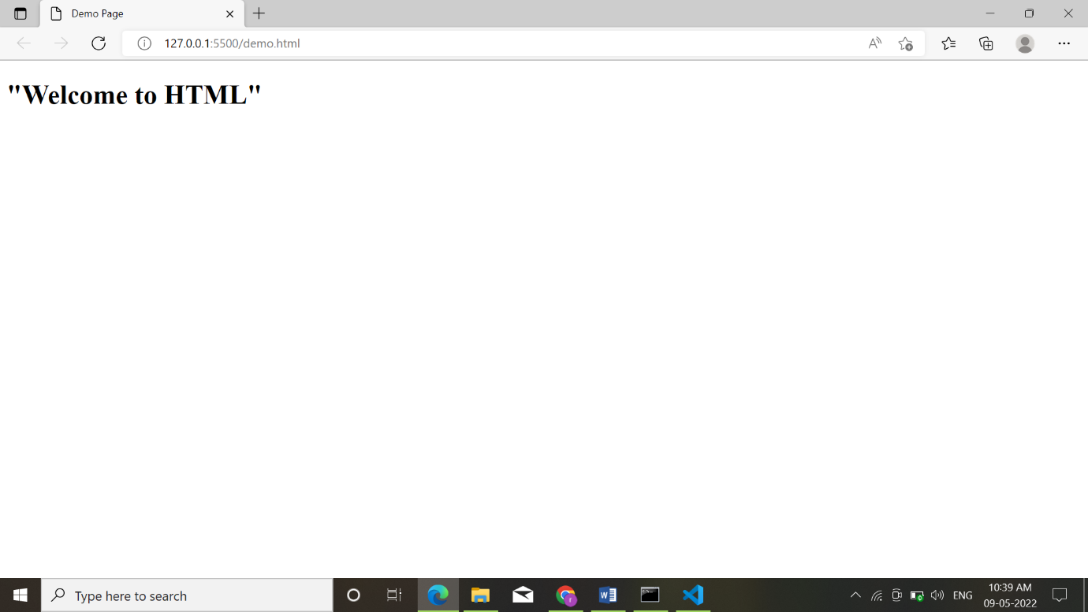

**Q. Explain Comments in HTML.**

**Ans:**

* Comments in the HTML document are an unexecutable part of the code as it is ignored by the Browser.
* As the Browser Ignore it, they are not displayed on the Browser.
* Comment helps us to understand the purpose of the code.
* It helps to maintain your code properly.

**Syntax:**

**<!......... Your comment goes here ……>**

**Example**

<!DOCTYPE html>

<html lang="en">

<head>

   <title>Demo Page</title>

</head>

<body>

*<!-- Order List    -->*

      <ol type="A">

         <li>IPHONE</li>

         <li>REDMI</li>

         <li>ONEPLUS</li>

         <li>MOTOROLA</li>

      </ol>

</body>

</html>