Response Letter

Dear Editor and Reviewers,

First of all, we would like to thank the editor and reviewers for reviewing our paper and for their valuable comments. We have carefully read all of the reviewers' comments and have made detailed revisions to our paper based on these comments. We believe that these revisions have made our paper better. The following is the response to the reviewers' comments:

****Reviewer 1:Luwei Xiao****

**1.The literature review could be more comprehensive by discussing additional recent works that have incorporated sentiment analysis or self-attention mechanisms into stock prediction models.**

Response：

We are deeply grateful to the reviewers for their valuable suggestions on parts of this paper. We fully recognise that the literature review section does need to be further expanded, especially with regard to recent studies involving the application of sentiment analysis or self-attention mechanisms to stock prediction models. With this in mind, we have added six recent papers and incorporated a number of other relevant research findings with the aim of enhancing the breadth and depth of the literature review. The specific additions to the literature are shown below:

Xiao, L., Wu, X., Yang, S., Xu, J., Zhou, J., & He, L. (2023). Cross-modal fine-grained alignment and fusion network for multimodal aspect-based sentiment analysis. Information Processing & Management, 60(6), 103508.

Gong, P., Liu, J., Zhang, X., & Li, X. (2023, June). A Multi-Stage Hierarchical Relational Graph Neural Network for Multimodal Sentiment Analysis. In ICASSP 2023-2023 IEEE International Conference on Acoustics, Speech and Signal Processing (ICASSP) (pp. 1-5). IEEE.

Luo, J., Zhuo, W., & Xu, B. (2023). A Deep Neural Network-based Assistive Decision Method for Financial Risk Prediction in Carbon Trading Market. Journal of Circuits, Systems and Computers. doi: 10.1142/S0218126624501536

Liu,B.,Li,M.,Ji,Z.,Li,H.,& Luo, J. (2024). Intelligent Productivity Transformation: Corporate Market Demand Forecasting With the Aid of an AI Virtual Assistant. Journal of Organizational and End User Computing (JOEUC), 36(1), 1-27. [http://doi.org/10.4018/JOEUC.336284](http://doi.org/10.4018/JOEUC.336284" \t "https://mail.google.com/mail/u/0/" \l "inbox/_blank)

Ding,K.,Choo,W. C., Ng, K. Y., & Zhang, Q. (2023). Exploring changes in guest preferences for Airbnb accommodation with different levels of sharing and prices: Using structural topic model. Frontiers in psychology, 14, 1120845. doi: 10.3389/fpsyg.2023.1120845

Huang, C., Han, Z., Li, M., Wang, X., & Zhao, W. (2021). Sentiment evolution with interaction levels in blended learning environments: Using learning analytics and epistemic network analysis. Australasian Journal of Educational Technology, 37(2), 81-95. doi: 10.14742/ajet.6749

Specific additions to the literature review can be found in the yellow highlights in the literature review section of the Manuscript (tracked changes).

**2.More details on the data collection and preprocessing steps could strengthen reproducibility, such as the specific news sources and dates.**

Response：

In order to effectively improve the reproducibility of the data collection and pre-processing steps, we have made the following careful modifications based on the valuable suggestions of the reviewers:

①We have provided detailed descriptions of the specific news sources, specific dates and categories of the datasets used, and have bolded the date parts of the datasets to help readers better understand the source and scope of the data. We have also added the FS100 dataset as part of the model training. The specific additions are shown below:

The FTSE 100 is an index of the 100 largest companies by market capitalisation on the London Stock Exchange, representing the UK's leading companies across a wide range of sectors such as financial services, energy, consumer goods, etc., and effectively reflecting the state of the UK stock market.

The first part of the news headline data was obtained from the Reuters website (2022) via a web crawler. In this study, news headline data was crawled from the financial, monetary, health, environment, healthcare and pharmaceutical sections of Reuters. Figure 2 illustrates the sample of news headlines collected on **January 1, 2020**.

Please refer to the "***Data Description***" and "***Data Preparation***" subsections of the "**EXPERIMENT**" section of the manuscript for the full paragraphs,

②In particular, we isolate the data pre-processing steps in detail and illustrate, in plain and detailed language, how to convert raw text into a format that can be processed by a pre-trained natural language processing model, in order to improve the reproducibility of the data pre-processing, as described below:

Meanwhile, we use the roberta.large model (Liu et al., 2019), a pre-trained deep learning model for natural language processing, to implement sentiment classification. First, we use roberta.large model's tokeniser to segment text into tokens; the tokeniser tries to split words or text fragments into smaller units until all units can be found in the vocabulary. Then, to identify the start and end of a sentence sequence, roberta.large model uses <s> as the start token of the sequence and </s> as the end token of the sequence.After splitting into tokens, these tokens are converted into indexes by looking up the corresponding unique index of each token in roberta.large model's vocabulary. Since the roberta.large model requires that all input sequences have the same length, shorter sequences must be padded and longer sequences must be truncated. In order for the model to know which positions are real tokens and which positions are padded tokens, an attention mask must also be created. For real tokens, the mask value is 1; for padded tokens, the mask value is 0. The above steps convert the raw text into a format that can be processed by the roberta.large model.

You can find the complete **Data** ***preprocessing*** section in the Experiment section of the Manuscript (tracked changes).

**3.Comparative experiments against more baseline models would further validate the proposed method's effectiveness.**

Response：

We have added a comparative experiment with the performance of the Convolutional Neural Network (CNN) model. The smaller the values of MAE, **RMSE and MAPE**, the smaller the error between the predicted value and the actual value of the model, and the better the prediction performance of the model. Meanwhile, in order to clarify the further use and rationality of **MAE, RMSE and MAPE** indicators, we add a new subsection of ***performance evaluation indicators and their rationality analysis*** in the experiment. By observing the experimental results, we can see that recurrent neural networks and deep learning models based on self-attention mechanism outperform convolutional neural networks in time series prediction of stock price forecasting. The results of the additional comparative experiments are shown below:

**Table 1. Indicators with 5,25,50 day time lag based on SP500**

**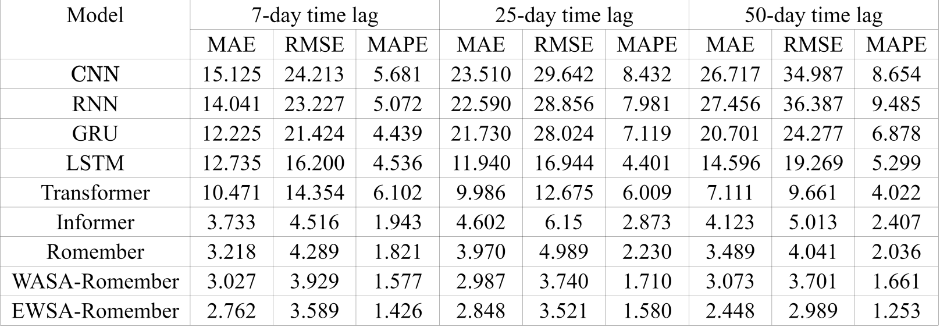**

**Table 2. Indicators with** **5,25,50 day time lag based on FTSE 100**

**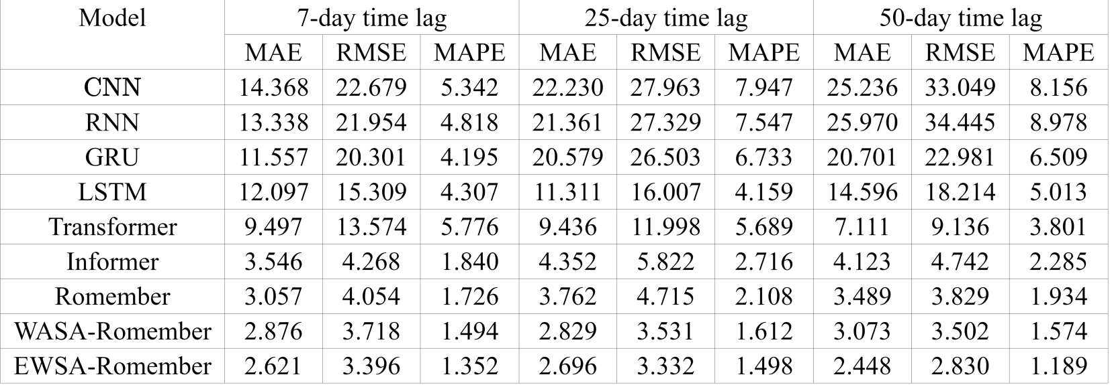**

A specific description of this section can be found in ***Prediction accuracy and robustness.***

**4.Quantitative analysis of the sentiment extraction components' contributions is lacking.**

Response：

In order to present a more intuitive and clear quantitative analysis of the model performance improvement due to sentiment features, we have added two new sections in the revised manuscript: "***A boost due to sentiment features***" and "***Comparison of model performance improvement using the EWSA approach compared to the WASA approach***". In these two chapters, we not only analyse the contribution of the sentiment extraction components in detail, but also bold the specific percentage of model performance improvement so that readers can more easily identify and understand these key figures. In addition, we have optimised the captions of the corresponding images to ensure that they accurately and clearly reflect the specific content and meaning of the images. This change is intended to improve the readability and interpretability of the information in the graphs, so that readers can more quickly grasp the key points of the results. The following additions and improvements have been made:

***3.******A boost due to sentiment features***

In particular, the inclusion of sentiment features in the Romember model significantly improves its predictive power compared to the version without sentiment features. Furthermore, EWSA-Romember outperforms WASA-Romember with fixed sentiment weights, especially in the long lag days (**50 days**). When trained on SP500 and FS100 data with a lag of fifty days, EWSA-Romember shows the highest average performance improvement compared to Informer's MAE, RMSE and MAPE metrics, which are **39.9%, 34.4%** and **46.6%** respectively. Figure 5 shows the performance comparison (in terms of percentage improvement) of Romember, 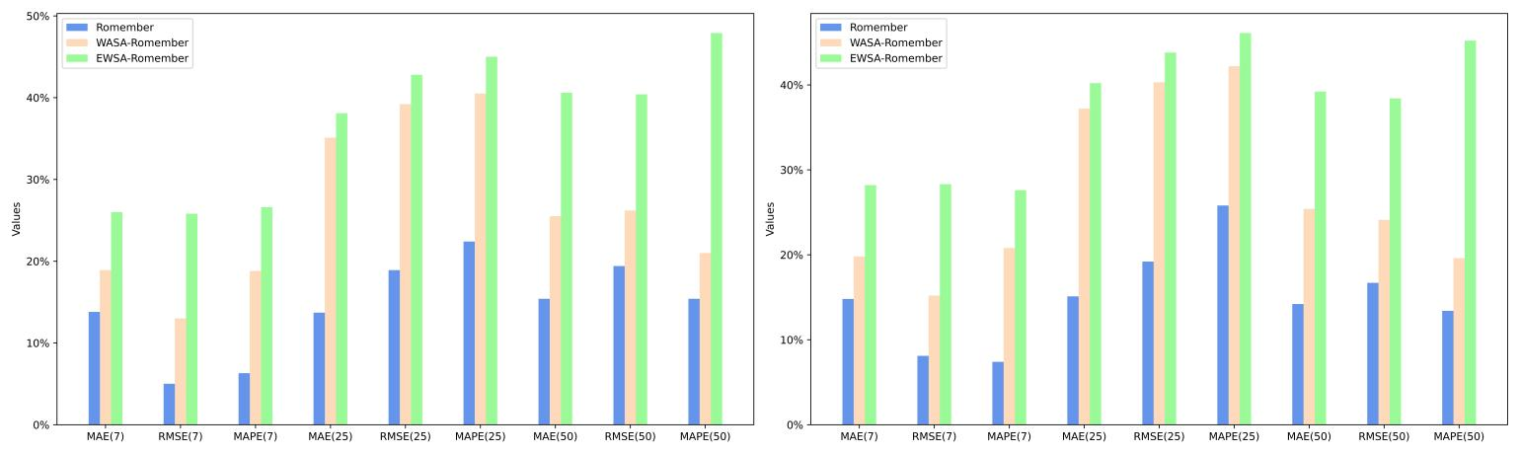WASA-Romember and EWSA-Romember with the Informer model on the three predictive performance metrics of MAE, RMSE and MAPE compared to Informer, with the results based on the FS100 dataset on the left and the results based on the SP500 dataset on the right. The left side is based on the FS100 dataset and the right side is based on the SP500 dataset.

**Figure 5. The percentage improvement in the prediction performance metrics MAE, RMSE, and MAPE over the Informer model**

***4.Comparison of model performance improvement using the EWSA approach compared to the WASA approach***

**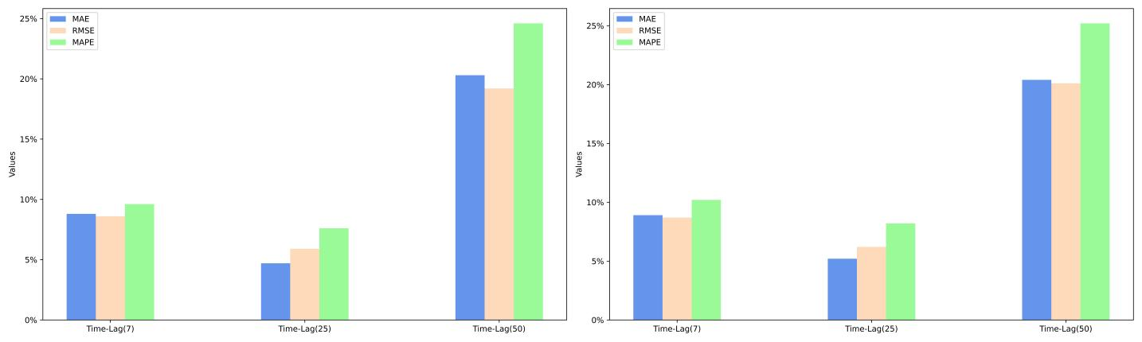**Based on the experimental results, it can be seen that when the lag period is 50 days, EWSA-Romember has the most significant performance improvement in MAE, RMSE and MAPE metrics compared to WASA-Romember, which are **20.4%, 19.6%** and **24.9%** respectively, which proves the effectiveness of the sentiment smoothing feature. The specific improvement percentages are shown in Figure 6. Figure 6 illustrates the percentage improvement of the prediction performance metrics MAE, RMSE, MAPE of EWSA-Romember compared to WASA-Romember. The left half of Figure 6 is the result obtained based on SP500 and the right half is the result obtained based on FS100.

**Figure 6. Comparison of EWSA and WASA in Terms of MAE, RMSE, and MAPE Improvements**

**5.The rotational position encoding merits deeper exploration of its effects versus absolute encodings.**

Response:

In order to further elucidate the specific impact of rotational position coding on model performance enhancement, we have added a new section, "***A boost due to rotational position coding***", to the revised manuscript. In this section, we provide an in-depth comparative analysis of the impact of rotational position coding on model performance and discuss its implications in practical applications. In addition, we provide a quantitative analysis of the significant aspects of model performance improvement so that readers can understand the advantages of this technique more intuitively and clearly. The specific additions are as follows:

***3.1*** ***A boost due to rotational position coding***

The experimental results, as shown in Tables 1 and 2, clearly indicate that the Romember model with the rotational position coding strategy significantly outperforms the Informer model in terms of prediction accuracy under the same delay conditions. Further analysis shows that rotational position coding is most effective in improving the predictive performance of the model over a longer time lag of days (25 days), as evidenced by the average rate of improvement in the performance metrics based on mean absolute error (MAE), root mean squared error (RMSE) and mean absolute percentage error (MAPE) for the two datasets - -**14.4%, 19.1% and 24.1%** respectively. This is particularly true when MAPE is used as the evaluation criterion. As a ratio indicator, MAPE provides a uniform metric that is independent of the stock price range, making it possible to compare model performance across different stocks or markets. It can therefore be concluded that rotational position coding significantly improves the robustness of the model in medium to long term forecasting. The specific experimental results are shown in Figure 5.

**Figure 5. The percentage improvement in the prediction performance metrics MAE, RMSE, and MAPE over the Informer model**

**6.More discussion of practical application potential and real-world trading implications would boost impact.**

Response：

We have added to the **CONCLUSION** section a discussion of the potential impact of the model in real world transactions, as well as possible application scenarios, with the aim of providing a more comprehensive picture of the potential of our model in real world applications. The specific additions are outlined below:

Meanwhile, by providing a more accurate and comprehensive market sentiment analysis framework, LEET can more effectively reflect the potential market sentiment and trends that are difficult to quantify, and help investors and financial institutions identify potential market volatility risks and predict market trends more accurately.

**7.As stock predictions depend on various external factors, addressing model robustness under changing market conditions could strengthen the findings.**

Response：

After careful consideration based on the valuable suggestions of the reviewers, we have made important changes to the paper, particularly in Sections ***Prediction accuracy and robustness*** and ***A boost due to rotational position coding***, where we have added a detailed analysis of model robustness and an exploration of model robustness enhancements. The specific additions are listed below:

***1.******Prediction accuracy and robustness***

Further analysis shows that rotational position coding is most effective in improving the predictive performance of the model over a longer time lag of days (25 days), as evidenced by the average rate of improvement in the performance metrics based on mean absolute error (MAE), root mean squared error (RMSE) and mean absolute percentage error (MAPE) for the two datasets - -**14.4%, 19.1% and 24.1%** respectively. This is particularly true when MAPE is used as the evaluation criterion. As a ratio indicator, MAPE provides a uniform metric that is independent of the stock price range, making it possible to compare model performance across different stocks or markets. It can therefore be concluded that rotational position coding significantly improves the robustness of the model in medium to long term forecasting. The specific experimental results are shown in Figure 4.

***3.1*** ***A boost due to rotational position coding***

This is particularly true when MAPE is used as the evaluation criterion. As a ratio indicator, MAPE provides a uniform metric that is independent of the stock price range, making it possible to compare model performance across different stocks or markets. It can therefore be concluded that rotational position coding significantly improves the robustness of the model in medium to long term forecasting. The specific experimental results are shown in Figure 5.

**8.The cited literature is not new enough. For example, you can refer to some new integrated learning methods:**

（1）Gong, P., Liu, J., Zhang, X., & Li, X. (2023, June). A Multi-Stage Hierarchical Relational Graph Neural Network for Multimodal Sentiment Analysis. In ICASSP 2023-2023 IEEE International Conference on Acoustics, Speech and Signal Processing (ICASSP) (pp. 1-5). IEEE.

（2）Xiao, L., Wu, X., Yang, S., Xu, J., Zhou, J., & He, L. (2023). Cross-modal fine-grained alignment and fusion network for multimodal aspect-based sentiment analysis. Information Processing & Management, 60(6), 103508.

Response：

We are very grateful to the reviewers for their suggestions on this section. We have therefore added the following six papers, as well as some other related studies, to increase the breadth and depth of the literature review. The specific references are as follows：

Xiao, L., Wu, X., Yang, S., Xu, J., Zhou, J., & He, L. (2023). Cross-modal fine-grained alignment and fusion network for multimodal aspect-based sentiment analysis. Information Processing & Management, 60(6), 103508.

Gong, P., Liu, J., Zhang, X., & Li, X. (2023, June). A Multi-Stage Hierarchical Relational Graph Neural Network for Multimodal Sentiment Analysis. In ICASSP 2023-2023 IEEE International Conference on Acoustics, Speech and Signal Processing (ICASSP) (pp. 1-5). IEEE.

Luo, J., Zhuo, W., & Xu, B. (2023). A Deep Neural Network-based Assistive Decision Method for Financial Risk Prediction in Carbon Trading Market. Journal of Circuits, Systems and Computers. doi: 10.1142/S0218126624501536

Liu,B.,Li,M.,Ji,Z.,Li,H.,& Luo, J. (2024). Intelligent Productivity Transformation: Corporate Market Demand Forecasting With the Aid of an AI Virtual Assistant. Journal of Organizational and End User Computing (JOEUC), 36(1), 1-27. [http://doi.org/10.4018/JOEUC.336284](http://doi.org/10.4018/JOEUC.336284" \t "https://mail.google.com/mail/u/0/" \l "inbox/_blank)

Ding,K.,Choo,W. C., Ng, K. Y., & Zhang, Q. (2023). Exploring changes in guest preferences for Airbnb accommodation with different levels of sharing and prices: Using structural topic model. Frontiers in psychology, 14, 1120845. doi: 10.3389/fpsyg.2023.1120845

Huang, C., Han, Z., Li, M., Wang, X., & Zhao, W. (2021). Sentiment evolution with interaction levels in blended learning environments: Using learning analytics and epistemic network analysis. Australasian Journal of Educational Technology, 37(2), 81-95. doi: 10.14742/ajet.6749

**9.Readability and language quality could be improved in some sections to enhance comprehension for a global readership.**

Response：

Based on these suggestions, and in order to further improve the overall readability and comprehension of the paper, we undertook a thorough linguistic proofreading and revision of the manuscript. Particular attention has been paid to those parts of the text that may not have been clear enough to the reader in the previous version, and improvements have been made accordingly. The most significant improvements are listed below:

①We refine the original Comparison of experimental results of different models into four layers: ***1.Prediction accuracy and robustness*  *2.Predictions for Romember with Predictions for Romember with and without the inclusion of emotional features 3.Comparison of performance between pre-improved model and improved model 4. Comparison of model performance improvement using the EWSA approach compared to the WASA approach*** and more detailed descriptions of each layer so that the reader can more clearly understand the experimental results and the meaning behind them.

②We have added a detailed description of the characteristics of the model performance evaluation metrics **MAE**, **RMSE** and **MAPE**, and the reasons for their selection, so that readers can understand the rationality and significance of the model evaluation metrics we have selected. For details, please refer to ***Performance judgement indicators and their rationality analysis*** section.

③We separate the data preprocessing section to explain the process of converting raw text into a form that can be processed by the pre-trained model for natural language processing in easy-to-understand and detailed language, so as to improve the reproducibility of the data preprocessing, as described in the following sections:

Meanwhile, we use the roberta.large model (Liu et al., 2019), a pre-trained deep learning model for natural language processing, to implement sentiment classification. First, we use roberta.large model's tokeniser to segment text into tokens; the tokeniser tries to split words or text fragments into smaller units until all units can be found in the vocabulary. Then, to identify the start and end of a sentence sequence, roberta.large model uses <s> as the start token of the sequence and </s> as the end token of the sequence.After splitting into tokens, these tokens are converted into indexes by looking up the corresponding unique index of each token in roberta.large model's vocabulary. Since the roberta.large model requires that all input sequences have the same length, shorter sequences must be padded and longer sequences must be truncated. In order for the model to know which positions are real tokens and which positions are padded tokens, an attention mask must also be created. For real tokens, the mask value is 1; for padded tokens, the mask value is 0. The above steps convert the raw text into a format that can be processed by the roberta.large model.

The complete data ***preprocessing*** section can be found in the Experiment section of the manuscript (tracked changes) in the yellow highlights of ***Data preprocessing***.

****Reviewer 2:****

**1.Strengthen the experimental validation of the LEET method using diverse datasets, including different stock markets and periods, to demonstrate the robustness and adaptability of the model.**

Response:

Dear reviewers, First of all, I would like to express my deep gratitude for your valuable comments and suggestions during the review process. Your feedback is very important for us to improve our paper and research. In response to your suggestions on improving the experimental validation of the LEET method using different datasets, we have carried out the following work and improvements.

Due to dataset limitations, it is difficult for us to obtain more stock market and news headline data for different time periods. However, in order to fully demonstrate the robustness and adaptability of the LEET method, we have tried to take the following steps:

**①Added experiments with different stock market data**: We have tried our best to extend our dataset by adding FS100 data from 30 March 2011 to 17 July 2020 to train the model. The timing of this dataset is consistent with that of the original dataset. These additional experimental results support the robustness and adaptability of our method. The specific additions are listed below:

**Description of the FS100 dataset:** The FTSE 100 is an index of the 100 largest companies by market capitalisation on the London Stock Exchange, representing the UK's leading companies across a wide range of sectors such as financial services, energy, consumer goods, etc., and effectively reflecting the state of the UK stock market.

②At the same time, we have included a new section titled ***Prediction Accuracy and Robustness*** to elaborate on the model's robustness as follows**:**

Furthermore, our proposed Romember, WASA-Romember and EWSA-Romember models show similar performance on the SP500 and FS100 datasets, demonstrating that these models have good robustness.The results of the experiment are presented in Tables 1 and 2.

**Table 1. Indicators with 5,25,50 day time lag based on SP500**

****

**Table 2. Indicators with 5,25,50 day time lag based on FTSE 100**

****

A full description of this section can be found in ***Comparison of experimental results of different models*** , Section ***1.Prediction accuracy and robustness***.

**③ An exhaustive analysis of rotational position coding for model robustness** improvement: ***A*** new section ***A boost due to rotational position coding*** is added to this paper, which provides an in-depth discussion of the comparison between the new model Romember with rotational position coding and the original model Informer based on absolute position coding in terms of performance enhancement, especially in terms of benefits in improving model robustness. Additional quantitative analyses are introduced to make the performance improvement more obvious and intuitive. Specific additions include：

***3.1*** ***A boost due to rotational position coding***

The experimental results, as shown in Tables 1 and 2, clearly indicate that the Romember model with the rotational position coding strategy significantly outperforms the Informer model in terms of prediction accuracy under the same delay conditions. Further analysis shows that rotational position coding is most effective in improving the predictive performance of the model over a longer time lag of days (25 days), as evidenced by the average rate of improvement in the performance metrics based on mean absolute error (MAE), root mean squared error (RMSE) and mean absolute percentage error (MAPE) for the two datasets - -**14.4%, 19.1% and 24.1%** respectively. This is particularly true when MAPE is used as the evaluation criterion. As a ratio indicator, MAPE provides a uniform metric that is independent of the stock price range, making it possible to compare model performance across different stocks or markets. It can therefore be concluded that rotational position coding significantly improves the robustness of the model in medium to long term forecasting. The specific experimental results are shown in Figure 5.

**Figure 5. The percentage improvement in the prediction performance metrics MAE, RMSE, and MAPE over the Informer model**

With these improvements, we believe we can better demonstrate the robustness and applicability of the LEET method in different contexts.

**2.Provide a more detailed comparative analysis with existing models, highlighting the advantages and improvements the LEET method offers in various scenarios.**

Response：

In order to highlight the improvements of the LEET method in different cases, we have made the following efforts:

① We have added a new section a to elaborate the improvement aspects of the new model Romember based on rotational position coding compared to the original absolute position coding Informer, as follows:

***3.1 A boost due to rotational position coding***

The experimental results, as shown in Tables 1 and 2, clearly indicate that the Romember model with the rotational position coding strategy significantly outperforms the Informer model in terms of prediction accuracy under the same delay conditions. Further analysis shows that rotational position coding is most effective in improving the predictive performance of the model over a longer time lag of days (25 days), as evidenced by the average rate of improvement in the performance metrics based on mean absolute error (MAE), root mean squared error (RMSE) and mean absolute percentage error (MAPE) for the two datasets - -**14.4%, 19.1% and 24.1%** respectively. This is particularly true when MAPE is used as the evaluation criterion. As a ratio indicator, MAPE provides a uniform metric that is independent of the stock price range, making it possible to compare model performance across different stocks or markets. It can therefore be concluded that rotational position coding significantly improves the robustness of the model in medium to long term forecasting. The specific experimental results are shown in Figure 5.

**Figure 5. The percentage improvement in the prediction performance metrics MAE, RMSE, and MAPE over the Informer model**

② We add an extra section a to show the actual results of the prediction of the LEET method and to discuss it. The details are as follows:

***2.Predictions for Romember with and without the inclusion of emotional features***

Figure 3 compares the WASA-Romember forecasts with those of Romember at different lags. The left half of Figure 4 shows the results based on the FTSE 100 and the right half on the S&P 500. In particular, the box in the figure shows that WASA-Romember, which includes sentiment features, outperforms Romember in terms of stock price prediction.

In addition, Figure 4 compares the results of EWSA-Romember and Romember using different lags. The left half of Figure 5 shows the results based on the FTSE 100 index and the right half shows the results based on the S&P 500 index. In particular, the boxed part of the figure shows that EWSA-Romember, which includes a sentiment profile, outperforms Romember in terms of stock price forecasting.

**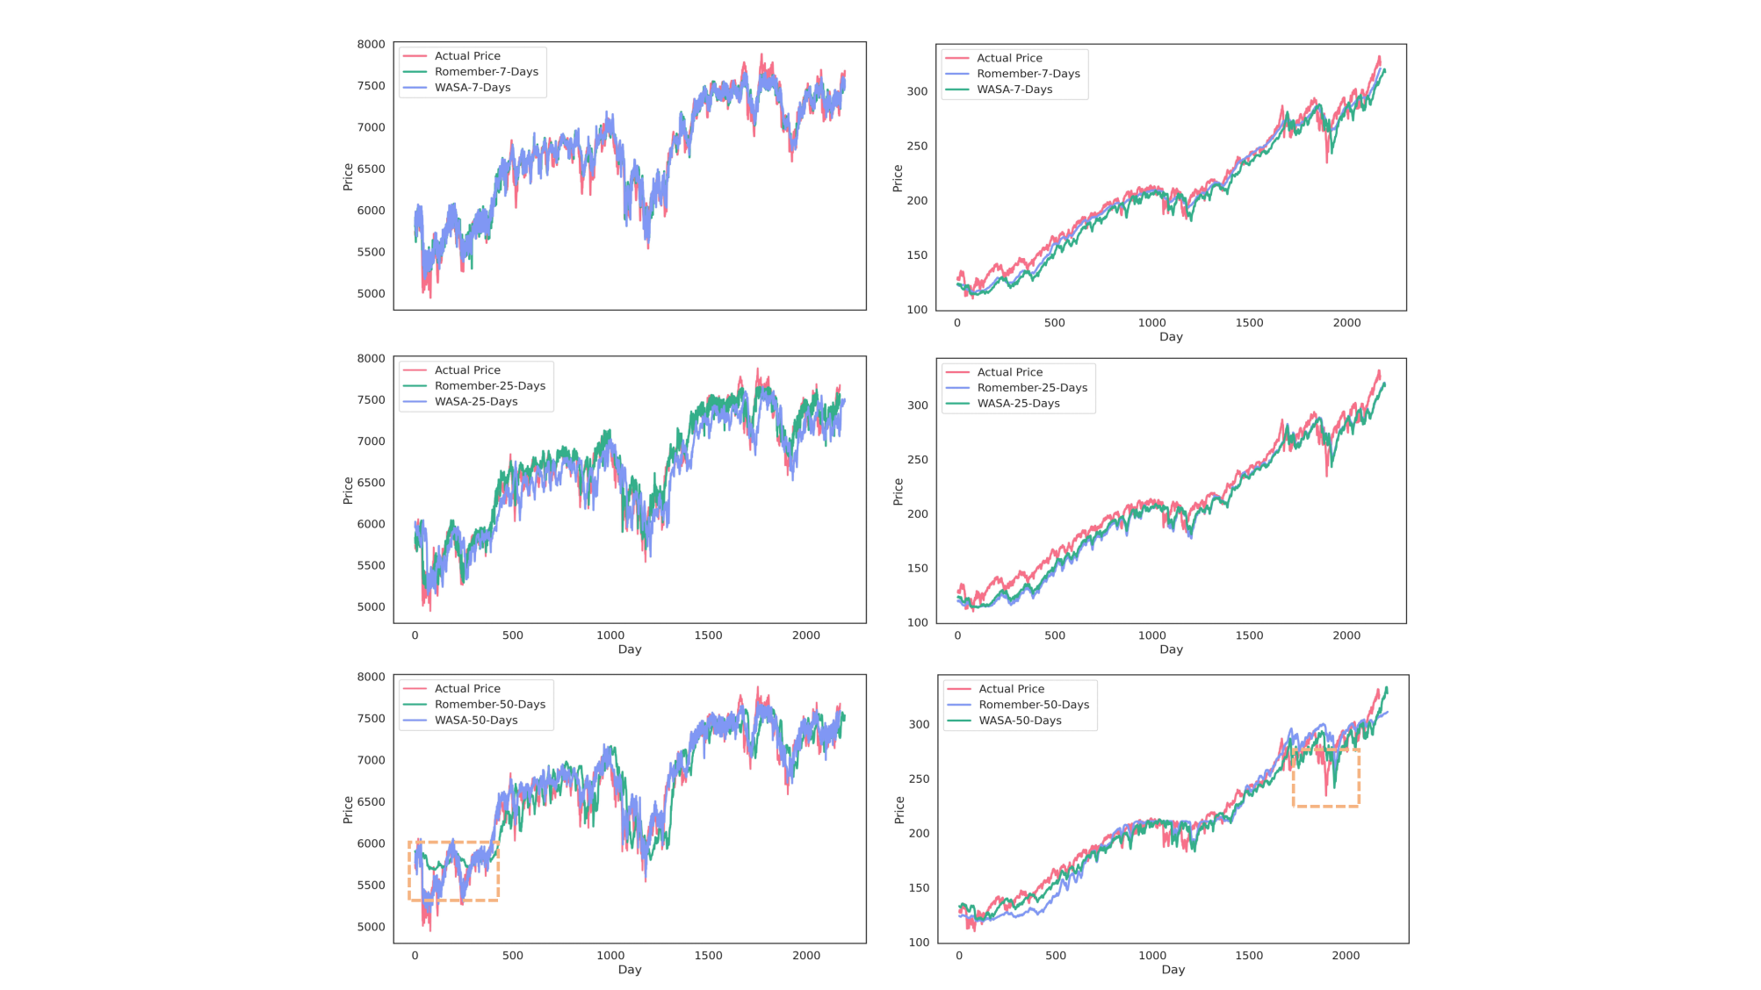**

**Figure 3. Comparison of stock price forecast results between Romember and WASA-Romember.**

**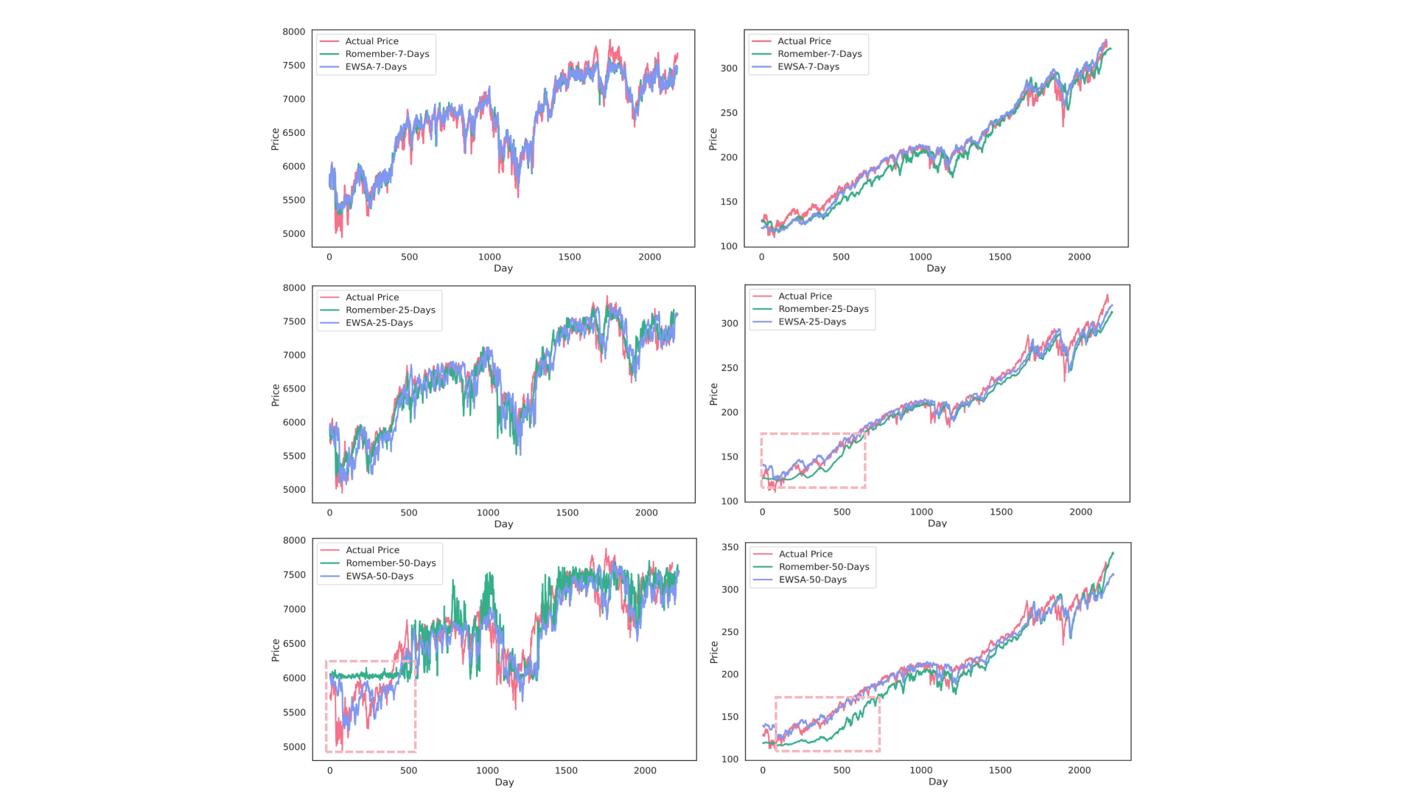**

**Figure 4. Comparison of stock price forecast results between Romember and EWSA-Romember.**

③We have also added a new section ***A boost due to sentiment features***, which provides a detailed discussion of the enhancement effect of affective features on the model, as follows:

***3.2 A boost due to sentiment features***

In particular, the inclusion of sentiment features in the Romember model significantly improves its predictive power compared to the version without sentiment features. Furthermore, EWSA-Romember outperforms WASA-Romember with fixed sentiment weights, especially in the long lag days (50 days). When trained on SP500 and FS100 data with a lag of fifty days, EWSA-Romember shows the highest average performance improvement compared to Informer's MAE, RMSE and MAPE metrics, which are 39.9%, 34.4% and 46.6% respectively. Figure 5 shows the performance comparison (in terms of percentage improvement) of Romember, WASA-Romember and EWSA-Romember with the Informer model on the three predictive performance metrics of MAE, RMSE and MAPE compared to Informer, with the results based on the FS100 dataset on the left and the results based on the SP500 dataset on the right. The left side is based on the FS100 dataset and the right side is based on the SP500 dataset.



**Figure 5. The percentage improvement in the prediction performance metrics MAE, RMSE, and MAPE over the Informer model**

④A new subsection a is also added to fully analyse the additional performance improvement of the Romember model by the EWSA sentiment feature extraction method compared to the WASA sentiment feature extraction method:

***4.Comparison of model performance improvement using the EWSA approach compared to the WASA approach***

Based on the experimental results, it can be seen that when the lag period is 50 days, EWSA-Romember has the most significant performance improvement in MAE, RMSE and MAPE metrics compared to WASA-Romember, which are **20.4%, 19.6%** and **24.9%** respectively, which proves the effectiveness of the sentiment smoothing feature. The specific improvement percentages are shown in Figure 6. Figure 6 illustrates the percentage improvement of the prediction performance metrics MAE, RMSE, MAPE of EWSA-Romember compared to WASA-Romember. The left half of Figure 6 is the result obtained based on SP500 and the right half is the result obtained based on FS100.

****

**Figure 6. Comparison of EWSA and WASA in Terms of MAE, RMSE, and MAPE Improvements**

⑤We have added a comparative experiment with the performance of the Convolutional Neural Network (CNN) model. The smaller the values of MAE, **RMSE and MAPE**, the smaller the error between the predicted value and the actual value of the model, and the better the prediction performance of the model. Meanwhile, in order to clarify the further use and rationality of **MAE, RMSE and MAPE** indicators, we add a new subsection of ***performance evaluation indicators and their rationality analysis*** in the experiment. By observing the experimental results, we can see that recurrent neural networks and deep learning models based on self-attention mechanism outperform convolutional neural networks in time series prediction of stock price forecasting. The results of the additional comparative experiments are shown below:

**Table 1. Indicators with 5,25,50 day time lag based on SP500**

****

**Table 2. Indicators with 5,25,50 day time lag based on FTSE 100**

****

A specific description of this section can be found in ***Prediction accuracy and robustness.***

**3.Enhance the sentiment analysis component by exploring more complex natural language processing techniques and considering diverse sources of sentiment data, such as social media and financial news.**

Response:

Thanks for your constructive comments! Based on your comments, we have added a new subsection a to FUTURE WORK, which describes the future direction of natural language processing technology, as follows:

3. Real-time data processing

To capture the dynamic nature of financial markets, our future research will focus on implementing real-time data processing. This will allow models to incorporate the latest market news, social media trends and economic reports as they become available. Real-time processing will make our models more sensitive to sudden market changes, providing investors with timely insights to guide their trading decisions.

4. Advanced natural language processing technology

We plan to explore the use of more advanced natural language processing (NLP) technologies that go beyond sentiment analysis. These technologies could include context-aware models capable of understanding the nuances of financial news, such as the difference between the short-term and long-term impact of an event.

At the same time, we have taken into account different categories of news data and have added descriptions of specific news sources, specific dates and categories of datasets, and bolded the dates of the datasets used. The additions are listed below:

The first part of the news headline data was obtained from the Reuters website (2022) via a web crawler. In this study, news headline data was crawled from the financial, monetary, health, environment, healthcare and pharmaceutical sections of Reuters. Figure 2 illustrates the sample of news headlines collected on **January 1, 2020**.

For more specific treatment, please refer to the yellow highlights in the Data description and Data preparation sections of the manuscript (tracked changes).

**4.Address how the model accounts for sudden, unexpected market changes and demonstrate its effectiveness in such scenarios.**

Response:

At the outset, I would like to express my sincere gratitude for your valuable comments during the review process. Your professional advice has been an important guide for our research. What follows is an explanation of how the model accounts for sudden and unexpected market changes and its effectiveness under these scenarios:

①Data sources:：

Sudden events such as political conflicts, natural disasters or major economic policy changes have a huge impact on the stock market. This is why we introduce external data sources, such as Reuters news and social media, to capture sudden changes in market sentiment. Reuters is a highly respected international news organisation with a long history and global reach, renowned for its impartial, objective and timely news coverage. News headlines are a timely and important source of market events and information, enabling stock prices to react more quickly. The precise and objective language used can accurately reflect the mood and emotions of market participants and the extent to which the market reacts to certain events. Meanwhile, news headlines provide a variety of information about company performance, industry trends and policy changes, which can be used to make an overall prediction of the share price. Secondly, when there is a breaking event with significant impact, it will inevitably cause the number of negative news items to spike, which will cause the sentiment extraction value to tend to be negative, exacerbating the negative sentiment of the day. The specific implementation details and content are shown below:

In order to obtain the sentiment tendency feature of the current news article, the pre-finetune text model for sentiment analysis, RoBERTa, is utilised to get the sentiment tendency feature of the current news for each article headlines .The values ofrepresent positive, neutral or negative sentiment and are denoted by -1, 0 and 1, respectively. The emotional profile of each news article can be specifically represented as follows:

To express the sentiment profile of each news article, we need to aggregate the sentiment values of the day. Thus, the sentiment feature of the day can be stated as follows:

Sent

For full details you can check the chapter ***Sentiment Extraction.***

②Aspects of emotion feature extraction methods

Considering that the longer the time interval the smaller the sentiment value, this work also proposes an exponentially weighted sentiment profile, called EWSA (Exponential Weighted Sentiment Analysis), which is:

As time passes, the earlier the sentiment feature is extracted, the smaller the weight value, making the model more inclined to learn about current, sudden and unexpected market conditions.

③Comparative aspects of model performance

***4.Comparison of model performance improvement using the EWSA approach compared to the WASA approach***

Based on the experimental results, it can be seen that when the lag period is 50 days, EWSA-Romember has the most significant performance improvement in MAE, RMSE and MAPE metrics compared to WASA-Romember, which are **20.4%, 19.6%** and **24.9%** respectively, which proves the effectiveness of the sentiment smoothing feature. The specific improvement percentages are shown in Figure 6. Figure 6 illustrates the percentage improvement of the prediction performance metrics MAE, RMSE, MAPE of EWSA-Romember compared to WASA-Romember. The left half of Figure 6 is the result obtained based on SP500 and the right half is the result obtained based on FS100.

****

**Figure 6. Comparison of EWSA and WASA in Terms of MAE, RMSE, and MAPE Improvements**

EWSA-Romember, which takes into account the time-value of sentiment, outperforms WASA-Romember, which is time-value-consistent, in terms of forecasting performance. It is more effective in explaining sudden and unexpected market changes.

**5.Consider developing a user-friendly interface that investors can utilize, providing actionable insights and predictions in an easily interpretable format.**

Response：

Thanks for your constructive comments, which have provided us with ground-breaking ideas for translating existing theoretical research into practical applications in the future! We have added a new section to **FUTURE WOEK** based on this idea, the **User-Friendly Dashboard**, which elaborates on this idea as follows:

We plan to design an intuitive dashboard that presents a holistic view of the market sentiment and trends, integrating the LEET method's insights with additional economic indicators. This dashboard will feature easy-to-understand visualizations, such as sentiment trend graphs, economic indicators charts, and predictive analytics insights. It will enable users to quickly grasp the current market sentiment, understand how it correlates with key economic indicators, and foresee potential market movements.

**6. Discuss any ethical and legal implications of sentiment analysis in stock market prediction, especially regarding data privacy and market manipulation.**

Response:

Thanks for your valuable comments! We take the ethical and legal aspects very seriously and recognise that while there is potential value in using sentiment data from social media and news feeds for stock market forecasting, this practice raises concerns about both data privacy and market fairness. Therefore, in our revised draft, we have added an additional section a, dedicated to the ethical and legal issues that may be involved when sentiment analysis is used in stock market forecasting. It is divided into three subsections a,b,c for more in-depth analyses as follows:

**Ethical aspect**

While the LEET method shows promising results in using emotional analysis for stock market predictions, it is imperative to discuss the ethical and legal implications associated with such methodologies, particularly with respect to privacy and market manipulation.

First of all, the use of emotional analysis in financial markets raises significant privacy concerns. The EWSA and WASA indices, which are fundamental to the LEET methodology, rely on vast amounts of data extracted from various sources, including social media, news outlets and forums. This data collection process must comply with strict data protection laws, such as the General Data Protection Regulation (GDPR) in the European Union and the California Consumer Privacy Act (CCPA) in the United States. It is crucial to ensure that data is collected and processed transparently, with the explicit consent of individuals, to avoid violating their privacy rights.

In addition, the application of the Romember long order sentiment time series model within the LEET framework requires ethical consideration of how emotional analysis could potentially be exploited for market manipulation. The predictive capabilities of the LEET method, while beneficial for understanding long-term market sentiment, may inadvertently create opportunities for information asymmetry. This asymmetry may enable certain investors to influence market trends based on sentiment analysis, thereby undermining the integrity of financial markets and violating principles of fair trading.

To address the ethical and legal challenges posed by sentiment analysis in stock market forecasting, particularly in terms of data privacy and market manipulation, this study provides a relevant discussion and suggests future improvements:

**Transparent use of data**

**1.Data source disclosure:** When using sentiment analysis tools such as the LEET method, clearly list all data sources, including social media platforms, news sites, forums, etc., and explain how this data is collected and processed.

**2.User consent for access:** Ensure that explicit user consent is obtained before personal data is collected. This can be done by updating privacy policies, providing easy-to-understand consent forms, etc.

**Ethical guidelines for sentiment analysis**

**1.Establish ethical guidelines:** Develop a set of ethical guidelines specific to the use of sentiment analysis in stock market forecasting, including but not limited to protecting individual privacy, ensuring data accuracy and avoiding bias.

**2.Avoid market manipulation:** Explicitly prohibit the use of sentiment analysis results for market manipulation or unfair trading practices. This includes preventing trading on the basis of undisclosed information or using sentiment analysis results to mislead other investors.

**Regulatory compliance and oversight**

**1.Working with regulators:** Proactively communicating with financial market regulators to ensure that sentiment analysis methods comply with existing market rules and regulations.

**2.Regular audits:** Conduct regular internal or third party audits to ensure that sentiment analysis tools are used in accordance with ethical and legal requirements, particularly with regard to data protection and market fairness.

**Investor education**

**1.Transparent risk disclosure:** Clearly disclose the potential risks and uncertainties when investors use forecasting tools based on sentiment analysis.

**2.Promoting rational investment:** Encouraging investors to make comprehensive and rational investment decisions by combining the results of sentiment analysis with other investment information such as fundamental analysis.

**7. Outline potential future enhancements to the model, such as integrating additional economic indicators or expanding to global stock markets.**

Response：

We have added a new section in FUTURE WORKa to provide an overview of future enhancements to the modelling model. This is broken down into four subsections: ***1. Integration of additional economic indicators 2. Extension to global equity markets 3. Real-time data processing 4. Advanced natural language*** processing technology and detailed descriptions. ***processing technology*** and is described in detail in four subsections. The details are shown below:

**8. Ensure that the manuscript is clear, well-organized, and free from technical jargon, making it accessible to a broader audience, including practitioners in the finance sector.**

Response：

In order to make the manuscript clear and well-organised, to improve the overall readability and comprehensibility of the paper, and to broaden the audience, we have thoroughly proofread and revised the language of the paper, especially those parts that may not have been clear enough for the readers before. The main improvements are listed below:

①We refine the original Comparison of experimental results of different models into four layers: ***1.Prediction accuracy and robustness*  *2.Predictions for Romember with Predictions for Romember with and without the inclusion of emotional features 3.Comparison of performance between pre-improved model and improved model 4. Comparison of model performance improvement using the EWSA approach compared to the WASA approach*** and more detailed descriptions of each layer so that the reader can more clearly understand the experimental results and the meaning behind them.

②We have added a detailed description of the characteristics of the model performance evaluation metrics **MAE**, **RMSE** and **MAPE**, and the reasons for their selection, so that readers can understand the rationality and significance of the model evaluation metrics we have selected. For details, please refer to ***Performance judgement indicators and their rationality analysis*** section.

③We separate the data preprocessing section to explain the process of converting raw text into a form that can be processed by the pre-trained model for natural language processing in easy-to-understand and detailed language, so as to improve the reproducibility of the data preprocessing, as described in the following sections:

Meanwhile, we use the roberta.large model (Liu et al., 2019), a pre-trained deep learning model for natural language processing, to implement sentiment classification. First, we use roberta.large model's tokeniser to segment text into tokens; the tokeniser tries to split words or text fragments into smaller units until all units can be found in the vocabulary. Then, to identify the start and end of a sentence sequence, roberta.large model uses <s> as the start token of the sequence and </s> as the end token of the sequence.After splitting into tokens, these tokens are converted into indexes by looking up the corresponding unique index of each token in roberta.large model's vocabulary. Since the roberta.large model requires that all input sequences have the same length, shorter sequences must be padded and longer sequences must be truncated. In order for the model to know which positions are real tokens and which positions are padded tokens, an attention mask must also be created. For real tokens, the mask value is 1; for padded tokens, the mask value is 0. The above steps convert the raw text into a format that can be processed by the roberta.large model.

The complete data ***preprocessing*** section can be found in the Experiment section of the manuscript (tracked changes) in the yellow highlights of ***Data preprocessing***.

**9. To enhance the depth and relevance of your study, it's recommended to explore, integrate, and acknowledge recent scholarly works in your field. Including insights and findings from these contemporary publications can significantly enrich your research's contextual framework and theoretical underpinnings.**

Response：

We are deeply grateful to the reviewers for their valuable suggestions on parts of this paper. We fully recognise that the literature review section does need to be further expanded, especially with regard to recent studies involving the application of sentiment analysis or self-attention mechanisms to stock prediction models. With this in mind, we have added six recent papers and incorporated a number of other relevant research findings with the aim of enhancing the breadth and depth of the literature review. The specific additions to the literature are shown below:

Xiao, L., Wu, X., Yang, S., Xu, J., Zhou, J., & He, L. (2023). Cross-modal fine-grained alignment and fusion network for multimodal aspect-based sentiment analysis. Information Processing & Management, 60(6), 103508.

Gong, P., Liu, J., Zhang, X., & Li, X. (2023, June). A Multi-Stage Hierarchical Relational Graph Neural Network for Multimodal Sentiment Analysis. In ICASSP 2023-2023 IEEE International Conference on Acoustics, Speech and Signal Processing (ICASSP) (pp. 1-5). IEEE.

Luo, J., Zhuo, W., & Xu, B. (2023). A Deep Neural Network-based Assistive Decision Method for Financial Risk Prediction in Carbon Trading Market. Journal of Circuits, Systems and Computers. doi: 10.1142/S0218126624501536

Liu,B.,Li,M.,Ji,Z.,Li,H.,& Luo, J. (2024). Intelligent Productivity Transformation: Corporate Market Demand Forecasting With the Aid of an AI Virtual Assistant. Journal of Organizational and End User Computing (JOEUC), 36(1), 1-27. [http://doi.org/10.4018/JOEUC.336284](http://doi.org/10.4018/JOEUC.336284" \t "https://mail.google.com/mail/u/0/" \l "inbox/_blank)

Ding,K.,Choo,W. C., Ng, K. Y., & Zhang, Q. (2023). Exploring changes in guest preferences for Airbnb accommodation with different levels of sharing and prices: Using structural topic model. Frontiers in psychology, 14, 1120845. doi: 10.3389/fpsyg.2023.1120845

Huang, C., Han, Z., Li, M., Wang, X., & Zhao, W. (2021). Sentiment evolution with interaction levels in blended learning environments: Using learning analytics and epistemic network analysis. Australasian Journal of Educational Technology, 37(2), 81-95. doi: 10.14742/ajet.6749

Specific additions to the literature review can be found in the yellow highlights in the literature review section of the Manuscript (tracked changes).

**Aditor:**

We would also like to thank the editor for your constructive comments, which have helped us to improve the quality of our articles. In response to your suggestions, we have made the following changes:

1 **.** **Additional authors**

We understand that adding authors after the initial decision is a very rare event, and we will ensure that this change is based on a true reflection of the contributions to the paper. For the addition of Huang Jiacheng and Tang Yong, we will provide a detailed, separate feedback letter called Response Letter for Adding Authors, and list the specific contributions of each new author, which will be uploaded as an additional file. We guarantee that these contributions have been made during the revision process and that all current co-authors have agreed to this change by responding to the confirmation email.

We will explicitly acknowledge the contributions of all additional authors in the revised paper and use the comment function to indicate which parts of the new text were generated by the participation of the additional authors. We have made all the necessary confirmations and ensured that this will be our final author list.

2 **.** **Image permissions**

Regarding Figure 1 (and its components such as templates, graphics, silhouettes, etc.), we confirm that the image was created by the author team and does not contain any copyrighted material. We will leave details in the part of the [note in the Confidential Information for PeerJ Staff](" \l "inbox/_blank) to confirm this. If there are any cases where the images were created by non-authors or contain copyrighted material, we will ensure that we obtain and upload the appropriate written permission to publish them under a CC BY 4.0 licence.

3 **.** **Image accessibility**

**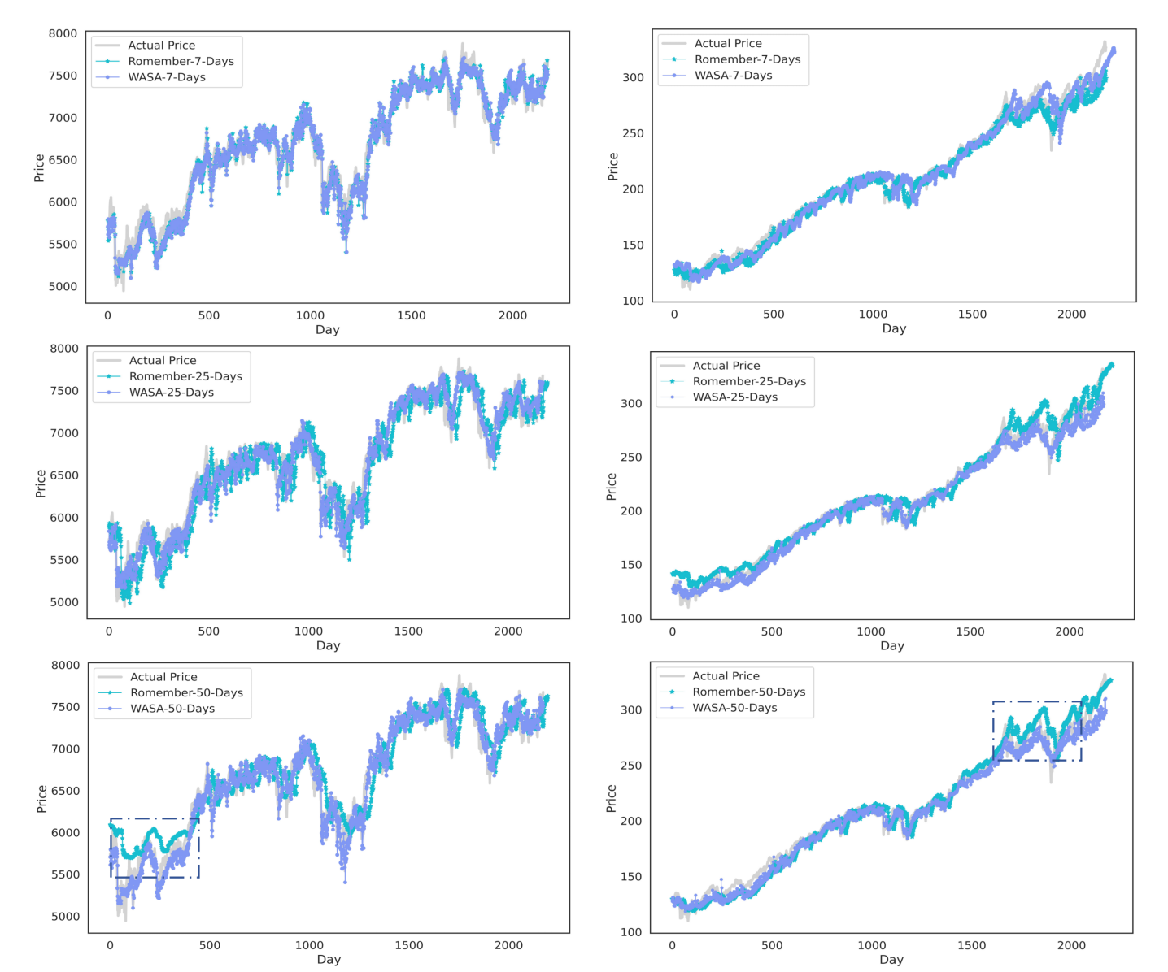**In response to the red/green issue used in Figures 3 and 4, we will adjust the colours according to your guidelines to improve accessibility for people who are colour blind and add small triangles and circles to ensure that graphic elements do not rely solely on colour for differentiation. We will provide replacement images that meet the minimum 900 pixel and maximum 3000 pixel requirements in PNG, EPS or vector PDF format, ensuring that there are no unwanted white borders around the image. Specific new images 3 and 4 are shown below:

**Figure 3. Comparison of stock price forecast results between Romember and WASA-Romember.**

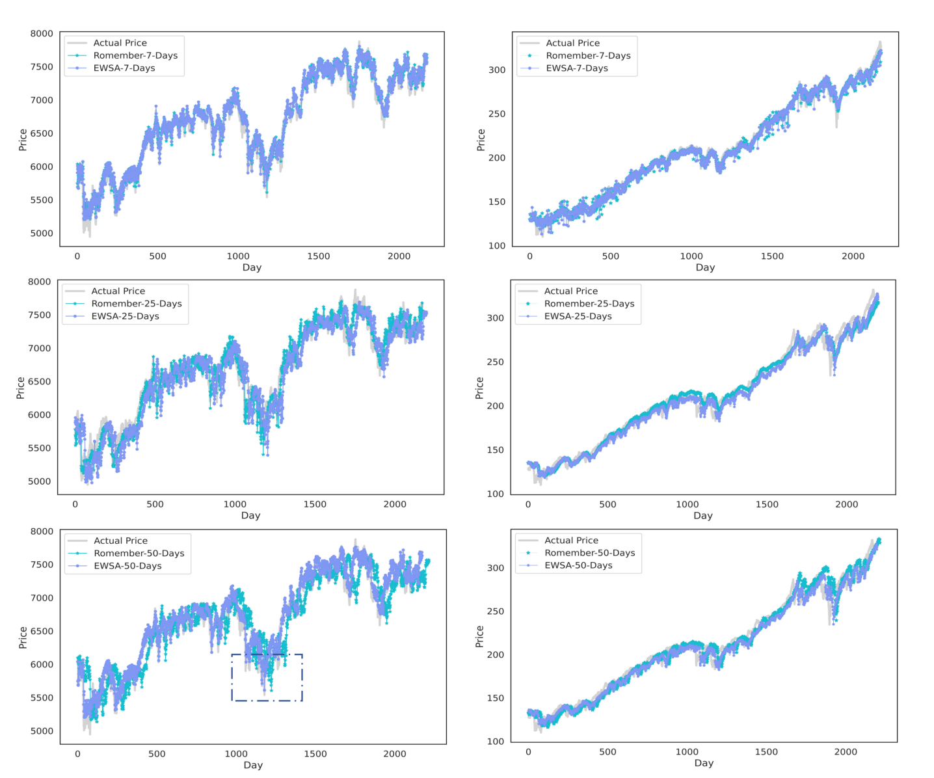

**Figure 4. Comparison of stock price forecast results between Romember and EWSA-Romember.**

4 **.** **Graphic Accessibility**

On the issue of relying on colour to differentiate lines in a diagram, we will avoid using colour alone to differentiate between different parts of an image. We have added both small triangles and small circles to ensure that graphical elements do not rely on colour alone for differentiation, and will adapt our images to meet your guidelines. We will provide a replacement image that meets the specified pixel requirements to ensure accessibility.

We hope that these revisions will satisfy the reviewers and bring our paper more in line with the journal's standards. We look forward to further comments from the editors and reviewers and are ready to continue to improve our work. Once again, we thank you for your interest and guidance in our work.

Yours sincerely，

Honglin Liao

onglinguge@gmail.com