MA3113* Topics in Mathematical Image Processing

**1st Written Report**

Wei-Zhi Chen & Po Jui Huang

Department of Mathematics

National Central University

**2024.03.31**

1. **Research Problem**
2. **Algorithms and Their Pros and Cons**
3. **Current Status**

After the first presentation, we are still adjusting our 3.0 version of algorithm and start on the process of version 3.1.

The adjustment of 3.0 version is that at the last meeting with prof. Yu at 3/26, we find that the rate parameter of criterion should be dynamic to handle all of the sample, since each of the sample has different number of colored pixels, for example, the red circle may have 23% of pixel which is red, thus we make the criterion be about 18.5% (if number of error pixel is less than 18.5% of the image, then we claim that there exist a circle here), however the blue cross may have 18% of pixel, if we still use the criterion above, then all of the parts will be claimed as there exist a cross. We will determine the rate parameter and add more feature in few days.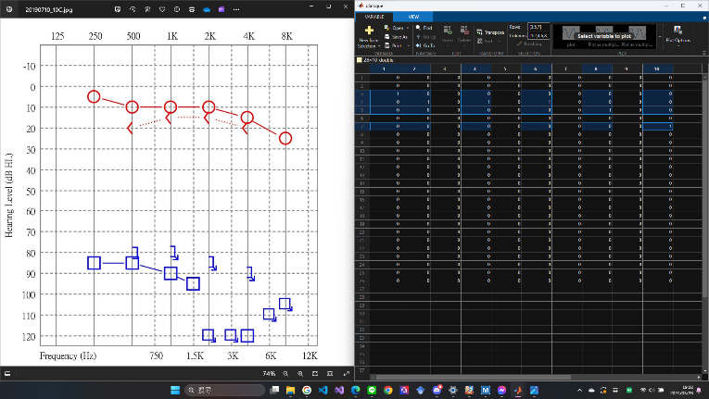

Figure1. The successful case

We are working on transforming the result into the table that the doctors required, this process may take us few days. We planned to finish the parameter adjustment and FdB (Frequency-Decibel) table this long weekend, and if the process goes faster than expected, we will also go on or finish the 3.1 version of algorithm.

1. **Scheduled Plan**

**IV-I. Algorithm Version 4.0**

This algorithm considered the potential problem—the straight line, before we compare the sample and the target, we re-process the target first, to be specific, we only let the part of the target shape we want left, so the perturbation from the outside of the target shape will decrease sharply, and we may increase the accuracy since we not only erase the perturbation from outside, but also decrease the misjudgment rate of other shape.

**IV-II. Hough Transform**

**IV-III. Material Researching**