**Code Optimization techniques**

**1st Code before optimize(Inline method)**

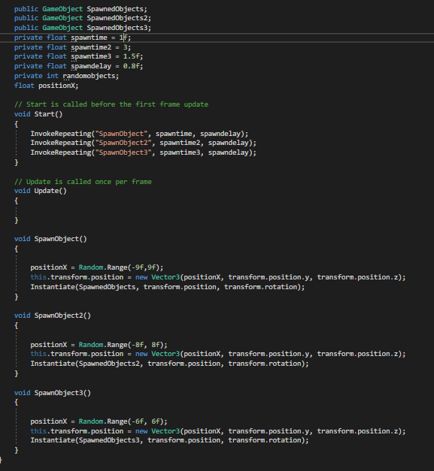

**1st code after Optimize**

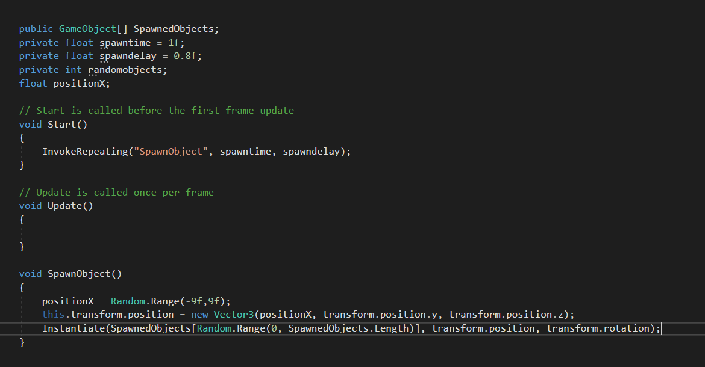

**2nd Code before optimize(Extract method)**

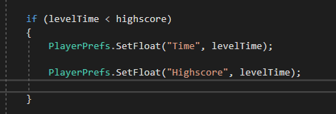

**2nd Code after optimize**

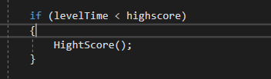

**3rd Code before optimize**

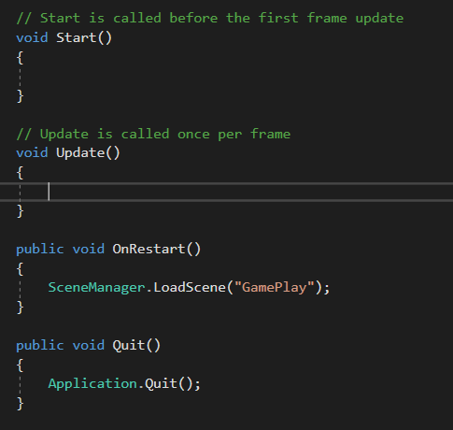

**3rd Code after optimize(Inline method)**

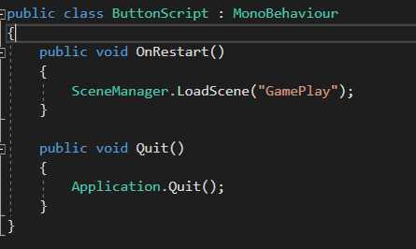

**4th Code before optimize**

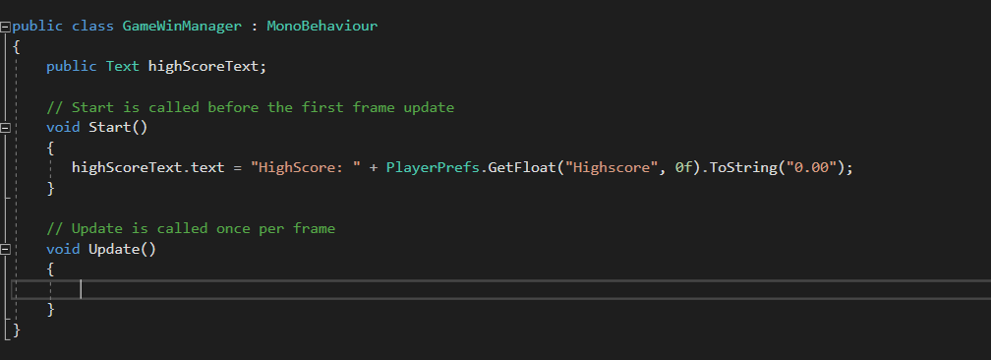

**4rd Code after optimize(Inline method)**

