**Technical Design**

**Game Idea**

This game is made to let people to understand what kind of things can be recycled and what kind of things that not able to be recycled.

**Game Features**

You are able to move the recycle bin around to catch the recyclable items. There are different kind of tings to catch and to avoid.

**Game Platform**

This game is made for Mobile and Computer.

**Game Flowchart**

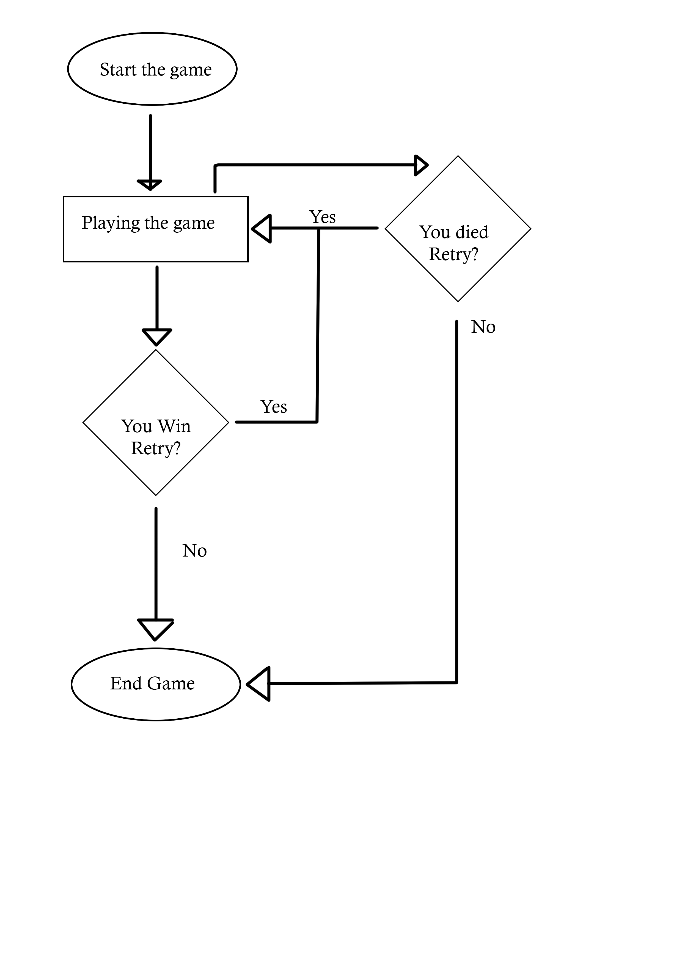

**UML**

|  |
| --- |
| GameWinManager |
| + highScoreText : Text |
| +Start():void  +Update() : void |

|  |
| --- |
| MoveBin |
| + itemsUpdate : Text  +timeText : Text  +levelTime : float  +highscore : float  + itemsCollected : float |
| + start() : void  + OnmouseDrag(): void  -Update(): void  -OnCollisionEnter() : void  - HighScore() : void |

|  |
| --- |
| Spawner |
| +SpawnedObjects : GameObject  - spawntime : float  - spawndelay : float  - randomobjects : int  + positionX : float |
| +Start() : void  + SpawnObjects(): void |

|  |
| --- |
| ButtonScript |
|  |
| +OnRestart() : void  +Quit() : void |

|  |
| --- |
| ObjectMovement |
| -ySpeed: float |
| + Update() : void  + Start() : void |