**MAHENDRA INSTITUTE OF ENGINEERING AND TECHONOLGY**

***SMART WATER MANAGEMENT***

**FUTURE MODEL &TRAINING,EVALUVATION**

**TEAM MEMBERS:**

**S.KANNAN**

**S.KATHIRKUMAR**

**M.KARUPPUCHSAMY**

**S.KISHORE**

**V.Kamesh**

**CORDINATOR:**

**Mr . SANTHANARAJA**

**FUTURE ENGINEERING MODEL :**

**Smart Water Management** : **The Future of Water Systems**

Welcome to Our Future Water's newsletter on "Smart Water Management: The Future of Water Systems." This edition highlights the urgent need for intelligent, integrated water management strategies in the face of mounting environmental pressures such as climate change, rapid urbanization, and growing population demands.

These challenges strain our water resources, vital for life, economic activities, and food and energy production. Adopting a Smart Water Management approach, which prioritizes efficient resource use, system resilience, and social equity, is increasingly essential for protecting health, prosperity, and environmental sustainability, particularly in regions dealing with resource scarcity and inequality.

Inadequate management of our water systems can exacerbate resource scarcity, deplete essential supplies, increase waste, and leave us ill-prepared to handle the impacts of climate change. This can negatively affect urban livability, water security, and sustainable economic development.

This newsletter edition explores strategies and innovative practices for managing water systems efficiently. We focus on integrating smart water meters, Artificial Intelligence (AI) and the Internet of Things (IoT) in water management, and smart irrigation systems. These technologies and practices are pivotal in steering us towards a more resilient, equitable, and sustainable future within the Smart Water Management framework.

Smart Water Meters

Smart water meters enhance water security, reduce waste, and promote efficient water use. Advanced technologies and innovative practices enable urban water utilities to monitor water use in real time. These include remote meter readings, leak detection, and data analytics that monitor and adjust water use based on real-time conditions. These practices ensure optimal water use and contribute to better water management and sustainability. Discover how Malta is upgrading its meters and helping customers save more.

**Integrating AI and IoT in Water Management**

Across the globe, the integration of AI and the IoT in water management is revolutionizing how we monitor, distribute, and conserve water. These technologies enable real-time data collection and analysis, facilitating predictive maintenance, leak detection, and efficient water distribution. AI and IoT technologies transform water management, promote efficiency, reduce waste, and contribute to a more sustainable and resilient water future. Explore how water utilities collaborate in Sydney to solve the global water leakage and supply disruption challenge.

**Smart Irrigation Systems :**

Smart irrigation systems represent an effective strategy for promoting water efficiency in urban landscapes and agriculture. These systems help city planners and farmers identify opportunities to save water and reduce costs, focusing on everything from plant water needs to soil moisture levels. By identifying areas for improvement, these systems can lead to substantial water savings, contributing to more sustainable urban and agricultural practices. Read how a cloud-based water management system using satellite data improved irrigation efficiency and reduced costs for farmers in Australia.

**Additional Insights :**

Nature-Based Solutions: Harnessing Ecosystems for Enhanced Water Quality and Flood Mitigation

Sustainable Vertical Farming: A Promising Solution to Modern Agriculture Challenges

Toronto’s Green Revolution: Harnessing Nature-Based Solutions for a Sustainable Urban Future

Latest Mark and Focus….

**TRAINING :**

## Section snippets

## Architecture of IoT based systems

IoT based water monitoring system consists of a controller, sensors, and an application to display the data. lists various components of an IoT based water monitoring system.

## Related work

The water management system can be broadly classified into two main categories namely water level monitoring systems and water quality monitoring systems. Water level monitoring systems are those systems that attempt to measure in real-time the water level of a water reservoir using sensors. The water quality monitoring system attempts to measure various water quality parameters like pH, conductivity, TDS, etc. value in the water by using different sensors.

## Proposed IoT based smart water management system

In this section, we propose an architecture for a smart water management system keeping in mind the key analysis of various techniques discussed earlier. The proposed system is an IoT based real-time smart water management system that will record water level as well as water quality parameters . The proposed system consisting of programs written in popular programming languages like python will be running in the controller e.g. Raspberry Pi. The controller will be connected to

**EVALUATION :**

Water-related challenges of the 21st century require innovative water management techniques to ensure a sustainable future. The techniques include

 water harvesting, desalination with renewable energy, water reuse, smart water management, and BGI……..

Each of which has the potential to transform the way we manage water.

As the water level in the tank rises or falls, the intelligent level device sends a signal to the regulated motor device to turn the motor on or off, respectively. IoT devices upload information to the cloud, which can be evaluated later. Users can tell the system to alert them if a specific threshold is met. A system for intelligent water management should allow for constant monitoring of water levels. Overflows and leaks in water systems can be spotted quickly by real-time monitoring. They need a constant data connection and a lot of juice to monitor in real time. Decisions can be made in real-time with the use of cloud computing. An increasing number of IoT devices are used in the water management system. Now that inexpensive sensors can be linked to the Internet of Things devices, we can more accurately assess water quality.

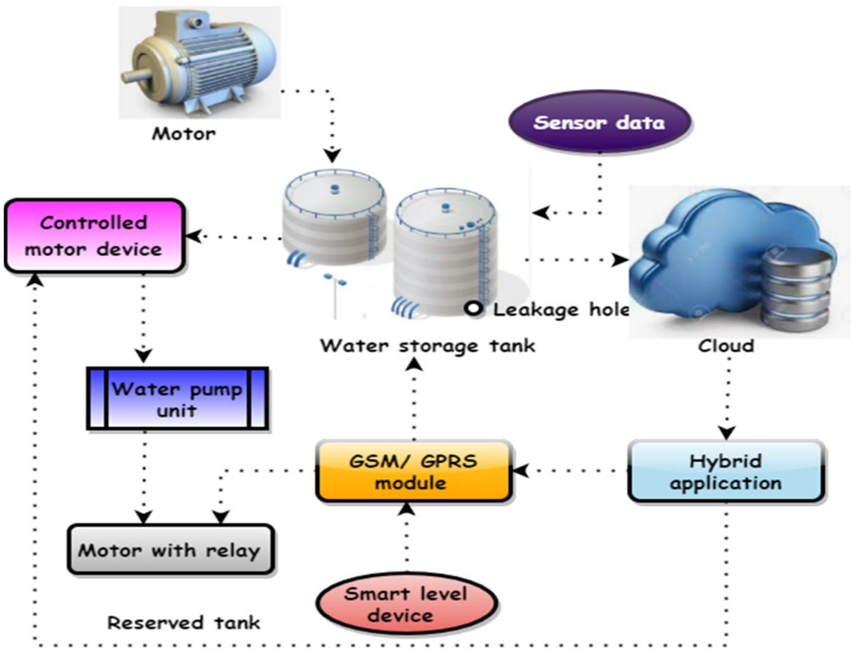

Smart Water Management is the activity of planning, developing, distributing and managing the use of water resources using an array of IoT technologies which are designed to increase transparency, and make more reasonable and sustainable usage of these water resources.

The total water demand in India is projected to increase by 22% and 32% in 2025 and 2050 respectively and, by 2050, 85% of this demand is expected to come from industrial and domestic sectors alone. Among the regions, the south and the northwest are expected to face the worst in next two years..