[ 2CEIT5PE18: MOBILE APPLICATION DEVELOPMENT]

Practical: 1



AIM- Develop a Kotlin program for demonstrating various programming concepts.

Submitted By: KANSAGARA KRISH KALPESHBHAI
Enrollment number: 23012011026



Department of Computer Engineering/Information Technology

- Store & Display Values in Different Variables: Create and display variables of different data types, including Integer, Double, Float, Long, Short, Byte, Char, Boolean, and String
Answer:
fun main(){
val intval : Int = 11
println("Integer Value = $intval")
val floatval : Float = 1.5f
println("Float Value = $floatval")
val charValue : Char = 'T'
println("Charcater Value = $charValue")
val stringValue : String = "Hello World"
println("String Value = $stringValue")
val boolValue : Boolean = true
println("Boolean Value = $boolValue")
val doubleValue : Double = 95.31
println("Double Value = $doubleValue")
val longValue : Long = 332254874
println("Long Value = $longValue")
val shortValue : Short = -124
println("Short Value = $shortValue")
val byteValue : Byte = 127
println("Byte Value = $byteValue")
}
Output:

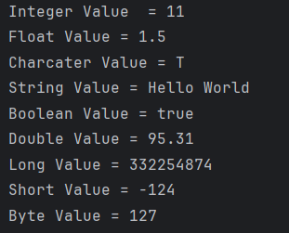

- Store & Display Values in Different Variables: Create and display variables of different data types, including Integer, Double, Float, Long, Short, Byte, Char, Boolean, and String
Answer:
fun main(){
var intvalue : Int = 11
println("Integer Value = $intvalue")
var doubleValue : Double = intvalue.toDouble()
println("Double Value (From Int) = $doubleValue")
var stringValue : String = "125"
var intValue : Int = stringValue.toInt()
println("Integer Value (From String) = $intValue")
var doubleString : Double = stringValue.toDouble()
println("Double Value (Form String) $doubleString")
}
Output:
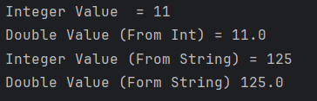
- Scan student’s information and display all the data: Input and display data of students, including their name, enrolment no, branch,etc.
Answer:
fun main(){
print("Student Enrollnment No : ")
val studentTEnroll = readln()

print("Student Name : ")
val studentName = readln()

print("Student Branch : ")
val studentBranch = readln()

print("Student Class : ")
val studentClass = readln()

print("Student Batch : ")
val studentBatch = readln()

print("Student Collage Name : ")
val studentCollage = readln()

print("Student University Name : ")
val studentUniversity = readln()

print("Student Age : ")
val studentAge = readln().toInt()

println("*********************")
println("Student Data : ")
println("Enrollment Number : $studentTEnroll")
println("Student Name : $studentName")
println("Student Age : $studentAge")
println("Student Branch : $studentBranch")
println("Student Class : $studentClass")
println("Student Batch : $studentBatch")
println("Student Collage : $studentCollage")
println("Student University : $studentUniversity")

}
Output:

- Check Odd or Even Numbers: Determine whether a number is odd or even using control flow within println() method.

Answer:
fun main(){
print("Enter a number : ")
val number = readln().toInt()
if (number % 2 == 0) {
println("$number is an even number.")
} else {
println("$number is an odd number.")
}
}
Output:
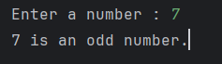

- Display Month Name: Use a when expression to display the month name based on user input.
Answer:
fun main(){
print("Enter a month : ")
val month = readLine()?.toInt()

val monthname = when (month){
1 -> "January"
2 -> "February"
3 -> "March"
4 -> "April"
5 -> "May"
6 -> "June"
7 -> "July"
8 -> "August"
9 -> "September"
10 -> "October"
11 -> "November"
12 -> "December"
else -> "Invalid month"
}
println("The month is: $monthname")
}
Output:
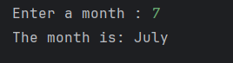
- User-Defined Function: Create a user-defined function to perform arithmetic operations (addition, subtraction, multiplication, division) on two numbers
Answer:
fun add(a: Int, b: Int, c: Int): Int {
return a + b + c
}

fun subtract(a: Int, b: Int, c: Int): Int {
return a - b - c
}

fun multiply(a: Int, b: Int, c: Int): Int {
return a * b * c
}

fun divide(a: Int, b: Int): Int {
return a / b
}

fun main() {
val a = 763
val b = 118
val c = -649

println("Addition of $a + $b + $c = ${add(a, b, c)}")
println("Subtraction of $a - $b - $c = ${subtract(a, b, c)}")
println("Multiplication of $a * $b * $c = ${multiply(a, b, c)}")
println("Division of $a / $b = ${divide(a, b)}")

}
Output:
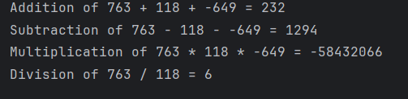
- Factorial Calculation with Recursion: Calculate the factorial of a number using recursion.

Answer:
fun factorial( n : Int ) : Int{
if (n == 0 || n == 1) {
return 1
} else {
return n * factorial(n - 1)
}
}

fun main(){
print("Enter a number to find its factorial: ")
val number = readln().toInt()
val result = factorial(number)
println("The factorial of $number is $result")
}
Output:
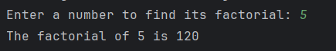
- Working with Arrays: Explore array operations such as Arrays.deepToString(), contentDeepToString(), IntArray.joinToString(), and use them to print arrays. Utilize various loop types like range, downTo, until, etc., to manipulate arrays. Sort an array of integers both without using built-in functions and with built-in functions.
Answer:
fun main() {
val array1 = intArrayOf(64, 25, 12, 22, 11, 90, 45, 78, 34, 23)
println("Array-1 : ${array1.joinToString()}")

val array2 = Array(5) { 0 }
println("Array-2 : ${array2.joinToString()}")

val array3 = Array(5) { it }
println("Array-3 : ${array3.joinToString()}")

val array4 = IntArray(5)
println("Array-4 : ${array4.joinToString()}")

val array5 = intArrayOf(1, 2, 3, 4, 5)
println("Array-5 : ${array5.joinToString()}")

val array6 = arrayOf(
intArrayOf(1,3),
intArrayOf(2,4),
intArrayOf(5,6),
)
println("Array-6 : ${array6.contentDeepToString()}")

val inputArray = IntArray(5)
println("Enter 5 integers:")
for (i in inputArray.indices) {
print("Element ${i + 1}: ")
inputArray[i] = readLine()?.toIntOrNull() ?: 0
}
println("Entered Array: ${inputArray.joinToString()}")

val builtInSorted = inputArray.sorted()
println("After sorting by built-in function: ${builtInSorted.joinToString()}")

println("After sorting by bubble sort:")
for (i in inputArray.indices) {
for (j in 0 until inputArray.size - i - 1) {
if (inputArray[j] > inputArray[j + 1]) {
val temp = inputArray[j]
inputArray[j] = inputArray[j + 1]
inputArray[j + 1] = temp
}
}
}
println(inputArray.joinToString())

println("Loops")
println("Using Range")
for (i in 1..10) {
print("$i ")
}
println()
println("Using DownTo")
for (i in 10 downTo 1) {
print("$i ")
}
println()
println("Using Until")
for (i in 1 until 10) {
print("$i ")
}
println()
println("Using ForEach")
inputArray.forEach { print("$it ") }
println()
}
Output:
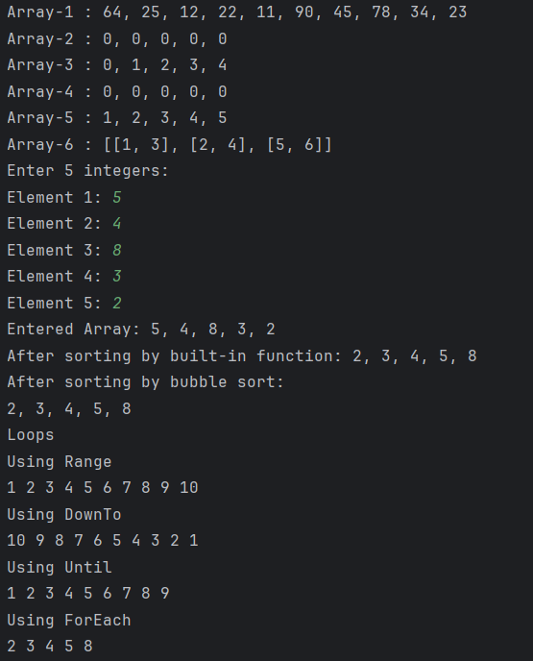
- Find Maximum Number from ArrayList: Write a program to find the maximum number from an ArrayList of integers.
Answer:
fun main(){
val numbers = ArrayList<Int>()
println("Enter the number of elements:")
val n = readLine()?.toIntOrNull() ?: 0
for (i in 1..n) {
print("Enter element $i: ")
val num = readLine()?.toIntOrNull() ?: 0
numbers.add(num)
}
if (numbers.isNotEmpty()) {
val maxNum = numbers.maxOrNull()
println("Maximum number is: $maxNum")
} else {
println("No numbers entered.")
}
}
Output:
- Class and Constructor Creation: Define different classes and constructors. Create a "Car" class with properties like type, model, price, owner, and miles driven. Implement functions to get car information, original car price, current car price, and display car information.
Answer:
class Car(
var type: String,
var model: Int,
var price: Double,
var owner: String,
var milesDriven: Int
) {
init {
println("Object of class is created and Init is called.")
}

fun getCarInfo(): String {
return "Car Information: $type, $model\nCar Owner: $owner\nMiles Drive: $milesDriven"
}

fun getOriginalCarPrice(): Double {
return price
}

fun getCurrentPrice(): Double {
return price - (milesDriven * 5)
}

fun displayCarInfo() {
println("----------")
println(getCarInfo())
println("Original Car Price: ${getOriginalCarPrice()}")
println("Current Car Price: ${getCurrentPrice()}")
println("----------")
}
}

fun main() {
println("Creating Car Class Object car1 in next line")
val car1 = Car("BMW", 2018, 100000.0, "Aman", 105)
car1.displayCarInfo()

println("Creating Car Class Object car2 in next line")
val car2 = Car("BMW", 2019, 400000.0, "Karan", 20)
car2.displayCarInfo()

println("******* ArrayList of Car **************")
val carList = ArrayList<Car>()
carList.add(Car("Toyota", 2017, 1080000.0, "KJS", 100))
carList.add(Car("Maruti", 2020, 4000000.0, "NPP", 200))

for (car in carList) {
car.displayCarInfo()
}
}
Output:
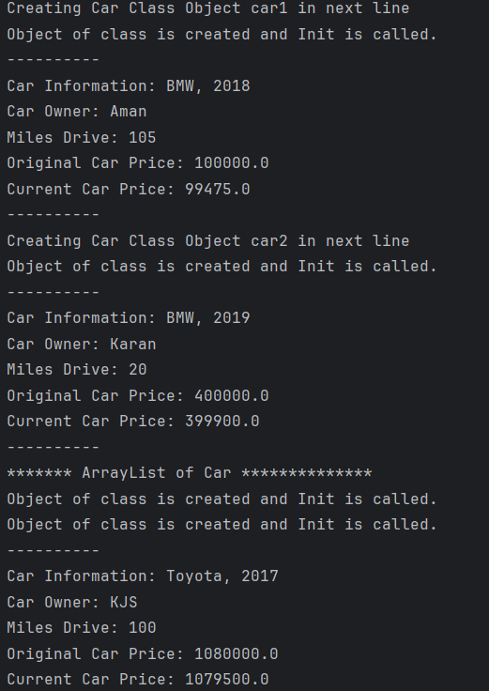
- Operator Overloading and Matrix Operations: Explain operator overloading and implement matrix addition, subtraction, and multiplication using a "Matrix" class. Overload the toString() function in the "Matrix" class for customized output.
Answer:
fun main() {
val firstMatrix = Matrix(arrayOf(intArrayOf(3, -2, 5), intArrayOf(3, 0, 4)), 2, 3)
val secondMatrix = Matrix(arrayOf(intArrayOf(2, 3), intArrayOf(-9, 0), intArrayOf(0, 4)), 3, 2)
val secondMatrix1 = Matrix(arrayOf(intArrayOf(6, 3), intArrayOf(9, 0), intArrayOf(5, 4)), 3, 2)

println("***************Addition***************")
print("Matrix:1 ")
print(secondMatrix1)
print("Matrix:2 ")
print(secondMatrix)
val thirdMatrix = secondMatrix1 + secondMatrix
println("Addition: $thirdMatrix")

println("***************Subtraction***************")
print("Matrix:1 ")
print(secondMatrix1)
print("Matrix:2 ")
print(secondMatrix)
val subtractMatrix = secondMatrix1 - secondMatrix
println("Subtraction: $subtractMatrix")

println("***************Multiplication***************")
print("Matrix:1 ")
print(firstMatrix)
print("Matrix:2 ")
print(secondMatrix)
val multiplication = firstMatrix * secondMatrix
println("Multiplication: $multiplication")
}
class Matrix(
private val data: Array<IntArray>,
private val noOfRow: Int,
private val noOfCol: Int
) {

operator fun plus(other: Matrix): Matrix {
val result = Array(noOfRow) { IntArray(noOfCol) }
for (i in 0 until noOfRow) {
for (j in 0 until noOfCol) {
result[i][j] = this.data[i][j] + other.data[i][j]
}
}
return Matrix(result, noOfRow, noOfCol)
}

operator fun minus(other: Matrix): Matrix {
val result = Array(noOfRow) { IntArray(noOfCol) }
for (i in 0 until noOfRow) {
for (j in 0 until noOfCol) {
result[i][j] = this.data[i][j] - other.data[i][j]
}
}
return Matrix(result, noOfRow, noOfCol)
}

operator fun times(other: Matrix): Matrix {
val result = Array(noOfRow) { IntArray(other.noOfCol) }
for (i in 0 until noOfRow) {
for (j in 0 until other.noOfCol) {
for (k in 0 until noOfCol) {
result[i][j] += this.data[i][k] * other.data[k][j]
}
}
}
return Matrix(result, noOfRow, other.noOfCol)
}

override fun toString(): String {
val builder = StringBuilder()
builder.append("($noOfRow x $noOfCol Matrix):\n")
for (i in 0 until noOfRow) {
for (j in 0 until noOfCol) {
builder.append("${data[i][j]} ")
}
builder.append("\n")
}
return builder.toString()
}
}
Output:

