**1. Introduction of Java(JDK, JRE and JVM).**

Java is a versatile and widely-used programming language that is especially known for its "**write once, run anywhere**" capability. This means that compiled Java code can run on all platforms that support Java without the need for recompilation.

## **Java Development Kit (JDK)**

The JDK is a software development kit used to develop Java applications. It includes:

* **Compiler (javac)**: Converts Java source code into bytecode.
* **Java Runtime Environment (JRE)**: Provides libraries and other components necessary for running Java applications.
* **Java Debugger (jdb)**: Used for debugging Java applications.
* **Other tools**: Such as javadoc (for generating documentation) and jar (for packaging applications into JAR files).

## **Java Runtime Environment (JRE)**

The JRE is a subset of the JDK and is used to run Java applications. It includes:

* **Java Virtual Machine (JVM)**: The engine that runs Java bytecode.
* **Core Libraries**: Essential libraries that provide basic functionalities such as data structures, utilities, networking, and more.
* **Other Components**: Supporting libraries and components necessary for running Java applications.

The JRE does not include development tools like the compiler or debugger, which are part of the JDK.

## **Java Virtual Machine (JVM)**

The JVM is the cornerstone of the Java platform and provides a runtime environment in which Java bytecode can be executed. It is platform-independent and can run on various hardware and software environments. The JVM performs several important tasks:

* **Loading**: Reads the compiled Java bytecode.
* **Verification**: Ensures the bytecode is correct and does not violate Java's security constraints.
* **Execution**: Converts bytecode into machine code and executes it.
* **Memory Management**: Manages memory through automatic garbage collection.

The JVM is available for different platforms, allowing Java applications to be platform-independent.

**2. Write a Java program to print the “Welcome to Java, let us Learn JAVA” on the console.**

**Program:-**

class Pr1_2

{

public static void main(String[] args)

{

System.out.println(“Welcome to Java, let us Learn JAVA”);

}

};

**Output:-**

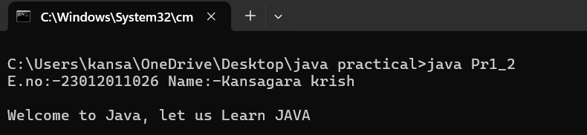

**3. Write a Java program to print the following pattern on the screen.**

**\*\*\*\*\*\*\*\*\*\*\*\*\*\*\*\*\*\*\*\*\*\*\*\*\*\*\***

**\* Let us learn Java \***

**\*\*\*\*\*\*\*\*\*\*\*\*\*\*\*\*\*\*\*\*\*\*\*\*\*\*\***

**Program:-**

class Pr1_3

{

public static void main(String[] krish)

{

System.out.println("E.no:-23012011026 Name:-Kansagara krish\n");

System.out.println("***************************");

System.out.println("*Let us learn java*");

System.out.println("***************************");

}

}

**Output:-**

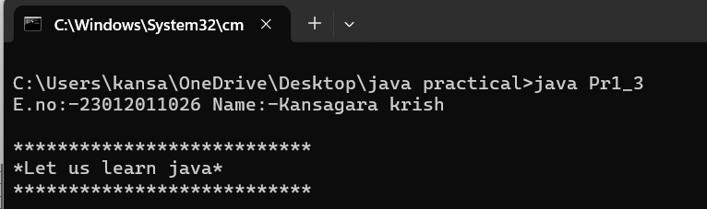

**4. Write a Java program to evaluate the following equations.**

**1. C = F-32/1.8**

**Program:-**

class Pr1_4_1

{

public static void main(String[] krgs)

{

double F=32;

double C;

C=F-32/1.8;

System.out.println("E.no:-23012011026 Name:-Kansagara krish\n");

System.out.print("Value in Celcius is "+C);

}

};

**Output:-**

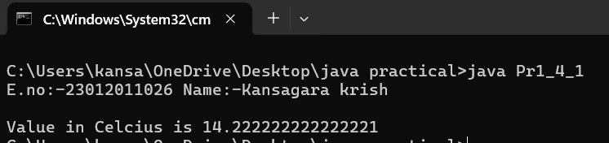

**2. Area = pi. r2 + 2. pi. R. h**

**Program:-**

class Pr1_4_2

{

public static void main(String[] krish)

{

double Area,pi=3.14,r=10,R=12,h=15;

Area=(pi*r*r)+(2*pi*R*h);

System.out.println("E.no:-23012011026 Name:-Kansagara krish\n");

System.out.print("Area is "+Area);

}

}

**Output:**-

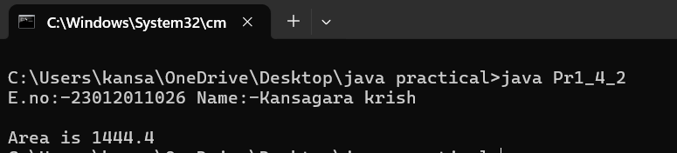

**3. Side = SQRT( a2 + b2 – 2abcos(x))**

**Program:-**

class Pr1_4_3

{

public static void main(String[] args)

{

double side,a=10,b=20,x=30;

side=Math.sqrt((a*a)+(b*b)-(2*a*b*Math.cos(x)));

System.out.println("E.no:-23012011026 Name:-Kansagara krish\n");

System.out.println("Side is "+side);

}

};

**Output:-**

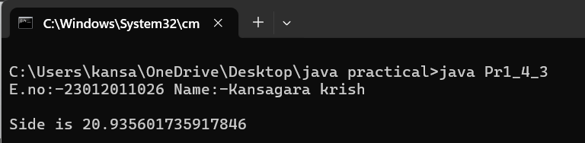

**5. Write a program to print your information using command line argument. (Take 3 arguments Enrollment No, Name, Branch)**

**i. using single line**

**ii. using multiple line**

OUTPUT:

//print output like this

Enrolment No: 21101212001

Name: Vijay

Branch: Compute

**Program:-**

class Pr1_5

{

public static void main(String[] args)

{

String E_no=args[0];

String Name=args[1];

String Branch=args[2];

System.out.println("23012011026 Kansagara krish");

System.out.println("Using single line");

System.out.print("Enrollment number is "+E_no+"\nmy name is "+Name+"\nBranch is "+Branch);

System.out.print("Using miltiplae line\n");

System.out.println("Enrollment number is "+E_no);

System.out.println("my name is "+Name);

System.out.println("Branch is "+Branch);

}

};

**Output:-**

