Architecture Design

***Amazon Sales Data Analysis***

***Written By:- Rahul Kansal***

***Version:- 0.2***

***Last Revised Date:- 08/05/2022***

**DOCUMENT CONTROL**

|  |  |  |  |
| --- | --- | --- | --- |
| **Version** | **Date** | **Author** | **Comments** |
| **0.1** | **07/05/2022** | **Rahul Kansal** | Introduction and architecture defined |
| **0.2** | **08/05/2022** | **Rahul Kansal** | Architecture & Architecture description appended and updated. |

**Change Records**

**Reviews:**

**VERSION DATE**

**REVIEWER**

**COMMENTS**

0.2

08- May -

2022

Rahul Kansal

Unit test cases to be added

**Approval Status:**

**VERSION**

**REVIEW**

**DATE**

**REVIEWED BY**

**APPROVED BY**

**COMMENTS**

# Contents

1. Introduction 04
   * What is Architecture Design Document? 04
   * Scope 04
2. Architecture 05
   * Power BI Architecture 05
   * Power BI Server Architecture 05
   * Gateway/Load Balancer 06
   * Application Server 06
   * VIZQL Server 07
   * Data Engine 07
   * Backgrounder 07
   * Data Server 07
   * Power BI Communication Flow 07
3. Deployment 08
   * Deployment Options in Power BI 09
   * Single Node Architecture 10
   * Three Node Architecture 11
   * Five Node Architecture 12

# Introduction

## What is Architecture design document?

Any software needs the architectural design to represents the design of software. IEEE defines architectural design as “the process of defining a collection of hardware and software components and their interfaces to establish the framework for the development of a computer system.” The software that is built for computer-based systems can exhibit one of these many architectures.

Each style will describe a system category that consists of :

* A set of components (eg: a database, computational modules) that will perform a function required by the system.
* The set of connectors will help in coordination, communication, and cooperation between the components.
* Conditions that how components can be integrated to form the system.
* Semantic models that help the designer to understand the overall properties of the system.

## Scope

Architecture Design Document (ADD) is an architecture design process that follows a step-by-step refinement process. The process can be used for designing data structures, required software architecture, source code and ultimately, performance algorithms. Overall, the design principles may be defined during requirement analysis and then refined during architectural design work.

# Architecture

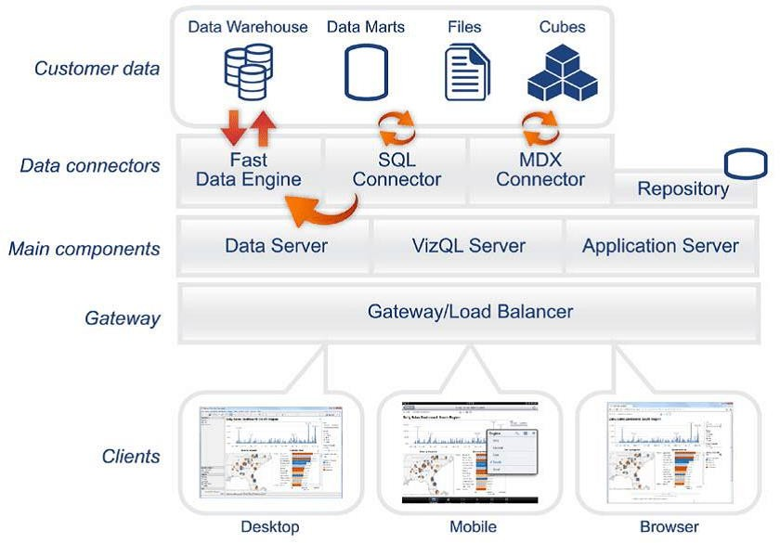

**Power BI Server Architecture**

Power BI has a highly scalable, n-tier client-server architecture that serves mobile clients, web clients and desktop-installed software. Power BI Server architecture supports fast and flexible deployments.

### ARCHITECTURE DESIGN

**6**

The following diagram shows Power BI Server’s architecture:

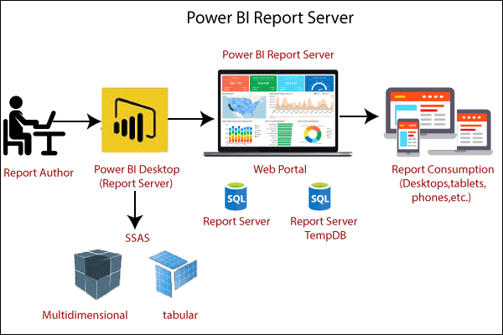

Power BI Server is internally managed by the multiple server processes.

## 1. Gateway/Load Balancer

It acts as an Entry gate to the Power BI Server and also balances the load to the Server if multiple Processes are configured.

**2) Application Server:-**

Application Server processes (wgserver.exe) handle browsing and permissions for the Power BI Server web and mobile interfaces. When a user opens a view in a client device, that user starts a session on Power BI Server. This means that an Application Server thread starts and checks the permissions for that user and that view.

## Repository:-

Power BI Server Repository is a PostgreSQL database that stores server data. This data includes information about Power BI Server users, groups and group assignments, permissions, projects, data sources, and extract metadata and refresh information.

## VIZQL Server:-

Once a view is opened, the client sends a request to the VizQL process (vizqlserver.exe). The VizQL process then sends queries directly to the data source, returning a result set that is rendered as images and presented to the user. Each VizQL Server has its own cache that can be shared across multiple users

## Data Engine:-

It Stores data extracts and answers queries.

## Backgrounder:-

The backgrounder Executes server tasks which includes refreshes scheduled extracts, tasks initiated from tabcmd and manages other background tasks.

## Data Server:-

Data Server Manages connections to Power BI Server data sources

It also maintains metadata from Power BI Desktop, such as calculations, definitions, and groups.

1. **Power BI Communication Flow**

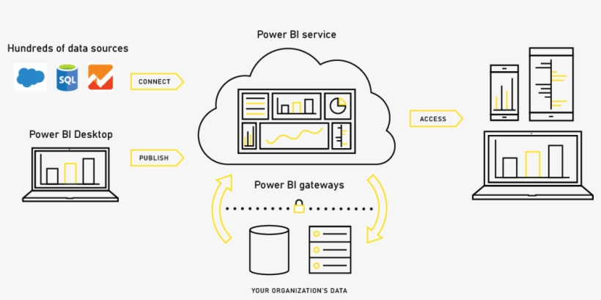

# Deployment Description

## Deployment options in Power BI

Power BI’s analytics platform offers three different deployment options depending on your

environment and needs. The below graphic shows each option at a glance:

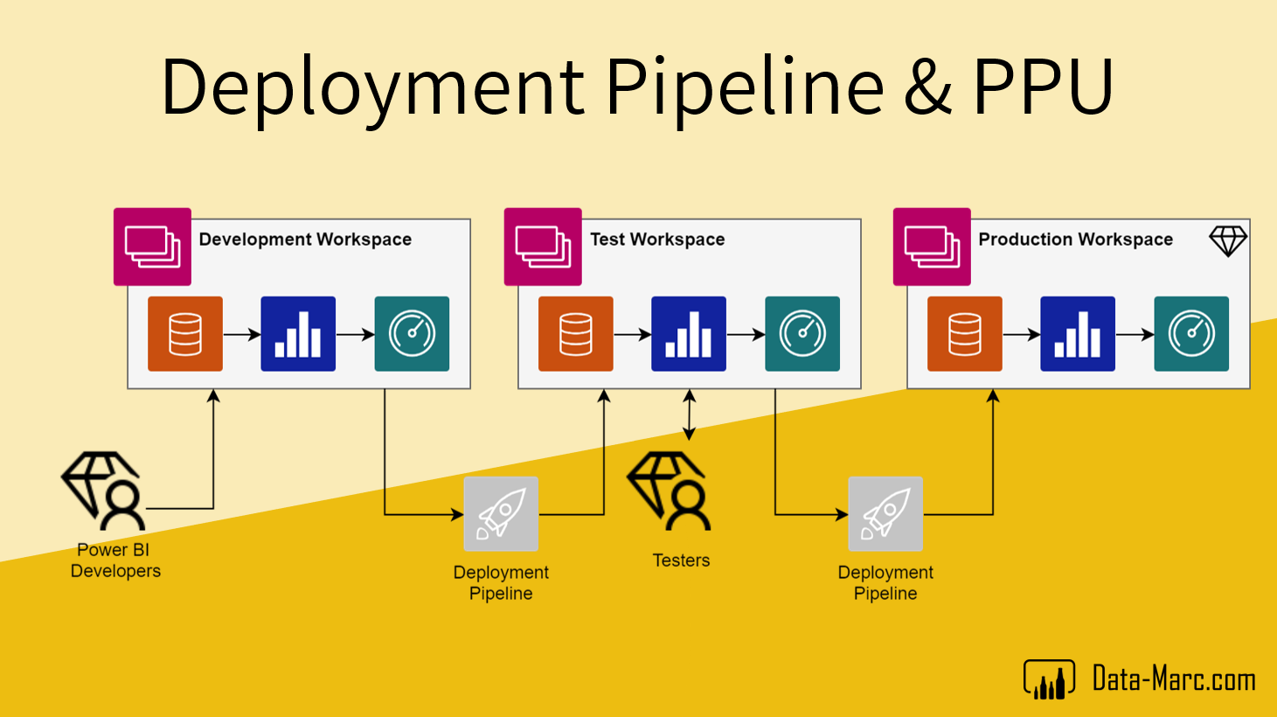

1. **Power BI Online** Get up and running quickly with no hardware required. Power BI Online is fully hosted by Power BI so all upgrades and maintenance are automatically managed for you.
2. **Power BI** deployed on public cloud: Leverage the flexibility and scalability of cloud infrastructure without giving up control. Deploy to Amazon Web Services, Google Cloud Platform, or Microsoft Azure infrastructure to quickly get started with Power BI Server (on your choice of Windows or Linux). Bring your own license or purchase on your preferred marketplace.
3. **Power BI deployed on-premises**: Manage and scale your own hardware and software (whether Windows or Linux) as needed. Customize your deployment as you see fit.

## Single Node Architecture

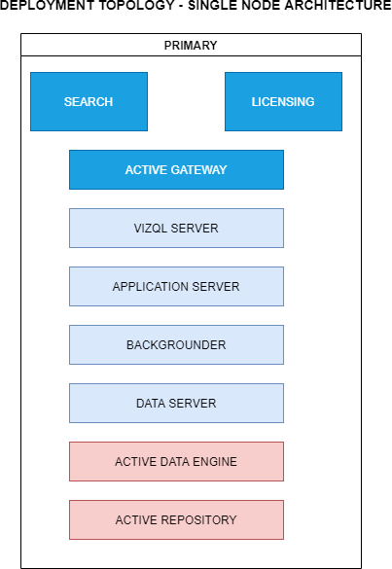

This architecture is a single node architecture. This is the most simple deployment topology.

## 3 Node Architecture

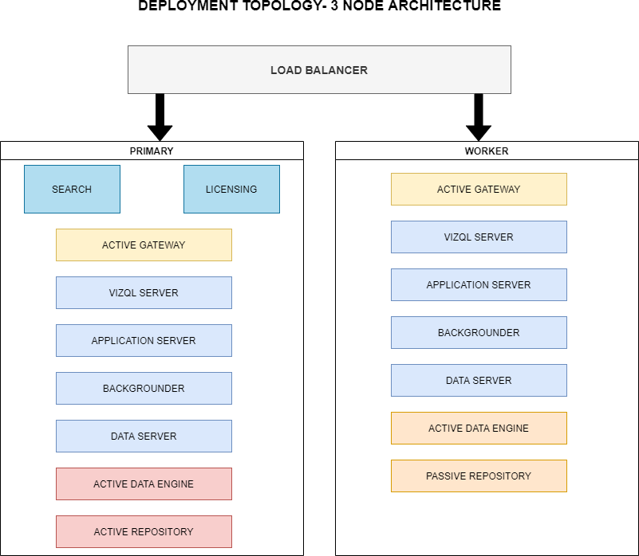

This architecture is a 3 Node Architecture which is more capable to handle concurrent requests.

If we need failover or high availability, or want a second instance of the repository, we must install Power BI Server on a cluster of at least three computers. In a cluster that includes at least three nodes, you can configure two instances of the repository, which gives our cluster failover capability.

## 5 Node Architecture

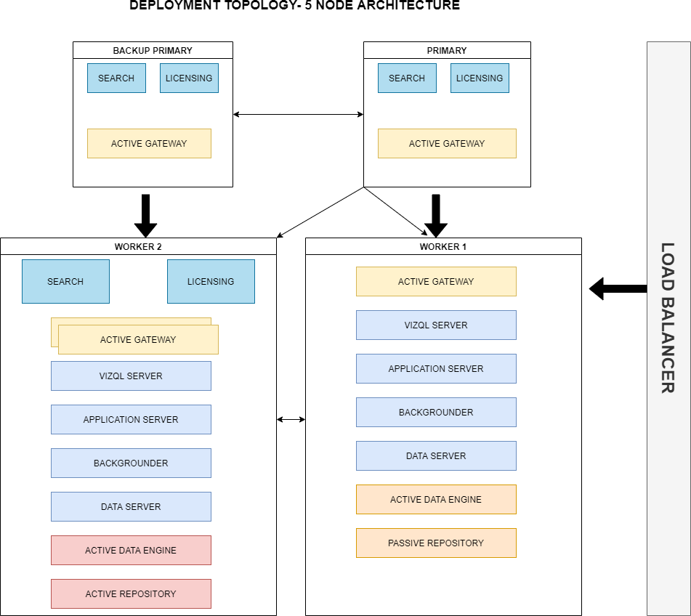

When we install Power BI Server on a Five-node cluster, we can install server processes on one or both nodes. A five-node cluster can improve the performance of Power BI Server, because the work is spread across multiple machines.

Note the following about five-node clusters:

* + - A five-node cluster does not provide failover or support for high availability.
    - You can't install more than one instance of the repository on a two-node cluster, and the repository must be on the initial node.