Low Level Design

# Amazon Sales Data Analysis

|  |  |
| --- | --- |
| **Written By** | Rahul Kansal |
| **Document Version** | 0.2 |
| **Last Revised Date** | 07/05/2022 |

**DOCUMENT CONTROL**

**Change Record:**

|  |  |  |  |
| --- | --- | --- | --- |
| **VERSION** | **DATE** | **AUTHOR** | **COMMENTS** |
| 0.1 | 04- May -  2021 | Rahul Kansal | Introduction and architecture defined |
| 0.2 | 07 - May -  2021 | Rahul Kansal | Architecture & Architecture description appended and  updated. |
|  |  |  |  |
|  |  |  |  |

**Reviews:**

|  |  |  |  |
| --- | --- | --- | --- |
| **VERSION** | **DATE** | **REVIEWER** | **COMMENTS** |
|  |  |  |  |

**Approval Status:**

|  |  |  |  |  |  |
| --- | --- | --- | --- | --- | --- |
| **VERSION** | **REVIEW**  **DATE** | **REVIEWED BY** |  | **APPROVED BY** | **COMMENTS** |
|  |  |  |  |  |  |

# Contents

1. **Introduction** **04**
   1. **What is Low-Level Design Document?** **04**

|  |  |  |
| --- | --- | --- |
| **1.2** | | **Scope** **04** |
| **2.** | **Architecture** **05** | |
| **3.** | **Architecture Description** **08** | |
|  | **3.1** | **Data Description** **08** |
|  | **3.2** | **Web Scrapping** **08** |
|  | **3.3** | **Data Transformation** **08** |
|  | **3.4** | **Data insertion into database** **08** |
|  | **3.5** | **Export Data from database** **12** |
|  | **3.6** | **Deployment** **12** |
| **4.** | **Unit** | **test cases** **15** |

# Introduction

## What is Low-Level design document?

* The goal of the LDD or Low-level design document (LLDD) is to give the internal logic design of the actual program code for the House Price Prediction dashboard. LDD describes the class diagrams with the methods and relations between classes and programs specs. It describes the modules so that the programmer can directly code the program from the document.

## Scope

* Low-level design (LLD) is a component-level design process that follows a step-by-step refinement process. The process can be used for designing data structures, required software architecture, source code and ultimately, performance algorithms. Overall, the data organization may be defined during requirement analysis and then refined during data design work.

# Architecture

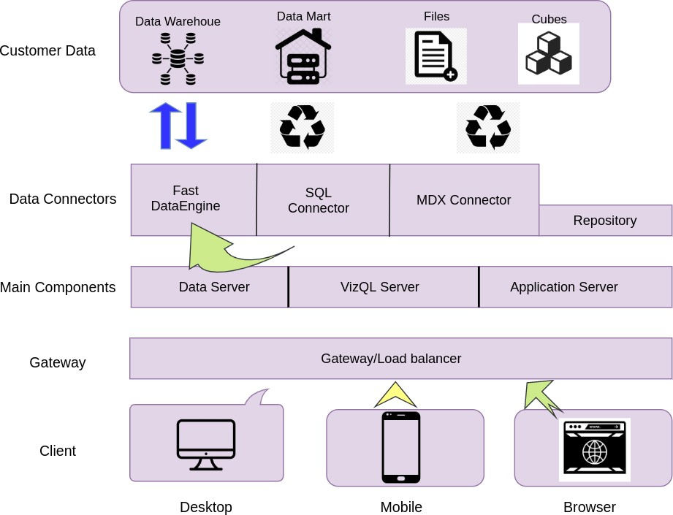

**Power BI Server Architecture**

Power BI has a highly scalable, n-tier client-server architecture that serves mobile clients, web clients and desktop-installed software. Power BI Server architecture supports fast and flexible deployments.

The following diagram shows Power BI Server’s architecture:

**LOW LEVEL DESIGN**

**6**

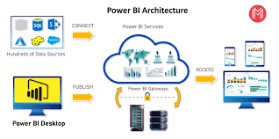

Power BI Server is internally managed by the multiple server

ocesses.

## 1. Gateway/Load Balancer

It acts as an Entry gate to the Power BI Server and also balances the load to the Server if multiple Processes are configured.

**2) Application Server:-**

Application Server processes (wgserver.exe) handle browsing and permissions for the Power BI Server web and mobile interfaces. When a user opens a view in a client device, that user starts a session on Power BI Server. This means that an Application Server thread starts and checks the permissions for that user and that view.

1. **Repository:-**

Power BI Server Repository is a PostgreSQL database that stores server data. This data includes information about Power BI Server users, groups and group assignments, permissions, projects, data sources, and extract metadata and refresh information.

1. **VIZQL Server:-**

Once a view is opened, the client sends a request to the VizQL process (vizqlserver.exe). The VizQL process then sends queries directly to the data source, returning a result set that is rendered as images and presented to the user. Each VizQL Server has its own cache that can be shared across multiple users

1. **Data Engine:-**

It Stores data extracts and answers queries.

1. **Backgrounder:-**

The backgrounder Executes server tasks which includes refreshes scheduled extracts, tasks initiated from tabcmd and manages other background tasks.

1. **Data Server:-**

Data Server Manages connections to Power Bi Server data sources

It also maintains metadata from Tableau Desktop, such as calculations, definitions, and groups.

# Architecture Description

## Data Description

The Dataset contains the sales trend of Amazon :

* + 1. It shows the profit of products according to countries.
    2. It shows the sales according to different aspects.
    3. Sales management is most useful system for growth of company.

## Web Scrapping

Web scraping is a technique to automatically extract content and data from websites using bots. It is also known as web data extraction or web harvesting. Web scrapping is made simple now days, many tools are used for web scrapping. Some of python libraries used for web scrapping are Beautiful Soup, Scrapy, Selenium, etc.

## Data Transformation

In the Transformation Process, we will convert our original datasets with other necessary attributes format. And will merge it with the Scrapped dataset.

## Data Insertion into Database

1. Database Creation and connection - Create a database with name passed. If the database is already created, open the connection to the database.
2. Table creation in the database.
3. Insertion of files in the table

**Step 2: Configuring Data Source**

The data source page loads up after configuring the Power BI connector and successfully signing in. This is how the page looks like:

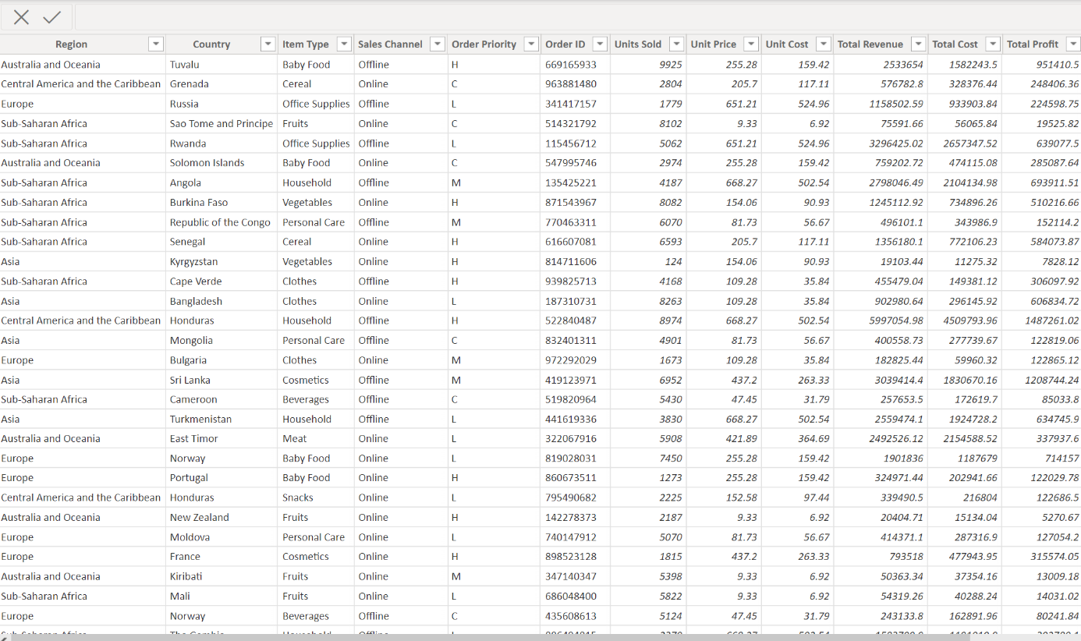

Select the data source name option and give a unique name to the database you are using. It’s considered a good

practice to have a unique name as it makes it much easier for users to identify the database from which data

being fetched.

To select the desired schema, you can use the schema drop-down list from the column on the left. You can also

perform a text-based search to find the desired option. Now similarly find and select the desired table and drag it

onto the canvas.

this is how you can connect SQL Server with Power BI. Now click on the sheets tab to begin the analysis.

Custom SQL features can be used to focus on specific SQL statements, rather than querying the entire

database

Click on the Custom SQL option from the panel on the left. A new dialogue box will now open up, where

you can provide the query you want to execute.

## Export Data from Database

Data Export from Database - The data in a stored database is exported as a CSV file to be used for Data Pre-processing.

## Deployment.

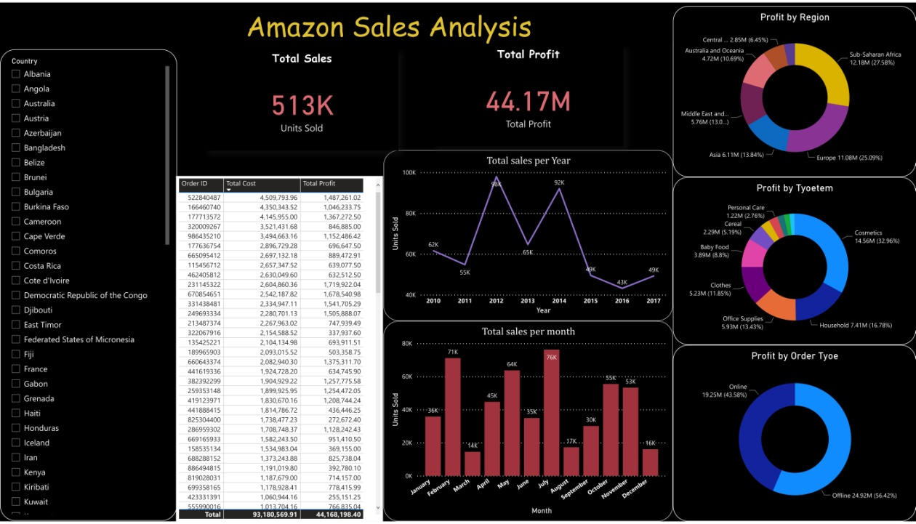

Once you’ve completed your dashboard, follow these steps:**-Server, Power Bi Public, Save To Power BI Public As**

You may be prompted to log into your Power BI Public profile first if this is your first time publishing.

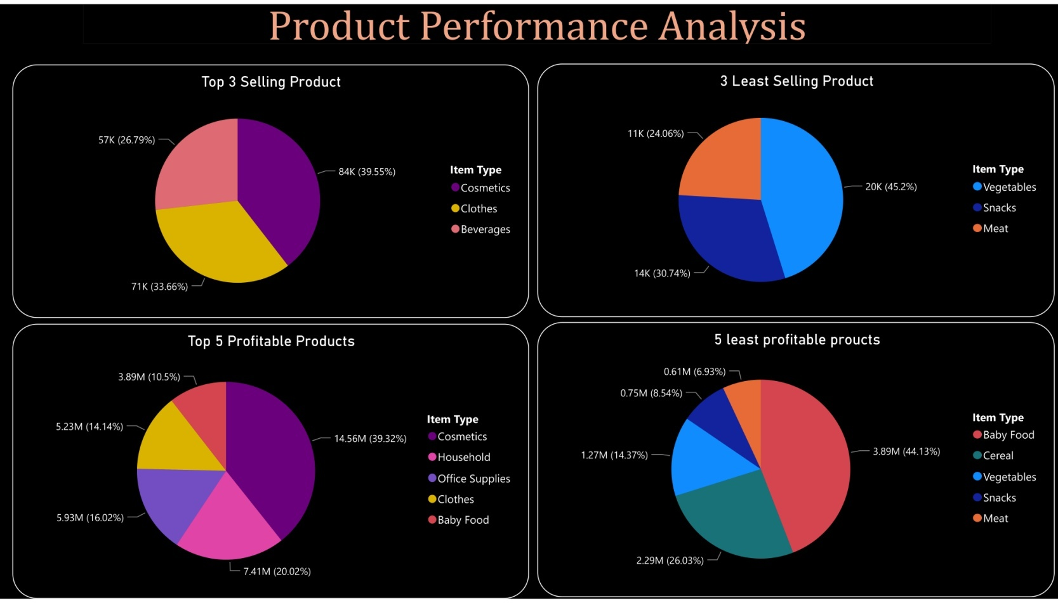

# 4. Unit Test Cases

|  |  |
| --- | --- |
| **Test case** | **Results** |
| Click on donut chart charts | It shows the profit by different aspects like region, order type etc. |
| Click on line chart | Shows total sales per year |
| Bar chart | Shows total sales per month |