***AMAZON SALES DATA ANALYSIS***

***Wireframe Documentation***

HOMEPAGE

As per the problem statement, we have divided analysis into two sections: -

# Impact of different factors in Sales of Amazon:

In this section we designed our first dashboard and tried to interpret the followings:

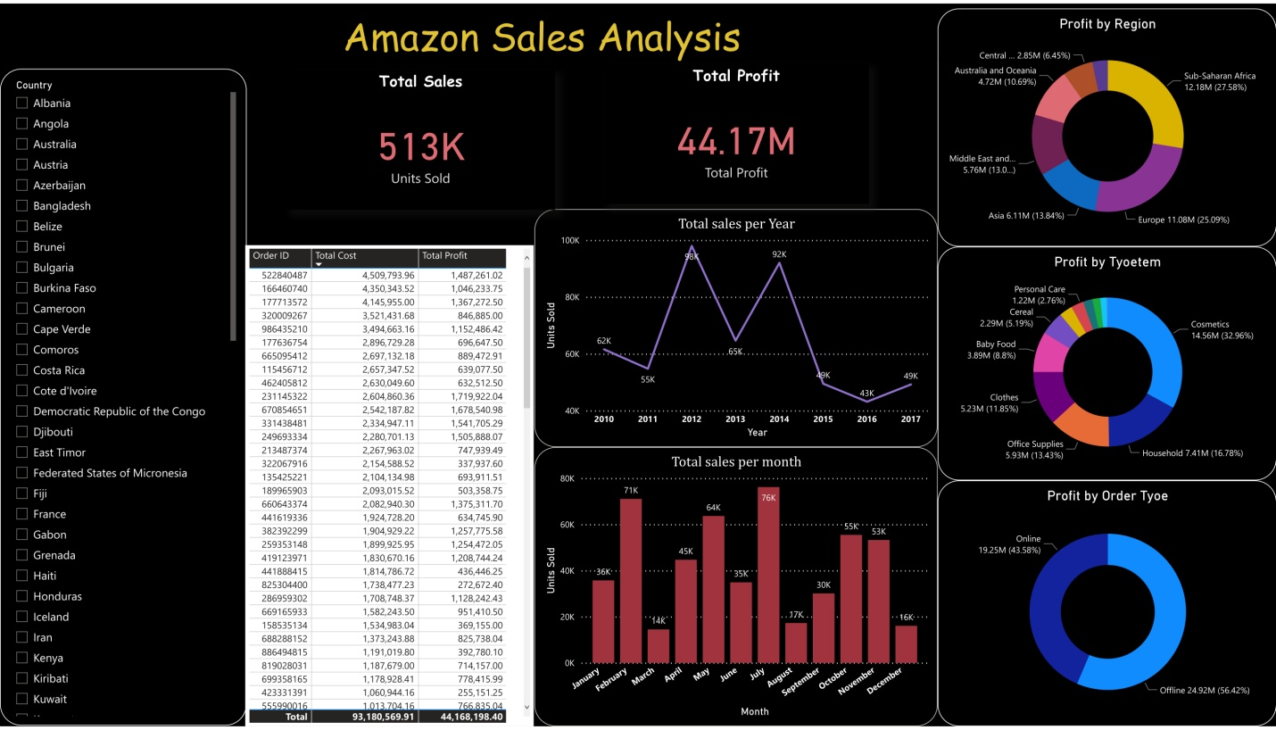

* Impact of Region, Itemtype etc. on Profit
* It shows sales trend of month and year.
* It shows the data based on different countries also.

2.PRODUCT PERFORMANCE:-

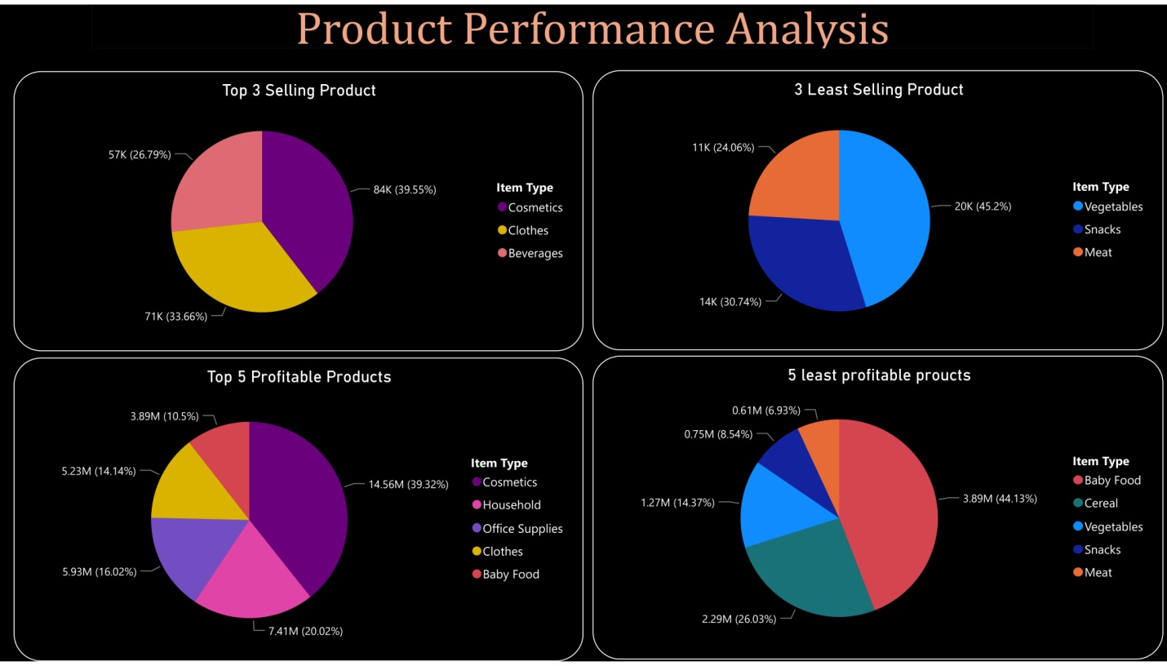

* Shows the most selling and least selling products
* Shows the most profitable and least profitable products