***SWIGGY BANGALORE RESTAURANTS***

***DATA ANALYSIS***

***Wireframe Documentation***

HOMEPAGE

As per the problem statement, we have divided analysis into two sections: -

# Impact of different factors on Bangalore Swiggy restaurants:

In this section we designed our first dashboard and tried to interpret the followings:

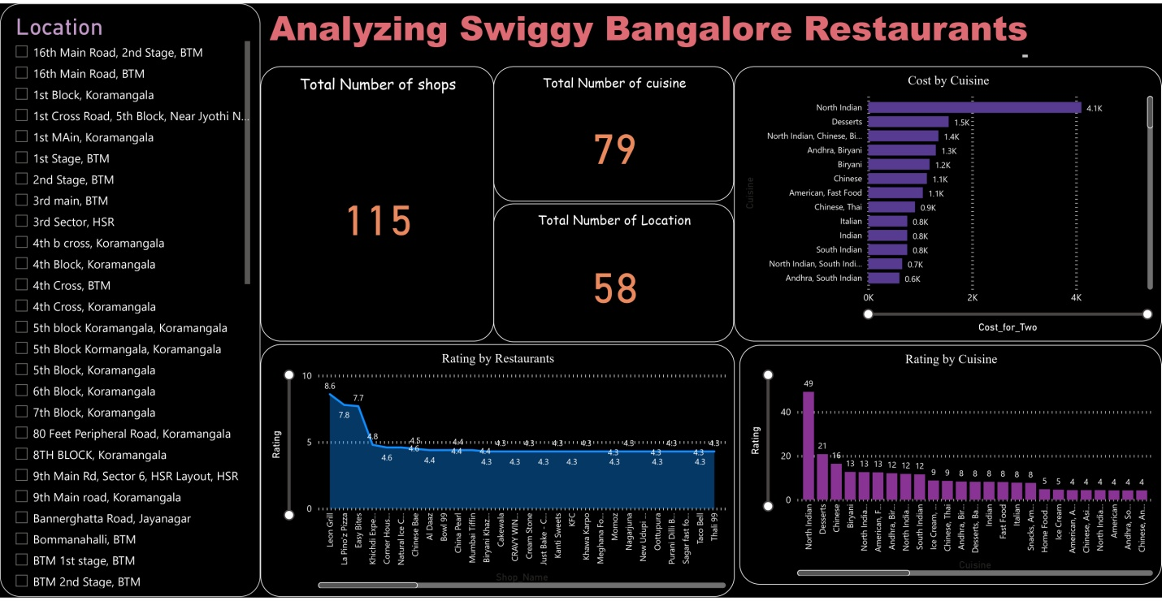

* Impact of Cuisine, specific restaurants etc. on ratings
* It shows the cost of different dishes .
* It shows the data based on different locations also.

2.SEGMENT BASED PERFORMANCE:-

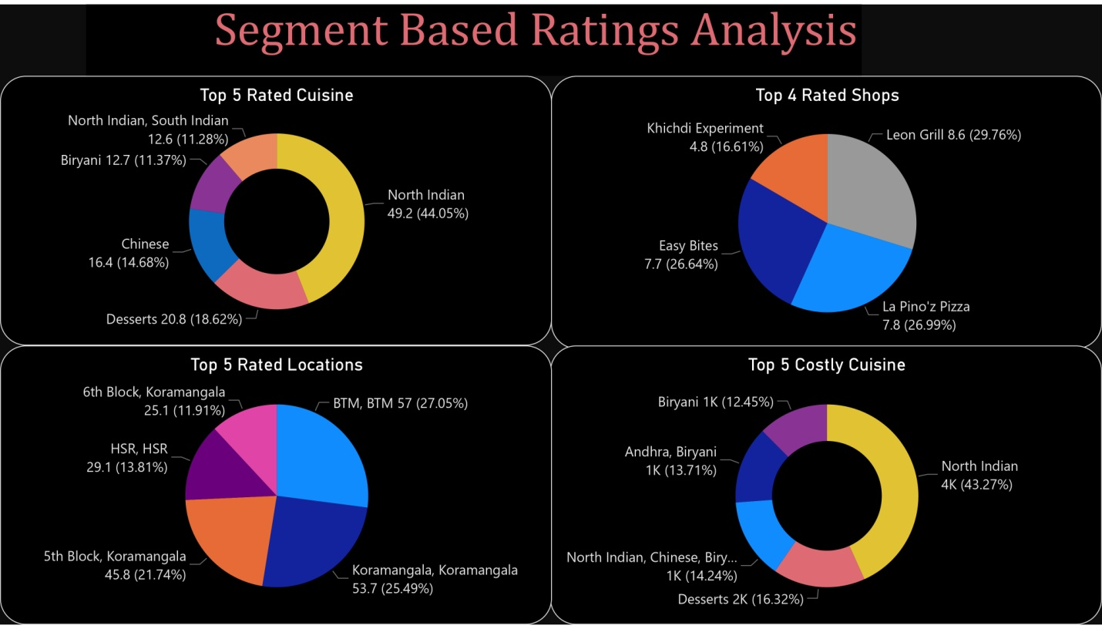

* Shows the top rated restaurants
* Shows the top rated locations and high cost dishes.