|  |  |  |  |  |  |
| --- | --- | --- | --- | --- | --- |
| **Experiment Number: 2** | | | | | |
| **Date of Performance:** | | **08-08-2022** | | | |
| **Date of Submission:** | | **22-08-2022** | | | |
| **Program Execution/ formation/ correction/ ethical practices (07)** | **Documentation (02)** | **Timely Submission (03)** | **Viva Answer to sample questions (03)** | **Experiment Total (15)** | **Sign** |
| **6** | **2** | **3** | **3** | **14** |  |

Experiment No: 2

**Title:** Online Banking System using Scrum Model

**Aim:**  Application of Agile Process models

**Lab Outcome:** CSL501: Identify requirements and apply software process models to selected case study

**Problem Statement :** Project on Online Banking System is to manage the details of Account , Bank, Customer ,Transaction, Internet Banking. It manage all information about Account, Balance, Internet Banking, Accounts .The project is totally built at administrative end and thus, only the administrator access is guaranteed the access .The purpose of the project is to build an application program to reduced the manual work for managing the account, balance, bank, customer. It tracks all the details of transaction, Customer and Internet Banking

# Agile Model

Agile SDLC model is a combination of iterative and incremental process models with focus on process adaptability and customer satisfaction by rapid delivery of working software products.

# Structure

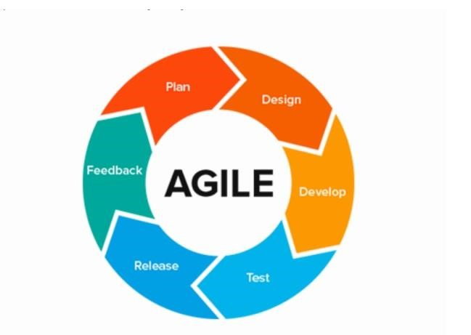

# Scrum

Scrum is an agile development methodology used in the development of Software based on iterative and incremental processes. Scrum is an adaptable, fast, flexible and effective agile framework that is designed to deliver value to the customer throughout the development of the project.

**Scrum Framework**

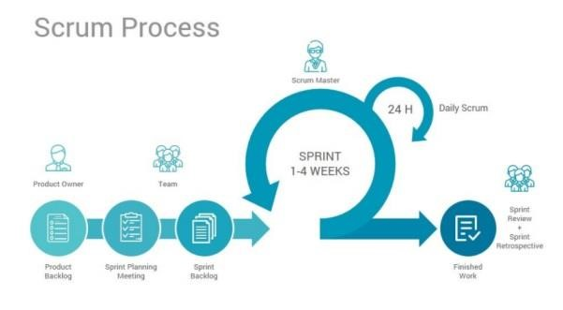

# Scrum Process :

# 1 Product Backlog

Accounts Management Module: Used for managing the Accounts details.

Internet Banking Module: Used for managing the details of Internet Banking

Balance Module: Used for managing the details of Balance

Bank Management Module: Used for managing the information and details of the Bank.

Customer Module: Used for managing the Customer details

Transaction Module: Used for managing the Transaction information Login Module: Used for managing the login details

Users Module: Used for managing the users of the system

**2) Sprint Planning :**

The Project Team Members will start from the website with login and registration features and proceed according to the Product Backlog all the way up to creating the all module.

The Sprint will be of 2 weeks which means that after every two weeks the team should have a functioning piece of the product to show for their work.

1. In the first Sprint, focus will be on creating a account module where user can create saving and current account

b) In the second Sprint, focus will be on creating a internet banking module for managing the details for internet banking

c) In the third week, focus will be on creating a tab for balance module for checking the balance in the account .

1. In the third week, bank management will be implemented for employee and manager details and access to various section in the website.

1. In the fourth week, customer module will be implemented for managing customer details like age, account type, pan card, Aadhar card and account password etc
2. In the fifth week, payment gateway and admin section will be implemented

# Daily Scrum

Daily Scrum will usually be 15 to 30 minutes long. In this time, Scrum team members interact with each other during the Sprint to encounter progress as well as issues. This is mainly supervised by the Scrum master to make sure that all of the scrum theories, rules, and practices are truly followed by the team members.

# Sprint Review

As when the sprint is ended, the product owner organizes a sprint review meeting. In this meeting, the development team reveals whatever they have accomplished so far since the last sprint. And then, the product owner informs about what is yet to be achieved on the product backlog, followed by the estimated time in which the project has to be completed.

# Sprint retrospective

The scrum team comes all together in a sprint retrospective meeting, where the team discusses what went well, what did not, and how they could have done it in a better way. This might be due to some technical issue or maybe a team member is burdened with tasks. The decision-makers decide how to solve such issues and put up a plan to get rid of them in the next sprint