|  |  |  |  |  |  |
| --- | --- | --- | --- | --- | --- |
| **Experiment Number : 3** | | | | | |
| **Date of Performance:** | | **08-08-2022** | | | |
| **Date of Submission:** | | **22-08-2022** | | | |
| **Program Execution/ formation/ correction/ ethical practices (07)** | **Documentation (02)** | **Timely Submission (03)** | **Viva Answer to sample questions (03)** | **Experiment Total (15)** | **Sign** |
| **7** | **2** | **3** | **3** | **15** |  |

Experiment No: 3

**SOFTWARE REQUIREMENT SPECIFICATION(SRS)**

**ONLINE BANKING SYSTEM**

**Index:**

* 1. Introduction.
     1. Purpose.
     2. Scope.
     3. Definition & Abbreviation.
     4. References.
  2. General Description.
     1. Product Perspective.
     2. Functionalities.
     3. User Characteristics.
     4. General Constraints.
     5. Assumptions & Dependencies.
  3. Specific Requirements.
     1. Functional Requirements.
        1. Context Diagram Extent List.
        2. Data Flow Diagram.
        3. Process Specification.
     2. External Interface Requirements.
        1. User Interface.
        2. Hardware Interface.
        3. Software Interface.
        4. Communication Interface.
     3. Non Functional Requirements.
     4. Other Requirements.

Software Quality Attributes.

* 1. Possible Product Evolution.
     1. Credit Card Management.
     2. Interface Evolution.
     3. Technological Evolution.

1. **Introduction:**

* 1. ***Purpose:***

The purpose of this document is to present a detailed description of the **Online Banking System**. It will explain the purpose and features of the system, the interfaces of the system, what the system will do, the constraints under which it must operate and how the system will react to external stimuli. This document is intended for both the stakeholders and the developers of the system and will be liable for the approval or disapproval of the project by the community of the Bank.

* 1. ***Scope:***

An online banking system will be applicable everywhere, where banking exists. It will be more efficient and easier way to have a record on systems through which everyone can easily access it according to his rights as compared to the traditional banking system. Every bank will prefer the online banking system instead of the traditional banking system as it contains many useful features and fastest methods for the transactions.

* 1. ***Definitions and Abbreviations:***

Following are the definitions for the jargoned words***.***

|  |  |
| --- | --- |
| **TERMS** | **DEFINITION** |
| SQL Server | Structure query language for the database purposes.Used to define procedures to store and retrieve data. |
| User | A lay person who needs the system to do his task efficiently and effectively. An account holder or a bank’s website visitor. |
| Database | Collection of all the information monitored by this system. |
| JSP | JSP Hypertext Preprocessor, A server side scripting language, is used to connect the html with the databases. |
| Credit Card | Credit holding cards, Buy everything and pay from the credit cards. These cards are of each bank and ensure that the person has an account and balance in the specific bank of which he holds the card. |
| Account Teller | Bank staff that provides information about an account to the user who visits the bank branch physically. |
| Computer Systems | Computers, which will be used as clients to access the server database according to its right. |
| Visitors | Anyone visiting the site. |
| Bank Features | All the benefits and characteristics that bank provide. These features will be explained to the new comer visiting the website without an account. |
| Administrator | A person that will be responsible for the addition and deletion of the staff members from the general database of the system.. |
| SRS | A document that completely describes all of the functions of a proposed system and the constraints under which it must operate. For example, this document. |
| Stake Holders | Any person with an interest in the project who is not a developer. |

* 1. ***References:***

This web application has been prepared on the basis of discussion with Team members, faculty members and also taken information from following books & website.

* + 1. Websites:
       1. www.google.com
       2. www.wikipedia.org

* + 1. Books:
       1. Fundamental of Software Engineering By Rajiv Mall.
       2. Software Engineering : A practitioner’s approach Ed. By Pressman, Roger.
       3. Software Engineering Seventh Edition Ian Sommerville.
       4. Software Engineering Ed.2 by Jalota & Pankaj.
       5. Schaum’s Series, “Software Engineering”.

1. **General Descriptions:**

* 1. ***Product Perspective:***

Following is the context or origin of online banking system. Comparison b/w the Tradition system and the new system can also be cleared through the system models.

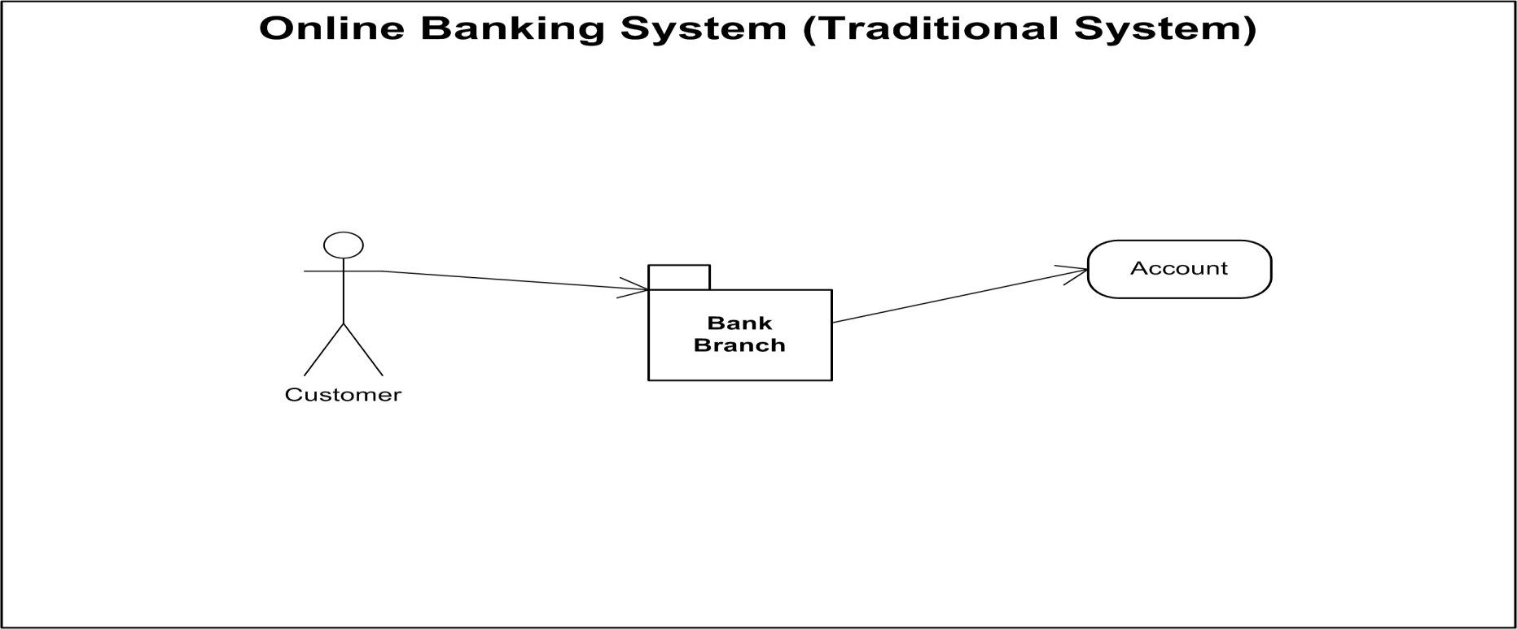

In traditional system, customer should have to visit the Bank branch physically for the transactions or some other task. It wastes time.

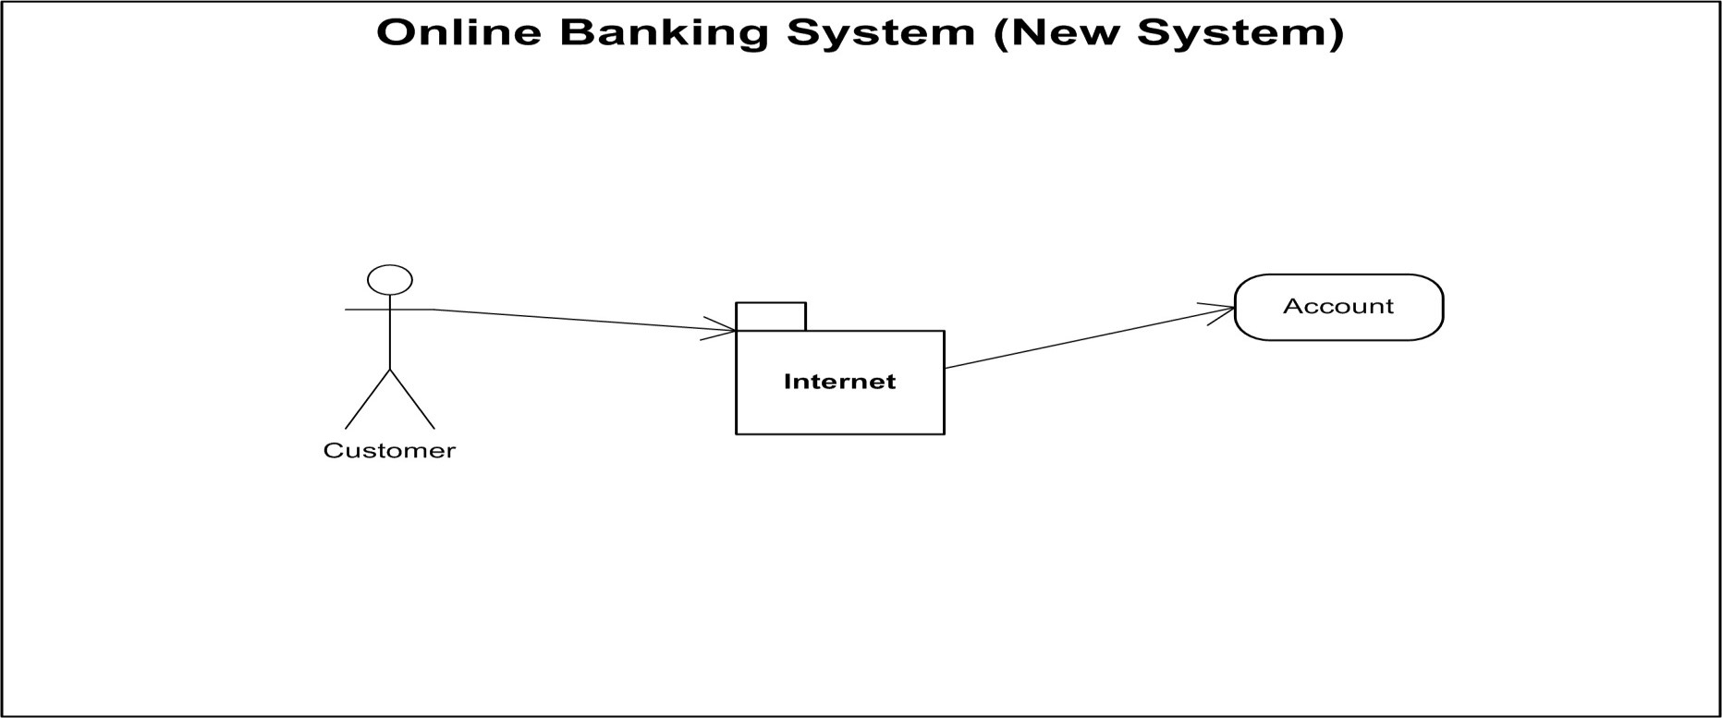

After implementing the online banking system customer will be able to connect to his account through the internet connection. Time usage will be minimized, task will be done fast instead of waiting someone other to complete his task.

* 1. ***Functionalities:***

This software will have following functionalities

* + 1. **Online balance check and transaction information:**

Customer will be able to check his balance online while sitting at home by accessing the database of the bank using his/her password and account no. allotted him by the bank.

* + 1. **Save or view up to 1 year past history of transaction:**

It will be easy for the customer to view or save his history transactions up to past 1year transactions. It will provide him the opportunity to maintain his bank balance and needs.

* + 1. **Balance transfer:**

This system will provide a path to the customer of the bank to transfer his balance to other account in easy steps. A small transfer fee will be applicable for this transaction.

* + 1. **Online record Entry:**

Bank staff will input and maintain their record online. It will be easy and efficient for them to serve more and more people in less time.

* + 1. **Online record search:**

Bank staff will easily search a record and update it if needed. Transactions will be faster even physically from the branch because it will be very easy for the bank staff to check the balance of a specific person and update its record if necessary.

* + 1. **Online Billing Option:**

Customers will be able to shop online and pay the bills from their account. A secure way will be provided for the billing. Online shopping will provide them the easiest way to buy and sell their items.

* + 1. **Check book Allotment:**

If the customer’s checks have been completed, a new check book will be allotted to him.

* 1. ***User Characteristics:***

There are various kinds of users for the product. Usually web products are visited by various users for different reasons.

The users include :

* + 1. Chancellor who will be acting as the controller and he will have all the privileges of administrator.

2.3.2.All the persons who needs to perform banking.

* 1. ***Generals Constraints:***

Some general constraints should be defined which will have a great part in the overall succession of the online banking project.

* + 1. ***Hardware Requirements:***

As this system is an online Web-based application so a client server will be the most suitable Organizational style for this system. Computer systems will be needed by each of the actor as well as that user must be connected to the internet. So, concisely following hardware will be needed.

1. Computer systems
2. Internet availability

***2.4.2. Safety and Security:*** This Project must be safe and secure because customers will directly contact their account through the internet. Software will have to identify the valid customer according to his/her bank details and password. So it is a difficult task to prevent the system by major disasters by preventing the unauthorized access to the system.

***2.5 Assumptions and Dependencies:***

Following are the assumptions and dependencies which are related to this online banking project.

1. This project is a stand-alone project so it will not affect the system where it will be embedded.
2. This project is a web-based project while the staff was addict of using traditional methods of data storage and retrieval so they will be trained a bit to jump to it.
3. This system will not depend on any other module. It will be a web-based so everyone will independently contact it.
4. It is will not affect the environment at all.
5. Banks will feel free to adopt it because it will not be so much expensive.
6. As this project contains valuable and new features so it will probably remove the previous online banking systems embedded in some banks.

1. ***Specific Requirements:***

How the online banking will interact with the environment, what will be the functional and non-functional requirement. These all the steps should be defined here for providing a powerful base to the design phase. The design of the project will completely depend on the functional and non-functional requirements. So these should be defined clearly and accurately for the effectiveness.

***3.1 Functional Requirements:***

Following are the services which this system will provide. These are the facilities and functions required by the customer.

1. Online balance check.
2. Online shopping opportunity.
3. Online data entry by the staff.
4. Updating the data.
5. Balance transfer.
6. Check book Allotment.

***3.1.1) Context Diagram and extent list:***

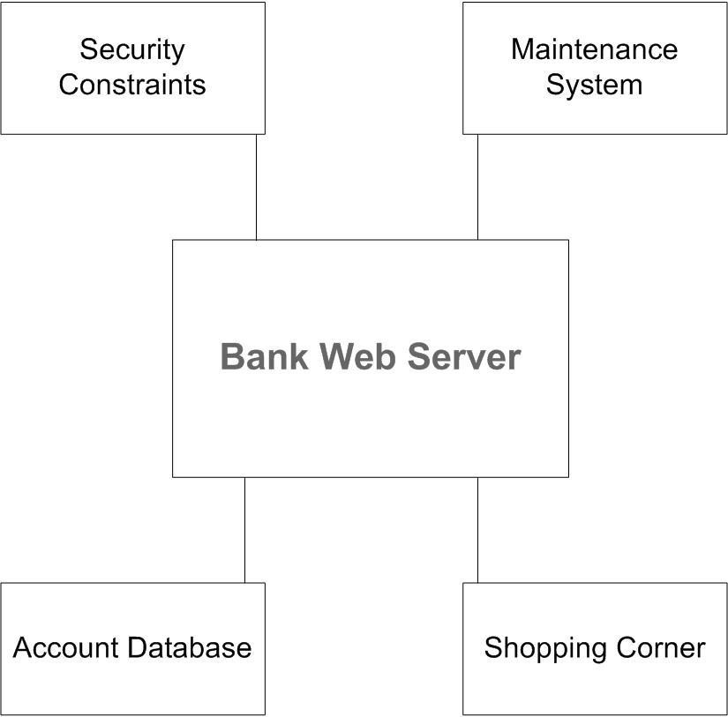

***3.1.2) Dataflow Diagram:***

Following is the data flow diagram for the online banking system.

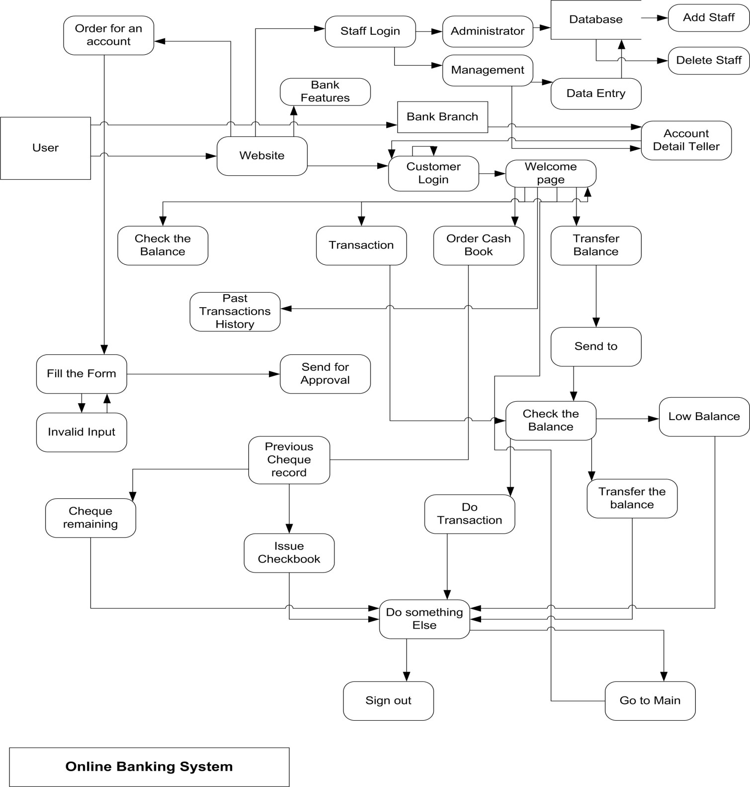

***3.1.3) Process Specification:***

All the process mentioned in the DFD are described as below.

**Customer Login:**

Each Customer will have its account Id and password. This page will require both of these attributes for them to access their account.

**Bank Features:**

It isn’t sure that each visitor of the Bank’s website will be a customer. He/she would be a normal visitor interested in reading the features bank provides. The website’s main page should provide him the basic features and benefits of the bank to these types of users.

**Order for an Account:**

A new visitor the Bank’s website would be interested in opening a new account in the Bank. So he must be provided an easy path to create a new account in the bank.

**Fill the Form:**

New comer should have to fill the form to register him/her self with the bank. After filling the form, If the values inputted by the user were logical correct, his contact details will be sent to the administration block else he will be asked to input the values again.

**Welcome Page:**

After a user will be login, he will provided an interface offering different tasks (Here this interface will provide many of the functionalities, which the customer needs in the software). He has to choose a task to carry on his work.

**Staff Login:**

On the Website main page, A staff login link will also be provided. Bank staff will use to input their ID’s and passwords to access their account. Here the type of staff will also be recognized, if he will be of administration block, he will be sent to the administration module else he will be sent to the record management module.

**Check the balance:**

After logging in, if the user wants to check his balance he will have to click the balance check link. It will tell him his current balance of the account through which he is logged in.

**Transfer Balance:**

If user wants to transfer his money to some other account, then this module will provide him this opportunity. He will input the account details of the receiver. After this process, server will check the balance of the user and if the transfer balance will be less than the account balance then transfer will take place else he will be alarmed that he has lo balance.

**Account detail teller:**

If the user physically contacts the Bank branch then he will provide his account detail to the management staff who will inform him about his account. User will be able to do every task at the branch that he can do online from his home.

**Order Cash Book:**

If user’s Cheque book has been finished, he will be able to order a new cheque book from this module.

***3.2) External Interface Requirements:***

These requirements are discussed under the following catagerisation.

***3.2.1. User interface:***

Application will be accessed through a Browser Interface. The interface would be viewed best using 1024 x 768 and 800 x 600 pixels resolution setting. The software would be fully compatible with Microsoft Internet Explorer for version 6 and above.

No user would be able to access any part of the application without logging on to the system.

***3.2.2. Hardware Interface:***

*3.2.2.1. Server Side:*

1. Operating System: Windows 9x/xp ,Windows ME.
2. Processor: Pentium 3.0 GHz or higher.
3. RAM: 256 Mb or more.
4. Hard Drive: 10 GB or more.

*3.2.2.2. Client side:*

1. Operating System: Windows 9x or above, MAC or UNIX.
2. Processor: Pentium III or 2.0 GHz or higher.
3. RAM: 256 Mb or more.

***3.2.3. Software Interface:***

*3.2.3.1 Client Side:*

HTML, Web Browser, Flash Player, MS Office, Windows XP/9x/ME.

*3.2.3.2. Web Server:*

HTML, MS Office, Windows XP/9x/ME.

***3.2.4. Communication Interface:***

The Customer must connect to the Internet to access theWebsite:

1. Dialup Modem of 52 kbps.
2. Broadband Internet.
3. Dialup or Broadband Connection with a Internet Provider.

***3.3) Non-Functional Requirements:***

Those requirements which are not the functionalities of a system but are the characteristics of a system are called the non-functionalities. Every software system has some non-functionalities. Just fulfilling the requirements of the user is not a good task, keeping the system accurate, easy to maintain, reliable and secure is also a basic part of software engineering. Online Banking System must have the following non-functional requirements so that I could be said as a complete system.

1. ***Conformance to specific standards:***

1. ***Performance constraints:***

This system must be fit according to the performance wise. It should use less memory and will be easily accessible by the user. Memory management should be done wisely so that none of the memory part goes wasted.

1. ***Hardware limitations:***

It should be designed in such a way that cheap hardware must be installed to access and use it effectively. It should be platform independent. There should be no hardware limitations. In should be designed to work with the low specification hardware so that it could easily work with the high specification hardware.

1. ***Maintainable:***

Each of the modules should be designed in such a way that a new module can easily be integrated with it.

1. ***Reliable:***

1. ***Testable:***

**3.4) Other Requirements:**

***Software Quality Attributes:***

The Quality of the System is maintained in such a way so that it can be very user friendly to all the users.

The software quality attributes are assumed as under: a) Accurate and hence reliable.

1. Secured.
2. Fast speed.
3. Compatibility.

1. ***Possible Product Evolution:***

Not even one system maintains its stability for a very long period. Every system requires evolution according to the time and fashion introduced in the market as well as due to lot of competition companies have to change their system to provide more features to their customers to compete the society.

Following are some perspectives according to which this system can be maintained in the future. These are key points according to which it would need a great evolution soon.

* 1. ***Credit Card Management:***

Credit cards are the key feature for the online shopping. These cards provide the easiest way to shop almost at all well known shopping malls and many other places. As it isn't so popular in the environment where this system is going to be installed but it might start working soon when this fashion (Requirement) will be needed. So it is the basic evolution which might be necessary soon.

* 1. ***Interface evolution:***

As the user interface created by the software designers will be good looking and easy to use but according to the fashion and time, selection of colors usually change person to person. Style of the system will become old and it will surely need evolution to provide a new and cool look to the users.

* 1. ***Technology Evolution:***

This system is going to be designed by using MS Access and JSP for the server pages and HTML for the user interface. As these languages provide much security in the current situation but According to the most security Issues these languages might crash or slow down in the future and at that time this system might be replaced by .net technology for the security purposes because Online Banking needs more safety and security than other software projects.