|  |  |  |  |  |  |
| --- | --- | --- | --- | --- | --- |
| **Experiment Number : 4** | | | | | |
| **Date of Performance:** | | **22-08-2022** | | | |
| **Date of Submission:** | | **29-08-2022** | | | |
| **Program Execution/ formation/ correction/ ethical practices (07)** | **Documentation (02)** | **Timely Submission (03)** | **Viva Answer to sample questions (03)** | **Experiment Total (15)** | **Sign** |
| **7** | **2** | **1** | **2** | **12** |  |

Experiment No: 4

**Aim:** Structured Data Flow Analysis of Online Banking System

**Lab Outcome:** CSL501: Develop architectural models for the selected case study.

[Data Flow Diagrams](https://www.geeksforgeeks.org/what-is-dfddata-flow-diagram/) are used to represent the flow of data as well as the processes and functions involved to store, manipulate, and distribute data among various components of the system and between the system and the environment of the system by a specific set of graphical representations. It also depicts the logical flow of information in a system and appropriately defines and determines the physical requirements for the construction of the system. The key features of a Data Flow Diagram involve simplicity of notation as well as generation of a clear overview of the manual and automated requirements of the system.   
The system is described as follows –

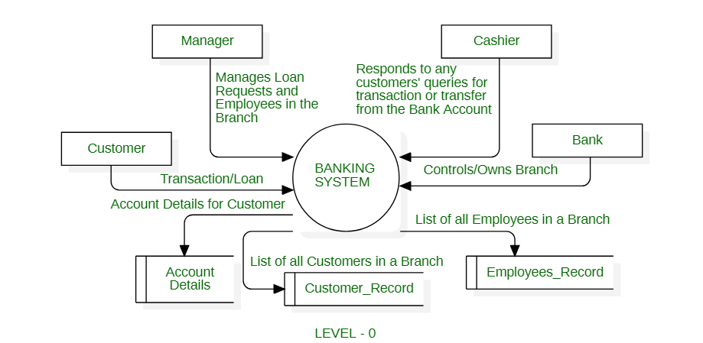

**Explanation :**

1. **Transaction Request/Loan Request –**  
   In this customer provides the specific details to initiate or support a transaction and the customer can apply for a loan through the system.
2. **Manager –**   
   The manager can access and manage any request as well as input commands to change or update Employee_Record Database. A Manager manages the employees of the bank as well as either accepts or rejects any Loan Request and hence inputs details to update the corresponding databases as  Customer_Record and Employee_Record Database.
3. **Cashier –**  
   Itresponds actively to any Transaction Request and assists the Manager. The cashier can also resolve any query from the Customer and provide immediate help to the Customer. However, a Cashier can not access any database independently.
4. **Bank_Headquarter –**   
   It acts as an entity that controls all the branches of the Bank. The entity can access all the databases, and it also controls the operations of the Manager. The Bank can modify or eliminate any policies as well as create new policies for the Online Banking System.
5. **Customer_Record –**  
   It stores all the non-personal details of an individual who is a Customer of any specific branch of the Bank. As an individual initiates a request to open an account in the Bank, Customer_Records creates a new entry that is unique and specific to the Customer only. This record is accessible by Managers or Employees of the Banks as and when required.
6. **Employee_Record –**  
   It stores the record of all the Employees at the Bank. The record can be accessed but not modified by the Customer of the Bank. The record can be modified by either the Manager of a Branch or by the Bank itself.
7. **Account_Details –**  
   Itstores the personal details of every individual Customer. It can be accessed/modified by the Customer only. The Bank can not modify the personal details of the Customer.

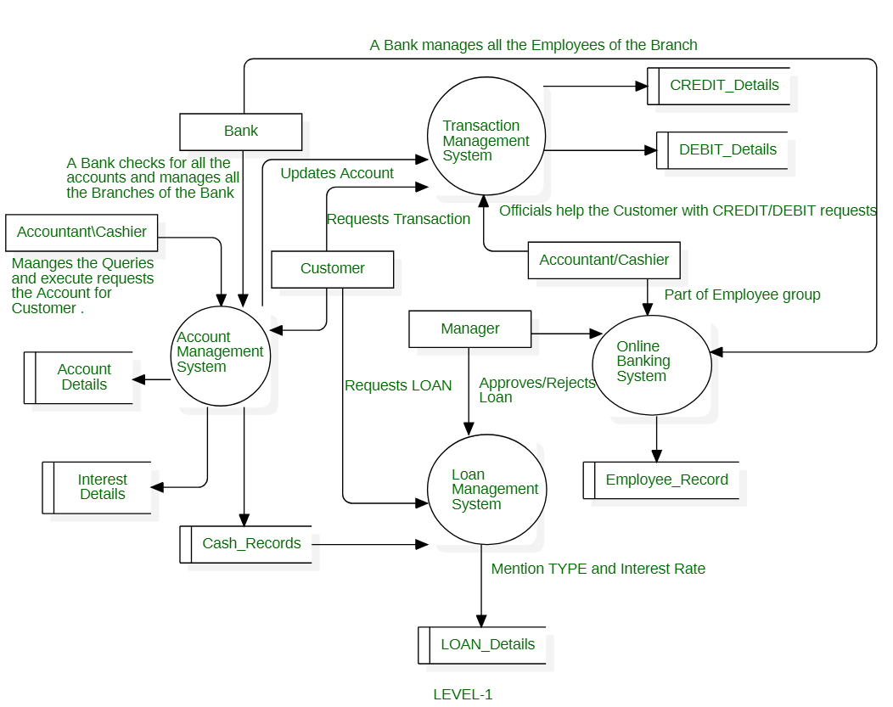

**Processes :**

1. **Account Management System –**   
   In this Customer can access all the services offered by the Bank by adding his details. As the Customer avails any services as a transaction or a loan, then the required data flows to Transaction Management System or the Loan Management System respectively. Any Customer can print the activity status of the account which fetches information from all the available databases using the Generate Customer Report System.
2. **Transaction Management System –**   
   It helps theCustomer to add/transfer money to another account. The Cashier may execute or help execute the transaction process on behalf of the Bank where the Bank updates all the corresponding details related to the Customer following a successful transaction.
3. **Loan Management System –**   
   It is used by the Customer to apply or request a Loan from theBank. The Manager can access the Loan_Details database to either accept or deny the request for the Loan. The Bank has the access to modify the Loan Management System as the Bank can set or modify any policies of the Loan offered by the Bank.
4. **Online Banking System –**   
   It provides other services like insurance, bill payments, etc.

The Level-2 Data Flow Diagram of an Online Banking System is as follows –

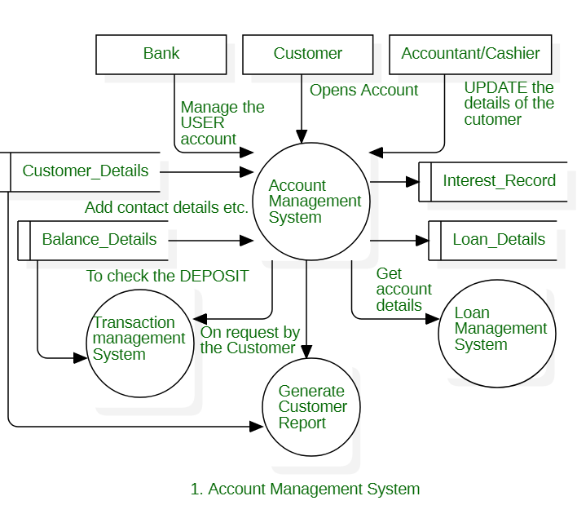

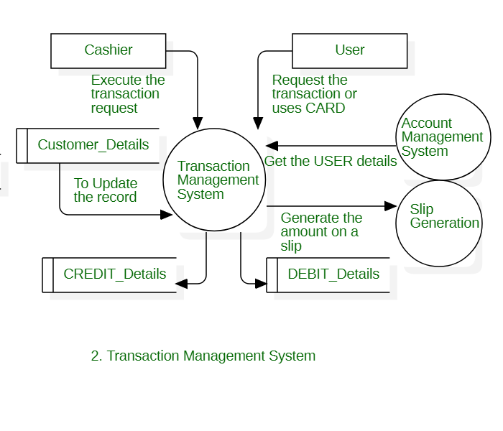

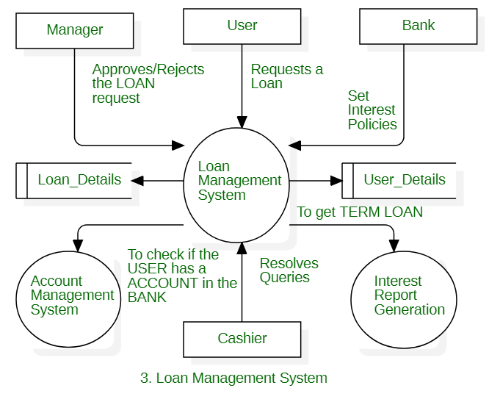

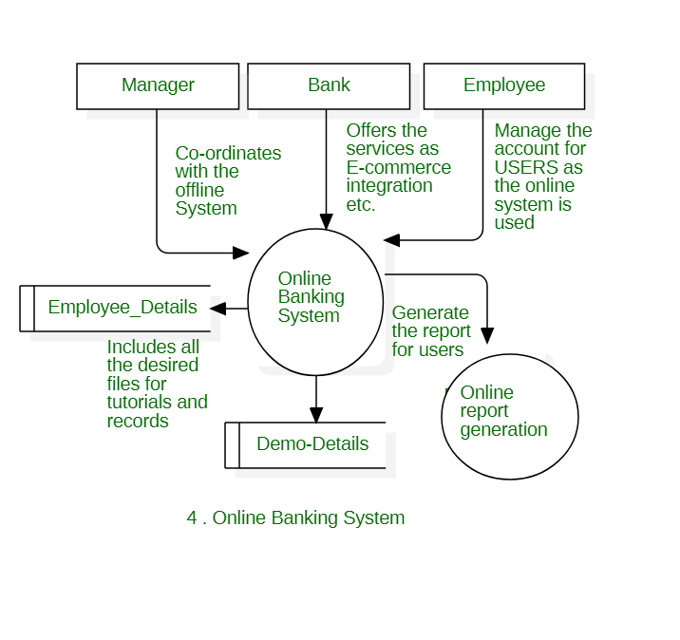Hence, a Data Flow Diagram clearly represents the flow of information or data in a system design.