|  |  |  |  |  |  |
| --- | --- | --- | --- | --- | --- |
| **Experiment Number : 5** | | | | | |
| **Date of Performance:** | | **22-08-2022** | | | |
| **Date of Submission:** | | **29-08-2022** | | | |
| **Program Execution/ formation/ correction/ ethical practices (07)** | **Documentation (02)** | **Timely Submission (03)** | **Viva Answer to sample questions (03)** | **Experiment Total (15)** | **Sign** |
| **6** | **2** | **2** | **3** | **13** |  |

Experiment No: 5

**Aim:** Use of metrics to estimate the cost

**Title:** Online Banking System

**Lab Outcome:** CSL501: Develop architectural models for the selected case study

**Problem Statement:** Project on Online Banking System is to manage the details of Account, Bank, Customer ,Transaction, Internet Banking. It manage all information about Account, Balance, Internet Banking , Accounts. The project is totally built at administrative end and thus, only the administrator access is guaranteed the access. The purpose of the project is to build an application program to reduced the manual work for managing the account, balance ,bank, customer. It tracks all the details of transaction, Customer and Internet Banking

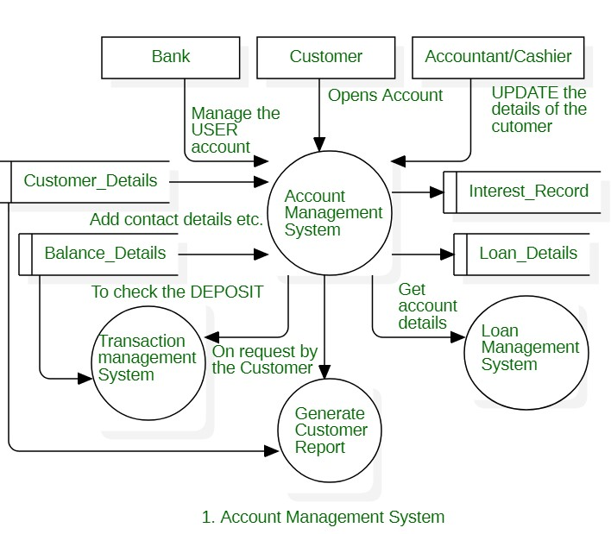

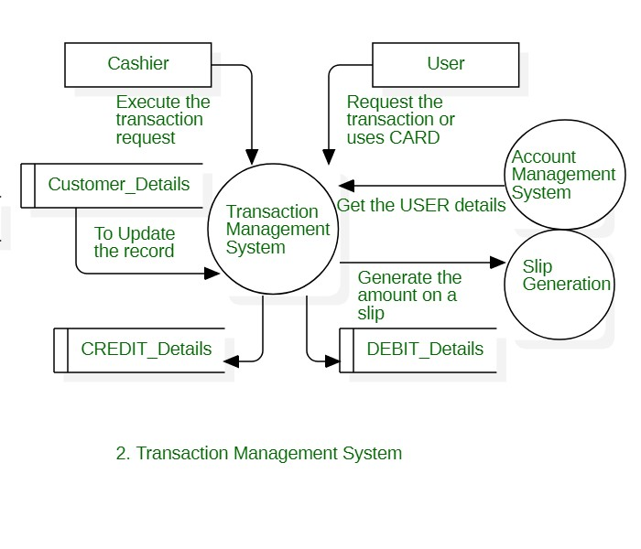

**Fi[i=1 to 14]Value Adjustment Factor:**

1. Does the system require reliable backup and recovery? **Ans.** 5
2. Are specialized data communications required to transfer information to or from the application? **Ans.** 3
3. Are there distributed processing functions? **Ans**. 5
4. Is performance critical? **Ans.** 2
5. Will the system run in an existing. heavily utilized operational environment? **Ans.** 5
6. Does the system require online data entry?

**Ans.** 5

1. Does the online data entry require the input transaction to be built over multiple screens or operations? **Ans.** 3
2. Are the ILFs updated online? **Ans.** 5
3. Are the inputs, outputs, files, or inquiries complex? **Ans.** 1

10.Is the internal processing complex? **Ans.** 4

11.Is the code designed to be reusable? **Ans**. 5

1. Are conversion and installation included in the design?

**Ans.** 5

1. Is the system designed for multiple installations in different organizations?

**Ans.** 5

1. Is the application designed to facilitate change and ease of use by the user? **Ans**. 5

∑(Fi ) = 58

|  |  |  |  |
| --- | --- | --- | --- |
| Information Domain Value | Count | Simple(Weighting Factor) | Value |
| External Inputs | 4 | 3 | 12 |
| External Outputs | 3 | 4 | 12 |
| External Inquires | 3 | 3 | 9 |
| Internal Logical Files | 2 | 7 | 14 |
| External Interface Files | 0 | 5 | 0 |
| Count Total |  |  | 47 |

Function Point = Count Total x [0.65 + 0.01 x ∑(Fi )]

= 47 x [0.65 + 0.01 x 58]

= 47 x [0.65+0.58]

= 47 x 1.23

= 57.8

**Conclusion:** Thus, we have successfully calculated the Function Point of the given system