|  |  |  |  |  |  |
| --- | --- | --- | --- | --- | --- |
| **Experiment Number: 7** | | | | | |
| **Date of Performance:** | | **29-08-2022** | | | |
| **Date of Submission:** | | **05-09-2022** | | | |
| **Program Execution/ formation/ correction/ ethical practices (07)** | **Documentation (02)** | **Timely Submission (03)** | **Viva Answer to sample questions (03)** | **Experiment Total (15)** | **Sign** |
| **7** | **2** | **3** | **3** | **15** |  |

Experiment No: 7

**Aim:** Write test cases for Black Box testing.

**Title:** Online Examination System.

**Lab Outcome:** Use computer-aided software engineering (CASE) tools.

**Problem Statement:**

**On-line** **examinations** contents providers to focus on creating effective assessment questions and focusing on exam’s feedback delivery to student.As the modern organizations are automated and computers are working as per the instructions, it becomes essential for the coordination of human beings, commodity and computers in a modern organizations. The administrators ,instructor,Students who are attending for online examination can communicate with the system through this projects, thus facilitating effective implementation and monitoring of various activities of Online Examinations like conducting Exams as per scheduled basis and delivering result to that particular use or student.And the details of students who attempted Online Examination are maintained at administrator.

**Black Box testing**

Black Box Testing is a software testing method in which the functionalities of software applications are tested without having knowledge of internal code structure, implementation details and internal paths. Black Box Testing mainly focuses on input and output of software applications and it is entirely based on software requirements and specifications. It is also known as Behavioral Testing.

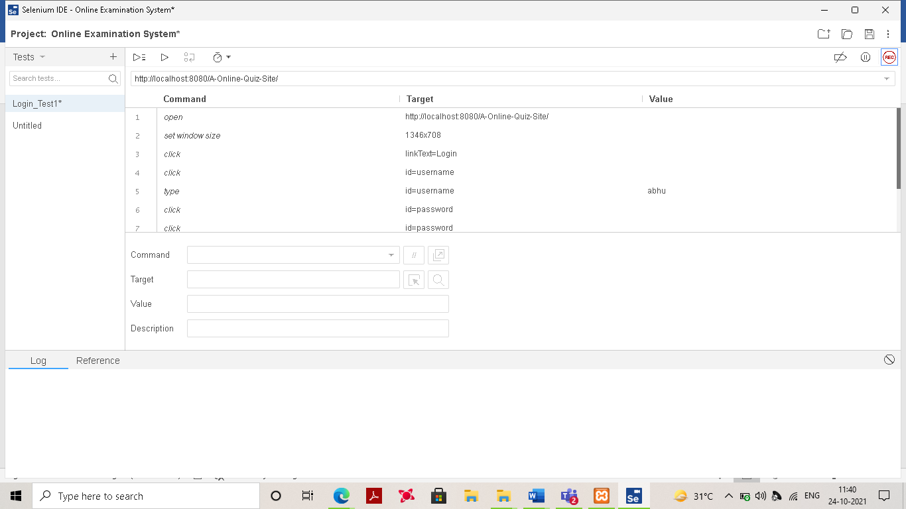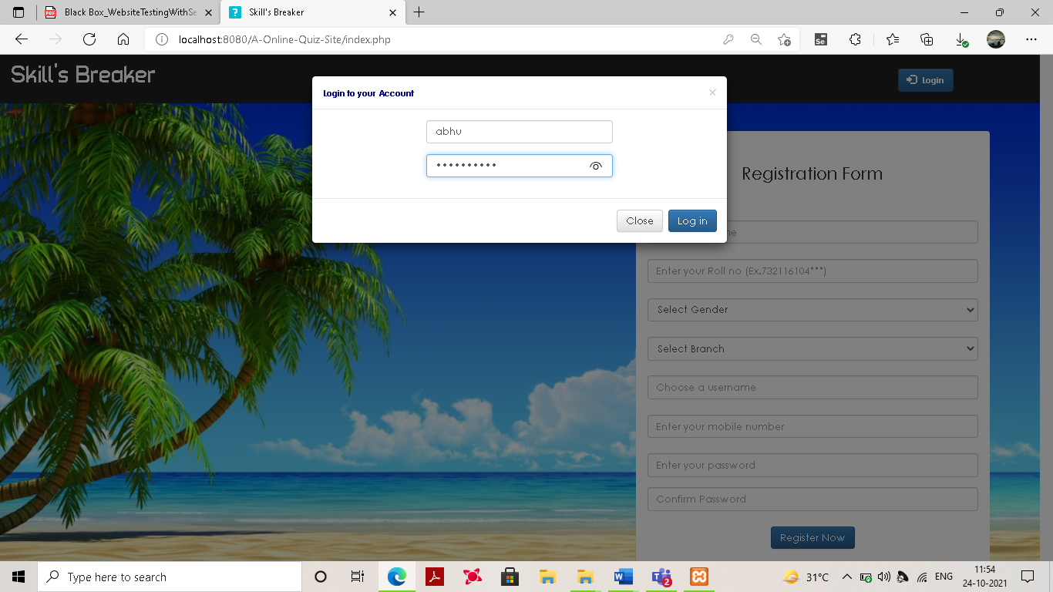

.

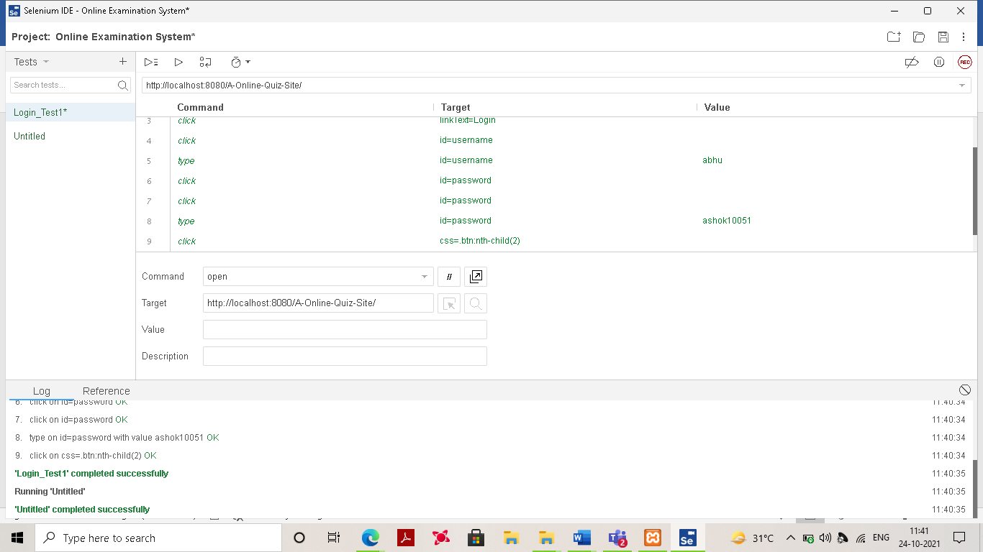

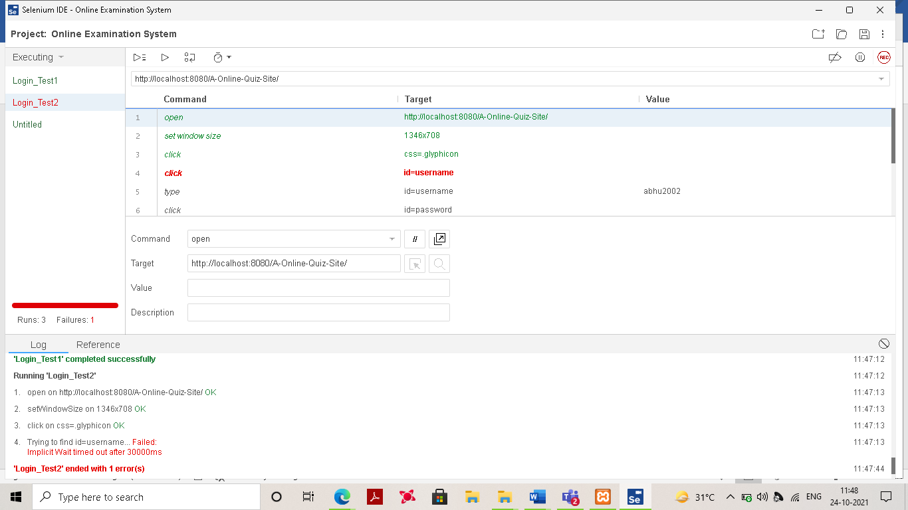

**Conclusion:** Selenium-IDE meets the need for automation of test cases for websites by using a simple solution, considering this is small software installed as Firefox plugin. Selenium-IDE provides flexibility in creating test cases allowing the organization of groups (Test Suites). Moreover, the data used in the execution of tests are editable during the execution itself, allowing the tests to be repeated with a greater variety of data, increasing tests quality