Understanding the R software/interface

General view upon opening
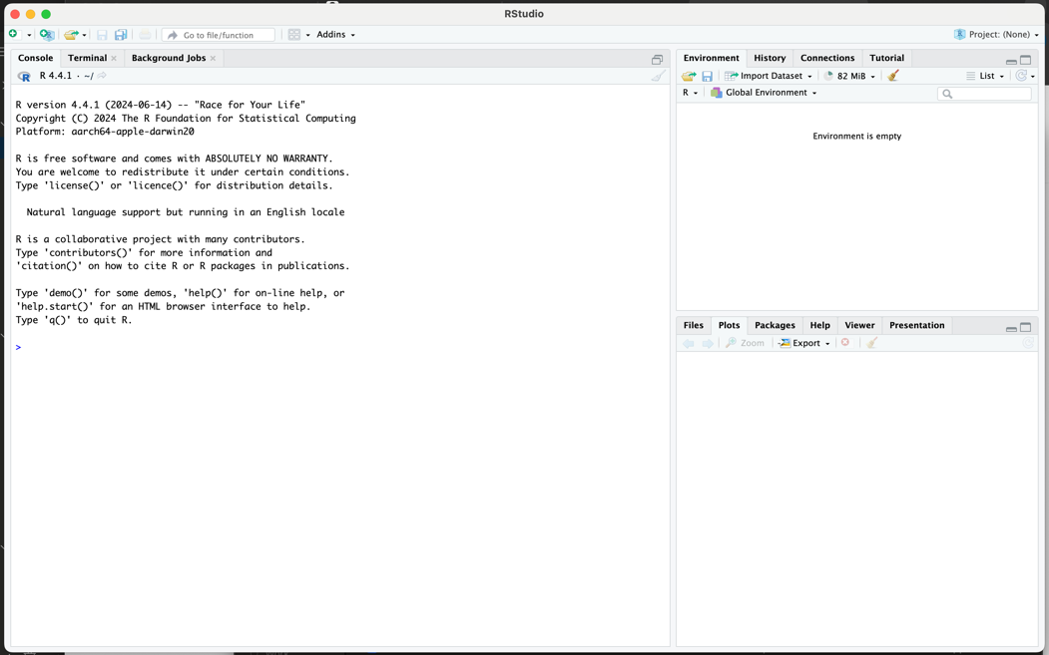

View when opening an R script
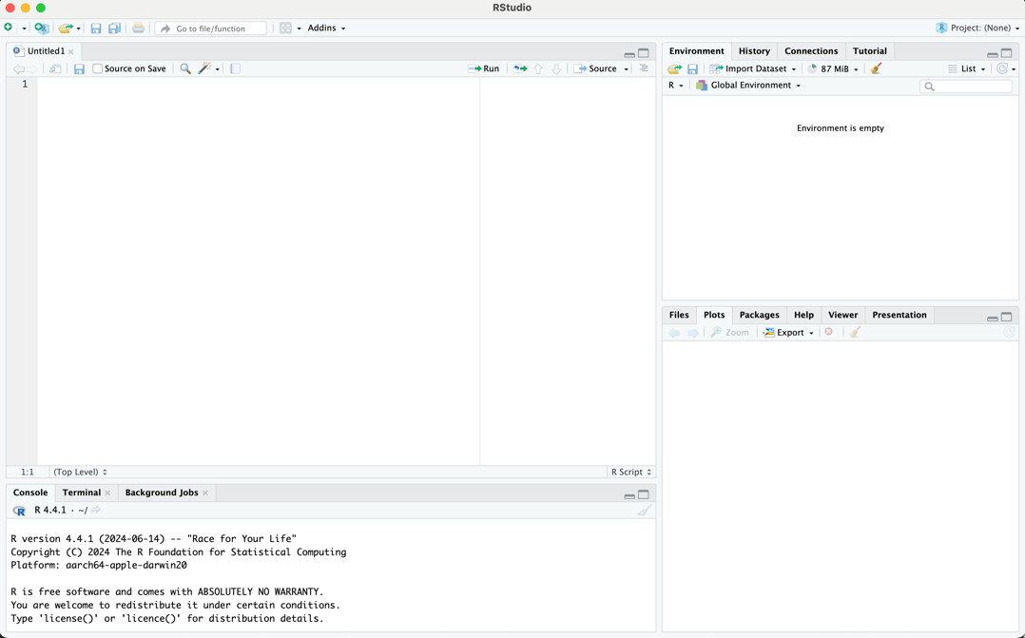

View of Environment when there is a dataframe (aka dataset) and a variable entered into the program.

