Exp No: 11

AIM:

STUDY OF GPIO & BIT ADDRESSING IN AT89C51

To study GPIO control and bit-addressable SFR using Embedded C.
OUTPUT:

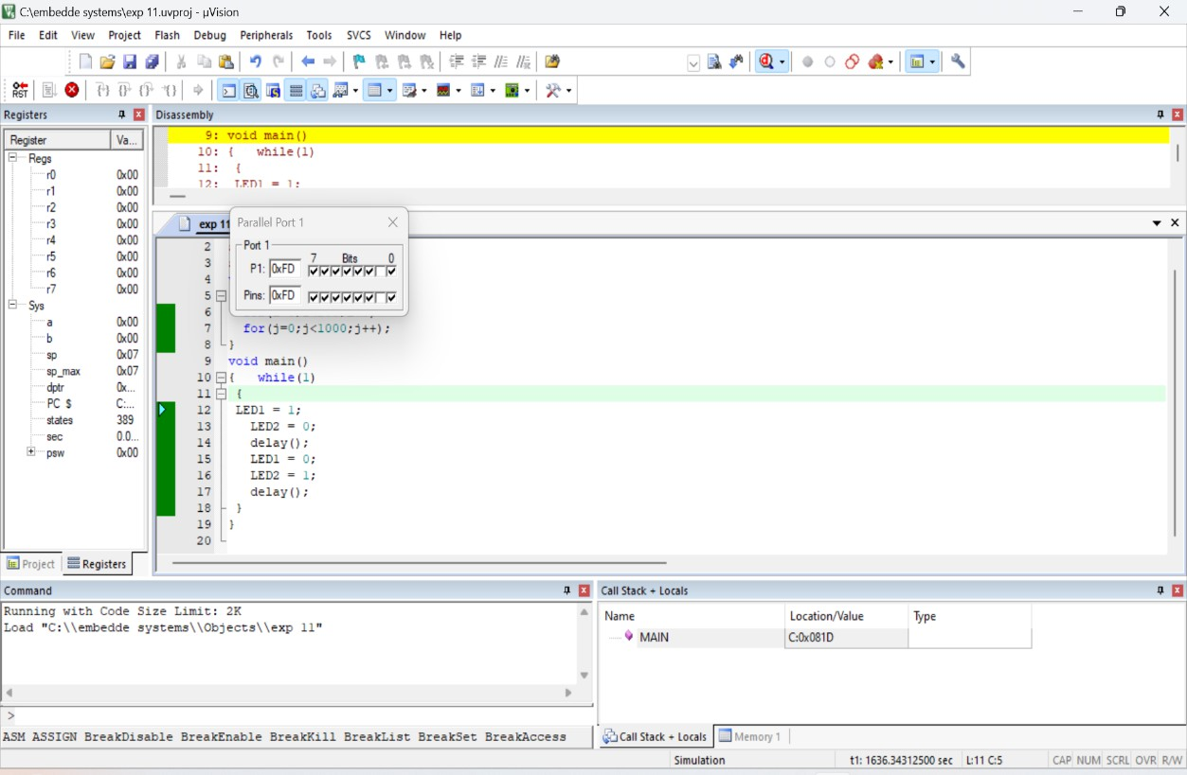

RESULT:
Thus GPIO and bit addressing was studied and in Port1 the pins P1.0 and P1.1 toggled alternately.

