Exp No: 15
EMBEDDED C PROGRAM TO CONVERT THE HEXADECIMAL DATA 0XCFH TO DECIMAL AND DISPLAY
THE DIGITS ON PORTS P0, P1 AND P2
AIM:
To write an Embedded C program to convert Hexadecimal numbers into Decimal and display the digits on ports using Keil software.
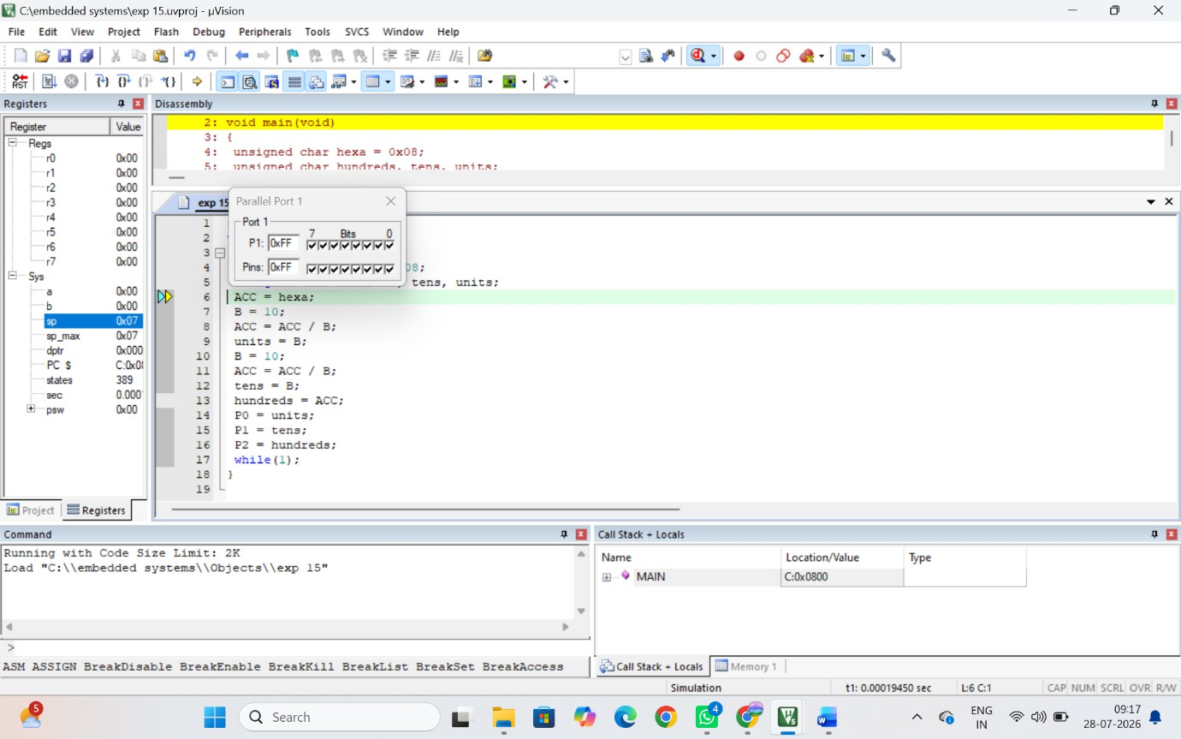
OUTPUT:

RESULT:
Thus the program has been successfully verified and executed

