Exp No: 17

UART INTERFACING USING INTERRUPT IN KEIL

AIM:
To receive serial data using interrupt.

OUTPUT:

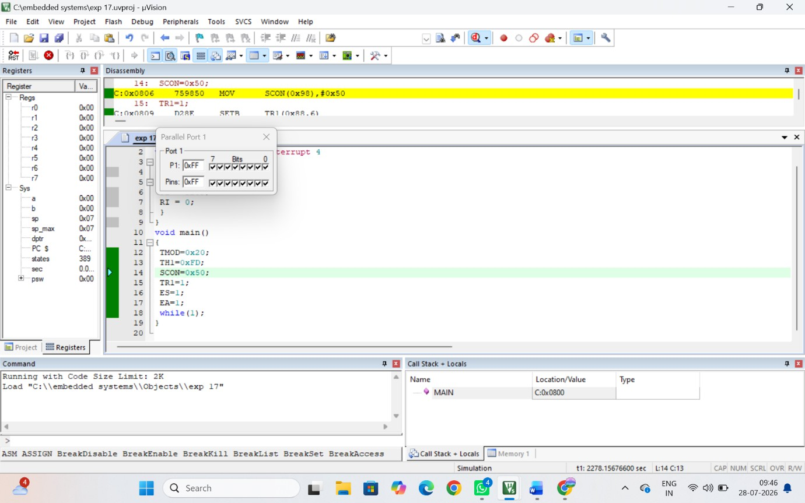

RESULT:
Thus the serial data was received using Interrupt and the received data was verified.

