**KANTONO MARION 2015/BIT/080/PS**

A base class for all GUI components is known as a view. For example buttons, text view, edit Text, progress bar, etc. A view Group is a subclass for the view class and it works as a container for other instances, for example List View, Linear layout, and so on.

Examples of views commonly used in android

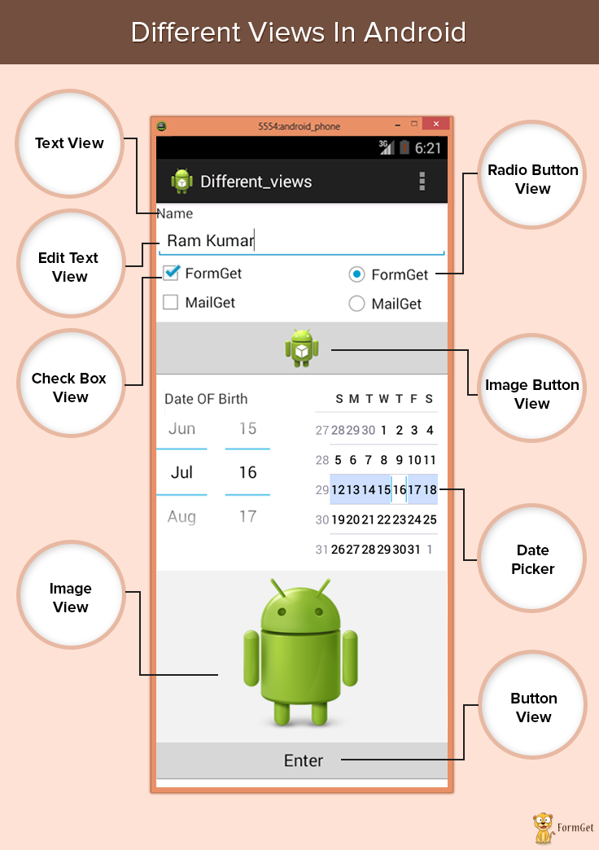

**REFERENCE for the diagram above:** <https://developer.android.com/reference/android/view/View.html>

Implementing the functionality of at least two views

**Text view.** It displays text on the android application screens especially phones. It also allows user to optionally edit what is being typed.

Note: Edit Text class is included to do so because the basic class does not do the editing

**Edit Text.** It is used by a user of the application to type or fill in what is required that is building the data interface taken from any user.

it also contains certain features through which we can hide the data which is confidential like when using edit text “password” you enter digits but another person next to you can’t see it because it is hidden that is displaying either “dots”(….) or “xxx” This class makes text to be editable in Android application

**Check Box**. It is mainly used in applications where we have to select one option from multiple provided. Checkbox is mainly used when 2 or more options are present.

A user may be able to select more than one option unlike for radio buttons where a user only selects one option

**A simple report explaining the views utilized.**

**Text view.** This displays text on the android application screens especially phones. In simple terms, when you are designing in android studio you use text view and type anything you want to be displayed. This mainly displays what a programmer wants a user of his/her application to view or read is displayed (text.)

Example of text views I have used are name, university, course and year of study, the text view “see the output” displays what has been entered after clicking on the button

**Edit Text**. This type of view is mainly used by the application users to type or filling in what is needed or required by the programmer or what the application requests for.

It helps in building the data interface taken from any user. A user can be able to edit or erase what he/she has typed.

**Button View**. When a user clicks or taps on a button, for example “send” it means that the button has to send some information to a database (where the data is to be saved and seen by the person responsible for that application it might be a company, individual).

The button must be working such that when a user uses it, a certain action must occur. For example in my application I am using a button “checked it out” so if a user of my app clicks on that button after inserting in what is required, he/she is able to see what has been typed meaning my there is an action taking place behind my button for it to display what has been typed. So buttons are very helpful in getting into content.

A screen shot for my application

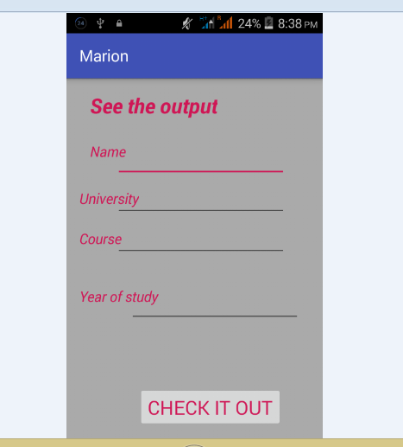

What my application displays

