**A simple report explaining the views utilized.**

**Text view.** This displays text on the android application screens especially phones. In simple terms, when you are designing in android studio you use text view and type anything you want to be displayed. This mainly displays what a programmer wants a user of his/her application to view or read is displayed (text.)

Example of text views I have used are name, university, course and year of study, the text view “see the output” displays what has been entered after clicking on the button

**Edit Text**. This type of view is mainly used by the application users to type or filling in what is needed or required by the programmer or what the application requests for.

It helps in building the data interface taken from any user. A user can be able to edit or erase what he/she has typed.

**Button View**. When a user clicks or taps on a button, for example “send” it means that the button has to send some information to a database (where the data is to be saved and seen by the person responsible for that application it might be a company, individual).

The button must be working such that when a user uses it, a certain action must occur. For example in my application I am using a button “checked it out” so if a user of my app clicks on that button after inserting in what is required, he/she is able to see what has been typed meaning my there is an action taking place behind my button for it to display what has been typed. So buttons are very helpful in getting into content.

A screen shot for my application

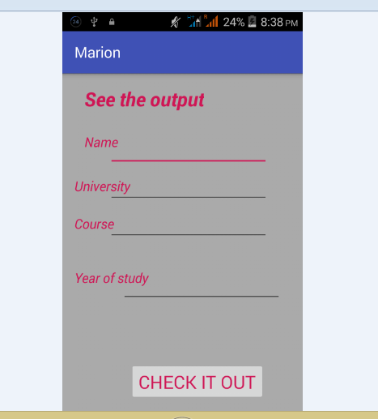

What my application displays

