MERIDIAN TECHNOLOGIES | INVESTOR DAY | MARCH 11, 2026 | CONFIDENTIAL

Investor Day Positioning Memo
Subject: Meridian's Strategic Identity Declaration — Agentic Work Platform
From: Catherine Park, President & CEO Date: March 5, 2026 For: Board + IR Pre-Read

EXECUTIVE SUMMARY
On March 11, Meridian will declare itself the governed agentic work platform — the only enterprise platform where AI agents operate under the audit, control, and compliance infrastructure that regulated industries require. This is not a pivot away from project management; PM is the surface on which our enterprise relationships were built and remain valuable. It is a declaration that the next decade of enterprise work will run on agents, and that Meridian is uniquely positioned to own the governance layer those agents require. No competitor has built it. Our customers have already told us they need it. The Helio acquisition gave us the engineering architecture to deliver it. This memo explains the position, the competitive rationale, the risks we are accepting, and the commitments we are making to investors.

THE POSITION
Meridian is the governed agentic work platform. Projects are how we started; governed agents are how enterprise work actually gets done in the next decade — and we run on the most trusted compliance infrastructure in the collaboration category.

WHY THIS POSITION, WHY NOW
- Customer demand is unambiguous. 18 of 22 enterprise advisory board sessions in the last 90 days flagged agent governance as a blocking requirement — not a nice-to-have. Auditability, role-based agent permissions, model selection, and data residency are the conditions under which regulated-industry buyers will greenlight agentic tooling at all.
- The white space is unoccupied. No competitor has built the governance layer for agentic enterprise. Asana and Monday have bundled AI into standard tiers but have no FedRAMP, no HIPAA, and no governance infrastructure for agent actions. Atlassian is the most credible agentic player (Rovo, consumption pricing) but is explicitly weaker outside software/IT organizations. Smartsheet owns the PM-with-governance narrative but is growing at low-single digits and is widely seen as an acquisition target.
- We have the infrastructure to win it. Meridian already has FedRAMP Moderate, HIPAA, and a governance stack cited in 23 enterprise wins. The Helio agent framework, acquired November 2025, compresses the agentic roadmap by 15 months. The Copilot governance suite ships Q1 2026. No competitor can replicate this in less than 12–18 months.
- The alternative is a losing position. Option A — PM-with-AI add-on pricing — is a race to the bottom. Asana bundled AI in November 2025. Monday bundled in January 2026. Mid-market customers are already refusing to pay $40/seat extra for Copilot. The bundling trend does not reverse. Declaring Option A means competing on price with players that have more users, more training data, and lower price points.

COMPETITIVE LANDSCAPE
Exhibit A — Four Competitors Across Key Dimensions (as of Feb 2026)
Competitor | AI Positioning | Pricing Posture | Latest Flagship  Announcement | Closer to  Meridian Option
Asana | "Work management  platform with AI  built in" — uses  agentic language;  flags AI Studio  and Smart Workflows | AI bundled into  Advanced+ tiers  (Nov 2025). No  consumption  pricing. | AI Studio + Smart  Workflows bundled  at no extra cost  (Nov 2025). Hinted  agent marketplace  later 2026. | Option B  (agentic language;  bundled pricing)
Monday.com | "Work OS,  supercharged with  AI" — broad  platform framing;  agents available  across the OS | monday AI Agents  bundled into Pro+  (Jan 2026). No  consumption. Most  aggressive bundler. | monday AI Agents  GA — customer-  buildable agents  in natural language  (Jan 2026). | Option A/B hybrid  (Work OS primary;  AI everywhere;  but no governance)
Smartsheet | "Enterprise work  platform you can  trust with AI" —  explicitly rejects  agentic framing;  prefers "AI-  augmented" | Smartsheet AI  bundled in Business+.  AI Compliance Pack  as premium add-on  (~$15/seat/mo).  No consumption. | AI Compliance Pack  — governance, audit,  model selection for  agents (Dec 2025).  Enterprise only. | Option A  (PM-centric;  governance focused;  low growth)
Atlassian  (Rovo) | "Agentic enterprise  platform for software  and IT teams" —  most committed  agentic posture;  "becoming an  agent company" | Rovo: per-seat  ($20/mo) + per-  action consumption.  Only competitor with  consumption pricing  today. | Rovo Studio GA —  developer-targeted  agent builder on  Atlassian infra  (Jan 2026). | Option B  (agentic; consumption  pricing; weaker in  regulated industries)

EXHIBIT B — COMPETITIVE POSITIONING MATRIX
X-axis: PM-centric → Agentic. Y-axis: Bundled/free → Premium/consumption. Green star = Meridian's declared Option B position.
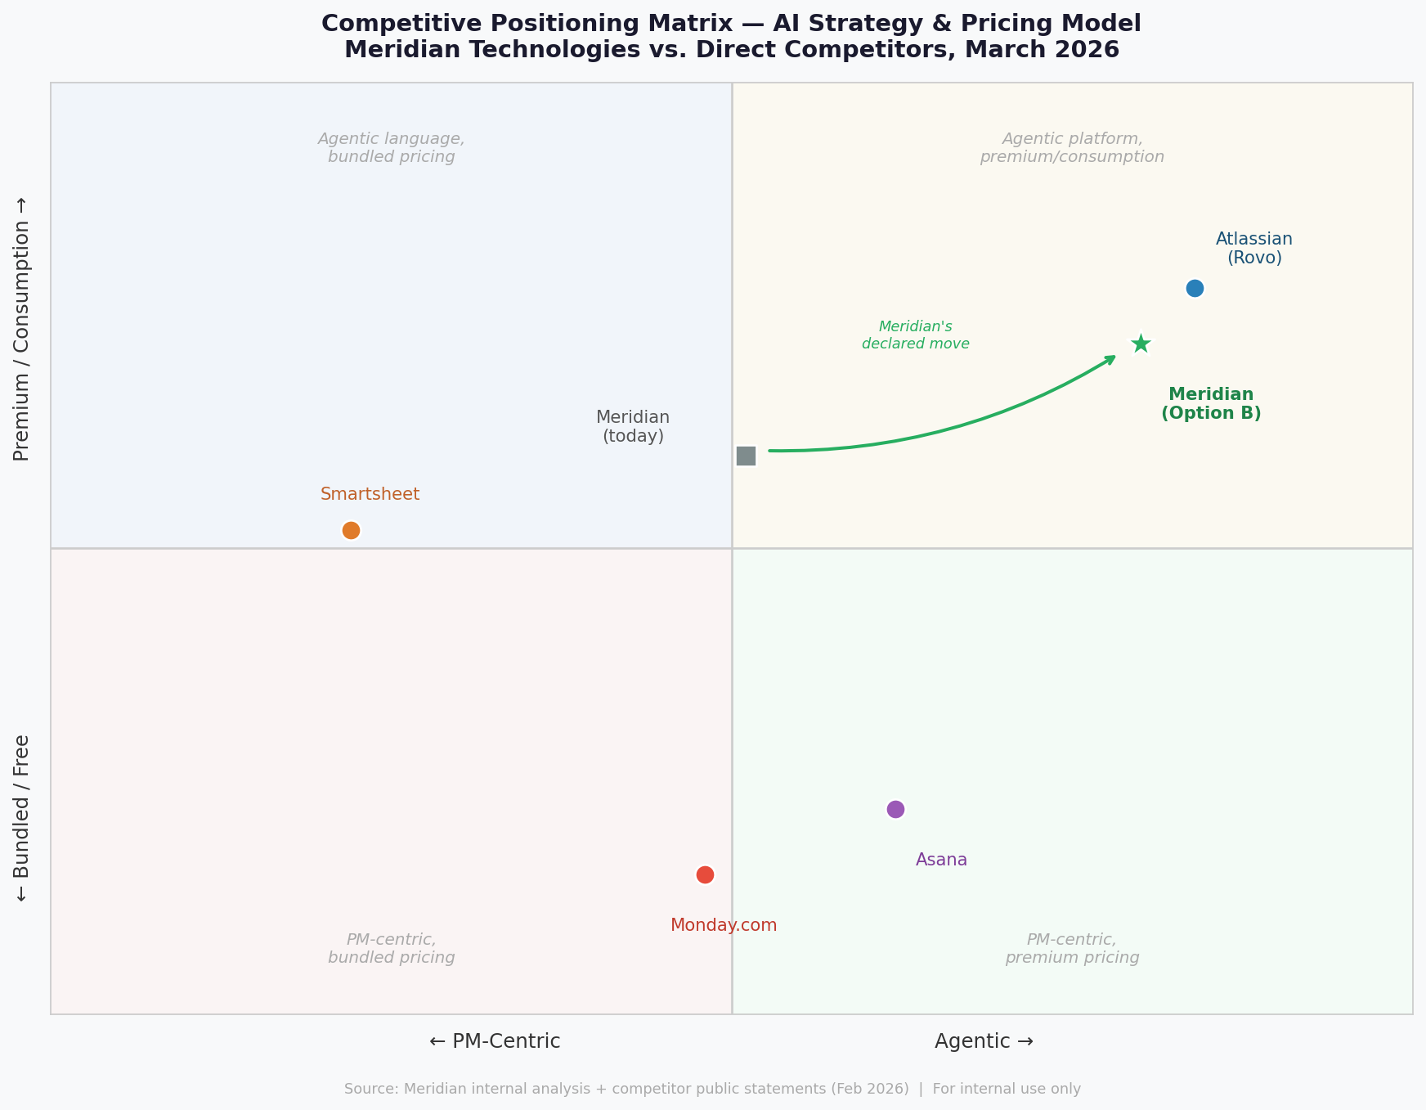

THREE RISKS WE ARE ACCEPTING
Risk 1: Consumption pricing adoption is slower than modeled.
Regulated-industry buyers have procurement cycles and budget approvals built around per-seat licenses. If consumption pricing adoption is 12–18 months slower than modeled, Meridian faces an air gap: PM revenue deemphasized before agentic consumption revenue ramps. Mitigation: per-seat licensing remains the default; consumption is an optional upgrade, not a requirement, through end of 2026.
Risk 2: Atlassian closes the regulated-industry governance gap faster than expected.
Atlassian's Rovo Studio, their Oct 2025 agent observability acquisition, and their Anthropic partnership signal a governance build. If Rovo ships a governed agentic layer for non-developer enterprise organizations by mid-2027, Meridian's 'only governed agentic platform' claim becomes 'one of two.' Atlassian has more engineers and a larger install base. Mitigation: ship the Copilot governance suite (Q1 2026) and secure two public regulated-industry lighthouse references before Investor Day.
Risk 3: The identity transition accelerates mid-market churn.
Mid-market is $194M ARR and NRR is already compressed to 102%. If 'agentic platform' lands in Q1 renewal conversations as 'deprioritizing PM features,' NRR could compress toward sub-100% — a $0–$4M ARR headwind on top of the existing SMB $30M drag. Mitigation: a clear internal communication playbook for Sales/CS before March 11, emphasizing that PM functionality is fully maintained and governance is the added layer.

THREE COMMITMENTS TO INVESTORS
Commitment 1: Governance suite ships Q1 2026 — no further slips.
The Copilot enterprise governance suite — agent-level audit logs, role-based agent permissions, model selection, and data residency controls — will be generally available in Q1 2026. This is the product that validates the governed agentic platform claim. We will report attach rate, enterprise coverage, and regulated-industry win rates publicly every quarter starting Q1 2026.
Commitment 2: Consumption pricing announced H2 2026; modeled conservatively.
We will announce the per-seat plus consumption pricing model in H2 2026 and provide investors with the assumptions behind our ramp projections. We will not bridge a guidance shortfall with consumption revenue that has not been contracted. The 2026 revenue guidance of $440–$455M does not assume consumption pricing as a material contributor; it is upside, not baseline.
Commitment 3: A clear, durable answer to 'what is Meridian' — one that holds for three years.
We will not shift this positioning in response to quarterly competitive moves. Asana and Monday have repositioned their AI narrative quarterly. We will not. The governed agentic platform for regulated enterprise is our identity for 2026, 2027, and 2028. Investors, customers, and employees will be able to hold us to it. We will report progress against it at every earnings call.

Catherine Park, President & CEO · Meridian Technologies (NASDAQ: MRDN) · Investor Day 2026 · Strictly Confidential

