BOARD OF DIRECTORS — ANNUAL STRATEGIC REVIEW | 2026

Meridian has a real asset in enterprise and a structural problem in growth —
this is the year we decide which story we tell.

Thank you for being here. This is my first annual strategic review with this board, and I want to use this time as a genuine working session — not a slideshow. I'll give you three minutes of honest context on where we stand, then I have one specific ask, and then I want your judgment.
ISSUE 1 · THE AI EXECUTION RISK — OUR MOST TIME-SENSITIVE PROBLEM
Copilot reached GA in September — one quarter late — with 710 paying seats and a 44% enterprise attach rate in Q4. That is early but real progress. The problem is what is required to sustain it: the Helio team (28 people, the backbone of our agentic roadmap) has a compensation cliff in 2026, our 2026 plan requires 80 net engineering hires in H1 against a 15% attrition rate, and we have not yet approved the senior engineering pay re-benchmark. If any of these three fail, the entire 2026 roadmap moves to the right — while Atlassian, Asana, and ClearAI accelerate.
Evidence: Magic number: 1.20 (Q1 2024) → 0.92 (Q4 2025) — below the 1.0 efficiency threshold. Copilot slipped 6 quarters from original promise. Roadmap doc: '2026 plan assumes 80 net hires… at current attrition, net adds are closer to 25.' Engineering survey: 27% of senior engineers flagged pay; 15–25 at near-term flight risk.
ISSUE 2 · STRATEGIC IDENTITY UNANSWERED — AND THE CLOCK IS RUNNING
At our Q4 earnings call I said: 'This is the year we decide what Meridian is.' The 2023–2026 board plan is explicitly marked superseded. We have no approved successor. Our sales team cannot crisply say what differentiates us from Asana with AI — 28% of sales reps said so in the October survey. The board authorized a successor plan by Q1 2026. I am ready to bring it today.
Evidence: Revenue growth: 28% (2022) → 19% (2023) → 16% (2024) → 11% (2025) → 10–14% guided (2026). Original 2026 revenue plan: $560M. Guided trajectory: $440–455M (~20% miss). Employee survey (Oct 2025): 28% of sales, 24% of marketing — 'can no longer crisply differentiate Meridian from Asana with AI.' NPS: 44 → 40 over same period.
ISSUE 3 · SMB HEMORRHAGE AND MID-MARKET PLATEAU ARE A COMPOUND DRAG
SMB is a $30M headwind to 2026 growth — Catherine flagged this explicitly in the Q4 guidance bridge. NRR in SMB is 84%, gross logo churn is 22%. More concerning: the materials do not answer whether SMB still seeds the mid-market funnel. If the PLG→ mid-market migration path is broken, mid-market's 6% growth (already down from double digits) may have further to fall. Mid-market NRR is now 102% — one bad renewal cycle from below 100%.
Evidence: SMB ARR: 38% of total (2022) → 13% (2025). NRR SMB: 115% (2022) → 84% (Q4 2025). NRR Mid-market: 115% (2022) → 102% (Q4 2025). CAC payback: 18.2 months (Q1 2024) → 22.4 months (Q4 2025). Segments doc: 'Does the PLG funnel still serve as top-of-funnel if SMB continues to contract?' — question unanswered in all materials.

EXHIBIT A — Three Signals of a Structural Growth Challenge
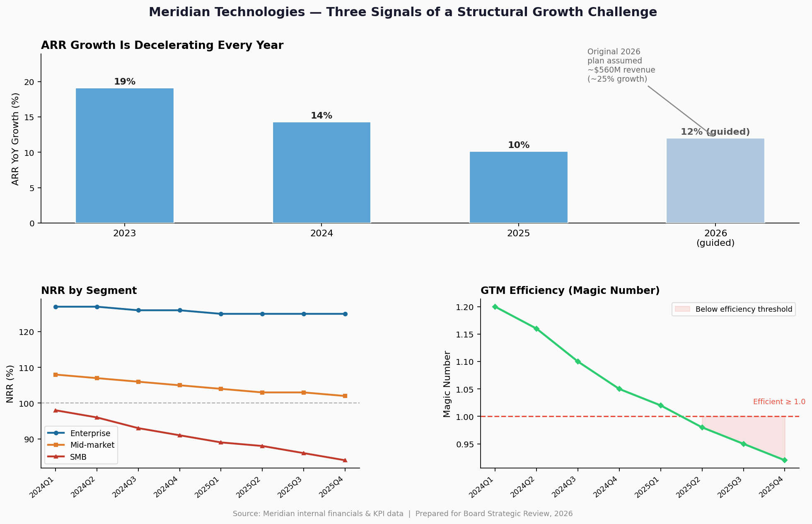
Left: ARR YoY growth declining every year since 2022; 2026 guided at 10–14% vs. the original plan's implied ~25%. Lower left: NRR by segment — enterprise holds at 125%, mid-market has compressed to 102%, SMB has collapsed to 84%. Lower right: Magic number below 1.0 since Q3 2025 — Meridian is spending more than a dollar to acquire a dollar of ARR.

MY ONE ASK OF THIS BOARD
I am asking the board to formally approve Meridian's successor strategic plan today — ending the ambiguity about what this company is. The two live options are: (A) a governed enterprise platform for agentic work, where we explicitly concede SMB and manage mid-market for cash; or (B) a full-spectrum AI platform, where we invest to compete across segments and accept a longer path to re-acceleration.
I have a strong point of view — I will share it at Investor Day on March 11 regardless. But I need board alignment before I walk out that door, because the engineering hiring decisions, the Helio retention structure, and the 2026 capital allocation all depend on which path this board has chosen. Every week of continued ambiguity has a measurable cost in talent risk, deal loss, and competitive distance.

Catherine Park, President & CEO · Meridian Technologies · Board Strategic Review 2026 · Confidential

