Kanu Gaba

Shomik Ghose

Mr. Billington

Period 4

Frustration Pong!

**2.** Our version of pong is different than the original because we have two paddles per player instead of one. The top paddle only moves up but the bottom paddle moves up and down. So, if the “up arrow” key or “w” key is pressed, then both paddles will move up, but if the “down arrow” key or “s” key is pressed, then only the bottom paddle will move down; creating frustration. When the top paddle reaches the top of the screen, it teleports back to the middle where it can continue to move upwards again. The bottom paddle won’t be able to move up past the halfway point on the screen. We also included a thin red bumper that moves down the screen whenever a player pressed any key. This bumper is used strategically so that it deflects the ball and causes the opposing player to react quickly.

**3.** To begin the game, open up DriverPong.java, then click the little red stick figure at the top of the screen.

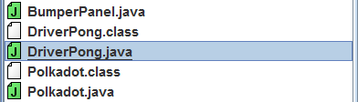

Now Frustration Pong has begun. The objective of the game is to score the black ball onto your opponent’s side of the screen, past their paddle and to avoid the ball from going past your own paddle. Every time you successfully hit the edge of your opponents screen, you will receive one point and it will be displayed at the top of the screen. First to 11 points wins.



Player 1 controls the green paddles using the up and down arrow keys. Player 2 controls the blue paddles using the “w” and “s” keys.

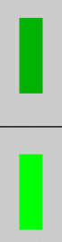 

Take note on how the top paddle is darker then the bottom paddle as it will become important soon. Now, this is not some normal pong, it is frustration pong. And here is where the frustration comes in. The top, darker paddle, only moves up while the bottom, lighter paddle, can move up and down. So, if a player presses the “up arrow” key or the “w” key, both their top paddle and their bottom paddle will move up. But, if they press the “down arrow” key or the “s” key, only their bottom paddle will move down. Once the top paddle reaches the top of the screen, it will be teleported back to the solid black line running horizontally through the middle of the screen. On the other hand, the bottom paddle will not be able to cross the horizontal solid black line. This line separates the bottom and the top paddle.



The dashed line running vertically down the middle of the screen is used to separate Player 1’s side and Player 2’s side.



But that’s not all the frustration there is in this version of pong. There is also a thin, red barrier that will rapidly move down the center of the screen. It will deflect the ball when they collide. This barrier is activated and rushes downwards whenever any player presses any key, so time it wisely.



Once the game is over, a screen like this will be displayed depending on who won. Left click on the screen to restart the game and play again.

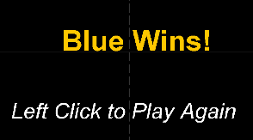

**4.** We learned how to create and implement a Boolean. We created a Boolean called GameState that was used to start and stop drawing all the buffers and the ball. It also allowed for restarting the game on the winner’s screen. We used assistance from a website called CodingBat. This website clearly taught us how to add a Boolean method to our Panel.

**5.** One error or bug that we encountered while writing our code was that after the game has ended and was in the restart or winners screen, while there was no visual display, the variables in timer that ran the ball and bumpers continued to run and caused the count to increase, changing who won the game while the game was over and nothing was displayed. We discovered this error while testing the final game. We noticed that the player who won the game changed because the count was continuing to change even though the game has ended. We modified the code to fix this by setting the ball’s dx and dy to 0 as soon as the game ended. Upon restarting, the ball’s dx and dy were reset back to random. And we didn’t need to stop the bumper’s controls, because there was no ball left to hit.

**6.** <http://codingbat.com/doc/java-if-boolean-logic.html> This source provided us information on how to create and implement a Boolean into our panel.