1) A 1 page overview of your design (a simple block diagram would suffice). The aim is to

quickly summarize your design so emphasize important components and abstractions.

(1 point)

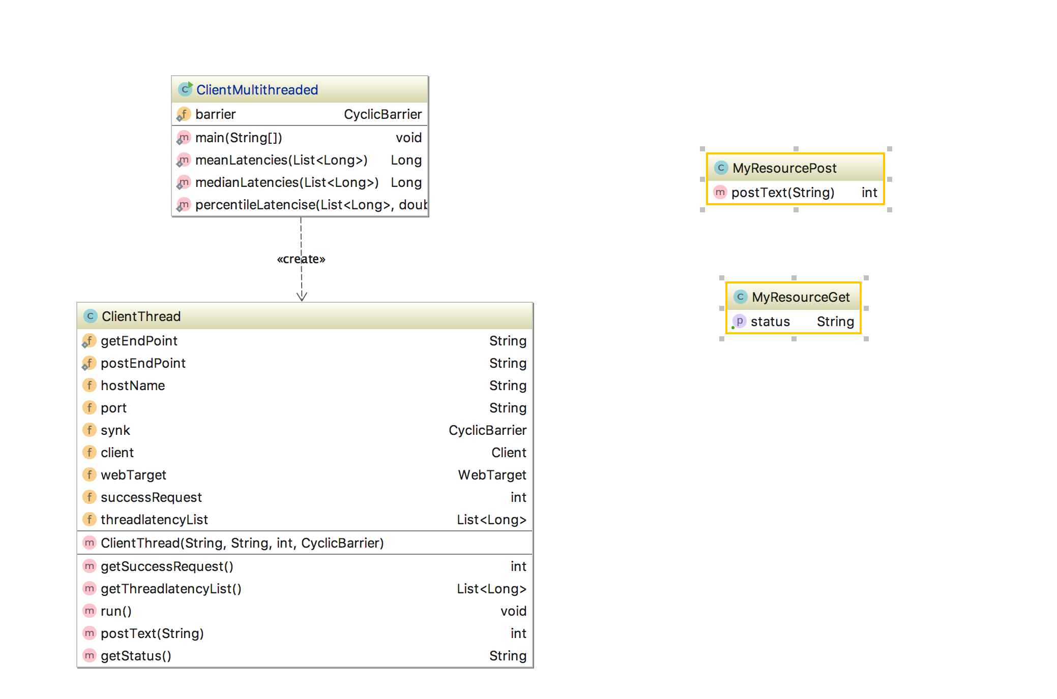

I have four classes as above showing.

Client Side: ClientTread, ClientMultithreader

Server Side: MyResourceGet, MyResourcePost

MyResourceGet and MyResourcePost create the GET/POST service.

ClientTread shows how each thread works.

ClientMultithreader contains a main function creating, managing the thread instances and monitoring their latencies.

2) URL to your git repo. (3 points. We’ll assess code quality)

URL: <https://github.com/Kanuo007/ClientAndServer>

Open the url and find the com package

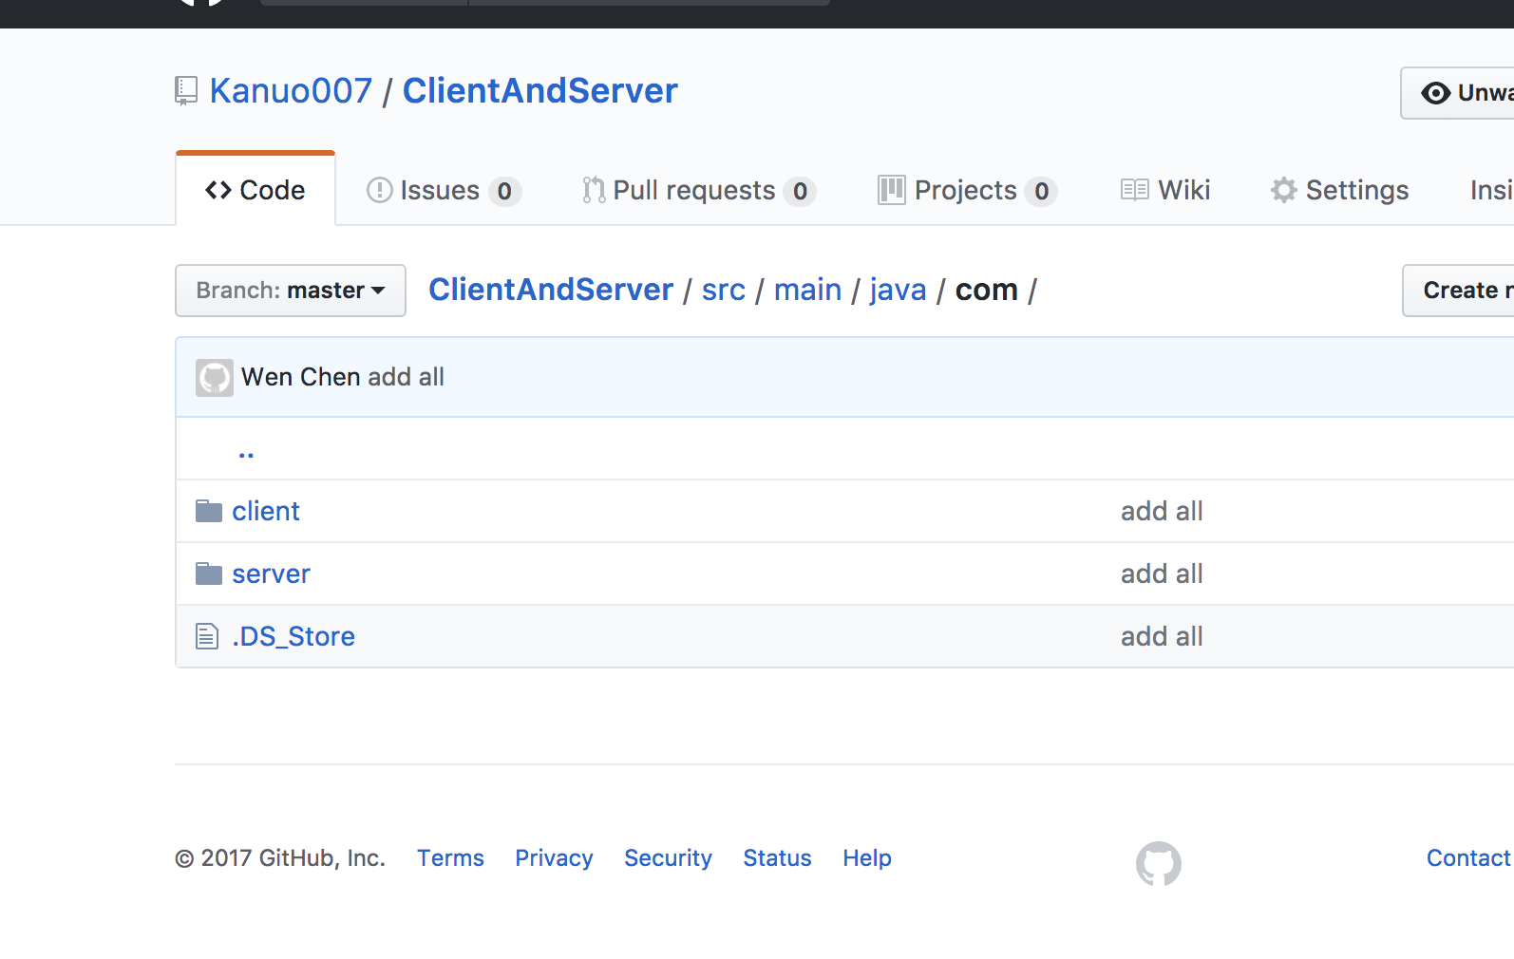

3) Two screenshots for step 4 showing correct execution and completion of the two

specified tests (3 points for each)

The test measures as follow:

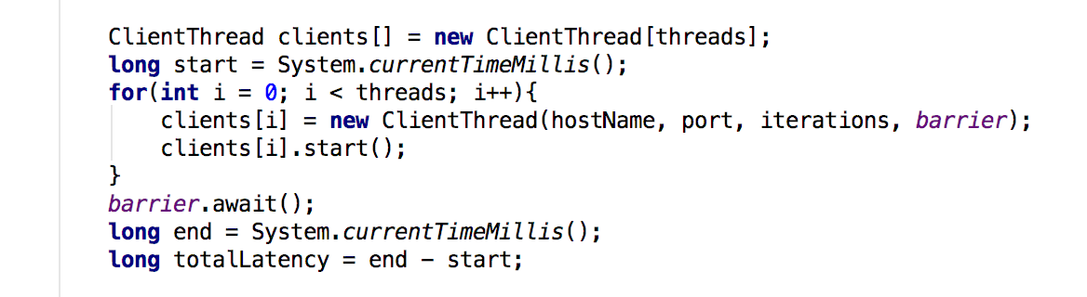

These are the two results:

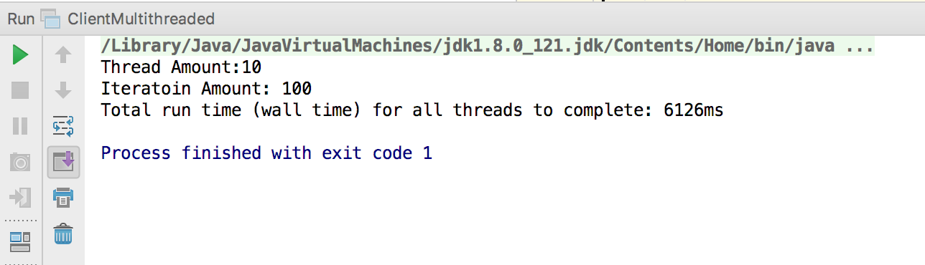

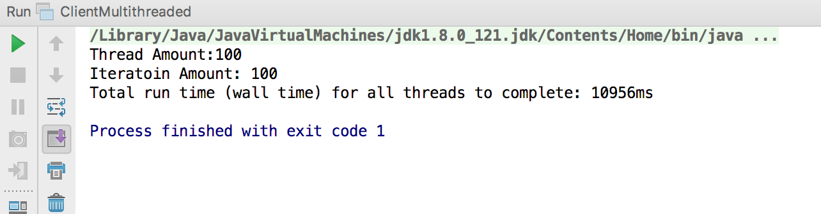

4) Two screenshots for step 5 showing correct execution and completion of the two specified tests. If you use an additional tool like a spreadsheet, show the results in this in addition to the two screenshots showing the test running (5 points for each)

I created a list containing all request latency for each thread. When all threads work done, put all these latencies to one list. Using these list to calculate the mean, median, percentile.

Using the same idea, I tracked the successful request for each thread and accumulate the sum.

Example how one thread track each get request latency and successful request.

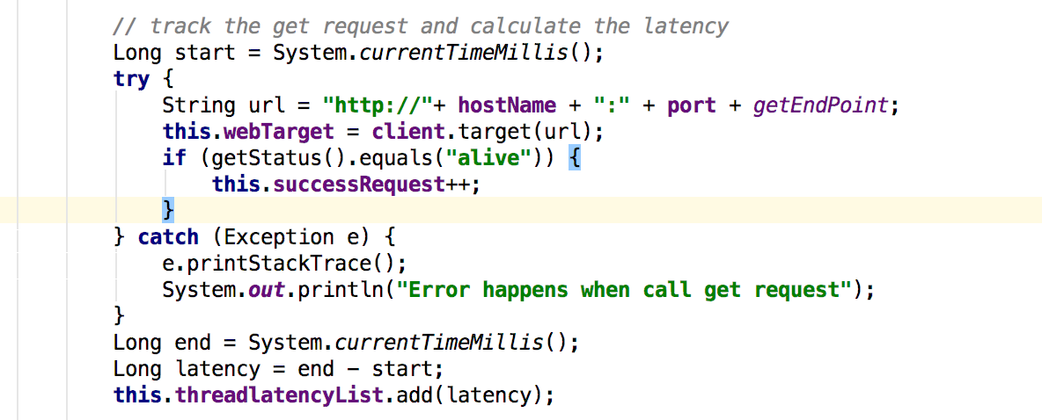

In the ClientMultithreaded, put all the latencies in on list when all threads done.

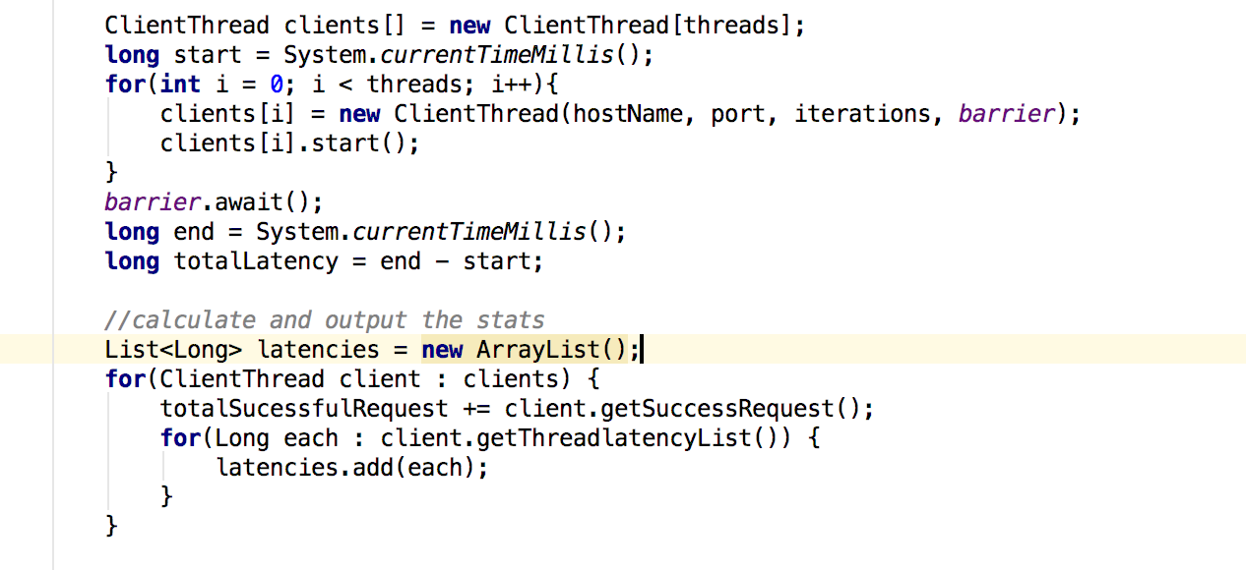

The result is as follow:

