PROGRAMMING FOR PROBLEM SOLVING

**TIC-TAC-TOE IN C**

Kanupriya Johari(**RA2111026010373)**

horizontal line

# 

### INTRODUCTION:

Tic-tac-toe is a paper-and-pencil game for two players, X and O, who take turns marking the spaces in a 3×3 grid.The player who succeeds in placing three of their marks in a horizontal, vertical, or diagonal row wins the game. Here, I have developed a **mini project in C Tic Tac Toe game** – a simple console application without graphics.

It is the same noughts and crosses or the Xs and Os, the other names for Tic-Tac-Toe, we have played with paper and pencil during our school days!

This Tic Tac Toe game in C is compiled in Code::Blocks with gcc compiler.

## 

### ABSTRACT:

While making a Tic Tac Toe game using C language, I have paid special attention to the use of arrays. The Xs and Os are kept in different arrays, and they are passed between several functions in the code to keep track of how the game goes. With the code here one can play the game choosing either X or O **against the computer**.

This Tic Tac Toe C game is such that one will have to input a numeric character, from 1 to 9, to select a position for X or O into the space/block one wants. For example: if one is playing with O and they input 2, the O will go to the first row – second column. If they want to place O in the third row – first column, you have to enter 7. And, it is similar for the other positions.

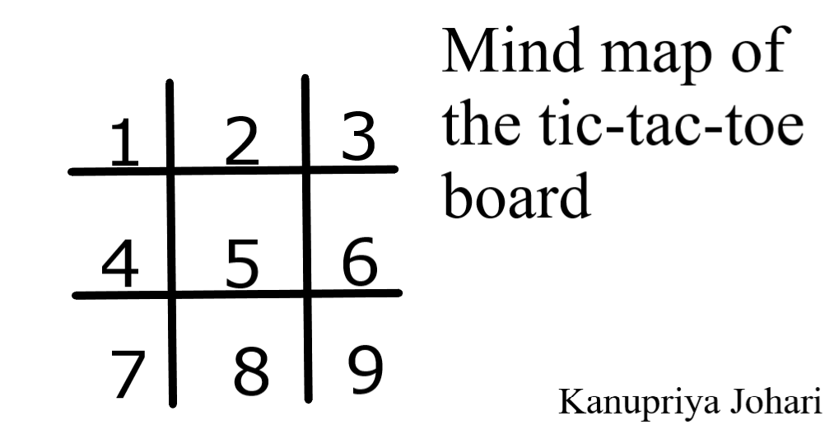

This has been done this way because it is just a console application without graphics designed in C language. The gotoxy function has been used to print text in any part of the screen.

### LIST OF FUNCTIONS USED IN THE PROJECT:

**void menu()** – In this mini project, this function displays the menu or welcome screen of this project. With this function, you can select whether you wish to play the game with X or with O or can even exit the game.

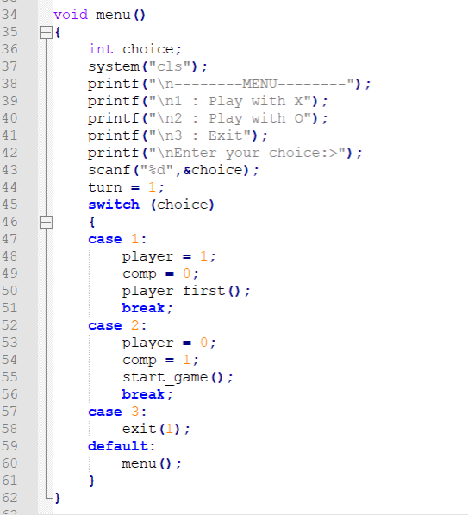 The code

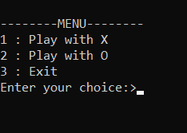 The menu function while the program is running

**void go(int n)**

For deciding whose turn it is

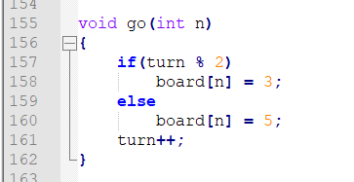

**void start_game()**

For the scenario in which the computer wins

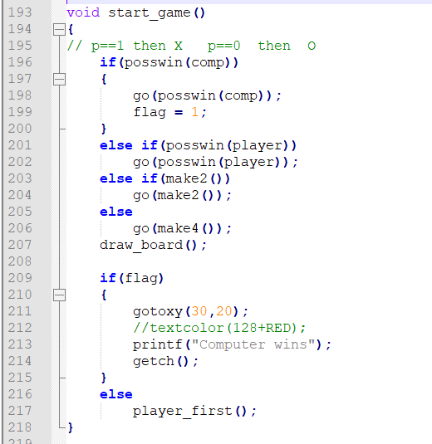

**void check_draw()**

For the scenario in which the game comes to a draw



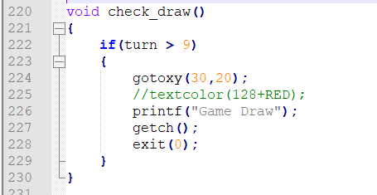

**void draw_board()**

Function to draw the board 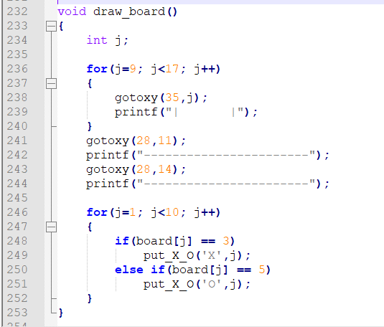

**void player_first()**

For the scenario in which the player wins

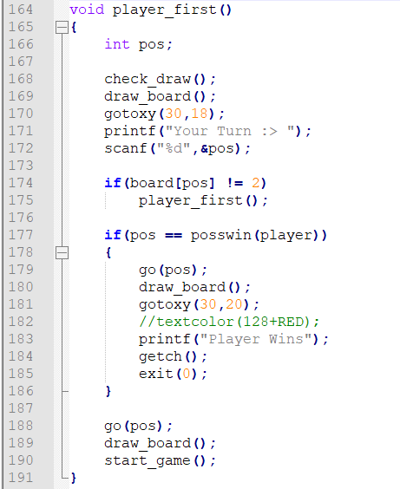

**void put_X_O(char ch, int pos)** – This function puts one of the numerical characters one inputs into the respective position in Tic-Tac-Toe. For example: if one is playing with X and they input 2, the X will go to the first row – second column. If they want to place X in the third row – first column, they have to enter 7. And, it is similar for the other positions.

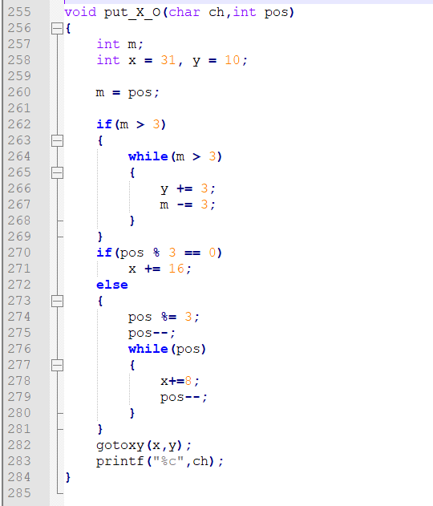

**void gotoxy (int x, int y)** – This function allows the user to print text in any place on the screen.

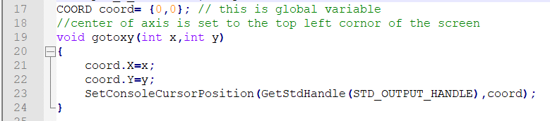

Here, COORD coord= {0,0}; is a global variable. It sets the center of the axis to the top left corner of the screen.

### GAME OUTPUT SCREENSHOTS:

1 ) PLAYER WINS

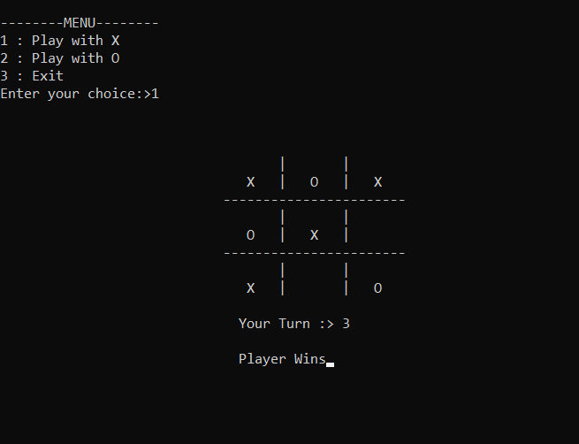

2 ) GAME DRAW

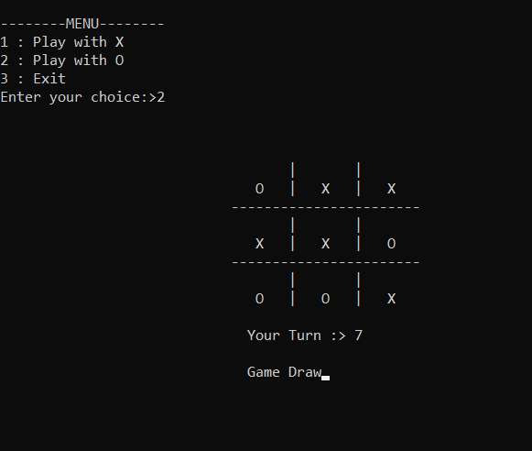

3 ) COMPUTER WINS

