**Open Source Development Technology**

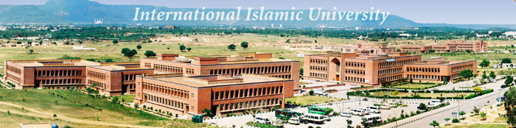



**Project Proposal**

**Submitted To:**

Respected Sir Kashif

**Submitted By:**

Reg# 778, Mehreen Kanwal.

Reg# 787, Saleha Muqadas.

Reg# 727, Hira Akhter

Reg# 780, Hira Asghar

**Class:**

BSSE/F08- B

**Introduction:**

We develop web application for **School Management System** in PHP language and MYSQL backend database as a semester project. It has three modules that are:

* Admin Section
* Finance Section
* Student Section

1. **Admin Section:**

Admin is handling finance and student section. After login admin can handle student information and also staff information. Staff can be of teaching staff and non-teaching staff. Admin can inform student and finance section about latest news and events held in school.

1. **Finance Section:**

Finance section is handling fee information in which information about fee record and fee structure take place.

1. **Student Section:**

Student section is last module in which student can do online registration and can view his/her result online.