

**BAHRIA UNIVERSITY, Karachi Campus**

*Department of Software Engineering*

REPORT

**Course Title:** Computer Communication & Networking

**Course Instructor:** Dr.Hussain **Class**: BSE- (5B)

**Lab Instructor:** Engr. Asma Shaheen  **Name:** Kanwal & Aima**n**

PROJECT TITLE:

**Hotel Management System**

GROUP MEMBERS LIST:

|  |  |  |  |
| --- | --- | --- | --- |
| S.NO | Enrollment | Name | Email |
| 01 | 02-131212-027 | Kanwal Shehzadi | kanwalshehzadi@gmail.com |
| 01 | 02-131212-028 | Aiman Zia Satti | aimanziasatti@gmail.com |
|  |  |  |  |

**Submission Date:** 08-January-2024

Contents

**1.** **INTRODUCTION** 3

**Introduction** 3

**Proposed Solution** 3

**Problem Statement** 3

**Technologies Used** 3

**2.** **DESIGN DESCRIPTION** 3

**Workflow Diagram** 3

**Use Case Diagram** 3

**User Interfaces** 3

**Commands** 3

**Conclusions and further work** 3

**3.** **REFERENCES** 3

# **INTRODUCTION**

## **Introduction**

## The Modern Hotel networking project aims to establish a robust and efficient network infrastructure across its three floors, encompassing various departments and services. The design and implementation focus on seamless communication between departments, secure remote access, and dynamic IP address allocation. The proposed solution incorporates routers, switches, VLANs, DHCP servers, and OSPF as the routing protocol.

## **Proposed Solution**

## The proposed solution involves the deployment of three routers, each connecting a specific floor, with serial DCE cables interconnecting them. OSPF will be implemented as the routing protocol to advertise routes and facilitate communication between departments. Each floor will have a dedicated switch, and VLANs will be configured for each department. DHCP servers on the routers will dynamically allocate IP addresses to devices in the network. Additionally, SSH will be configured on all routers for secure remote login.

## **Problem Statement**

## The current hotel network lacks a structured design and faces issues with inter-departmental communication and secure remote access. The absence of VLANs and proper routing protocols leads to inefficiencies. There is a need for a comprehensive solution that addresses these issues and ensures a secure, organized, and efficient network infrastructure.

## **Technologies Used**

**Cisco Packet Tracer:** The core technology enabling the creation of a simulated environment for testing and optimizing hotel management functionalities.

**Routers:** Three routers will be deployed, one for each floor, to facilitate inter-floor communication using OSPF.

**Switches**: Each floor will have a dedicated switch to connect and manage devices within that floor.

**VLANs:** VLANs will be configured for each department, enhancing network segmentation and security.

**DHCP:** DHCP servers on routers will dynamically allocate IP addresses to devices in the network.

**OSPF:** OSPF will be used as the routing protocol to advertise routes and enable efficient communication between floors.

**SSH:** Secure Shell (SSH) will be configured on all routers to provide secure remote login capabilities.

**Port Security:** Port security will be implemented on the IT department switch, allowing only the designated Test-PC to access port fa0/1 using the sticky method and a violation mode of shutdown.

# **DESIGN DESCRIPTION**

## **Workflow Diagram**

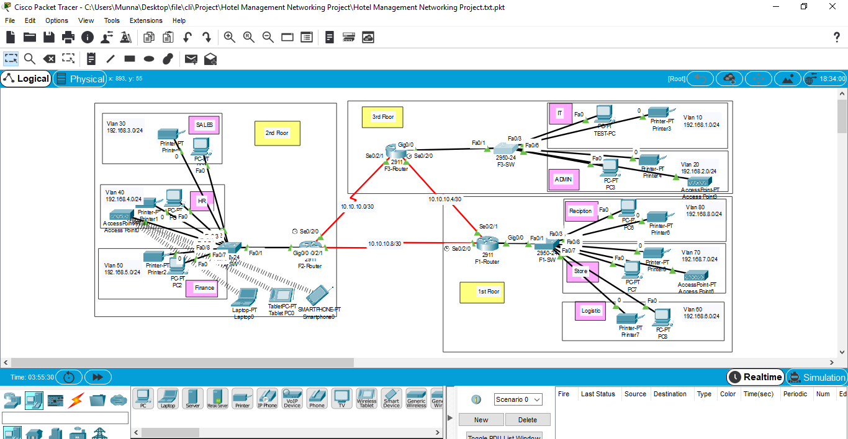

## **Use Case Diagram**

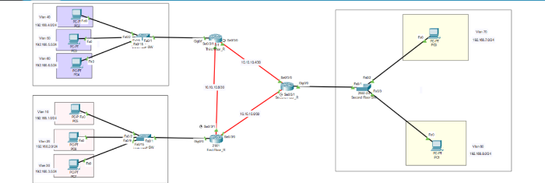

## **User Interfaces**

**Device Management Interface:**

Router interfaces for OSPF configuration.

Switch interfaces for VLAN setup.

DHCP server interface for IP address management.

**Remote Login Interface:**

SSH client for secure remote login.

**Test-PC Interface:**

User interface to test connectivity and network access.

## **Commands**

**ROUTER CONFIGURATION (FOR EACH ROUTER):**

**Router in IT Department (3rd Floor):**

interface serial0/0

ip address 10.10.10.1 255.255.255.252

no shutdown

interface serial0/1

ip address 10.10.10.9 255.255.255.252

no shutdown

router ospf 1

network 10.10.10.0 255.255.255.0 area 0

network 10.10.10.8 255.255.255.0 area 0

**Routers in 1st and 2nd Floor:**

interface serial0/0

ip address 10.10.10.x 255.255.255.252

no shutdown

interface serial0/1

ip address 10.10.10.y 255.255.255.252

no shutdown

router ospf 1

network 10.10.10.x 255.255.255.0 area 0

network 10.10.10.y 255.255.255.0 area 0

**SWITCH CONFIGURATION (FOR EACH SWITCH):**

**IT Department Switch (3rd Floor):**

interface range fa0/1

switchport mode access

switchport access vlan 10

switchport port-security

switchport port-security mac-address sticky

switchport port-security violation shutdown

spanning-tree portfast

**1st and 2nd Floor Switches:**

interface range fa0/1

switchport mode access

switchport access vlan <Respective VLAN ID>

spanning-tree portfast

**DHCP Configuration (for each router):**

ip dhcp pool VLANxx

network <VLAN Network Address> <Subnet Mask>

default-router <Router IP Address>

dns-server <DNS Server IP Address>

**SSH Configuration :**

line vty 0 4

transport input ssh

login local

## **Conclusions and further work**

The implemented network design for Vic Modern Hotel successfully addresses inter-departmental communication, secure remote access, and dynamic IP address allocation. To enhance the system further, continuous monitoring, regular updates to security protocols, and implementation of additional security measures such as firewalls and intrusion detection systems are recommended. Additionally, ongoing training for IT personnel and regular network audits can contribute to the network's resilience and efficiency. Future work may also involve exploring technologies like virtual LAN extensions (VXLAN) for scalability and network expansion.

# **REFERENCES**

The development of this project will be guided by a thorough review of existing literature and technologies. Key references include:

* Smith, J. (2021). "Smart Homes: A Comprehensive Review of Technologies and Applications." Journal of IoT Research, 7(2), 112-135.
* Patel, R., & Wang, L. (2019). "IoT-Based Home Automation for Energy Management: A Review." IEEE Access, 7, 162248-162262.
* Johnson, M., et al. (2020). "Security in IoT-Based Smart Homes: A Comprehensive Survey." Journal of Cybersecurity, 5(1), 1-25. 1.