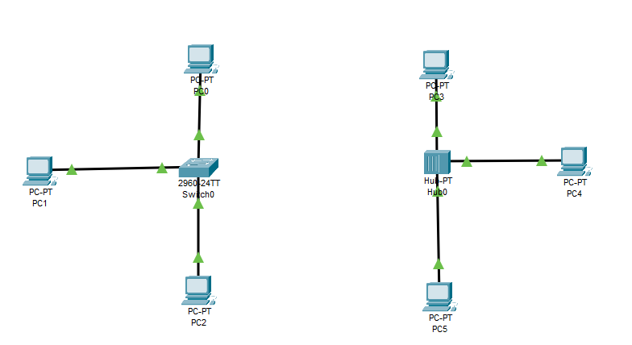

Switch and hub both will send packets to all devices at start but the second time when we send packets switch will send it only to the desired destination and hub will send it again to everyone.So we can simply say that the switchis a smart device and hub is dumb.

***Setting the switch password using line console 0***

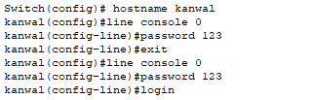

***Setting the switch privilege mode password***

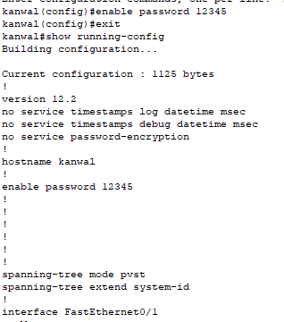

***Encrypt password using enable secret***

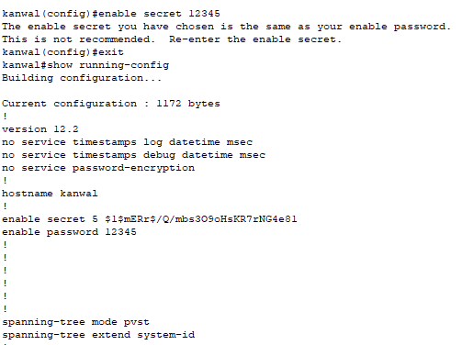

***Creating multiple users and setting the password encryption at once***

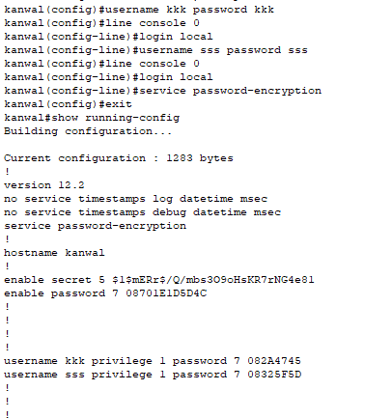

***banner***

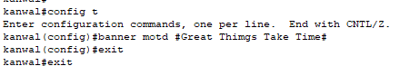

***Set clock***

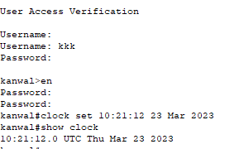

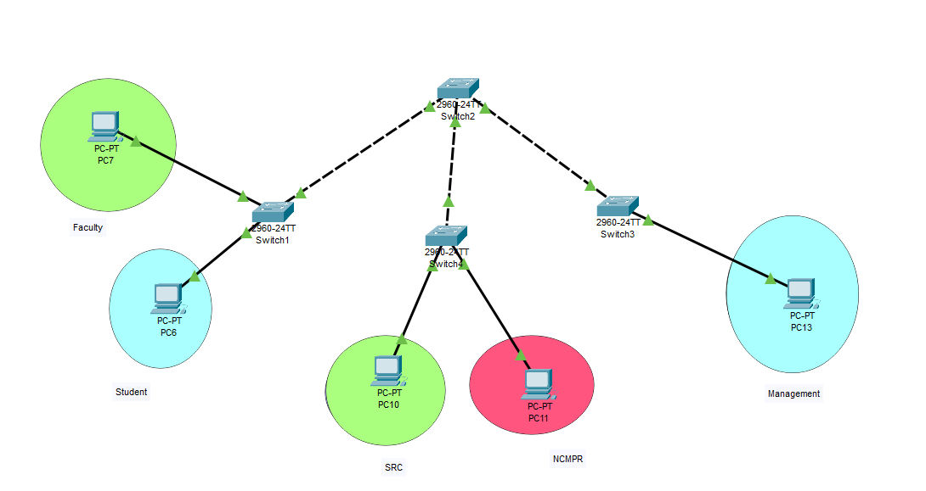

***SWITCH B CONFIGURED TO STUDENT AND FACULTY***

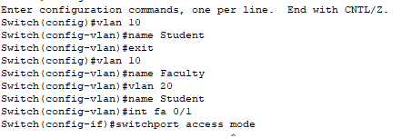

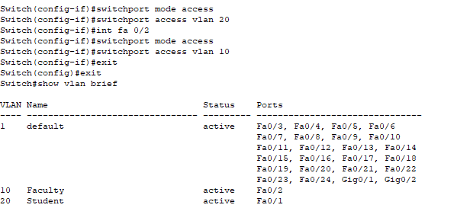

***SWITCH C CONFIGURED TO SRC AND NCMPR***

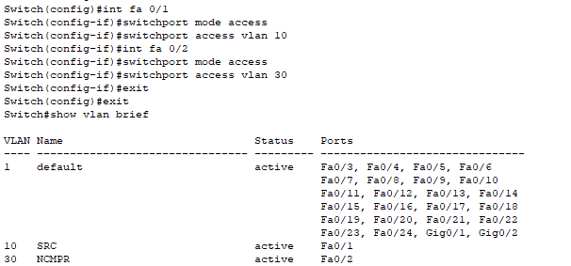

***SWITCH D CONFIGURED TO MANAGEMENT***

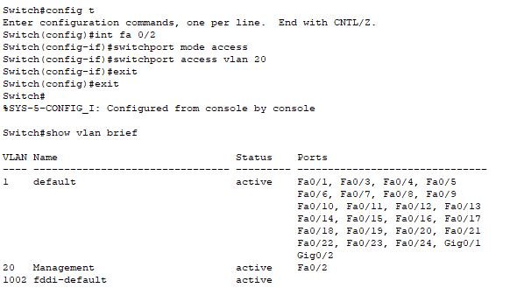

**FACULTY TO SRC**

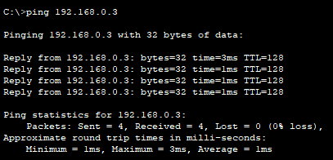

**STUDENT TO SRC**

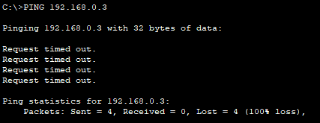

**STUDENT TO MANAGEMENT**

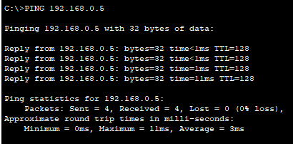

**STUDENT TO NCMPR**

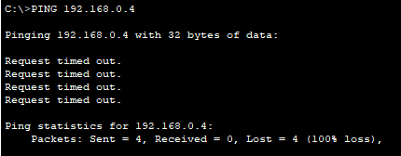

**MANAGEMENT TO MANAGEMENT**

